UNITED STATES

SECURITIES AND EXCHANGE COMMISSION
Washington, D.C. 20549

FORM 8-K

CURRENT REPORT

Pursuant to Section 13 or 15(d) of the Securities Exchange Act of 1934

Date of Report (Date of earliest event reported): June 25, 2026

Applied Optoelectronics, Inc.

(Exact name of registrant as specified in its charter)

Delaware

(State or other jurisdiction of incorporation)

001-36083

(Commission File Number)

76-0533927

(I.R.S. Employer Identification No.)

13139 Jess Pirtle Blvd.

Sugar Land, Texas 77478

(Address of principal executive offices and zip code)

(281) 295-1800

(Registrant’s telephone number, including area code)

Check the appropriate box below if the Form 8-K filing is intended to simultaneously satisfy the filing obligation of the registrant under any of the following provisions (see General Instruction A.2. below):

- Written communications pursuant to Rule 425 under the Securities Act (17 CFR 230.425)

- Soliciting material pursuant to Rule 14a-12 under the Exchange Act (17 CFR 240.14a-12)

- Pre-commencement communications pursuant to Rule 14d-2(b) under the Exchange Act (17 CFR 240.14d-2(b))

- Pre-commencement communications pursuant to Rule 13e-4(c) under the Exchange Act (17 CFR 240.13e-4(c))

Securities registered pursuant to Section 12(b) of the Act:

Title of each class | Trading Symbol(s) | Name of each exchange on which registered
Common Stock, Par value $0.001 | AAOI | NASDAQ Global Market

Indicate by check mark whether the registrant is an emerging growth company as defined in Rule 405 of the Securities Act of 1933 (§230.405 of this chapter) or Rule 12b-2 of the Securities Exchange Act of 1934 (§240.12b-2 of this chapter).

Emerging growth company ☐

If an emerging growth company, indicate by check mark if the registrant has elected not to use the extended transition period for complying with any new or revised financial accounting standards provided pursuant to Section 13(a) of the Exchange Act. o

Item 1.01 Entry into a Material Definitive Agreement.

On June 25, 2026, Applied Optoelectronics, Inc. (the “Company”) entered into a Standard Form of Agreement Between Owner and Design-Builder (AIA Document A141–2024), together with the related exhibits package (collectively, the “Design-Build Agreement”), with LCC3 Solution Inc. (the “Design-Builder”). Pursuant to the Design-Build Agreement, the Design-Builder will provide design-build services for the Company’s OMD 3 (FAB4) cleanroom construction project located at 11555 North Spectrum Blvd., Houston, Texas 77047 (the “Project”).

The Project consists of the design-build of approximately 195,591 square feet of ISO Class 6-certified cleanroom space, 36,500 square feet of office space, and 73,780 square feet of space designated for shipping and receiving, quality and reliability testing, and inventory operations. The scope of the Project includes design, engineering, procurement, construction, testing, commissioning, and related closeout activities.

The total contract amount for the Project is approximately $94.1 million, inclusive of design, construction, and related professional services, as set forth in the Design-Build Agreement. Payments under the Design-Build Agreement are generally based on progress, with 10% retainage withheld from each pay application and released upon final completion, subject to final acceptance and completion of punch list items. Pay applications are submitted monthly, and payments are due within 15 days after the Company’s receipt of a properly completed pay application.

The Design-Build Agreement provides for liquidated damages in the event of delays in achieving specified key milestones or substantial completion, subject to contractual adjustments and conditions, with aggregate liquidated damages capped at $4.9 million.

The Design-Build Agreement also provides that the Design-Builder may be eligible to earn certain incentives, subject to the terms and conditions set forth therein, including (i) schedule-based incentives tied to the timely achievement of specified key milestones of up to $6.0 million and (ii) performance-based incentives, including up to $4.9 million tied to cleanroom validation testing and up to $4.9 million tied to warranty performance.

The Project has a targeted Substantial Completion date of January 10, 2027.

Item 2.03 Creation of a Direct Financial Obligation or an Obligation under an Off-Balance Sheet Arrangement of a Registrant.

The information contained in Item 1.01 of this Current Report on Form 8-K with respect to the Lease Agreement is incorporated by reference into Item 2.03.

Item 9.01 Financial Statements and Exhibits.

(d) Exhibits

10.1 Standard Form of Agreement Between Owner and Design-Builder (AIA Document A141–2024), executed as of June 25, 2026, by and between Applied Optoelectronics, Inc. and LCC3 Solution Inc.

10.2* Exhibits to Design-Build Contract Between Owner and Design-Builder, executed as of June 25, 2026

104 Cover Page Interactive Data File (embedded within the Inline XBRL document).

- Certain identified information has been excluded from this exhibit because it is both not material and is the type that the registrant treats as private or confidential.

2

SIGNATURES

Pursuant to the requirements of the Securities Exchange Act of 1934, the registrant has duly caused this report to be signed on its behalf by the undersigned hereunto duly authorized.

Date: July 1, 2026 | APPLIED OPTOELECTRONICS, INC.
 | By: | /s/ DAVID C. KUO
 | Name | David C. Kuo
 | Title: | Senior Vice President and Chief Legal Officer

3

Exhibit 10.1

 Document A141® – 2024

Standard Form of Agreement Between Owner and Design-Builder fora Traditional Design-Build Project

AGREEMENT made as of the 25th day of June in the year 2026 (In words, indicate day, month, and year.)

BETWEEN the Owner:

(Name, legal status, address, and other information)

Applied Optoelectronics, Inc.

13139 Jess Pirtle Blvd.

Sugar Land, TX 77478

and the Design-Builder:

(Name, legal status, address, and other information)

LCC3 Solution Inc.

7165 Colleyville Blvd. Suite 101

Colleyville, TX 76034

Phone 817-416-0098

for the following Project:

(Name, location, and detailed description)

OMD3 Fab (FAB4) Manufacturing Cleanroom Project 11555 North Spectrum Blvd. Houston, TX 77047

The Owner and Design-Builder agree as follows.

ADDITIONS AND DELETIONS: The author of this document may have revised the text of the original AIA standard form. An Additions and Deletions Report that notes revisions to the standard form text is available from the author and should be reviewed. A vertical line in the left margin of this document indicates where the author has added to or deleted from the original AIA text.

This document has important legal consequences. Consultation with an attorney is encouraged with respect to its completion or modification.

Consultation with an attorney is also encouraged with respect to professional licensing requirements in the jurisdiction where the Project is located.

AIA Document A141 – 2024. Copyright © 2004, 2014, and 2024. All rights reserved. “The American Institute of Architects,” “American Institute of Architects,” “AIA,” the AIA Logo, and “AIA Contract Documents” are trademarks of The American Institute of Architects. This document was produced at 19:01:47 CDT on 06/23/2026 under Subscription No. 20250156492
which expires on 08/29/2026, is not for resale, is licensed for one-time use only, and may only be used in accordance with the AIA Contract Documents® Terms of Service. To report copyright violations, e-mail docinfo@aiacontracts.com

User Notes:

1

TABLE OF ARTICLES

- GENERAL PROVISIONS

- COMPENSATION AND PROGRESS PAYMENTS
- GENERAL REQUIREMENTS OF THE WORK OF THE DESIGN-BUILD CONTRACT

4DESIGN PHASE OF WORK

5FINAL DESIGN AND CONSTRUCTION

6CHANGES IN THE WORK

7OWNER’S RESPONSIBILITIES
- TIME
- PAYMENT APPLICATIONS AND PROJECT COMPLETION

10PROTECTION OF PERSONS AND PROPERTY

11INSURANCE AND BONDS

12UNCOVERING AND CORRECTION OF CONSTRUCTION WORK

13COPYRIGHTS AND LICENSES

14TERMINATION OR SUSPENSION

15CLAIMS AND DISPUTES

16MISCELLANEOUS PROVISIONS

17SCOPE OF THIS AGREEMENT

AIA Document A141 – 2024. Copyright © 2004, 2014, and 2024. All rights reserved. “The American Institute of Architects,” “American Institute of Architects,” “AIA,” the AIA Logo, and “AIA Contract Documents” are trademarks of The American Institute of Architects. This document was produced at 19:01:47 CDT on 06/23/2026 under Subscription No. 20250156492
which expires on 08/29/2026, is not for resale, is licensed for one-time use only, and may only be used in accordance with the AIA Contract Documents® Terms of Service. To report copyright violations, e-mail docinfo@aiacontracts.com

User Notes:

2

 | TABLE OF EXHIBITS
Exhibit A | Scope of Work and Owner’s Criteria
Exhibit A-1 | Owner-Provided Equipment
Exhibit B-1 | Contract Sum and Schedule of Values
Exhibit B-2 | Payment Schedule
Exhibit B-3 | Separated Contract Requirements
Exhibit B-4 | Design-Builder Rates
Exhibit C-1 | Design Delivery Schedule
Exhibit C-2 | Construction Schedule
Exhibit C-3 | Project Schedule Key Milestones
Exhibit C-4 | Delay Liquidated Damages and Timely Completion Incentives
Exhibit D-1 | Design-Builder Performance Guarantee Requirements
Exhibit D-2 | Performance Earned Incentives and Liquidated Damages
Exhibit E-1 | Design-Builder Key Personnel/Project Organization
Exhibit E-2 | List of Design-Builder’s Architect, Consultants, and Subcontractors
Exhibit E-3 | Design-Builder’s Quality Assurance and Quality Control Manual
Exhibit F-1 | Change Order Terms and Limitations
Exhibit F-2 | Form of Change Order Request
Exhibit F-3 | Form of Change Order
Exhibit G-1 | Form of Conditional Waiver and Release on Progress Payment
Exhibit G-2 | Form of Unconditional Waiver and Release on Progress Payment
Exhibit G-3 | Form of Conditional Waiver and Release on Final Payment
Exhibit G-4 | Form of Unconditional Waiver and Release on Final Payment
Exhibit G-5 | Form of All Bills Paid Affidavit
Exhibit H-1 | Mechanical Completion Conditions
Exhibit H-2 | Notice of Mechanical Completion Form
Exhibit H-3 | Mechanical Completion Certificate
Exhibit I-1 | Pre-Commissioning, Commissioning, Start Up, and Testing Conditions
Exhibit I-2 | Notice of Performance Test Completion
Exhibit I-3 | Form of Performance Test Completion Certificate
Exhibit J-1 | Substantial Completion Conditions
Exhibit J-2 | Notice of Substantial Completion
Exhibit J-3 | Form of Substantial Completion Certificate
Exhibit K-1 | Final Completion Conditions
Exhibit K-2 | Notice of Final Completion Form
Exhibit K-3 | Final Completion Certificate
Exhibit L | Insurance Requirements
Exhibit M | Non-Disclosure and Confidentiality Agreement
Exhibit N | Dispute Resolution Procedures
Exhibit O | Not Used

AIA Document A141 – 2024. Copyright © 2004, 2014, and 2024. All rights reserved. “The American Institute of Architects,” “American Institute of Architects,” “AIA,” the AIA Logo, and “AIA Contract Documents” are trademarks of The American Institute of Architects. This document was produced at 19:01:47 CDT on 06/23/2026 under Subscription No. 20250156492
which expires on 08/29/2026, is not for resale, is licensed for one-time use only, and may only be used in accordance with the AIA Contract Documents® Terms of Service. To report copyright violations, e-mail docinfo@aiacontracts.com

User Notes:

3

ARTICLE 1 GENERAL PROVISIONS

Owner hereby retains Design-Builder, and Design-Builder hereby agrees to be retained by Owner, to perform or cause to be performed the Work in accordance with the terms set forth in this Agreement. Where this Agreement describes the Work or Equipment in general terms, but not in complete detail (and except as otherwise stated in the Scope of Work or elsewhere in this Agreement as being the responsibility of Owner), it is understood and agreed that the Work and Equipment include any reasonably foreseeable incidental work and materials that are required and necessary to complete the Project in accordance with this Agreement. Design-Builder acknowledges that this Agreement constitutes an obligation to perform the Work, including to procure, construct, test, start-up and commission the Project, for a stipulated sum. Design-Builder hereby represents and commits that it can complete the Work for the Contract Price in accordance with the Project Schedule.

§ 1.1 Owner’s Criteria

This Agreement is based on the Owner’s Criteria set forth in this Section 1.1. The Owner’s Criteria is fixed as of the date of this Agreement.

(For each item in Section 1.1.1 through 1.1.10, insert the information or a statement such as “not applicable” or “unknown at the time of execution.)

- 1.1.1 The Owner’s program for the Project:

(Identify below, or in an attached exhibit, the documentation in which the program is setf orth, or state the manner in which the program will be developed.)

See Exhibit A.

- 1.1.2 The Owner’s design requirements for the Project:

(Identify below, or in an attached exhibit, the documentation that contains the Owner’s design requirements, including any performance specifications for the Project.)

See Exhibit A.

- 1.1.3 The Project’s physical characteristics:

(Identify or describe below, or in an attached exhibit, if appropriate, size, location, dimensions, or other pertinent information, such as geotechnical or environmental reports; site, boundary, topographic, or existing building surveys; traffic and utility studies; availability of public and private utilities and services; legal description of the site; Project and site requirements; etc.)

See Exhibit A.

- 1.2 Project Team

- 1.2.1 The Owner identifies the following representative in accordance with Section 7.1.1: (List name, address, and other information.)

Dr. Fred Chang

Senior Vice President and North America General Manager

Applied Optoelectronics, Inc.

13139 Jess Pirtle Blvd.,

Sugar Land, TX 77478

fchang@ao-inc.com

281-295-1800

Owner’s Authorized Representative listed herein is the only authorized representative that may execute any change related to the Project or waive any requirements in the Design-Build Documents. No other person is authorized to authorize such changes on behalf of the Owner. No officer, agent, representative, or employee of the Owner shall be personally responsible for any liability arising under this Agreement.

- 1.2.2 The Owner will retain the following consultants and Separate Contractors: Not Applicable. (List name, address, and other information.)

- 1.2.3 The Design-Builder identifies the following representative in accordance with Section 3.1.2: (List name, address and other information.)

AIA Document A141 – 2024. Copyright © 2004, 2014, and 2024. All rights reserved. “The American Institute of Architects,” “American Institute of Architects,” “AIA,” the AIA Logo, and “AIA Contract Documents” are trademarks of The American Institute of Architects. This document was produced at 19:01:47 CDT on 06/23/2026 under Subscription No. 20250156492
which expires on 08/29/2026, is not for resale, is licensed for one-time use only, and may only be used in accordance with the AIA Contract Documents® Terms of Service. To report copyright violations, e-mail docinfo@aiacontracts.com

User Notes:

4

Mingzheng (Miles) Yang

LCC3 Solution Inc.

7165 Colleyville Blvd. Suite 101

Colleyville, TX 76034

Phone: 817-416-0098

- 1.2.4 The Design-Builder shall retain the Architect, Consultants, Subcontractors, and suppliers, identified in Exhibit E-2 - List of Design-Builder’s Architect, Consultants and Subcontractors. To the extent that not all parties have been selected by Design-Builder as of the execution of this Agreement, Design-Builder shall supplement Exhibit E-2 within 30 days after the effective date of this Agreement.
(List name, discipline, address, and other information.)

- 1.2.5 Neither the Owner’s nor the Design-Builder’s representative shall be changed without ten days’ notice to the other party.

- 1.2.6 Design-Builder has assigned Key Personnel as set forth in Exhibit E-1 Design-Builder Key Personnel/Project Organization. Those Key Personnel shall not be changed, removed, or substituted from the Project without Owner’s prior written approval.

- 1.3 Dispute Resolution

- 1.3.1 Initial Resolution of Claims. Claims shall be:

(Check the appropriate box.)

- Subject to a Meet and Confer obligation in accordance with Section 15.2.1 and Exhibit N Dispute Resolution Procedures].

- ]Referred to the following Project Neutral for an initial decision in accordance with Section 15.2.2. (Insert name, address, and contact information for Project Neutral.)

If the Owner and Design-Builder do not select a Project Neutral above, the Parties shall meet and confer as a condition precedent to mediation pursuant to Section 15.3.

- 1.3.2 Binding Dispute Resolution. For any Claim subject to, but not resolved by, mediation pursuant to Section 15.3, the method of binding dispute resolution shall be the following:
(Check the appropriate box.)

[ X ] Arbitration pursuant to Exhibit N.

Design-Builder shall include Exhibit N in each contract with any entity engaged by Design-Builder to perform the Work.

§ 1.4 DEFINITIONS

Applicable Laws. Applicable Law(s) means all laws, statutes, ordinances, codes, rules and regulations, orders of public authorities, and interpretations by authorities having jurisdiction over the Work.

Architect. The Architect is a person or entity providing architectural and engineering Design Services for the Design-Builder for all or a portion of the Work and is lawfully licensed to practice architecture or engineering, as appropriate, in the applicable jurisdiction. The Architect is referred to throughout the Design-Build Documents as if singular in number. Architect may be Design-Builder or a Consultant separately contracted by and through Design-Builder and shall provide all documents with appropriate seal and license as the Architect of Record.

Confidential Information. Confidential Information is information containing confidential or business proprietary information that is designated as “confidential” as defined by the NDCA attached as Exhibit M Non-Disclosure and Confidentiality Agreement.

AIA Document A141 – 2024. Copyright © 2004, 2014, and 2024. All rights reserved. “The American Institute of Architects,” “American Institute of Architects,” “AIA,” the AIA Logo, and “AIA Contract Documents” are trademarks of The American Institute of Architects. This document was produced at 19:01:47 CDT on 06/23/2026 under Subscription No. 20250156492
which expires on 08/29/2026, is not for resale, is licensed for one-time use only, and may only be used in accordance with the AIA Contract Documents® Terms of Service. To report copyright violations, e-mail docinfo@aiacontracts.com

User Notes:

5

Construction Work. “Construction Work” is the construction, and services to support construction, required by the Design-Build Documents, whether completed or partially completed, and whether new construction or modification of existing structures, and includes all other demolition, abatement, disposal, labor, materials, equipment, and services provided, or to be provided, by the Design-Builder to fulfill the Design-Builder’s obligations under the Design-Build Documents. Where the Work requires construction that modifies or interfaces with existing structures, the Design-Builder shall take such actions as are necessary to make the Work compatible with and appropriately interface with the as-built conditions of the existing structures.

Consultant. A Consultant is a person or entity providing services for the Design-Builder for all or a portion of the Work and is referred to throughout the Design-Build Documents as if singular in number. If the Consultant provides professional services, the Consultant shall have the appropriate expertise and be lawfully licensed to provide such services, as required by the applicable jurisdiction.

Contract. The Design-Build Documents form the Contract. The Contract represents the entire and integrated agreement between the parties and supersedes prior negotiations, representations, or agreements, either written or oral. The Contract may be amended or modified only by a Modification. The Design-Build Documents shall not be construed to create a contractual relationship of any kind between any persons or entities other than the Owner and the Design-Builder (although the Owner does not waive any third-party beneficiary rights or rights to assignment it may otherwise have as to the Architect, Consultants, or Subcontractors of any tier). This Contract is a standard form created by the America Institute of Architects (AIA) with modifications that have been agreed between the Parties. The Parties agree that neither Party shall be considered the author of the Contract, and any ambiguities shall be neutrally construed.

Contract Sum. The Contract Sum is the amount to be paid to the Design-Builder for performance of the Work.

Contract Time. The Contract Time is the period of time identified in Exhibit C-2 Project Schedule, measured from the date for commencement of the Construction Work, including authorized adjustments, established as the period for the Design-Builder to achieve Substantial Completion of the Work.

Day. The term “day” as used in the Design-Build Documents shall mean calendar day unless otherwise specifically defined.

Design Services. “Design Services” are the professional services, including those services that are rendered by architects and engineers, which are required to fulfill the Design-Builder’s obligations under the Design-Build Documents. Design Services do not include professional or other services necessary to support Construction Work which are provided by Subcontractors engaged by the Design-Builder; provided however, that Design-Builder is nonetheless responsible for the complete design and performance of the Work per the requirements of the Contract.

Design-Build Documents. The Design-Build Documents consist of this Agreement between Owner and Design-Builder and Exhibits listed in this

Agreement, which are expressly incorporated herein (collectively hereinafter “Agreement”) and Modifications issued after execution of this

Agreement, all of which form the Contract and are as fully a part of the Contract as if attached to this Agreement or repeated herein. A Modification is

- a written amendment to the Contract signed by both parties, (2) a Change Order, or (3) a Change Directive. The Design-Build Documents will also include the Drawings, Specifications, and other documents created by Design-Builder and used to complete the Project. If anything in the other Design-Build Documents, other than a Modification, is inconsistent with this Agreement, this Agreement shall govern.

Design-Builder. The Design-Builder is the person or entity identified as such in this Agreement and is referred to throughout the Design-Build Documents as if singular in number. The term “Design-Builder” means the Design-Builder or the Design-Builder’s authorized representative. The Design-Builder shall be lawfully licensed in the jurisdiction where the Project is located and insured as required herein. The Design-Builder shall be and operate as an independent contractor in the performance of the Work and shall have complete control over and responsibility for all personnel performing the Work. Design-Builder is not authorized to enter into any agreements or undertakings for or on behalf of the Owner or to act as or be an agent or employee of the Owner. The Design-Builder will cooperate with the Owner and Architect to create an environment of mutual respect and focus on the success of the Project.

Design-Builder’s Equipment. “Design-Builder’s Equipment” means all of the equipment, materials, apparatus, structures, tools, supplies and other goods provided and used by Design-Builder and its Subcontractors and Consultants for performance of the Work, but which are not intended to be incorporated into the Project.

AIA Document A141 – 2024. Copyright © 2004, 2014, and 2024. All rights reserved. “The American Institute of Architects,” “American Institute of Architects,” “AIA,” the AIA Logo, and “AIA Contract Documents” are trademarks of The American Institute of Architects. This document was produced at 19:01:47 CDT on 06/23/2026 under Subscription No. 20250156492
which expires on 08/29/2026, is not for resale, is licensed for one-time use only, and may only be used in accordance with the AIA Contract Documents® Terms of Service. To report copyright violations, e-mail docinfo@aiacontracts.com

User Notes:

6

Early Release Work. “Early Release Work” is a limited, predetermined portion of the Project or scope of the Work that the Owner authorizes the Design-Builder to commence before the commencement of the Work. Early Release Work may be authorized by a Limited Notice to Proceed (LNTP) or written Work Authorization Amendment when issued in writing and signed by Owner.

Equipment. “Equipment” means all of the equipment, materials, apparatus, structures, tools, supplies, goods and other items required to complete the Work, excluding: (a) the Owner-Provided Equipment described in Exhibit A-1 Owner-Provided Equipment, if any, and any items related thereto, and (b) Design-Builder’s Equipment.

Instruments of Service. Instruments of Service are representations, in any medium of expression now known or later developed, of the tangible and intangible creative work performed by the Design-Builder, Subcontractors, Architect, or Consultants under their respective agreements. Instruments of Service may include, without limitation, studies, surveys, models, sketches, drawings, specifications, and other similar materials.

Notice

Where the Design-Build Documents require one party to notify or give notice to the other party, such notice shall be provided in writing to the designated representative of the party to whom the notice is addressed and shall be deemed to have been duly served if delivered in person, by mail, by courier, or by electronic transmission as set forth below:

Notice from Design-Builder to Owner shall be delivered in all cases via e-mail to the other party’s designated representative, and clearly captioned "NOTICE" in the subject and body of the electronic transmission. For all legal notices, a copy shall also be delivered either in person, by mail, or by courier.

Notice of Claims as provided in Section 15.1.3 shall be provided in writing and shall be deemed to have been duly served only if delivered to the designated representative of the party to whom the notice is addressed by certified or registered mail, or by courier providing proof of delivery with a copy via e-mail designated as a "NOTICE OF CLAIM" or "CLAIM.”.

Owner. The Owner is the person or entity identified as such in this Agreement and is referred to throughout the Design-Build Documents as if singular in number. The term “Owner” means the Owner or the Owner’s authorized representative.

Owner-Provided Equipment. “Owner-Provided Equipment” means the equipment, if any, set forth in Exhibit A-1 Owner-Provided Equipment.

Project. The Project is comprised of all design, engineering, construction, testing and commissioning, of which the Work performed under the Design-Build Documents may be the whole or a part, and may include design and construction by the Owner and by Separate Contractors.

Prudent Manufacturing Industry Practices. “Prudent Manufacturing Industry Practices” means, in connection with the design, engineering, procurement, construction, testing and commissioning of a manufacturing semiconductor clean room of a type and size and having attributes similar to the Project, those practices, methods, specifications and standards of safety, performance, dependability, efficiency and economy generally recognized by industry members in the United States as good and proper, and such other practices, methods or acts which, in the exercise of reasonable judgment by those reasonably experienced in the industry in light of the facts known at the time a decision is made, would be expected to accomplish the result intended at a reasonable cost and consistent with Applicable Laws, reliability, and safety.

Subcontractor. A Subcontractor is a person or entity (a) performing all or a portion of the construction, (b) supplying materials, equipment, or labor required in connection with the Work, for the Design-Builder. Each Subcontractor shall be lawfully licensed, if required in the jurisdiction where the Project is located and insured as required herein. Reference to “Subcontractor(s)” herein shall include subcontractors of any tier, consultants, Architect. Design professionals providing Design Services and suppliers.

Work. “Work” means all necessary work and services, including all obligations described in this Agreement, required in connection with (a) the design, engineering, procurement, construction, assembly, installation, start-up and testing support and completion of the Project; (b) the procurement, installation and incorporation of the Equipment into the Project, as may be required herein and any amendment, and installation and incorporation of Owner-Provided Equipment into the Project when included in the Scope of Work in Exhibit A or by amendment; (c) the provision, management and supervision of all Personnel, transportation, administration and other services as required in connection with any of the foregoing; (d) the performance of, and incorporation into the Project of, the Engineering; (e) the work and services set forth in any executed limited notice to proceed; (f) the inspection and furnishing of all materials, equipment, machinery, tools, temporary structures, and temporary utilities as required in connection with the foregoing; and (g) any other product or result of the foregoing, as more particularly described in Exhibit A. “Work” For clarity, Work means (a) Preconstruction Services, (b) other services required of the Design-Builder during the Design Phase, (c) Design Services performed during the Design Phase, (d) Design Services performed during the Construction Phase, and (e) Construction Work required by the Design-Build Documents.

AIA Document A141 – 2024. Copyright © 2004, 2014, and 2024. All rights reserved. “The American Institute of Architects,” “American Institute of Architects,” “AIA,” the AIA Logo, and “AIA Contract Documents” are trademarks of The American Institute of Architects. This document was produced at 19:01:47 CDT on 06/23/2026 under Subscription No. 20250156492
which expires on 08/29/2026, is not for resale, is licensed for one-time use only, and may only be used in accordance with the AIA Contract Documents® Terms of Service. To report copyright violations, e-mail docinfo@aiacontracts.com

User Notes:

7

- 1.6 Relationship of the Parties. The Design-Builder accepts the relationship of trust and confidence established by this Agreement and covenants with the Owner to exercise the Design-Builder’s skill and judgment in furthering the interests of the Owner; to furnish efficient construction administration, management services, and supervision with sufficient quantities of fully qualified, competent and experienced personnel; to furnish at all times an adequate supply of workers and materials; to furnish and employ throughout the Project timely and appropriate and quality assurance and quality control procedures related to design, construction, and commissioning, and to perform the Work in an expeditious and economical manner consistent with the Owner’s interests. The Owner agrees to furnish and approve, in a timely manner, information required by the Design-Builder and to make payments to the Design-Builder in accordance with the requirements of the Design-Build Documents; provided that Design-Builder, at all times, will inform Owner of time needed for responses or information so that the Project is not delayed.

ARTICLE 2 COMPENSATION AND PROGRESS PAYMENTS

§ 2.1 CONTRACT SUM

The Owner shall pay the Design-Builder the Contract Sum in current U.S. funds for the Design-Builder’s performance of the Agreement as set forth in Exhibit B-1. The Contract Sum shall be the amount to be paid to the Design-Builder for the proper performance of the Work. The Contract Sum shall include Early Release Work to the extent authorized in writing by Owner prior to execution of this Agreement. Costs to design, complete, and commission the Work which exceed the Contract Sum shall be borne by the Design-Builder. The Contract Sum shall be paid in accordance with the Payment Schedule attached hereto as Exhibit B-2 Payment Schedule and the terms in this Agreement.

§ 2.2 SEPARATED CONTRACT

If this Project is subject to particular tax treatment, the terms of such treatment are set forth in Exhibit B-3 Separated Contract Requirements. Design-

Builder agrees to comply with all terms and conditions as set forth in Exhibit B-3.

- 2.3 For properly submitted and complete Applications for Payment, undisputed amounts unpaid thirty (35) days after the invoice due date shall bear interest as set forth in Texas Property Code Chapter 28.

- 2.4 RETAINAGE. Owner shall withhold reserved funds in the amount equal to ten (10%) percent of all payments to Design-Builder under this Agreement as retainage (the “Retainage”). The Retainage shall be held by Owner as security for the performance of Design-Builder’s obligations hereunder. The Parties acknowledge that because the Retainage shall constitute security, Owner may utilize the same to, among other things, cure any Design-Builder default, offset Liquidated Damages, pay unpaid Subcontractors (if any), remove Liens filed or claimed by Subcontractors, and/or offset against any other amounts payable by Design-Builder to Owner under this Agreement.

- 2.5 EARNED INCENTIVE

To the extent Design-Builder has an opportunity to earn an incentive pursuant to its performance during this Project and through the 2-year warranty period per paragraph 12.2.2, the terms and conditions of such Performance Incentive are included in Exhibit D-2 Performance Incentives.

§ 2.6 LIQUIDATED DAMAGES

The Design-Builder’s liability for liquidated damages resulting from the Design-Builder’s failure to achieve Key Milestones and Substantial Completion within the Contract Time are as set forth in Exhibit C-3 Project Schedule Key Milestones.

ARTICLE 3 GENERAL REQUIREMENTS OF THE WORK OF THE DESIGN-BUILD CONTRACT

- 3.1 General

- 3.1.1 The Design-Builder shall comply with any applicable licensing requirements in the jurisdiction where the Project is located.

AIA Document A141 – 2024. Copyright © 2004, 2014, and 2024. All rights reserved. “The American Institute of Architects,” “American Institute of Architects,” “AIA,” the AIA Logo, and “AIA Contract Documents” are trademarks of The American Institute of Architects. This document was produced at 19:01:47 CDT on 06/23/2026 under Subscription No. 20250156492
which expires on 08/29/2026, is not for resale, is licensed for one-time use only, and may only be used in accordance with the AIA Contract Documents® Terms of Service. To report copyright violations, e-mail docinfo@aiacontracts.com

User Notes:

8

- 3.1.2 Design-Builder’s Key Personnel and Project Manager. The Design-Builder shall designate in writing the Project Manager, who shall have express authority to bind the Design-Builder with respect to all matters under this Agreement. Design-Builder’s Key Personnel and Organization plan sets forth the project management personnel and is attached hereto as Exhibit E-1. The Design-Builder’s Key Personnel identified on Exhibit E-1, including but not limited to Design-Builder’s Project Manager, may only be changed by Design-Builder upon the receipt of the prior written consent of Owner, which may be withheld in Owner’s sole discretion. Owner may request that Design-Builder change the Design-Builder’s Key Personnel including Design-Builder’s Project Manager with Design-Builder’s consent, and such consent shall not be unreasonably withheld, conditioned or delayed. The Design-Builder’s Project Manager shall have the responsibility, authority and supervisory power of Design-Builder’s for design, engineering, construction, procurement, testing and start-up of the Work, as well as all matters relating to the administration of the provisions of this Agreement, and will be primarily located at the Project Site on a daily basis. All communications from Owner to Design-Builder’s Project Manager shall be deemed to be given to Design-Builder.

- 3.1.3 The Design-Builder shall perform the Work in accordance with this Agreement, the Design-Build Documents, Applicable Laws, and industry standards. The Design-Build Documents shall be designed in accordance with all Applicable Laws and standards applicable to the Work. The Design-Builder shall not be relieved of its obligations to perform the Work in accordance with the Design-Build Documents by the activities, tests, inspections, or approvals of the Owner or any third-party inspectors or consultants of Owner.

- 3.1.4 If the Design-Builder performs Work contrary to Applicable Laws, the Design-Builder shall assume responsibility for such Work and shall bear

the costs attributable to correction and any other Work affected thereby.

- 3.1.4.1 Neither the Design-Builder nor any Subcontractor, Consultant, or Architect shall be obligated to perform any act which they believe will violate any Applicable Laws. If the Design-Builder determines that implementation of any instruction received from the Owner, including those in the Owner’s Criteria, would cause a violation of any Applicable Laws, the Design-Builder shall notify the Owner in writing. Upon confirmation by the Owner that a change to the Owner’s Criteria is required to remedy the violation, the Owner and the Design-Builder shall execute a Modification.

- 3.1.5 The Design-Builder shall be responsible to the Owner for acts and omissions of the Design-Builder’s employees, Architect, Contractor, Consultants, Subcontractors, and their agents and employees, and any other persons or entities performing portions of the Work for, or on behalf of, the Design-Builder.

- 3.1.6 The Design-Builder shall schedule and conduct periodic meetings with the Owner to review matters such as procedures, progress,

coordination, and scheduling of the Work.

- 3.1.7 The Design-Builder shall furnish the services of Architects, Consultants, Subcontractors, and suppliers identified in Article 1 or otherwise required to fulfill its obligations under the Design-Build Documents. When Applicable Law requires that services be performed by licensed professionals, the Design-Builder shall provide those services through qualified and licensed professionals.

- 3.1.8 The Design-Builder, with the assistance of the Owner, shall prepare and file documents required to obtain necessary approvals of authorities having jurisdiction over the Project.

- 3.1.9 Progress Reports

- 3.1.9.1 The Design-Builder shall keep the Owner informed of the progress and quality of the Work. On a monthly basis, or otherwise as agreed to by the Owner and Design-Builder, the Design-Builder shall submit written progress reports to the Owner, showing estimated percentages of completion and other information identified below:

.1 Work completed for the period;

.2 Project schedule status;

.3 Submittal schedule and status report, including a summary of outstanding Submittals;

.4 Requests for information to be provided by the Owner, including those that are outstanding and the timeframe in which Owner must respond so as not to delay the Work;
.5 Approved Change Orders and Change Directives;

.6 Pending Change Order and Change Directive status reports;

.7 Tests and inspection reports;

.8 Status report of Work rejected by the Owner;

.9 Status of submissions and approvals required by authorities having jurisdiction over the Project;

.10 Status of Claims previously submitted in accordance with Article 15;

.11 Cumulative total of the Cost of the Work to date including the Design-Builder’s compensation and Reimbursable Expenses, if any;

AIA Document A141 – 2024. Copyright © 2004, 2014, and 2024. All rights reserved. “The American Institute of Architects,” “American Institute of Architects,” “AIA,” the AIA Logo, and “AIA Contract Documents” are trademarks of The American Institute of Architects. This document was produced at 19:01:47 CDT on 06/23/2026 under Subscription No. 20250156492
which expires on 08/29/2026, is not for resale, is licensed for one-time use only, and may only be used in accordance with the AIA Contract Documents® Terms of Service. To report copyright violations, e-mail docinfo@aiacontracts.com

User Notes:

9

.12 Current Project cash-flow and forecast reports;

.13 Additional information as required by the Owner.

- 3.1.9.1.1 In addition to its monthly progress reports, the Design-Builder shall submit daily reports to the Owner for each Day during the Contract Time. The daily report must identify all activities performed related to the Work, including but not limited to numbers of workers by trade, Equipment in use or delivered, inspections scheduled or performed, and performance of Change Order and Construction Change Directive Work. The daily report shall be completed electronically on a form approved by the Owner.

- 3.1.10 Design-Builder’s Schedule

- 3.1.10.1 The Design-Builder, as part of the Design-Builder’s evaluation of the Owner’s Criteria, shall prepare and submit for the Owner’s acceptance a Project schedule, which shall provide for expeditious and practicable execution of the Work. The Project schedule shall (1) include the time required for design and construction, (2) not exceed time limits set forth under the Design-Build Documents, (3) be revised only with written approval of Owner, (4) include allowances for periods of time required for the Owner’s review, and (5) include allowances for approval of submissions by authorities having jurisdiction over the Project.

- 3.1.10.2 The Design-Builder shall perform the Work in strict accordance with the most recent Project Schedule accepted by the Owner, attached hereto as Exhibit C-2 Project Schedule which may only be revised through an approved Change Order executed by Owner.

- 3.1.11 Standard of Care

The Design-Builder shall perform the Work consistent with Prudent Manufacturing Industry Practices. Design-Builder shall perform the Work in a manner that is (a) in compliance with Prudent Manufacturing Industry Practices; (b) in compliance with the terms of this Agreement (including all Exhibits attached hereto); (c) in compliance with all Applicable Laws; (d) in a safe, expeditious, good, diligent and workmanlike manner, (e) in compliance with the safety regulations and standards adopted under the Occupational Safety and Health Act of 1970, as amended from time to time; (f) in compliance with the written specifications of the manufacturers of all Equipment, Owner-Provided Equipment (if any), and all manufacturers warranties. In no event will references in any provision of this Agreement to one or more of the standards, guidelines, practices, regulations, Applicable Laws, or permits be interpreted to limit the applicability of all such standards, guidelines, practices, regulations, laws, and permits to such provision.

§ 3.1.12 Warranty

The Design-Builder warrants to the Owner that the Work, including all labor, materials, and Equipment, furnished under the Contract will be of good quality and new. The Design-Builder shall furnish satisfactory evidence as to the kind and quality of materials and equipment. The Design-Builder further warrants that the Construction Work will conform to the requirements of the Design-Build Documents and Applicable Laws. The Design-Builder further warrants that the Work will be performed in a good and workmanlike manner and will be free from defects. Construction Work not conforming to these requirements may be considered defective. For warranty purposes, the design services by the Design-Builder are expressly excluded from the warranties in this Section or any other warranties contained herein; provided, however, for the avoidance of any doubt, the foregoing exclusion shall not be deemed to release the Design-Builder (including anyone with whom Design-Builder contracts to perform the Work) who perform professional design services from any liability whatsoever arising out of their negligent act, errors, and omissions. Design-Builder’s warranty excludes remedy for damage or defect caused by abuse, alterations to the materials, equipment, or construction not executed by the Design-Builder, improper or insufficient maintenance, improper operation, or normal wear and tear and normal usage. The Design-Builder agrees to assign to the Owner at the time of Final Completion of the Work any and all Equipment, Subcontractor, or manufacturer’s warranties relating to materials and labor used in the Work and further agrees to perform the Work in such manner so as to preserve any and all such manufacturer’s warranties.

- 3.1.13 Royalties, Patents and Copyrights

- 3.1.13.1 The Design-Builder shall pay all royalties and license fees for designs, processes, or products, required by the Design-Build Documents.

- 3.1.13.2 The Design-Builder shall defend suits or claims for infringement of copyrights and patent rights and shall hold the Owner and its Separate Contractors and consultants harmless from loss on account thereof, but shall not be responsible for defense or loss when a particular design, process, or product of a particular manufacturer or manufacturers is required by the Owner, or where the copyright violations are contained in the Owner’s Criteria. However, if an infringement of a copyright or patent is discovered by, or made known to, the Design-Builder, the Design-Builder shall be responsible for the loss unless such information is promptly furnished to the Owner. If the Owner receives notice from a patent or copyright owner of an alleged violation of a patent or copyright, attributable to the Design-Builder, the Owner shall give prompt notice to the Design-Builder.

AIA Document A141 – 2024. Copyright © 2004, 2014, and 2024. All rights reserved. “The American Institute of Architects,” “American Institute of Architects,” “AIA,” the AIA Logo, and “AIA Contract Documents” are trademarks of The American Institute of Architects. This document was produced at 19:01:47 CDT on 06/23/2026 under Subscription No. 20250156492
which expires on 08/29/2026, is not for resale, is licensed for one-time use only, and may only be used in accordance with the AIA Contract Documents® Terms of Service. To report copyright violations, e-mail docinfo@aiacontracts.com

User Notes:

10

- 3.1.14 Indemnification

- 3.1.14.1 GENERAL INDEMNITY. TO THE FULLEST EXTENT PERMITTED BY LAW, DESIGN-BUILDER SHALL DEFEND, INDEMNIFY, AND HOLD HARMLESS OWNER, ITS EMPLOYEES, DIRECTORS, OWNERS, MEMBERS, MANAGERS, PARTNERS, OFFICERS, PARENTS, SUBSIDIARIES, AGENTS, AND AFFILIATES, (HEREINAFTER REFERRED TO INDIVIDUALLY AS AN “INDEMNITEE” AND COLLECTIVELY AS THE “INDEMNITEES”) FROM AND AGAINST ALL LOSSES, DAMAGES, AND EXPENSES, INCLUDING BUT NOT LIMITED TO REASONABLE ATTORNEYS’ FEES AND COSTS INCURRED BY INDEMNITEES:

  - CAUSED BY OR RESULTING FROM ANY NEGLIGENT OR INTENTIONAL ACT OR OMISSION OR VIOLATION OF APPLICABLE LAW BY THE DESIGN-BUILDER, ARCHITECT, CONTRACTOR, ANY CONSULTANTS, SUBCONTRACTORS OR ANY OTHER ENTITY OVER WHICH THE FOREGOING ENTITIES EXERCISE CONTROL;

  - CAUSED BY OR RESULTING FROM ANY CLAIM ASSERTING INFRINGEMENT OR ALLEGED INFRINGEMENT OF A PATENT, TRADEMARK, COPYRIGHT OR OTHER INTELLECTUAL PROPERTY RIGHT IN CONNECTION WITH THE INFORMATION FURNISHED BY OR THROUGH DESIGN-BUILDER, ARCHITECT, THEIR AGENTS, ANY CONSULTANT UNDER CONTRACT, OR ANY OTHER ENTITY OVER WHICH THE DESIGN-BUILDER EXERCISES CONTROL;

  - DUE TO THE FAILURE OF DESIGN-BUILDER, ARCHITECT, CONSULTANTS OR SUBCONTRACTORS UNDER CONTRACT, OR ANY OTHER ENTITY OVER WHICH THE DESIGN-BUILDER EXERCISES CONTROL TO PAY ANY CONTRACTING PARTY OR VENDOR AMOUNTS DUE FOR SERVICES PROVIDED IN CONNECTION WITH THE PROJECT; OR

  - OTHERWISE ARISING OUT OF OR RESULTING FROM THE PERFORMANCE OF THE SERVICES UNDER THIS AGREEMENT, INCLUDING SUCH CLAIMS, DAMAGES, LOSSES OR EXPENSES ATTRIBUTABLE TO BODILY INJURY, SICKNESS, DISEASE OR DEATH, OR TO INJURY TO OR DESTRUCTION OF TANGIBLE PROPERTY, INCLUDING LOSS OF USE RESULTING THEREFROM.

THIS INDEMNITY DOES NOT REQUIRE INDEMNIFICATION FOR CLAIMS, DAMAGES, LOSSES, COSTS AND EXPENSES TO THE EXTENT CAUSED BY OR RESULTING FROM THE NEGLIGENT ACTS OR OMISSIONS OF THE OWNER OR INDEMNITEES.

DIRECTLY OR INDIRECTLY EMPLOYED BY THEM, OR ANYONE FOR WHOSE ACTS THEY MAY BE LIABLE, THE INDEMNIFICATION OBLIGATION UNDER SECTION 3.1.14 SHALL NOT BE LIMITED BY A LIMITATION ON AMOUNT OR TYPE OF DAMAGES, COMPENSATION, OR BENEFITS PAYABLE BY OR FOR THE DESIGN-BUILDER OR A SUBCONTRACTOR UNDER WORKERS’ COMPENSATION ACTS, DISABILITY BENEFIT ACTS, OR OTHER EMPLOYEE BENEFIT ACTS.

- 3.1.14.2 INDEMNIFICATION FOR EMPLOYEE INJURY CLAIMS. TO THE FULLEST EXTENT PERMITTED BY LAW, DESIGN-BUILDER `SHALL DEFEND, INDEMNIFY AND HOLD HARMLESS OWNER AND INDEMNITEES FROM AND AGAINST ALL DAMAGES, LOSSES, COSTS, AND EXPENSES, INCLUDING BUT NOT LIMITED TO REASONABLE ATTORNEYS’ FEES, ARISING OUT OF OR RESULTING FROM BODILY INJURY OR DEATH OF ANY EMPLOYEE OF THE DESIGN-BUILDER, ARCHITECT, CONTRACTOR, OR ANY OF SUBCONTRACTORS OR CONSULTANTS OR ANYONE DIRECTLY OR INDIRECTLY EMPLOYED BY THEM OR ANYONE OVER WHOM DESIGN-BUILDER IS LEGALLY RESPONSIBLE, BROUGHT BY SUCH INJURED EMPLOYEE OR THE EMPLOYEE’S WORKERS COMPENSATION INSURANCE CARRIER (HEREINAFTER REFERRED TO AS AN "EMPLOYEE INJURY CLAIM") WHETHER OR NOT ARISING OUT OF OR RESULTING FROM ANY NEGLIGENCE ON THE PART OF OWNER, BUT NOT TO THE EXTENT OF OWNER’S NEGLIGENCE, GROSS NEGLIGENCE, OR WILFUL MISCONDUCT; IT BEING EXPRESSLY THE INTENT OF THE PARTIES FOR DESIGN-BUILDER TO INDEMNIFY OWNER FOR ITS OWN NEGLIGENCE EXCEPT AS PROVIDED FOR HEREIN ABOVE. IN CLAIMS AGAINST ANY PERSON OR ENTITY INDEMNIFIED UNDER THIS SECTION 3.1.14 BY AN EMPLOYEE OF THE DESIGN-BUILDER, A SUBCONTRACTOR, ANYONE DIRECTLY OR INDIRECTLY EMPLOYED BY THEM, OR ANYONE FOR WHOSE ACTS THEY MAY BE LIABLE, THE INDEMNIFICATION OBLIGATION UNDER SECTION 3.1.14 SHALL NOT BE LIMITED BY A LIMITATION ON AMOUNT OR TYPE OF DAMAGES, COMPENSATION, OR BENEFITS PAYABLE BY OR FOR THE DESIGN-BUILDER OR A SUBCONTRACTOR UNDER WORKERS’ COMPENSATION ACTS, DISABILITY BENEFIT ACTS, OR OTHER EMPLOYEE BENEFIT ACTS.

- 3.1.14.3 LIMITATION ON INDEMNITY FOR CLAIMS THAT ARISE FROM PROFESSIONAL SERVICES. The general indemnification provided for in Section 3.1.14.1 expressly excludes the duty of Design-Builder to defend the Owner and the Indemnitees to the extent that claims relate to negligent errors or omissions in the performance of professional services. However, the absence of the duty to defend shall not preclude Owner and Indemnitees from recovery of all attorneys’ fees, expenses, and costs as part of its damages where and to the extent such amounts are caused by the negligence of Design-Builder, its Architect, Contractor, or any of Subcontractors or Consultants or anyone directly or indirectly employed by Design-Builder or for whom Design-Builder is legally responsible. Nothing in this section shall apply to indemnification for claims arising from non-professional services in Sections 3.1.14.1 and 3.1.14.2 of this Agreement.

AIA Document A141 – 2024. Copyright © 2004, 2014, and 2024. All rights reserved. “The American Institute of Architects,” “American Institute of Architects,” “AIA,” the AIA Logo, and “AIA Contract Documents” are trademarks of The American Institute of Architects. This document was produced at 19:01:47 CDT on 06/23/2026 under Subscription No. 20250156492
which expires on 08/29/2026, is not for resale, is licensed for one-time use only, and may only be used in accordance with the AIA Contract Documents® Terms of Service. To report copyright violations, e-mail docinfo@aiacontracts.com

User Notes:

11

- 3.1.14.3 ATTORNEY’S FEES. Notwithstanding the other provisions of Section 3.1.14 to the contrary and to the fullest extent permitted by Applicable Law, to the extent Owner or Indemnitees incur attorneys’ fees, costs, and expenses related to dispute resolution and defense of any Claim asserted against the Owner or any Indemnitee that arises out of or results from the acts or omissions of the Design-Builder described in Sections 3.1.14.1 or 3.1.14.2 above Design-Builder shall reimburse Owner all attorney’s fees, costs, and expenses, including expert fees, in proportion to the Design-Builder’s liability found after a final adjudication of liability.

- 3.1.14.2 In claims against any person or entity indemnified under this Section 3.1.14 by an employee of the Design-Builder, a Subcontractor, anyone directly or indirectly employed by them, or anyone for whose acts they may be liable, the indemnification obligation under Section 3.1.14 shall not be limited by a limitation on amount or type of damages, compensation, or benefits payable by or for the Design-Builder or a Subcontractor under workers’ compensation acts, disability benefit acts, or other employee benefit acts.

- 3.1.15 Contingent Assignment of Agreements

- 3.1.15.1 Each agreement for a portion of the Work is assigned by the Design-Builder to the Owner, provided that

.1 assignment is effective only after termination of the Contract by the Owner for cause pursuant to Sections 14.1.4 or 14.2.2 and only for those agreements that the Owner accepts by notifying the Design-Builder and the Architect, Consultants, and Subcontractors whose agreements are accepted for assignment; and

.2 assignment is subject to the prior rights of the surety, if any, obligated under bond relating to the Contract.

When the Owner accepts the assignment of an agreement, the Owner assumes the Design-Builder’s rights and obligations under the agreement, but only for events and payment obligations that arise after the effective date of the assignment.

- 3.1.15.2 Upon such assignment, if the Work has been suspended for more than 60 days, the compensation under the assigned agreement shall be equitably adjusted for increases in cost resulting from the suspension.

- 3.1.15.3 Upon assignment to the Owner under this Section 3.1.15, the Owner may further assign the agreement to a successor design-builder or other entity. If the Owner assigns the agreement to a successor design-builder or other entity, the Owner shall nevertheless remain legally responsible for all of the successor design-builder’s or other entity’s obligations under the agreement.

- 3.1.16 Design-Builder’s Insurance and Bonds. The Design-Builder shall purchase and maintain insurance and provide bonds as set forth in Exhibit L -

Insurance Requirements.

ARTICLE 4 DESIGN PHASE WORK

- 4.1 General

- 4.1.1 Any information submitted by the Design-Builder, and any interim decisions made by the Owner, shall be for the purpose of facilitating the design process and shall not modify the Owner’s Criteria unless the Owner and Design-Builder execute a Modification.

- 4.1.2 The Design-Builder shall advise and make recommendations to the Owner on proposed site use and improvements, selection of materials, building systems, and equipment, and temporary Project facilities. The Design-Builder shall also provide the Owner with recommendations, consistent with the Owner’s Criteria, on constructability; availability of materials and labor; time requirements for procurement, installation, and construction; and factors related to construction cost including, but not limited to, costs of alternative designs or materials, preliminary budgets, life-cycle data, and possible cost reductions.

- 4.2 Evaluation of the Owner’s Criteria

AIA Document A141 – 2024. Copyright © 2004, 2014, and 2024. All rights reserved. “The American Institute of Architects,” “American Institute of Architects,” “AIA,” the AIA Logo, and “AIA Contract Documents” are trademarks of The American Institute of Architects. This document was produced at 19:01:47 CDT on 06/23/2026 under Subscription No. 20250156492
which expires on 08/29/2026, is not for resale, is licensed for one-time use only, and may only be used in accordance with the AIA Contract Documents® Terms of Service. To report copyright violations, e-mail docinfo@aiacontracts.com

User Notes:

12

- 4.2.1 The Design-Builder shall visit the Project site to become generally familiar with local conditions under which the Work is to be performed. By executing this Agreement, Design-Builder represents and warrants that it has reviewed Owner’s Criteria and established that the Contract Sum and Contract Time are reasonable amounts and time in which to fully perform the Work.

- 4.3 Preliminary Design

- 4.3.1 The Design-Builder has prepared and submitted a Preliminary Design to the Owner.

ARTICLE 5 FINAL DESIGN AND CONSTRUCTION WORK

- 5.1 Design Development and Construction Documents

- 5.1.1 The Work shall be designed and engineered to be suitable for Owner’s use in connection with the Project and Owner’s intended use per industry standards, Owner’s Criteria, and Applicable Laws. Upon the execution of the this Agreement, the Design-Builder shall prepare Construction Documents. The Construction Documents shall establish the quality levels of materials and systems required for permitting and completion of the Construction Work. The Construction Documents shall be consistent with the Design-Build Documents, Applicable Laws, and industry standards.

- 5.1.2 The Design-Builder shall provide the Construction Documents to the Owner for the Owner’s information. If the Owner discovers any deviations between the Construction Documents and the Design-Build Documents, the Owner shall promptly notify the Design-Builder of such deviations in writing. The Construction Documents shall not modify the Design-Build Documents unless the Owner and Design-Builder execute a Modification. The failure of the Owner to discover any such deviations shall not relieve the Design-Builder of the obligation to perform the Work in accordance with the Design-Build Documents.

- 5.1.3 The Design-Builder shall be responsible as part of its design services (with the assistance of the Owner) for coordinating and filing documents required for the approval of all governmental authorities having jurisdiction over the Project. The Design-Builder shall be responsible for making the changes in the Construction Documents required by the governmental and utility authorities at Design-Builder’s time and expense.

- 5.2 Construction Work

- 5.2.1 Commencement. Except for any Early Release Work described in Section 5.2.2, the date of commencement of the Construction Work shall be the date identified in a Notice to Proceed issued by Owner after execution of this Agreement.

- 5.2.1.1 Project Schedule. The Design-Builder has submitted to owner Exhibit C-2 Project Schedule is a detailed construction schedule, utilizing the CPM method (“Construction Schedule”). With each Application for Payment, and on intervals as Owner may request, Design-Builder shall provide an updated Construction Schedule for Owner’s review and approval. Each Construction Schedule shall contain detail appropriate for the Project, including (1) the date of commencement of the Work, interim schedule milestone dates, and the date of Substantial Completion; (2) an apportionment of the Work by construction activity; and (3) the time required for completion of each portion of the Work. The schedule shall provide for the orderly progression of the Work to completion and shall not exceed time limits current under the Design-Build Documents. The Construction Schedule shall be prepared by a competent scheduler, and used by the Design-Builder to plan, prosecute, and coordinate the Work in an orderly and expeditious manner. Providing updated or changed Construction Schedules to Owner shall not change the guaranteed dates for Key Milestones, Substantial Completion, Testing and Commissioning, or Final Completion, and any other key dates set forth in Exhibit C-2 without an approved and executed Change Order.

- 5.2.2 Early Release Work – Not applicable.

- 5.2.3 Supervision. The Design-Builder shall supervise and direct the Construction Work, using the Design-Builder’s best skill and attention. The Design-Builder shall be fully and solely responsible for, and have control over, construction means, methods, techniques, sequences, and procedures, and for coordinating all portions of the Construction Work under the Contract.

- 5.3 Submittals

- 5.3.1 Submittals consist of Shop Drawings, Product Data, and Samples.

.1 Shop Drawings. Shop Drawings are drawings, diagrams, schedules, calculations, and other data specially prepared for the Construction Work by the Design-Builder or a Subcontractor, Sub-subcontractor, manufacturer, supplier, or distributor, to illustrate some portion of the Construction Work.

AIA Document A141 – 2024. Copyright © 2004, 2014, and 2024. All rights reserved. “The American Institute of Architects,” “American Institute of Architects,” “AIA,” the AIA Logo, and “AIA Contract Documents” are trademarks of The American Institute of Architects. This document was produced at 19:01:47 CDT on 06/23/2026 under Subscription No. 20250156492
which expires on 08/29/2026, is not for resale, is licensed for one-time use only, and may only be used in accordance with the AIA Contract Documents® Terms of Service. To report copyright violations, e-mail docinfo@aiacontracts.com

User Notes:

13

.2 Product Data. Product Data are illustrations, standard schedules, performance charts, instructions, brochures, diagrams, and other information furnished by the Design-Builder to illustrate materials or equipment for some portion of the Construction Work.

.3 Samples. Samples are physical examples that illustrate materials, equipment, or workmanship, and establish standards by which the Construction Work will be judged.

- 5.3.1.4 Submittals are not Design-Build Documents. Their purpose is to demonstrate how the Design-Builder proposes to conform to the information given and the design concept expressed in the Design-Build Documents for those portions of the Construction Work for which the Design-Build Documents require submittals. Review by the Owner is subject to the limitations of Section 5.3.3.1. Informational submittals upon which the Owner is not expected to take responsive action may be so identified in the Design-Build Documents. Submittals may be returned by the Owner without action. Notwithstanding anything to the contrary herein, Design-Builder is fully responsible for the design and the review and approval of Submittals from Contractor, Subcontractors, and Consultants. Nothing herein, including any review by Owner or Owner’s separate consultants, shall shift such responsibility from Design-Builder to Owner.

- 5.3.1.5 Submittal Schedule. If Owner requests to review Submittals during performance of the Construction Work, the Design-Builder, prior to submitting any submittals, and thereafter as necessary to maintain a current submittal schedule, shall provide a submittal schedule for the Owner’s approval. The Owner’s approval shall not be unreasonably delayed or withheld. The submittal schedule shall (1) be coordinated with the Design-Builder’s construction schedule, and (2) allow the Owner reasonable time to review submittals. If the Design-Builder fails to submit a submittal schedule or fails to provide submittals in accordance with the approved submittal schedule, the Design-Builder shall not be entitled to any increase in the Contract Sum or extension of Contract Time based on the time required for review of submittals.

- 5.3.1.6 Documents and Submittals at the Site

The Design-Builder shall make available, at the Project site, the entire Project file, including but not limited to Change Orders, Change Directives, and other Modifications, in good order and marked currently to indicate field changes and selections made during performance of the Construction Work, and the all Submittals. These shall be in electronic form or paper copy, available to the Owner, and delivered to the Owner upon completion of the Work as a record of the Construction Work as constructed.

- 5.3.2 Design-Builder’s Submittal Responsibilities

- 5.3.2.1 The Design-Builder shall review for compliance with the Design-Build Documents, approve, and submit to the Owner after Design-Builder’s thorough review and approval, Submittals required by the Design-Build Documents, in accordance with the submittal schedule approved by the Owner or, in the absence of an approved submittal schedule, with reasonable promptness and in such sequence as to cause no delay in the Construction Work or in the activities of the Owner or of Separate Contractors.

- 5.3.2.2 By submitting Submittals, the Design-Builder represents to the Owner that the Design-Builder has (1) reviewed and approved them, (2) determined and verified materials, field measurements, and field construction criteria related thereto and (3) checked and coordinated the information contained within such submittals with the requirements of the Construction Work and of the Design-Build Documents.

- 5.3.2.3 If a Submittal is required to be approved by Owner, Design-Builder shall perform no portion of the Construction Work for which the Design-Build Documents require submittal and review of Submittals, until the respective submittal has been approved by the Owner.

- 5.3.2.4 The Construction Work shall be in accordance with approved submittals except that the Design-Builder shall not be relieved of responsibility for deviations from the requirements of the Design-Build Documents or Applicable Laws by the Owner’s approval of Submittals. The Design-Builder shall not be relieved of responsibility for errors or omissions in Submittals by the Owner’s approval, review, (or lack thereof).

- 5.3.2.5 The Design-Builder shall direct specific attention, in writing or on resubmitted Submittals, to revisions other than those requested by the Owner on previous submittals. In the absence of such notice, the Owner’s approval of a resubmission shall not apply to such revisions.

- 5.3.3 Owner’s Submittal Responsibilities

- 5.3.3.1 The Owner may review the Design-Builder’s Submittals, but only for the limited purpose of general conformance with the information and design concept expressed in the Design-Build Documents. Review of such submittals, if any, is not conducted for the purpose of determining the accuracy and completeness of other details such as dimensions and quantities, or for substantiating instructions for installation or performance of equipment or systems, all of which remain the responsibility of the Design-Builder as required by the Design-Build Documents. The Owner’s review of the Design-Builder’s Submittals shall not relieve the Design-Builder of the obligations under Sections 3.1.3, 3.1.11, and 5.3.2. The Owner’s review shall not constitute approval of safety precautions or of any construction means, methods, techniques, sequences, or procedures. The Owner’s approval of a specific item shall not indicate approval of an assembly of which the item is a component.

AIA Document A141 – 2024. Copyright © 2004, 2014, and 2024. All rights reserved. “The American Institute of Architects,” “American Institute of Architects,” “AIA,” the AIA Logo, and “AIA Contract Documents” are trademarks of The American Institute of Architects. This document was produced at 19:01:47 CDT on 06/23/2026 under Subscription No. 20250156492
which expires on 08/29/2026, is not for resale, is licensed for one-time use only, and may only be used in accordance with the AIA Contract Documents® Terms of Service. To report copyright violations, e-mail docinfo@aiacontracts.com

User Notes:

14

- 5.3.3.3 The persons or entities, in addition to the Owner’s representative, who are required to review the Design-Builder’s Submittals are as follows: Not Applicable.
(List name, address, and other information.)

- 5.4 Services Necessary to Support Construction Work

- 5.4.1 The Design-Builder shall provide the services required to complete the Construction Work including services required to carry out the Design-Builder’s responsibilities for construction means, methods, techniques, sequences, and procedures. The Design-Builder shall perform such services in compliance with all Applicable Laws and applicable industry standards.

- 5.4.2 All drawings, calculations, specifications, certifications, Shop Drawings, and other Submittals prepared under the Design-Build Documents shall be signed and sealed by design professionals licensed and authorized pursuant to the authorities having jurisdiction over such Work.

- 5.4.3 The Owner shall be entitled to rely upon the services, certifications, and approvals provided by the design professionals under Section 5.4.2, it being understood that Owner is relying upon Design-Builder’s professional services and expertise. The Owner shall provide prompt notice to the Design-Builder if the Owner observes or otherwise becomes aware of any errors, omissions, or inconsistencies in such services or information; provided that nothing herein requires Owner to discover same. The Owner is not required to ascertain that the services, certifications, and approvals performed or provided by the Design-Builder or the licensed design professional in connection with the Construction Work are in accordance with Applicable Laws, but the Owner shall promptly report to the Design-Builder any nonconformity discovered by, or made known to, the Owner.

- 5.5 Labor and Materials

- 5.5.1 Unless otherwise provided in the Design-Build Documents, the Design-Builder shall provide and pay for labor, materials, equipment, tools, construction equipment and machinery, water, heat, utilities, transportation, and other facilities and services, necessary for proper execution and completion of the Construction Work, whether temporary or permanent, and whether or not incorporated or to be incorporated in the construction.

- 5.5.2 When a material or system is specified in the Design-Build Documents, the Design-Builder may make substitutions only with the consent of the Owner and in accordance with a Change Order or Change Directive.

- 5.5.3 The Design-Builder shall enforce strict discipline and good order among the Design-Builder’s employees and other persons carrying out the Construction Work. The Design-Builder shall not permit employment of unfit persons or persons not properly skilled in tasks assigned to them. The Design-Builder shall immediately remove from the Work any person whose removal the Owner requests with reasonable cause at no change in the Contract Sum or Contract Time.

- 5.5.4 All products and materials incorporated into the Project as part of the Work shall be certified as "asbestos-free" and "lead-free" by United States standards, and shall also be free of all hazardous materials. At the completion of the Project, the Design-Builder shall submit Certifications of Asbestos-Free and of Lead-Free Materials certifying that all materials and products incorporated into the Work meet the requirements of this Section and shall also certify that materials and products incorporated into the Work are free of hazardous materials.

- 5.6 Taxes

Except to the extent this Project is subject to a terms related to a separated contract which is contained in Exhibit B-3 Separated Contract Requirements, Design-Builder shall pay all sales, consumer, use and similar taxes, for the Construction Work provided by the Design-Builder, that are legally enacted when this Agreement is executed, whether or not yet effective or merely scheduled to go into effect. Design-Builder acknowledges and agrees that the Contract Sum includes all tariffs or other additional costs for international supply of products, materials, or Equipment required for the Work and that it shall not be entitled to an increase in the Contract Sum for such costs.

§ 5.7 Permits, Fees, Notices and Compliance with Laws

AIA Document A141 – 2024. Copyright © 2004, 2014, and 2024. All rights reserved. “The American Institute of Architects,” “American Institute of Architects,” “AIA,” the AIA Logo, and “AIA Contract Documents” are trademarks of The American Institute of Architects. This document was produced at 19:01:47 CDT on 06/23/2026 under Subscription No. 20250156492
which expires on 08/29/2026, is not for resale, is licensed for one-time use only, and may only be used in accordance with the AIA Contract Documents® Terms of Service. To report copyright violations, e-mail docinfo@aiacontracts.com

User Notes:

15

- 5.7.1 Unless otherwise provided in the Design-Build Documents, the Design-Builder shall secure and pay for the building permit as well as any other permits, fees, licenses, and inspections by government agencies, necessary for proper execution of the Construction Work and Substantial Completion of the Project.

- 5.7.2 The Design-Builder shall comply with and give notices required by applicable laws, statutes, ordinances, codes, rules and regulations, and lawful orders of public authorities, applicable to performance of the Construction Work.

- 5.7.3 Concealed or Unknown Conditions. If the Design-Builder encounters conditions at the site that are (1) subsurface or otherwise concealed physical conditions that differ materially from those indicated in the Design-Build Documents indicated in information or reports provided to the Design-Builder by the Owner, or (2) unknown physical conditions of an unusual nature that differ materially from those ordinarily found to exist and generally recognized as inherent in construction activities of the character provided for in the Design-Build Documents, the Design-Builder shall promptly provide notice to the Owner before conditions are disturbed and in no event later than 14 days after the conditions are first observed. The Owner shall promptly investigate such conditions and, if the Owner determines that they differ materially and cause an increase or decrease in the Design-Builder’s cost of, or time required for, performance of any part of the Work, the Contract Sum or Contract Time, or both, shall be equitably adjusted. If the Owner determines that the conditions at the site are not materially different from those indicated in the Design-Build Documents and that no change in the terms of the Contract is justified, the Owner shall promptly notify the Design-Builder, stating the reasons. If the Design-Builder disputes the Owner’s determination, the Design-Builder may submit a Claim as provided in Article 15. No increase to the Contract Sum or the Contract Time shall be allowed if the Design-Builder knew or reasonably should have known of the concealed conditions prior to executing this Agreement.

- 5.7.4 If, in the course of the Construction Work, the Design-Builder encounters human remains, or recognizes the existence of burial markers, archaeological sites, or wetlands, not indicated in the Design-Build Documents, the Design-Builder shall immediately suspend any operations that would affect them and shall notify the Owner. Upon receipt of such notice, the Owner shall promptly take any action necessary to obtain governmental authorization required to resume the operations. The Design-Builder shall continue to suspend such operations until otherwise instructed by the Owner but shall continue with all other operations that do not affect those remains or features. Requests for adjustments in the Contract Sum and Contract Time arising from the existence of such remains or features may be made as provided in Article 15.

- 5.8 Allowances

- 5.8.1 The Design-Builder shall include in the Contract Sum all allowances stated in the Design-Build Documents. Items covered by allowances shall be supplied for such amounts, and by such persons or entities as the Owner may direct, but the Design-Builder shall not be required to employ persons or entities to whom the Design-Builder has reasonable objection.

- 5.8.2 Unless otherwise provided in the Design-Build Documents,

.1 allowances shall cover the cost to the Design-Builder of materials and equipment delivered at the site and all required taxes, less applicable trade discounts;

.2 the Design-Builder’s costs for unloading and handling at the site, labor, installation costs, overhead, profit, and other expenses contemplated for stated allowance items, shall be included in the Contract Sum but not in the allowances; and

.3 whenever costs are more than or less than allowances, the Contract Sum shall be adjusted accordingly by Change Order. The amount of the Change Order shall reflect (1) the difference between actual costs and the allowances under Section 5.8.2.1 and (2) changes in Design-Builder’s costs under Section 5.8.2.2.

- 5.8.3 The Owner shall make selections of materials and equipment with reasonable promptness for allowances requiring Owner selection.

- 5.9 Subcontracts and Other Agreements

- 5.9.1 Those portions of the Construction Work that the Design-Builder does not customarily perform with the Design-Builder’s own personnel shall be performed under subcontracts or other appropriate agreements with the Design-Builder. The Owner may designate specific persons from whom, or entities from which, the Design-Builder shall obtain bids. The Design-Builder shall obtain bids from subcontractors, and from suppliers of materials or equipment fabricated especially for the Construction Work, who are qualified to perform that portion of the Construction Work in accordance with the requirements of the Design-Build Documents. The Design-Builder shall deliver such bids to the Owner with an indication as to which bids the Design-Builder intends to accept. The Owner then has the right to review the Design-Builder’s list of proposed subcontractors and suppliers and, subject to Section 5.9.1.1, to object to any subcontractor or supplier. Any approval or objection by the Owner shall not relieve the Design-Builder of its responsibility to perform the Construction Work in accordance with the Design-Build Documents. The Design-Builder shall not be required to contract with anyone to whom the Design-Builder has reasonable objection.

AIA Document A141 – 2024. Copyright © 2004, 2014, and 2024. All rights reserved. “The American Institute of Architects,” “American Institute of Architects,” “AIA,” the AIA Logo, and “AIA Contract Documents” are trademarks of The American Institute of Architects. This document was produced at 19:01:47 CDT on 06/23/2026 under Subscription No. 20250156492
which expires on 08/29/2026, is not for resale, is licensed for one-time use only, and may only be used in accordance with the AIA Contract Documents® Terms of Service. To report copyright violations, e-mail docinfo@aiacontracts.com

User Notes:

16

- 5.9.1.1 When a specific subcontractor or supplier (1) is recommended to the Owner by the Design-Builder; (2) is qualified to perform that portion of the Construction Work; and (3) has submitted a bid that conforms to the requirements of the Design-Build Documents without reservations or exceptions, but the Owner requires that another bid be accepted, then the Design-Builder may require that a Change Order be issued to adjust the Contract Sum by the difference between the bid of the person or entity recommended to the Owner by the Design-Builder and the amount of the subcontract or other agreement actually signed with the person or entity designated by the Owner.

- 5.9.2 Subcontracts or other agreements shall conform to the applicable payment provisions of this Agreement and shall not be awarded on the basis of cost plus a fee without the Owner’s prior written approval. If a subcontract is awarded on the basis of cost plus a fee, the Design-Builder shall provide in the Subcontract for the Owner to receive the same audit rights with regard to the Subcontractor as the Owner receives with regard to the Design-Builder in Article 9.

- 5.9.3 If the Owner reasonably concludes that any portion of the Work subcontracted by the Design-Builder is not being performed in accordance with the Design-Build Documents, or if the Owner otherwise has reasonable objection to the involvement of a particular subcontractor in connection with the Project, the Design-Builder shall, upon request of the Owner, remove the Subcontractor performing such Work. This removal shall not relieve the Design-Builder of its responsibility for the performance of the Work or compliance with all of the requirements of the Contract within the Contract Sum and Contract Time.

- 5.10 Use of Site

The Design-Builder shall confine operations at the site to areas permitted by applicable laws, statutes, ordinances, codes, rules and regulations, lawful orders of public authorities, and the Design-Build Documents, and shall not unreasonably encumber the site with materials or equipment.

§ 5.11 Cutting and Patching

The Design-Builder shall not cut, patch, or otherwise alter fully or partially completed construction by the Owner or a Separate Contractor except with written consent of the Owner and Separate Contractor. Consent shall not be unreasonably withheld. The Design-Builder shall not unreasonably withhold, from the Owner or Separate Contractor, its consent to cutting or otherwise altering the Construction Work.

- 5.12 Cleaning Up

- 5.12.1 The Design-Builder shall (and shall cause its Subcontractors to) keep the premises and surrounding area free from accumulation of waste materials and rubbish caused by operations under the Contract. Design-Builder shall maintain the Site in a neat and orderly condition throughout the performance of the Work and shall at all times keep the Site reasonably free from waste materials, rubbish and Hazardous Materials produced by the Work. At completion of the Construction Work, the Design-Builder shall remove waste materials, rubbish, the Design-Builder’s tools, construction equipment, machinery and surplus materials from and about the Project. As part of the Work, Design-Builder will arrange and pay for disposal of sewage and wastes generated by Design-Builder or its personnel as necessary to enable Design-Builder to perform the Work. Prior to the Final Completion Date or as soon as practicable after the termination of this Agreement by Owner, Design-Builder shall (a) remove all Design-Builder’s Equipment from the Site, (b) tear down and remove all temporary structures on the Site built by it or its Subcontractors and restore such areas to a condition consistent with that of a newly constructed semiconductor clean room, (c) reclaim, in accordance with the applicable requirements of Owner, laydown areas and other construction areas as required by the applicable, and (d) remove and dispose of all waste and rubbish generated by Design-Builder and its Subcontractors from and around the Site. Design-Builder shall provide to Contractor all legally required waste disposal manifests, if any, upon request.

- 5.12.2 If the Design-Builder fails to clean up as provided in the Design-Build Documents, the Owner may do so and the Owner shall be entitled to reimbursement from the Design-Builder.

- 5.13 Access to Construction Work

The Design-Builder shall provide the Owner and its Separate Contractors and consultants with access to the Construction Work in preparation and progress wherever located. The Design-Builder shall notify the Owner regarding Project safety criteria and programs, which the Owner, and its Separate Contractors and consultants, shall comply with while at the site.

AIA Document A141 – 2024. Copyright © 2004, 2014, and 2024. All rights reserved. “The American Institute of Architects,” “American Institute of Architects,” “AIA,” the AIA Logo, and “AIA Contract Documents” are trademarks of The American Institute of Architects. This document was produced at 19:01:47 CDT on 06/23/2026 under Subscription No. 20250156492
which expires on 08/29/2026, is not for resale, is licensed for one-time use only, and may only be used in accordance with the AIA Contract Documents® Terms of Service. To report copyright violations, e-mail docinfo@aiacontracts.com

User Notes:

17

- 5.14 Construction Work by Owner or by Separate Contractors

- 5.14.1 Owner’s Right to Perform Construction and to Award Separate Contracts

- 5.14.1.1 The term “Separate Contractor(s)” shall mean contractors retained by the Owner under separate agreements. The Owner reserves the right to perform construction or operations related to the Project with the Owner’s own forces, and with Separate Contractors retained under provisions substantially similar to those of this Agreement. The Owner will notify the Design-Builder promptly after execution of any agreement with a Separate Contractor.

- 5.14.1.2 The Owner shall coordinate the activities of the Owner’s own forces, and of each Separate Contractor, with the Construction Work of the Design-Builder, who shall cooperate with them. The Design-Builder shall participate in a joint review of the construction schedules of the Owner and any Separate Contractors and after mutual agreement the Design-Builder shall revise its construction schedule. The construction schedules shall then constitute the schedules to be used by the Design-Builder, Separate Contractors, and the Owner until subsequently revised.

- 5.14.1.3 Not used.

- 5.15 Owner’s Right to Clean Up

If a dispute arises among the Design-Builder, Separate Contractors, and the Owner as to the responsibility under their respective contracts for maintaining the premises and surrounding area free from waste materials and rubbish, the Owner may clean up and will allocate the cost among those responsible.

- 5.16 Mutual Responsibility

- 5.16.1 The Design-Builder shall afford the Owner and Separate Contractors reasonable opportunity for introduction and storage of their materials and equipment and performance of their activities, and shall connect and coordinate the Design-Builder’s construction and operations with theirs as required by the Design-Build Documents.

- 5.16.2 If part of the Design-Builder’s Construction Work depends for proper execution or results upon construction or operations by the Owner or a Separate Contractor, the Design-Builder shall, prior to proceeding with that portion of the Construction Work, promptly notify the Owner of apparent discrepancies or defects in the construction or operations by the Owner or Separate Contractor that would render it unsuitable for proper execution and results of the Design-Builder’s Construction Work. Failure of the Design-Builder to notify the Owner of apparent discrepancies or defects prior to proceeding with the Construction Work shall constitute an acknowledgment that the Owner’s or Separate Contractor’s completed or partially completed construction or operations is fit and proper to receive the Design-Builder’s Construction Work. The Design-Builder shall not be responsible for discrepancies or defects in the construction or operations by the Owner or Separate Contractor that are not apparent.

- 5.16.3 The Design-Builder shall reimburse the Owner for costs the Owner incurs that are payable to a Separate Contractor because of the Design-Builder’s delays, improperly timed activities, or defective Construction Work. The Owner shall be responsible to the Design-Builder for costs the Design-Builder incurs because of a Separate Contractor’s delays, improperly timed activities, damage to the Construction Work or defective Construction Work.

- 5.16.4 The Design-Builder shall promptly remedy damage that the Design-Builder causes to completed or partially completed Construction Work or to property of the Owner or Separate Contractors as provided in Section 10.2.5.

ARTICLE 6 CHANGES IN THE WORK

- 6.1 General

- 6.1.1 Changes in the Work may be accomplished after execution of the Contract, and without invalidating the Contract, by Change Order or Change Directive, subject to the limitations stated in this Article 6 and elsewhere in the Design-Build Documents.

- 6.1.2 A Change Order shall be based upon agreement between the Owner and Design-Builder. The Owner may issue a Change Directive without agreement by the Design-Builder.

- 6.1.3 Changes in the Work shall be performed under applicable provisions of the Design-Build Documents. The Design-Builder shall proceed promptly with changes in the Work, unless otherwise provided in the Change Order or Change Directive.

- 6.1.4 Limitations as to Change Orders and Costs. The Parties herein agree that notwithstanding anything in the Design-Build Documents or terms of this Agreement to the contrary, Design-Builder’s rights to increased costs, fees, and expenses related to any change shall be governed by the terms and limitations in Exhibit F Change Order Terms and Limitations.

AIA Document A141 – 2024. Copyright © 2004, 2014, and 2024. All rights reserved. “The American Institute of Architects,” “American Institute of Architects,” “AIA,” the AIA Logo, and “AIA Contract Documents” are trademarks of The American Institute of Architects. This document was produced at 19:01:47 CDT on 06/23/2026 under Subscription No. 20250156492
which expires on 08/29/2026, is not for resale, is licensed for one-time use only, and may only be used in accordance with the AIA Contract Documents® Terms of Service. To report copyright violations, e-mail docinfo@aiacontracts.com

User Notes:

18

§ 6.2 Change Orders

A Change Order is a written instrument signed by the Owner and Design-Builder stating their agreement upon all of the following:

.1 The change in the Work;

.2 The amount of the adjustment, if any, in the Contract Sum; and

.3 The extent of the adjustment, if any, in the Contract Time.

- 6.2.1 Before effectuating a change in the Work or the Design-Build Documents, the Owner may request that the Design-Builder prepare a Change Order proposal (“Change Order Request”), stating the proposed amount of change in the Contract Sum, if any, and the extent of change in the Contract Time, if any, arising from the proposed change, and information requested in Exhibit F-1. The Owner and the Design-Builder shall thereafter confer regarding the proposal. If the Owner does not accept the proposal and thereafter memorialize the proposal in a Change Order, the proposal shall be of no force or effect.

- 6.2.2 Agreement on any Change Order shall constitute a final settlement of all matters relating to the change in the Work which is the subject of the Change Order, including but not limited to, all direct and indirect costs associated with such change and any and all adjustments to the Contract Sum, if any, and the Construction Schedule. In the event a Change Order increases the Contract Sum, Design-Builder shall include the Work covered by such Change Orders in Applications for Payment as if such Work were originally part of the Design-Build Documents.

- 6.3 Change Directives

- 6.3.1 A Change Directive is a written order signed by the Owner directing a change in the Work prior to agreement on adjustment, if any, in the Contract Sum or Contract Time, or both. The Owner may by Change Directive, without invalidating the Contract, order changes in the Work within the general scope of the Contract consisting of additions, deletions, or other revisions. Subject to the limitations in Section 6.1.4, the Contract Sum or Contract Time, or both, shall be adjusted accordingly.

- 6.3.2 A Change Directive shall be used in the absence of total agreement on the terms of a Change Order.

- 6.3.3 If the Change Directive provides for an adjustment to the Contract Sum an adjustment in the Design-Builder’s compensation, the adjustment shall be based on one of the following methods:
.1 Mutual acceptance of a lump sum properly itemized and supported by sufficient substantiating data to permit evaluation;

.2 Unit prices stated in the Design-Build Documents or subsequently agreed upon;

.3 Cost to be determined in a manner agreed upon by the parties and a mutually acceptable fixed or percentage fee. The Design-

Builder shall keep and present, in such form as the Owner may prescribe, an itemized accounting together with appropriate supporting data; or

.4 As provided in Section 6.3.4.

- 6.3.4 If the Design-Builder does not respond promptly or disagrees with the method for adjustment in the Contract Sum the Owner shall determine the adjustment on the basis of reasonable expenditures and savings of those performing the Work attributable to the change, including, in case of an increase, an amount for overhead and profit as set forth in this Agreement, or if no such amount is set forth in this Agreement, a reasonable amount. In such case, the Design-Builder shall keep and present, in such form as the Owner may prescribe, an itemized accounting together with appropriate supporting data. Unless otherwise provided in the Design-Build Documents, costs for the purposes of this Section 6.3.4 shall be limited to the following:

.1 Additional costs of professional services;

.2 Costs of labor, applicable payroll taxes, fringe benefits required by agreement or custom, workers’ compensation insurance, and other employee costs approved by the Owner;

.3 Costs of materials, supplies, and equipment, including cost of transportation, whether incorporated or consumed;

.4 Rental costs of machinery and equipment, exclusive of hand tools, whether rented from the Design-Builder or others;

.5 Costs of premiums for all bonds and insurance, permit fees, and sales, use, or similar taxes, directly related to the change; and

.6 Costs of supervision and field office personnel directly attributable to the change.

AIA Document A141 – 2024. Copyright © 2004, 2014, and 2024. All rights reserved. “The American Institute of Architects,” “American Institute of Architects,” “AIA,” the AIA Logo, and “AIA Contract Documents” are trademarks of The American Institute of Architects. This document was produced at 19:01:47 CDT on 06/23/2026 under Subscription No. 20250156492
which expires on 08/29/2026, is not for resale, is licensed for one-time use only, and may only be used in accordance with the AIA Contract Documents® Terms of Service. To report copyright violations, e-mail docinfo@aiacontracts.com

User Notes:

19

- 6.3.5 Upon receipt of a Change Directive, the Design-Builder shall promptly proceed with the change in the Work involved and advise the Owner of the Design-Builder’s agreement or disagreement with the method, if any, provided in the Change Directive for determining the proposed adjustment in the Contract Sum or Contract Time.

- 6.3.6 Not used.

- 6.3.7 If the Design-Builder disagrees with the adjustment in Contract Time, the Design-Builder may make a Claim in accordance with the applicable provisions of Article 15.

- 6.3.8 The amount of credit to be allowed by the Design-Builder to the Owner for a deletion or change that results in a net decrease in the Contract Sum shall be actual net cost. When both additions and credits covering related Work or substitutions are involved in a change, the allowance for overhead and profit shall be figured on the basis of net increase, if any, with respect to that change.

- 6.3.9 Pending final determination of the total cost of a Change Directive to the Owner, the Design-Builder may request payment for Work completed under the Change Directive in Applications for Payment. The Owner will make an interim determination for purposes of certification for payment for those costs deemed to be reasonably justified. The Owner’s interim determination of cost shall adjust the Contract Sum or on the same basis as a Change Order, subject to the right of Design-Builder to disagree and assert a Claim in accordance with Article 15.

- 6.3.10 When the Owner and Design-Builder agree with a determination concerning the adjustments in the Contract Sum or and Contract Time, or otherwise reach agreement upon the adjustments, such agreement shall be effective immediately and the Owner and Design-Builder shall execute a Change Order. Change Orders may be issued for all or any part of a Change Directive.

ARTICLE 7 OWNER’S RESPONSIBILITIES

- 7.1 General

- 7.1.1 The Owner shall designate in writing a representative who shall have express authority to bind the Owner with respect to all matters requiring the Owner’s approval or authorization.

- 7.1.2 The Owner shall render decisions in a timely manner and in accordance with the Design-Builder’s schedule; provided that Design-Builder must inform Owner in writing as to any timing needed for decisions in order to maintain the Project Schedule. The Owner shall furnish to the Design-Builder, within a reasonable time after receipt of a written request, information necessary and relevant for the Design-Builder to evaluate, give notice of, or enforce mechanic’s lien rights. Such information shall include a correct statement of the record legal title to the property on which the Project is located, usually referred to as the site, and the Owner’s interest therein.

- 7.1.3 The Owner shall furnish and coordinate the services of the Owner’s consultants and Separate Contractors with those services provided by the Design-Builder. The Owner shall require that its consultants and contractors maintain insurance, including professional liability insurance, as appropriate to the services or work provided.

- 7.1.4 The Owner shall furnish the services of consultants required by a material change in the Owner’s Criteria or authorize the Design-Builder to furnish them pursuant to a Change Order or Change Directive.

- 7.1.5 Not applicable.

- 7.1.6 Except as otherwise provided in the Design-Build Documents or when direct communications have been specially authorized, the Owner shall communicate through the Design-Builder with persons or entities employed or retained by the Design-Builder, including the Architect and Subcontractors.

- 7.1.7 Not used.

- 7.1.8 Visits to the site by the Owner shall not be construed to create an obligation on the part of the Owner to make on-site inspections to check the quality or quantity of the Work. The Owner shall not have control over, charge of, or responsibility for the construction means, methods, techniques, sequences, or procedures, or for the safety precautions and programs in connection with the Work.

- 7.1.9 The Owner shall not be responsible for the Design-Builder’s failure to perform the Work in accordance with the requirements of the Design-Build Documents. The Owner shall not have control over or charge of, and will not be responsible for, acts or omissions of the Design-Builder, Architect, Consultants, Subcontractors, or their agents or employees, or any other persons or entities performing portions of the Work.

AIA Document A141 – 2024. Copyright © 2004, 2014, and 2024. All rights reserved. “The American Institute of Architects,” “American Institute of Architects,” “AIA,” the AIA Logo, and “AIA Contract Documents” are trademarks of The American Institute of Architects. This document was produced at 19:01:47 CDT on 06/23/2026 under Subscription No. 20250156492
which expires on 08/29/2026, is not for resale, is licensed for one-time use only, and may only be used in accordance with the AIA Contract Documents® Terms of Service. To report copyright violations, e-mail docinfo@aiacontracts.com

User Notes:

20

- 7.1.10 The Owner may reject Work that does not conform to the Design-Build Documents. The Owner may require inspection or testing of the Construction Work in accordance with Section 16.5.2, whether or not the Construction Work is fabricated, installed, or completed. However, neither this authority of the Owner nor a decision made in good faith either to exercise or not to exercise such authority shall give rise to a duty or responsibility of the Owner to the Design-Builder.

- 7.1.11 The Owner shall determine the date or dates of Substantial Completion in accordance with Section 9.9 and the date of final completion in accordance with Section 9.10.

- 7.1.12 The Owner acknowledges that accelerated or fast-track design and construction, or phased construction, provides a benefit, but also carries with it associated risks. Such risks include the Owner incurring costs for the Design-Builder to coordinate and redesign portions of the Project affected by procuring or installing elements of the Project prior to the completion of all relevant Design-Build Documents, and costs for the Design-Builder to remove and replace previously installed Construction Work. If the Owner approves accelerated or fast-track design and construction, or phased construction, the Owner agrees to include in the budget for the Work sufficient contingencies to cover such costs.

- 7.2 Information and Services Required of the Owner

- 7.2.1 The Owner shall furnish information or services required of the Owner by the Design-Build Documents with reasonable promptness; provided that Design-Builder must always inform Owner as to timing needed in order to maintain Project Schedule.

- 7.2.2 The Owner shall provide, to the extent under the Owner’s control and if not required by the Design-Build Documents to be provided by the Design-Builder, the results and reports of prior tests, inspections, or investigations conducted for the Project involving structural or mechanical systems; chemical, air and water pollution; hazardous materials; or environmental and subsurface conditions and information regarding the presence of pollutants at the Project site.

- 7.2.3 The Owner shall promptly obtain easements, zoning variances, and legal authorizations or entitlements regarding site utilization where essential to the execution of the Project.

- 7.2.4 The Owner shall cooperate with the Design-Builder in securing building and other permits, licenses, and inspections.

- 7.2.5 The Design-Builder should assume that the locations of hidden utilities, plumbing or electrical runs indicated in the surveys of the site or as-built locations provided by the Owner are shown in approximate locations, but the Design-Builder is responsible for making all utility location verifications. The Design-Builder shall not damage or interrupt utilities or utility services of any kind. The Design-Builder shall bear the risk of loss arising out of its Work which directly or indirectly damages or interrupts any utilities or utilities services, or causes or contributes to damages of any nature, except in the case where the loss resulted because the utility location information provided by Owner or utility provider was significantly inaccurate.

- 7.2.6 If the Owner knows of a fault or defect in the Work or non-conformity with the Design-Build Documents, the Owner shall give prompt notice thereof to the Design-Builder.

- 7.2.7 Evidence of the Owner’s Financial Arrangements

- 7.2.7.1 The Design-Builder may request that the Owner furnish reasonable evidence that the Owner has made financial arrangements to fulfill the Owner’s obligations under the Contract.

- 7.2.7.2 Upon written request by the Design-Builder, the Owner shall furnish to the Design-Builder reasonable evidence that the Owner has made financial arrangements to fulfill the Owner’s obligations under the Contract only if (1) the Owner fails to make payments to the Design-Builder as the Design-Build Documents require; (2) the Design-Builder identifies in writing a reasonable concern regarding the Owner’s ability to make payment when due; or (3) a change in the Work materially changes the Contract Sum. If the Owner fails to provide such evidence, as required, within thirty (30) days of the Design-Builder’s request, the Design-Builder may immediately stop the Work and, in that event, shall notify the Owner that the Work has stopped. However, if the request is made because a change in the Work materially changes the Contract Sum under (3) above, the Design-Builder may immediately stop only that portion of the Work affected by the change until reasonable evidence is provided. If the Work is stopped under this Section 7.2.7, the Contract Time shall be extended appropriately and the Contract Sum shall be increased by the amount of the Design-Builder’s reasonable costs of shutdown, delay and start-up, plus interest as provided in the Design-Build Documents.

AIA Document A141 – 2024. Copyright © 2004, 2014, and 2024. All rights reserved. “The American Institute of Architects,” “American Institute of Architects,” “AIA,” the AIA Logo, and “AIA Contract Documents” are trademarks of The American Institute of Architects. This document was produced at 19:01:47 CDT on 06/23/2026 under Subscription No. 20250156492
which expires on 08/29/2026, is not for resale, is licensed for one-time use only, and may only be used in accordance with the AIA Contract Documents® Terms of Service. To report copyright violations, e-mail docinfo@aiacontracts.com

User Notes:

21

- 7.2.7.3 After the Owner furnishes evidence of financial arrangements under this Section 7.2.7, the Owner shall not materially vary such financial arrangements without prior notice to the Design-Builder.

- 7.2.7.4 Where the Owner has designated information furnished under this Section 7.2.7 as “confidential,” the Design-Builder shall keep the information confidential as set forth in Article 16.

- 7.2.8 Unless required by the Design-Build Documents to be provided by the Design-Builder, the Owner shall furnish the services of geotechnical engineers or other consultants when such services are reasonably necessary to properly carry out the Design Services furnished by the Design-Builder and the design-Builder notifies Owner prior to execution of this Agreement. Such services may include, but are not limited to, test borings, test pits, determinations of soil bearing values, percolation tests, evaluations of hazardous materials, ground corrosion and resistivity tests, and necessary operations for anticipating subsoil conditions. The services of geotechnical engineer(s) or other consultants shall include preparation and submission of all appropriate reports and professional recommendations.

- 7.2.9 The Owner shall furnish surveys to describe physical characteristics, legal limitations and utility locations for the site of the Project, and a written legal description of the site. The surveys and legal information shall include, as applicable, grades and lines of streets, alleys, pavements, and adjoining property and structures; designated wetlands; adjacent drainage; rights-of-way, restrictions, easements, encroachments, zoning or deed restrictions, and boundaries and contours of the site; locations, dimensions, and other necessary data with respect to existing buildings, other improvements and trees; and information concerning available utility services and lines, both public and private, above and below grade, including inverts and depths. All the information on the survey shall be referenced to a Project benchmark.

- 7.2.10 Unless required by the Design-Build Documents to be provided by the Design-Builder, the Owner shall, upon request from the Design-Builder, furnish the services of other consultants when such services are reasonably necessary to properly carry out the Design Services furnished by the Design-Builder. In such event, the Design-Builder shall identify the services required.

- 7.2.11 The Owner shall furnish all legal, insurance, and accounting services, including auditing services, that may be reasonably necessary at any time for the Project to meet the Owner’s needs and interests. The Owner is not required to furnish such services for the Design-Builder’s benefit.

- 7.3 Owner’s Right to Stop Construction Work

If the Design-Builder fails to correct Construction Work which is not in accordance with the requirements of the Design-Build Documents as required by Section 12.2 or persistently fails to carry out Construction Work in accordance with the Design-Build Documents, the Owner may issue a written order to the Design-Builder to stop the Construction Work, or any portion thereof, until the cause for such order has been eliminated; however, the right of the Owner to stop the Construction Work shall not give rise to a duty on the part of the Owner to exercise this right for the benefit of the Design-Builder or any other person or entity, except to the extent required by Section 5.14.1.2.

§ 7.4 Owner’s Right to Carry Out the Construction Work

If the Design-Builder defaults or neglects to carry out the Construction Work in accordance with the Design-Build Documents and fails within a ten-day period after receipt of notice from the Owner to commence and continue correction of such default or neglect with diligence and promptness, the Owner may, without prejudice to other remedies the Owner may have, correct such default or neglect. The Owner may, pursuant to Section 9.5.1, withhold or nullify a payment in whole or in part, to the extent reasonably necessary to reimburse the Owner for the reasonable cost of correcting such deficiencies. If current and future payments are not sufficient to cover such amounts, the Design-Builder shall pay the difference to the Owner. If the Design-Builder disagrees with the actions of the Owner, or the amounts claimed as costs to the Owner, the Design-Builder may file a claim pursuant to Article 15. The right of the Owner to correct the Work pursuant to this Section shall not give rise to any duty on the part of the Owner to exercise this right for the benefit of itself or others. The Owner’s exercise of its rights under this Section shall not adversely affect any warranties applicable to the Project or rights available to it pursuant to Applicable Law.

AIA Document A141 – 2024. Copyright © 2004, 2014, and 2024. All rights reserved. “The American Institute of Architects,” “American Institute of Architects,” “AIA,” the AIA Logo, and “AIA Contract Documents” are trademarks of The American Institute of Architects. This document was produced at 19:01:47 CDT on 06/23/2026 under Subscription No. 20250156492
which expires on 08/29/2026, is not for resale, is licensed for one-time use only, and may only be used in accordance with the AIA Contract Documents® Terms of Service. To report copyright violations, e-mail docinfo@aiacontracts.com

User Notes:

22

ARTICLE 8 TIME

- 8.1 Progress and Completion

- 8.1.1 Time limits stated herein for the Design-Builder’s performance of the Work are of the essence of the Contract. By executing this Agreement, the Design-Builder confirms that the Contract Time is a reasonable period for performing the Work.

- 8.1.2 The Design-Builder shall proceed expeditiously with adequate forces and shall achieve the Key Milestones, Mechanical Completion, Substantial Completion, and Final Completion within the Contract Time.

- 8.2 Delays and Extensions of Time

- 8.2.1 If the Design-Builder is delayed at any time in the commencement or progress of the Work by (1) an act or neglect of the Owner or consultant, or of a Separate Contractor; (2) changes ordered in the Work; (3) unexpected, industry-wide labor disputes, fire (not caused by Design-Builder or its Subcontractors), unusual delay in deliveries (not caused by Design-Builder’s or its Subcontractors’ failure to properly coordinate or plan), unavoidable casualties, unanticipated, abnormal, and adverse weather conditions documented in accordance with Section 15.1.6.2; (4) delay authorized by the Owner pending mediation and binding dispute resolution; or (5) other causes that the Owner determines justify delay, then the Contract Time shall be extended for such reasonable time as the Owner may determine provided however, that Design-Builder may not receive an extension of time unless (a) the delay causes a delay to the critical path of the Project Schedule, (b) the Design-Builder, its Subcontractors or Consultants, were not at fault, in whole or in part, and could not, using reasonable efforts, mitigate or avoid such delay, and (c) Design-Builder submitted notice and request to Owner within seven (7) days of the event causing the delay. Owner’s exercise of any of any right(s) under this Agreement shall not under any circumstances be construed as delay or interference with Design-Builder’s performance of the Work. Design-Builder shall not be entitled to a time extension except as set forth in this Section 8.2.1.

- 8.2.2 If Owner, or a separate contractor employed by the Owner, or an employee of any of them, or anyone for whom the Owner is responsible, delays, disrupts, or interferes with the Design-Builder’s performance or progress of the Work, then Design-Builder shall be entitled to an equitable adjustment of the Contract Sum made in accordance with Section 14.1.5.

- 8.2.3 With the limited exception of an equitable adjustment in Contract Sum under 8.2.2, it is understood and agreed that the Design-Builder’s sole and exclusive remedy in the event of a delay for which Design-Builder is entitled to an extension of time per the terms of 8.2.1 shall be an extension of the Guaranteed Substantial Completion date. In no event shall the Design-Builder be entitled to recovery of any damages, costs or expenses, whether actual, direct, indirect, consequential, lost opportunity costs, impact damages, or other similar remuneration for delays.

- 8.2.4 Recovery Plan. If, in the Owner’s opinion, the Project is behind schedule or the Work has not progressed or reached a level of completion required to meet the Key Milestones, the Design-Builder shall either on its own initiative or as requested by Owner, provide to Owner a written recovery plan detailing the Design-Builder’s proposal for bringing the Work back on schedule (“Recovery Plan”). The Recovery Plan shall include ways in which Design-Builder plans to recover the schedule, including but not limited to: (1) working additional shifts or overtime; (2) supplying additional manpower, equipment, and facilities; and (3) other similar measures (hereinafter referred to collectively as “Corrective Measures”). Such Corrective Measures shall continue until the progress of the Work complies with the state of completion required by the Project Schedule. If a Recovery Plan is requested by Owner, the Recovery Plan shall be submitted to Owner within three (3) days of its request and shall be in addition to any other remedies available to Owner under the Contract, at law, or equity. Design-Builder shall implement the Recovery Plan immediately upon approval by Owner.

- 8.2.4.1 Neither approval by Owner of such Recovery Plan nor Design-Builder’s prosecution of the Work in compliance with such Recovery Plan shall (i) be deemed in any way to have relieved Design-Builder of its obligations under this Agreement relating to the failure to timely achieve any Key Milestone by the date required therefor or (ii) be a basis for a Change Order or any other compensation or an increase in the Contract Price. The cost of preparing the Recovery Plan shall be for Design-Builder’s account (without reimbursement of Owner), and the cost of executing under the Recovery Plan shall be at Design-Builder’s sole cost unless the delay was due to an Excusable Delay for which Owner has approved an extension of time per the terms of 8.2.1.

In the event of a Excusable Delay, which the Design-Builder is entitled to a time extension, Owner may similarly direct acceleration in the form of implementing a Recovery Plan and the Design-Builder shall provide the costs to Owner for prior approval and Design-Builder agrees to perform same on the basis that the Design-Builder will be reimbursed only for the actual, direct costs of implementing such plan. The Owner may exercise the right furnished the Owner under or pursuant to this Section 8.2.4 as frequently as the Owner deems necessary to ensure that the Design-Builder’s performance of the Work will comply with the Key Milestone Dates set forth in this Agreement (including all Exhibits and Modifications thereto).

AIA Document A141 – 2024. Copyright © 2004, 2014, and 2024. All rights reserved. “The American Institute of Architects,” “American Institute of Architects,” “AIA,” the AIA Logo, and “AIA Contract Documents” are trademarks of The American Institute of Architects. This document was produced at 19:01:47 CDT on 06/23/2026 under Subscription No. 20250156492
which expires on 08/29/2026, is not for resale, is licensed for one-time use only, and may only be used in accordance with the AIA Contract Documents® Terms of Service. To report copyright violations, e-mail docinfo@aiacontracts.com

User Notes:

23

- 8.2.5 Failure to Provide Project Schedule Requirements. If Design-Builder fails to comply with its obligations to provide Owner with Project Schedule updates, progress reports, a Recovery Plan, or any other reporting requirements, including those set forth in this Section 8.2.5, without limiting any other rights that Owner may have with respect of such failure, Owner may withhold any and all further payments otherwise owing Design-Builder until such failure is corrected.

ARTICLE 9 PAYMENT APPLICATIONS AND PROJECT COMPLETION § 9.1 Contract Sum

The Contract Sum is stated in Exhibit B-1 Contract Sum and Schedule of Values. As full consideration to Design-Builder for the complete and proper performance of the Work and Design-Builder’s other covenants in this Agreement, and subject to the provisions of this Article, Owner will pay Design-Builder the Contract Sum, subject to offsets as set forth in this Agreement. The Contract Sum may be adjusted only pursuant an approved Change Order executed by Owner.

§ 9.2 Schedule of Values

A schedule of values is attached hereto as Exhibit B-1, which allocates the entire Contract Sum to the various portions of the Work. The schedule of values shall be prepared in the form, and supported by the data to substantiate its accuracy, required by the Owner. This schedule, unless objected to by the Owner, shall be used as a basis for reviewing the Design-Builder’s Applications for Payment. Any changes to the schedule of values shall be submitted to the Owner and supported by such data to substantiate its accuracy as the Owner may require, and unless objected to by the Owner, shall be used as a basis for reviewing the Design-Builder’s subsequent Applications for Payment.

- 9.3 Applications for Payment

- 9.3.1 Design-Builder’s right to receive any payment to be paid to it hereunder is conditioned upon its submitting to the Owner, a complete Application for Payment on the form and with the detail and information as required by Owner and evidence that Design-Builder has achieved the percentage completion or Milestone required for payment pursuant to Exhibit B-2. The Design-Builder shall submit to the Owner an itemized Application for Payment for completed portions of the Work. The Application for Payment shall be notarized and supported by all data substantiating the Design-Builder’s right to payment that the Owner requires, including copies of requisitions, and releases and waiver of liens from the Architect, Consultants, Subcontractors, and suppliers, and shall reflect retainage if provided for in the Design-Build Documents.

- 9.3.1.1 As provided in Section 6.3.9, Applications for Payment may include requests for payment on account of changes in the Work that have been properly authorized by Change Directives, or by interim determinations of the Owner, but not yet included in Change Orders.

- 9.3.1.2 Design-Builder shall not submit for review and approval any Application for Payment which is incomplete, inaccurate or lacks the detail, specificity or supporting documentation required by this Agreement. Design-Builder acknowledges that any Application for Payment which is deficient in any manner shall not constitute a valid and proper Application for Payment, and Design-Builder shall be required to resubmit said Application for Payment in proper form prior to Owner incurring any obligation to make payment on account thereof. Applications for Payment shall not include requests for payment for portions of the Work for which the Design-Builder does not intend to pay the Architect, Contractor, a Consultant, a Subcontractor, or a supplier, unless such Work has been performed by others whom the Design-Builder intends to pay.

- 9.3.2 Unless otherwise provided in the Design-Build Documents, payments shall be made for services provided as well as materials and Equipment delivered and suitably stored at the site for subsequent incorporation in the Work; provided that the items are organized, protected from the elements or theft, grouped together in a secure location and may be counted in a reasonable period of time, and that they do not interfere with access to or use of the Owner’s property, or Project site. If approved in advance by the Owner, payment may similarly be made for materials and equipment suitably stored off the site at a location agreed upon in writing. Payment for materials and equipment stored on or off the site shall be conditioned upon compliance by the Design-Builder with procedures satisfactory to the Owner to establish the Owner’s title to such materials and equipment or otherwise protect the Owner’s interest, and shall include the costs of applicable insurance, storage, and transportation to the site, for such materials and equipment stored off the site. Payment for materials and Equipment stored on or off the site shall be conditioned upon compliance by the Design-Builder withprocedures satisfactory to the Owner to establish the Owner’s title to such materials and equipment or otherwise protect the Owner’s interest, including but not limited to pictures of the materials provided to Owner, review and confirmation of full delivery in accordance with Purchase Orders, security and storage sufficient to protect from theft or damage, and evidence sufficient to show that the materials are covered by applicable insurance policies, and shall include the costs of applicable insurance, storage and transportation to the site for such materials and equipment stored off the site.

AIA Document A141 – 2024. Copyright © 2004, 2014, and 2024. All rights reserved. “The American Institute of Architects,” “American Institute of Architects,” “AIA,” the AIA Logo, and “AIA Contract Documents” are trademarks of The American Institute of Architects. This document was produced at 19:01:47 CDT on 06/23/2026 under Subscription No. 20250156492
which expires on 08/29/2026, is not for resale, is licensed for one-time use only, and may only be used in accordance with the AIA Contract Documents® Terms of Service. To report copyright violations, e-mail docinfo@aiacontracts.com

User Notes:

24

- 9.3.3 The Design-Builder warrants that title to all Work, covered by an Application for Payment will pass to the Owner no later than the time of payment. The Design-Builder further warrants that, upon submittal of an Application for Payment, all Work for which payments have been received from the Owner shall, to the best of the Design-Builder’s knowledge, information, and belief, be free and clear of liens, claims, security interests, or encumbrances, in favor of the Design-Builder, Architect, Consultants, Subcontractors, suppliers, or any other persons or entities that provided labor, materials, and equipment relating to the Work. DESIGN-BUILDER SHALL DEFEND THE OWNER, AT THE DESIGN-BUILDER’S COST AND EXPENSE, AGAINST ANY ACTIONS, LAWSUITS, LIENS, CLAIMS, OR PROCEEDINGS BROUGHT AGAINST THE OWNER AS A RESULT OF LIENS FILED AGAINST THE SITE OR THE PROJECT OR CLAIMS FOR NON-PAYMENT, EXCEPT TO THE EXTENT THAT SUCH LIENS ARE THE RESULT OF OWNER’S WRONGFUL FAILURE TO PAY THE DESIGN-BUILDER IN ACCORDANCE WITH THE CONTRACT.

- 9.3.4 Lien Waivers Condition Precedent to Payment. With each Application for Payment, and as an express condition to such payment by the Owner, Design-Builder shall submit a conditional lien waiver and release (and affidavit of payment of bills, if requested) from Design-Builder and Subcontractors and suppliers of any tier performing Work (attached as Exhibit G-1 or furnishing materials or Equipment during the period covered by the Application for Payment as required by the Agreement. For each Application for Payment after the first Application for Payment, Design-Builder will, as a condition to payment by the Owner, provide executed and notarized unconditional waivers and releases of lien (the form of which is attached hereto as Exhibit G-2) for each Subcontractor and supplier performing Work on the Project for which the previous Application for Payment was submitted and approved.

- 9.4 Review of Application for Payment

The Owner shall, within the time period to issue payment, either (1) issue to the Design-Builder payment in the full amount of the Application for Payment;

- inform Design-Builder that the Application for Payment lacks information or backup; (3) issue to the Design-Builder payment for such amount the

Owner determines is properly due, and notify the Design-Builder of the Owner’s reasons for withholding certification in part as provided in Section 9.5.1; or (4) withhold certification of the entire Application for Payment, and notify the Design-Builder of the Owner’s reason for withholding certification in whole as provided in Section 9.5.1.

- 9.5 Decisions to Withhold Payment

- 9.5.1 The Owner may withhold a payment in whole or in part to the extent reasonably necessary to protect the Owner due to the Owner’s determination that the Work has not progressed to the point indicated in the Design-Builder’s Application for Payment, or the quality of the Work is not in accordance with the Design-Build Documents. If the Owner withholds payment, Owner will notify the Design-Builder as provided in Section 9.4. The Owner payment for the amount that the Owner deems to be due and owing within the time period set forth in this Agreement. The Owner may also withhold payment or, because of subsequently discovered evidence, may nullify the whole or a part of a payment, via back charge or offset, previously issued to such extent as may be necessary to protect the Owner from loss for which the Design-Builder is responsible because of

.1 Failure to perform Work in accordance with the Design-Build Documents;

.2 Third-party claims filed or reasonable evidence indicating probable filing of such claims, unless security acceptable to the Owner is provided by the Design-Builder;

.3 Failure of the Design-Builder to make payments properly to the Architect, Consultants, Subcontractors, suppliers, or others, for services, labor, materials, or equipment;

.4 Reasonable evidence that the Work cannot be completed for the unpaid balance of the Contract Sum;

.5 Damage to the Owner or a Separate Contractor; or

.6 Reasonable evidence that the Work will not be completed within the Contract Time, and that the unpaid balance would not be adequate to cover actual or liquidated damages for the anticipated delay.

.7 The Owner’s imposition of Liquidated Damages;

.8 Failure to properly submit any other documents required of the Design-Builder under the Design-Build Documents;

.9 abandonment of the Work or Project;

.10 other material breach of the Contract Documents; or

.11 any Claims of the Owner against the Design-Builder.

AIA Document A141 – 2024. Copyright © 2004, 2014, and 2024. All rights reserved. “The American Institute of Architects,” “American Institute of Architects,” “AIA,” the AIA Logo, and “AIA Contract Documents” are trademarks of The American Institute of Architects. This document was produced at 19:01:47 CDT on 06/23/2026 under Subscription No. 20250156492
which expires on 08/29/2026, is not for resale, is licensed for one-time use only, and may only be used in accordance with the AIA Contract Documents® Terms of Service. To report copyright violations, e-mail docinfo@aiacontracts.com

User Notes:

25

- 9.5.2 If the Design-Builder disputes the Owner’s decision regarding a Certificate for Payment under Section 9.5.1, in whole or in part, Design-Builder shall nevertheless expeditiously continue to prosecute the Work as long as Owner continues to make payment for that portion of the Work over which there is no dispute. The Design-Builder may submit a Claim in accordance with Article 15.

- 9.5.3 When the above reasons for withholding payment are removed or resolved, the Owner shall make payments for amounts previously withheld related to that which was removed or resolved.

- 9.5.4 If the Owner withholds payment under Section 9.5.1.3, the Owner may, at its sole option, issue joint checks to the Design-Builder and to any other persons or entities providing Work for the Design-Builder to whom the Design-Builder failed to make payment for Work properly performed or material or equipment suitably delivered.

- 9.6 Progress Payments

- 9.6.1 Based upon complete and accurate Applications for Payment, the Owner shall make payment in the manner and within the time provided

herein. Contractor shall submit Applications for Payment pursuant to the Payment Schedule attached as Exhibit B-2.

- 9.6.1.1 Applications for Payment show the percentage of completion of each portion of the Work as of the end of the period covered by the Application for Payment. With each such Application for Payment, Design-Builder will submit evidence that Design-Builder has properly achieved the Milestone or percentage completion as required in Exhibit B-2, and written conditional lien waivers and releases on forms as attached hereto Exhibits G-1 and G-2.

- 9.6.1.2 Within thirty (30) Days after its receipt of a Application for Payment, provided the conditions set forth in this Agreement have been satisfied, Owner shall pay to Design-Builder the amount for the respective Work performed in accordance with the terms of Exhibit B-2 reduced by: (a) any portion thereof that Owner in good faith disputes as not being due and owing (subject to Design-Builder’s right to dispute such deduction), (b) any overpayment made by Owner for any previous period, (c) any Liquidated Damages payable by Design-Builder, (d) any amounts withheld pursuant to Sections 9.5, (e) any costs incurred by Contractor in enforcing any provision hereof (including attorneys’ and other consultants’ fees) regardless of whether such provisions expressly provide for withholding or set-off.

- 9.6.2 In taking action on the Design-Builder’s Applications for Payment, the Owner shall be entitled to rely on the accuracy and completeness of the information furnished by the Design-Builder, and such action shall not be deemed to be a representation that (1) the Owner has made a detailed examination, audit, or arithmetic verification, of the documentation submitted in accordance with Section 9.3.1 or other supporting data; (2) that the Owner has made exhaustive or continuous on-site inspections; or (3) that the Owner has made examinations to ascertain how or for what purposes the Design-Builder has used amounts previously paid on account of the Contract. Such examinations, audits, and verifications, if required by the Owner, will be performed by the Owner’s auditors acting in the sole interest of the Owner.

- 9.6.3 Design-Builder shall use all sums advanced to it pursuant to the Agreement solely for the purpose of performance of the Work in accordance with the Contract Documents. The Design-Builder shall pay each person or entity providing Work for the Design-Builder, no later than seven days after receipt of payment from the Owner. Payment shall be the amount to which the person or entity providing Work for the Design-Builder is entitled, reflecting percentages actually retained from payments to the Design-Builder on account of the portion of the Work performed by the person or entity. The Design-Builder shall, by appropriate agreement with each person or entity providing Work for the Design-Builder, require each person or entity providing Work for the Design-Builder to make payments to subconsultants and subcontractors in a similar manner.

- 9.6.4 The Owner will, on request and if practicable, furnish to the person or entity providing Work for the Design-Builder, information regarding percentages of completion or amounts applied for by the Design-Builder and action taken thereon by the Owner on account of portions of the Work done by such person or entity providing Work for the Design-Builder.

- 9.6.5 The Owner has the right to request written evidence from the Design-Builder that the Design-Builder has properly paid any other persons or entities providing Work for the Design-Builder, amounts paid by the Owner to the Design-Builder for the Work. If the Design-Builder fails to furnish such evidence within seven days, the Owner shall have the right to contact the other person or entity providing Work for the Design-Builder to ascertain whether they have been properly paid. The Owner shall have no obligation to pay, or to see to the payment of money to any other person or entity providing services or Work for the Design-Builder, except as may otherwise be required by law. If Owner receives notice of an unpaid claim from a Subcontractor or supplier of any tier, the Owner may elect to pay any such Subcontractor or supplier directly or issue a joint check, after five (5) business days written notice to Design-Builder, but not to the extent Design-Builder provides written notice to Owner within such five (5) business day period that Design-Builder disputes the amount due the Subcontractor. In no event shall any joint payment or direct payment made by Owner under this Agreement be construed to create any (i) contract between the Owner and a Subcontractor or supplier of any tier, (ii) obligations from the Owner to such Subcontractor or supplier, or (iii) rights in such Subcontractor or supplier against the Owner.

AIA Document A141 – 2024. Copyright © 2004, 2014, and 2024. All rights reserved. “The American Institute of Architects,” “American Institute of Architects,” “AIA,” the AIA Logo, and “AIA Contract Documents” are trademarks of The American Institute of Architects. This document was produced at 19:01:47 CDT on 06/23/2026 under Subscription No. 20250156492
which expires on 08/29/2026, is not for resale, is licensed for one-time use only, and may only be used in accordance with the AIA Contract Documents® Terms of Service. To report copyright violations, e-mail docinfo@aiacontracts.com

User Notes:

26

- 9.6.6 The Design-Builder’s payments to suppliers shall be treated in a manner similar to that provided in Sections 9.6.3, 9.6.4 and 9.6.5.

- 9.6.6.1 Except with the Owner’s prior written approval, the Design-Builder shall not make advance payments to suppliers for materials or equipment.

- 9.6.7 A Certificate for Payment, a progress payment, or partial or entire use or occupancy of the Project by the Owner shall not constitute acceptance of Work not in accordance with the Design-Build Documents.

- 9.6.8 Unless the Design-Builder provides the Owner with a payment bond in the full penal sum of the Contract Sum, payments received by the Design-Builder for Work properly performed by the Architect, Consultants, Subcontractors, and other persons or entities providing Work for the Design-Builder, shall be held by the Design-Builder for the Architect and those Consultants, Subcontractors, or other persons or entities. Nothing contained herein shall require money to be placed in a separate account and not commingled with money of the Design-Builder, create any fiduciary liability or tort liability on the part of the Design-Builder for breach of trust, or entitle any person or entity to an award of punitive damages against the Design-Builder for breach of the requirements of this provision.

- 9.6.9 Provided the Owner has fulfilled its payment obligations as set forth in this Agreement, the Design-Builder shall defend and indemnify the Owner from all loss, liability, damage or expense, including reasonable attorney’s fees and litigation expenses, arising out of any lien claim or other claim for payment by any Architect, Consultant, Subcontractor, or any other person or entity providing Work for the Design-Builder. Upon receipt of notice of a lien claim or other claim for payment, the Owner shall notify the Design-Builder. Within 14 days of Owner’s notice, Design-Builder shall cause such lien or claim to be released, removed, or resolved, which can be by Design-Builder filing a surety bond for the property against which the lien or other claim for payment has been asserted to remove the lien from the Property.

- 9.6.10 Failure of Payment

If, through no fault of the Design-Builder, the Owner improperly fails to make payment of the undisputed amount within the time required herein, then the Design-Builder may, upon seven additional days’ notice to the Owner, stop the Work until payment of the amount owing has been received. No amounts shall be due or owing that are not properly documented or supported, are part of an incomplete or incorrect Application for Payment, or are in dispute. The Contract Time shall be extended appropriately and the Contract Sum shall be increased by the amount of the Design-Builder’s reasonable, direct costs of shutdown, delay, and start-up, plus interest as provided for in the Design-Build Documents.

§ 9.7 Mechanical Completion

Mechanical Completion with respect to the Work shall occur when (i) all Equipment, components and systems have been installed at the Project, (b) the Project is ready for performance testing and commissioning, and (c) any other conditions set forth on Exhibit H-1 have been satisfied in accordance with this Agreement (“Mechanical Completion”).

- 9.7.1 Confirmation of Mechanical Completion. When Design-Builder believes it has satisfied all of the requirements for Mechanical Completion, Design-Builder shall submit a Mechanical Completion Certificate to Owner. Within five (5) Business Days following the date on which a Mechanical Completion Certificate is received by Owner, Owner shall review and inspect all Work related thereto and shall either (a) countersign and deliver to Design-Builder the Mechanical Completion Certificate or (b) if reasonable cause exists for doing so, notify Design-Builder that Mechanical Completion has not been achieved. Any notice issued pursuant to clause (b) above shall state in detail Owner’s reasons for rejecting such Mechanical Completion Certificate. If Mechanical Completion has not been achieved and Owner delivers the notice under clause (b) above, Design-Builder promptly shall take such action, including the performance of additional Work, so as to achieve Mechanical Completion. Upon completing such actions, Design-Builder shall issue a new Mechanical Completion Certificate for consideration by Owner. Such procedure shall be repeated as necessary until Mechanical Completion is achieved. For all purposes of this Agreement, the date of achievement of Mechanical Completion shall be the date that the Mechanical Completion Certificate that is ultimately accepted by Owner.

AIA Document A141 – 2024. Copyright © 2004, 2014, and 2024. All rights reserved. “The American Institute of Architects,” “American Institute of Architects,” “AIA,” the AIA Logo, and “AIA Contract Documents” are trademarks of The American Institute of Architects. This document was produced at 19:01:47 CDT on 06/23/2026 under Subscription No. 20250156492
which expires on 08/29/2026, is not for resale, is licensed for one-time use only, and may only be used in accordance with the AIA Contract Documents® Terms of Service. To report copyright violations, e-mail docinfo@aiacontracts.com

User Notes:

27

- 9.7.2 Mechanical Completion Liquidated Damages. Owner and Design-Builder acknowledge and agree that any failure of Design-Builder to achieve Mechanical Completion by the Guaranteed Mechanical Completion Date will directly cause substantial damage to Owner, which damage cannot be ascertained with reasonable certainty. Thus, if such failure occurs, Design-Builder shall pay to Owner, as liquidated and agreed damages and not as a penalty, the amounts as set forth in Exhibit C-4 for delayed Mechanical Completion (“Mechanical Completion Liquidated Damages”). The Parties agree that estimation of damages would be difficult as of the execution date of this Agreement; and therefore, the amount included as Mechanical Completion Liquidated Damages is a reasonable estimate and the parties best attempt to make Owner whole for failure to achieve that milestone.

- 9.8 Project Testing

- 9.8.1 As a condition to the achievement of Substantial Completion, Design-Builder shall be responsible to ensure that the Performance Tests are conducted and completed in accordance with the requirements set forth in Exhibit I-1 Pre-Commissioning, Commissioning, Start Up and Testing Conditions. Design-Builder’s suitably qualified personnel (or the personnel of a Subcontractor acting under Design-Builder’s supervision) shall schedule, manage and oversee the operation of the Project and the Equipment, including all Owner-Provided Equipment, during the Performance Tests. Design-Builder shall provide Owner with at least fourteen (14) Days’ prior written notice of the commencement of each Performance Test, in order to permit Owner’s Representatives to arrange attendance at the Performance Test. Owner’s Representatives, an independent engineer, if any, and any quality consultant notified to Design-Builder by Owner in writing prior to the date of the test shall be entitled to attend and observe each Performance Test.

- 9.8.2 Confirmation of Performance Tests. As soon as practicable following the completion of the Performance Tests, Design-Builder shall submit a Notice of Performance Test Completion to Owner on a form as attached hereto as Exhibit I-2 Notice of Performance Test Completion. Within five (5) Business Days following the date on which a Notice of Performance Test Completion is received by Owner, Owner shall review and inspect the results of the applicable Performance Test set forth on the Notice of Performance Test Completion, and all Work related thereto, and shall either (a) deliver to Design-Builder the Performance Test Completion Certificate or (b) if reasonable cause exists for doing so, notify Design-Builder that Performance Test Completion has not been achieved. Any notice issued pursuant to clause (b) above shall state in detail Owner’s reasons for rejecting such Performance Test Completion. If Performance Test Completion has not been achieved and Owner delivers the notice under clause (b) above, Design-Builder promptly shall take such action, including the performance of additional Work and the conducting of additional Performance Tests, so as to achieve Performance Test Completion. Upon completing such actions, Design-Builder shall issue a new Performance Test Completion Certificate for consideration by Owner. Such procedure shall be repeated as necessary until Performance Test Completion is achieved. For all purposes of this Agreement, the date of achievement of Performance Test Completion shall be the date that the Performance Test Completion Certificate is issued by Owner.

- 9.9 Substantial Completion

- 9.9.1 Substantial Completion is the stage in the progress of the Construction Work when the (1) Work is complete in accordance with the Design-Build Documents so that the only remaining items are minor in nature and do not impact the performance of the Project for its intended use, (2) Design-Builder has received a Certificate of Occupancy from the authority having jurisdiction, (3) the Project is complete so that the Owner can occupy or utilize the Construction Work for its intended use, (4) the Project has passed all Performance Tests and received a Performance Test Completion Certificate; and (5) a Punch List has been approved by Owner. The date of Substantial Completion is the date certified by the Owner in accordance with this Section 9.9. The fact that the Owner may occupy the Work or a designated portion thereof does not indicate that the Work is Substantially Complete or is acceptable in whole or in part, nor does such occupation toll or change any liquidated damages due the Owner.

- 9.9.2 When the Design-Builder considers that the Construction Work, or a portion thereof which the Owner agrees to accept separately, is substantially complete, the Design-Builder shall prepare and submit to the Owner a comprehensive list of items to be completed or corrected prior to final payment. Failure to include an item on such list does not alter the responsibility of the Design-Builder to complete all Work in accordance with the Design-Build Documents.

- 9.9.3 Punch List. Prior to submittal of the initial proposed Substantial Completion Certificate, Design-Builder will prepare and deliver to Owner a comprehensive written list setting forth all of the items that remain to be performed in order to complete the Work, provided such items of Work on such list shall only be items that are (i) minor in nature, (ii) not related to the functionality, utility, operation or restoration Work, and (iii) not related to the compliance of any such Work with any Applicable Laws.

AIA Document A141 – 2024. Copyright © 2004, 2014, and 2024. All rights reserved. “The American Institute of Architects,” “American Institute of Architects,” “AIA,” the AIA Logo, and “AIA Contract Documents” are trademarks of The American Institute of Architects. This document was produced at 19:01:47 CDT on 06/23/2026 under Subscription No. 20250156492
which expires on 08/29/2026, is not for resale, is licensed for one-time use only, and may only be used in accordance with the AIA Contract Documents® Terms of Service. To report copyright violations, e-mail docinfo@aiacontracts.com

User Notes:

28

Upon receipt of the Design-Builder’s list, the Owner shall make an inspection to determine whether the Construction Work or designated portion thereof is substantially complete. If the Owner’s inspection discloses any item, whether or not included on the Design-Builder’s list, which is not sufficiently complete in accordance with the Design-Build Documents so that the Owner can occupy or utilize the Construction Work or that would prevent use of the Project by Owner, the Design-Builder shall, before issuance of the Certificate of Substantial Completion, complete or correct such item upon notification by the Owner. In such case, the Design-Builder shall then submit a request for another inspection by the Owner to determine Substantial Completion.

- 9.9.4 Prior to issuance of the Certificate of Substantial Completion under Section 9.9.5, the Owner and Design-Builder shall discuss and then determine the parties’ obligations to obtain and maintain property insurance following issuance of the Certificate of Substantial Completion.

- 9.9.5 When the Construction Work or designated portion thereof is substantially complete, the Design-Builder will prepare for the Owner’s signature a Certificate of Substantial Completion that shall, upon the Owner’s signature, establish the date of Substantial Completion; establish responsibilities of the Owner and Design-Builder for security, maintenance, heat, utilities, damage to the Construction Work, and insurance; and fix the time within which the Design-Builder shall finish all items on the list accompanying the Certificate. Warranties required by the Design-Build Documents shall commence on the date of Substantial Completion of the Construction Work or designated portion thereof unless otherwise provided in the Certificate of Substantial Completion.

- 9.9.6 The Certificate of Substantial Completion shall be submitted by the Design-Builder to the Owner for written acceptance of responsibilities assigned to it in the Certificate.

- 9.9.7 Completion of Punch List. Design-Builder shall complete all Punch List items within thirty (30) Days of Substantial Completion (or within such reasonable period that Owner may agree to correct a specific item in the event that any Punch List items are, because of their nature, incapable of correction during that period) provided that the Design-Builder commences to correct the item within that period and thereafter diligently and in good faith pursues the corrective action to completion. If, at thirty days after the Date of Substantial Completion, the Owner considers that the punch list items are unlikely to be completed within the next fifteen days, the Owner may, upon three (3) days’ written notice to the Design-Builder, take over and perform some or all of the punch list items. The Owner may deduct from the reimbursable Contract Sum the actual cost of performing this punch list Work, including any design costs, plus 10% to account for the Owner’s transaction costs, in addition to any and all Liquidated Damages.

- 9.10 Partial Occupancy or Use

- 9.10.1 The Owner may occupy or use any completed or partially completed portion of the Construction Work at any stage when such portion is designated by separate agreement with the Design-Builder, provided such occupancy or use is consented to, by endorsement or otherwise, by the insurer providing property insurance and authorized by authorities having jurisdiction over the Project. Such partial occupancy or use may commence whether or not the portion is substantially complete, provided the Owner and Design-Builder have accepted in writing the responsibilities assigned to each of them for payments, retainage, if any, security, maintenance, heat, utilities, damage to the Construction Work, and insurance, and have agreed in writing concerning the period for correction of the Work and commencement of warranties required by the Design-Build Documents. When the Design-Builder considers a portion substantially complete, the Design-Builder shall prepare and submit a list to the Owner as provided under Section 9.9.2. Consent of the Design-Builder to partial occupancy or use shall not be unreasonably withheld. The stage of the progress of the Construction Work shall be determined by written agreement between the Owner and Design-Builder.

- 9.10.2 Immediately prior to such partial occupancy or use, the Owner and Design-Builder shall jointly inspect the area to be occupied, or portion of the Construction Work to be used, in order to determine and record the condition of the Construction Work.

- 9.10.3 Unless otherwise agreed upon, partial occupancy or use of a portion or portions of the Construction Work shall not constitute acceptance of Construction Work not complying with the requirements of the Design-Build Documents.

- 9.11 Final Completion and Final Payment

- 9.11.1 Final Completion shall have occurred with respect to the Work when (a) Substantial Completion has occurred with respect to all parts of the Project, (b) all Punch List Items have been completed, and (c) any other conditions set forth in Exhibit K-1 Final Completion Conditions have been satisfied. Upon Design-Builder’s determination that Final Completion has occurred, Design-Builder shall provide notice that the Work is ready for final inspection and acceptance, and upon receipt of a final Application for Payment, the Owner will promptly make such inspection. Within five (5) Business Days following the date on which a Notice of Final Completion is received by Owner, Owner shall review and inspect all Work related thereto and shall either (a) deliver to Design-Builder the Final Completion Certificate or (b) if reasonable cause exists for doing so, notify Design-Builder that Final Completion has not been achieved. Any notice issued pursuant to clause (b) above shall state in detail Owner’s reasons for rejecting such Final Completion. If Final Completion has not been achieved and Owner delivers the notice under clause (b) above, Design-Builder promptly shall take such action, including the performance of additional Work, so as to achieve Final Completion. Upon completing such actions, Design-Builder shall issue a new Notice of Final Completion for consideration by Owner. Such procedure shall be repeated as necessary until Final Completion is achieved. For all purposes of this Agreement, the date of achievement of Final Completion shall be the date of the Final Completion Certificate that is ultimately issued by Owner.

AIA Document A141 – 2024. Copyright © 2004, 2014, and 2024. All rights reserved. “The American Institute of Architects,” “American Institute of Architects,” “AIA,” the AIA Logo, and “AIA Contract Documents” are trademarks of The American Institute of Architects. This document was produced at 19:01:47 CDT on 06/23/2026 under Subscription No. 20250156492
which expires on 08/29/2026, is not for resale, is licensed for one-time use only, and may only be used in accordance with the AIA Contract Documents® Terms of Service. To report copyright violations, e-mail docinfo@aiacontracts.com

User Notes:

29

- 9.11.2 Neither final payment nor any remaining retained percentage or reserved funds shall become due until the Owner has approved the Final Completion Certificate and the Design-Builder has provided to the Owner all required information below:

  - an affidavit on the form attached hereto as Exhibit G-5 All Bills Paid Affidavit that payrolls, bills for materials and equipment, and other indebtedness connected with the Construction Work, for which the Owner or the Owner’s property might be responsible or encumbered, (less amounts withheld by Owner) have been paid or otherwise satisfied,

  - a certificate evidencing that insurance required by this Agreement to remain in force after Final Payment is currently in effect and will not be canceled or allowed to expire until at least thirty (30) days’ prior written notice has been given to the Owner,,

  - a written statement that the Design-Builder knows of no reason that the insurance will not be renewable to cover the period required by the Design-Build Documents,

  - consent of surety or lender, if any, to final payment,

  - an as-constructed record copy of the Construction Documents marked to indicate field changes and selections made

during construction,

- documentation of all written guarantees and warranties, maintenance and operating manuals and files, including but not limited to a list of all Subcontractors and contact information, copies of all warranties and any special warranties, such as manufacturer’s warranties, product data, and maintenance and operations manuals and electronic files,

- Conditional Waiver and Release on Final Payment documents from Design-Builder and all Subcontractors and suppliers furnishing materials, equipment or labor on the Project on forms attached hereto as Exhibit G-3, executed and notarized;

- certificates from the Design-Builder that the Project has been completed in accordance with the Contract Documents and

this Agreement,

- the Design-Builder’s satisfactory cleaning of the site of the Work,

- copies of all certificates from authorities having jurisdiction over the Project (including Certificates of Occupancy);

- one hard copy and PDF set of As-Built Drawings showing, without limitation, all utility lines, all piping, ducts and similar work installed or altered by the Design-Builder; and

- a download on an external drive of the Project file from the project management software, and any other information requested of Owner with regard to the close-out of the Project.

All of the foregoing requirements are collectively referenced herein as “Close-Out Documents” and are express conditions precedent to Final Payment becoming due and owing. Within ten (10) days of Final Payment, Design-Builder shall submit an unconditional lien waiver and release of lien upon Final Payment Exhibit G-4 from Design-Builder and all Subcontractors.

AIA Document A141 – 2024. Copyright © 2004, 2014, and 2024. All rights reserved. “The American Institute of Architects,” “American Institute of Architects,” “AIA,” the AIA Logo, and “AIA Contract Documents” are trademarks of The American Institute of Architects. This document was produced at 19:01:47 CDT on 06/23/2026 under Subscription No. 20250156492
which expires on 08/29/2026, is not for resale, is licensed for one-time use only, and may only be used in accordance with the AIA Contract Documents® Terms of Service. To report copyright violations, e-mail docinfo@aiacontracts.com

User Notes:

30

If an Architect, Consultant, Subcontractor, or any other person or entity providing services, labor, materials, or equipment relating to the Work, refuses to furnish a release or waiver required by the Owner, and provided that such lien is not the result of the Owner’s wrongful failure to pay the Design-Builder undisputed amounts in accordance with this Agreement, the Owner at Owner’s option, may elect to (a) retain such amount as to defray the cost of defending or discharging any claim or lien, and to pay all costs, expenses, and attorneys’ fees, the total of which shall be no less than 150% of the claimed amount, or (b) accept a bond from the Design-Builder, satisfactory to the Owner and in compliance with Applicable Law, to release and indemnify the Owner and/or its property against such lien or otherwise settles or releases such claim or lien to Owner’s satisfaction, and fully complies with the provisions of Applicable Laws. The cost of any premiums incurred in connection with indemnity bonds shall be the responsibility of the Design-Builder and shall not be part of or cause any increase in the Contract Sum If a lien, claim, security interest, or encumbrance remains unsatisfied after payments are made, the Design-Builder shall refund to the Owner all money that the Owner may be compelled to pay in discharging such liens, claims, security interests, or encumbrances, including all costs, expenses, and reasonable attorneys’ fees.

- 9.11.3 Release of Retainage. Within thirty-five (35) Days after Final Completion Date, subject to completion of all requirements for Final Completion, including but not limited to successful Testing and Commissioning pursuant to Section 9.8, completion of all Substantial Completion requirements, and certification of same, submission of all Close-Out Documents and information required herein for Final Payment, Owner shall release to Design-Builder the Retainage less any amounts utilized by Owner pursuant to Section 2.4 or withheld as set forth in this Agreement.

- 9.11.4 Acceptance of final payment by the Design-Builder shall constitute a waiver of claims by the Design-Builder except those previously made in writing and identified by the Design-Builder as unsettled at the time of final Application for Payment.

- 9.12 Interest

Payments due and unpaid under the Contract shall bear interest from the date payment is due at the rate stated below, or in the absence thereof, at the legal rate prevailing from time to time at the place where the Project is located.

(Insert rate of interest agreed upon, if any.)

%

ARTICLE 10 PROTECTION OF PERSONS AND PROPERTY

§ 10.1 Safety Precautions and Programs

As between Owner and Design-Builder, the Design-Builder shall be responsible for initiating, maintaining, and supervising all safety precautions and programs in connection with the performance of the Work pursuant to this Agreement. Where consideration of labor, equipment or safety is involved, Design-Builder is responsible for all decisions, and Owner shall not incur any liability as a result of Design-Builder’s decisions. Design-Builder shall monitor the establishment and execution of effective safety practices known to the industry, as applicable to the Work on this Project, and compliance with all Applicable Laws. The Design-Builder shall be solely and completely responsible for conditions of the Project site, including safety of all persons and property, during performance of the Work.

- 10.2 Safety of Persons and Property

- 10.2.1 The Design-Builder shall be responsible for precautions for the safety of, and reasonable protection to prevent damage, injury, or loss to

.1 employees and persons performing the Construction Work and others who may be affected thereby;

.2 the Construction Work and materials and equipment to be incorporated therein, whether in storage on or off the site, under care, custody, or control of the Design-Builder, a Subcontractor, or any other person or entity; and
.3 other property at the site or adjacent thereto, such as trees, shrubs, lawns, walks, pavements, roadways, or structures, and utilities not designated for removal, relocation, or replacement in the course of construction.

- 10.2.2 The Design-Builder shall comply with, and give notices required by, Applicable Laws bearing on the safety of persons or property, or their protection from damage, injury, or loss.

- 10.2.3 The Design-Builder shall implement, erect, and maintain, as required by existing conditions and performance of the Contract, reasonable safeguards for safety and protection, including posting danger signs and other warnings against hazards; promulgating safety regulations; and notifying the owners and users of adjacent sites and utilities of the safeguards. Owner shall require its separate contractors, if any, to abide by all onsite safety measures in accordance with Applicable Laws. To the extent Design-Builder knows of any safety violations or unsafe practices of Owner’s separate contractors, Design-Builder shall provide Owner with immediate notice thereof. Design-Builder shall also be responsible for all measures reasonably necessary to protect any property adjacent to the Project and improvements therein. Any damage caused by Design-Builder or its subcontractors to such property or improvements shall be promptly repaired by the Design-Builder.

AIA Document A141 – 2024. Copyright © 2004, 2014, and 2024. All rights reserved. “The American Institute of Architects,” “American Institute of Architects,” “AIA,” the AIA Logo, and “AIA Contract Documents” are trademarks of The American Institute of Architects. This document was produced at 19:01:47 CDT on 06/23/2026 under Subscription No. 20250156492
which expires on 08/29/2026, is not for resale, is licensed for one-time use only, and may only be used in accordance with the AIA Contract Documents® Terms of Service. To report copyright violations, e-mail docinfo@aiacontracts.com

User Notes:

31

- 10.2.4 When use or storage of explosives or other hazardous materials or equipment, or unusual methods, are necessary for execution of the Construction Work, the Design-Builder shall exercise utmost care, and carry on such activities under supervision of properly qualified personnel.

- 10.2.5 The Design-Builder shall promptly remedy damage and loss (other than damage or loss insured under property insurance required by the Design-Build Documents) to property referred to in Sections 10.2.1.2 and 10.2.1.3, caused in whole or in part by the Design-Builder, the Architect, a Consultant, a Subcontractor, or anyone directly or indirectly employed by any of them, or by anyone for whose acts they may be liable and for which the Design-Builder is responsible under Sections 10.2.1.2 and 10.2.1.3. The Design-Builder may make a Claim for the cost to remedy damage or loss to the extent such damage or loss is attributable to acts or omissions of the Owner, or anyone directly or indirectly employed by the Owner, or by anyone for whose acts the Owner may be liable, and not attributable to the fault or negligence of the Design-Builder. The foregoing obligations of the Design-Builder are in addition to the Design-Builder’s obligations under Section 3.1.14.

- 10.2.6 The Design-Builder shall designate a responsible member of the Design-Builder’s organization, at the site, whose duty shall be the prevention of accidents. This person shall be the Design-Builder’s superintendent unless otherwise designated by the Design-Builder in writing to the Owner.

- 10.2.7 The Design-Builder shall not permit any part of the construction or site to be loaded so as to cause damage or create an unsafe condition.

- 10.2.8 Injury or Damage to Person or Property.

The Design-Builder shall immediately report in writing to the Owner all accidents arising out of or in connection with the Work which cause death, personal injury, or property damage, giving full details and statements of any witnesses. In addition, if death, serious personal injuries, or serious property damages are caused, the accident shall be reported immediately by telephone or messenger to the Owner. Design-Builder shall provide complete access to the site for inspection or interviews of persons present at the site.

- 10.2.9 The performance of the services by the Design-Builder set forth in this Article 10 shall not relieve the Subcontractors of their responsibility for the safety of persons and property and for compliance with all federal, state and local statutes, rules, regulations and orders of any governmental authority applicable to the conduct of the Work or the Project.

- 10.2.10 When all or a portion of the Work is suspended for any reason, the Design-Builder shall securely fasten down all coverings and protect the Work, including but not limited to the staging areas, as necessary, from injury by any cause.

- 10.2.11 Design-Builder shall be responsible for any of its fines, penalties or charges by any regulatory body by reason of any violation of safety or health regulations in the performance of the Work by Design-Builder, Subcontractors, or Sub-Subcontractors.

- 10.2.12 Fire Prevention. Design-Builder shall be responsible for providing adequate fire prevention and protection at the Project Site and shall take all reasonable precautions to minimize the risk of fire at the Project Site. Design-Builder shall provide instruction to its Personnel in fire prevention control. Design-Builder shall provide appropriate fire-fighting and fire protection equipment and systems at the Project Site. Notwithstanding the foregoing sentence, this Agreement shall not and does not obligate Design-Builder or any of its Subcontractors’ employees to fight any fires. In the event of a fire, Design-Builder or any of its Subcontractors’ employees shall immediately take steps to ensure the safety of themselves and others and shall contact the local fire department to report such fire and to determine the appropriate actions. Design-Builder shall promptly collect and remove combustible debris and waste material from the Project Site and shall not permit such debris and material to accumulate.

- 10.2.13 Security and Protection of Property. At all times until Substantial Completion, Design-Builder shall protect from damage, weather, deterioration, theft, vandalism and malicious mischief and shall bear the risk of any uninsured loss or destruction of, or injury or damage to, all materials, equipment, tools, and other items incorporated or to be incorporated in the Work or designated portion, or consumed or used in the performance of the Work or designated portion, and all Work in process and completed Work or designated portion. Design-Builder shall use the same care to protect any of Owner’s property at any time such property is in its possession or under its control while performing the Work as it does with its own property and shall be responsible for damage to such property resulting from Design-Builder’s failure to take such precautions or use such care. Design-Builder is responsible for any deductible amounts related to any insurance coverage.

AIA Document A141 – 2024. Copyright © 2004, 2014, and 2024. All rights reserved. “The American Institute of Architects,” “American Institute of Architects,” “AIA,” the AIA Logo, and “AIA Contract Documents” are trademarks of The American Institute of Architects. This document was produced at 19:01:47 CDT on 06/23/2026 under Subscription No. 20250156492
which expires on 08/29/2026, is not for resale, is licensed for one-time use only, and may only be used in accordance with the AIA Contract Documents® Terms of Service. To report copyright violations, e-mail docinfo@aiacontracts.com

User Notes:

32

- 10.2.14 Alcohol and Drugs. Design-Builder shall not possess, consume, import, sell, give, barter or otherwise dispose of any alcoholic beverages or drugs (excluding drugs for proper medical purposes and then only in accordance with Applicable Laws) at the Project Site, or permit or suffer any such possession, consumption, importation, sale, gift, barter or disposal by its Subcontractors, Consultants, or Personnel. Subject to requirements of Applicable Laws, Design-Builder shall have in place a drug and alcohol testing program that includes pre-employment and reasonable cause-based drug testing and random drug and alcohol testing on Design-Builder’s Personnel. Design-Builder shall immediately identify and remove from its employment, or, as applicable, require its Sub-Subcontractors of any tier to remove from the Project Site, any Person (whether in the charge of Design-Builder or any of its Subcontractors) that violates this Section 10.2.14, or any other Person, including any Person using a prescription drug under supervision of and approval from a medical doctor, who does or whose actions may create any unsafe condition or other situation that may cause damage or harm to any Person or property.

- 10.2.15 Arms and Ammunition. Design-Builder and its Personnel shall not possess, import, sell, give, barter or otherwise dispose of, to any Person or Persons, any arms or ammunition of any kind at the Project Site, or permit or suffer the same as aforesaid, and shall at all times assure that the Project Site is kept free from arms and ammunition. Design-Builder shall immediately identify and remove from the Project Site any Person that violates this Section 10.2.15.

- 10.2.16 Disorderly Conduct. As between Owner and Design-Builder, Design-Builder shall be responsible for the conduct and deeds of its Personnel relating to this Agreement and the consequences thereof. Design-Builder shall at all times take all reasonable precautions to prevent any unlawful, riotous or disorderly conduct by or among such Personnel and for the preservation of peace, protection and safety of Persons and property in the area of the Project Site against the same.

- 10.3 Hazardous Materials

- 10.3.1 The Design-Builder is responsible for compliance with any requirements included in the Design-Build Documents regarding hazardous materials or substances. If the Design-Builder encounters a hazardous material or substance not addressed in the Design-Build Documents and if reasonable precautions will be inadequate to prevent foreseeable bodily injury or death to persons resulting from a material or substance, including but not limited to asbestos or polychlorinated biphenyl (PCB), encountered on the site by the Design-Builder, the Design-Builder shall, upon recognizing the condition, immediately stop Construction Work in the affected area and notify the Owner of the condition.

- 10.3.2 Upon receipt of the Design-Builder’s notice, the Owner shall obtain the services of a licensed laboratory to verify the presence or absence of the material or substance reported by the Design-Builder and, in the event such material or substance is found to be present, to cause it to be rendered harmless. Unless otherwise required by the Design-Build Documents, the Owner shall furnish in writing to the Design-Builder the names and qualifications of persons or entities who are to perform tests verifying the presence or absence of the material or substance or who are to perform the task of removal or safe containment of the material or substance. The Design-Builder will promptly reply to the Owner in writing stating whether or not the Design-Builder has reasonable objection to the persons or entities proposed by the Owner. If the Design-Builder has an objection to a person or entity proposed by the Owner, the Owner shall propose another to whom the Design-Builder has no reasonable objection. When the material or substance has been rendered harmless, Construction Work in the affected area shall resume upon written agreement of the Owner and Design-Builder. By Change Order, the Contract Time shall be extended appropriately, and the Contract Sum shall be increased by the amount of the Design-Builder’s reasonable additional costs of shutdown, delay, and start-up.

- 10.3.3 To the fullest extent permitted by law, the Owner shall indemnify and hold harmless the Design-Builder, the Architect, Consultants, and Subcontractors, and employees of any of them, from and against claims, damages, losses, and expenses, including but not limited to attorneys’ fees, arising out of or resulting from performance of the Construction Work in the affected area, if in fact the material or substance presents the risk of bodily injury or death as described in Section 10.3.1 and has not been rendered harmless, provided that such claim, damage, loss, or expense is attributable to bodily injury, sickness, disease or death, or to injury to, or destruction of, tangible property (other than the Construction Work itself), except to the extent that such damage, loss, or expense is due to the fault or negligence of the party seeking indemnity or if the removal of such material or substance was a part of the Design-Builder’s Work.

AIA Document A141 – 2024. Copyright © 2004, 2014, and 2024. All rights reserved. “The American Institute of Architects,” “American Institute of Architects,” “AIA,” the AIA Logo, and “AIA Contract Documents” are trademarks of The American Institute of Architects. This document was produced at 19:01:47 CDT on 06/23/2026 under Subscription No. 20250156492
which expires on 08/29/2026, is not for resale, is licensed for one-time use only, and may only be used in accordance with the AIA Contract Documents® Terms of Service. To report copyright violations, e-mail docinfo@aiacontracts.com

User Notes:

33

- 10.3.4 The Owner shall not be responsible under this Section 10.3 for hazardous materials or substances the Design-Builder brings to the site unless such materials or substances are required by the Owner’s Criteria. The Owner shall be responsible for hazardous materials or substances required by the Owner’s Criteria, except to the extent of the Design-Builder’s fault or negligence in the use and handling of such materials or substances. Design-Builder shall store all hazardous materials safely. The Design-Builder shall not install hazardous materials, including without limitation asbestos or polychlorinated biphenyl (PCB), in the Work.

- 10.3.5 The Design-Builder shall indemnity and reimburse the Owner for the cost and expense the Owner incurs (1) for remediation of hazardous materials or substances the Design-Builder brings to the site and negligently handles, or (2) where the Design-Builder fails to perform its obligations under Section 10.3.1, except to the extent that the cost and expense are due to the Owner’s fault or negligence.

- 10.3.6 If, without fault or negligence on the part of the Design-Builder, the Design-Builder is held liable by a government agency for the cost of remediation of a hazardous material or substance solely by reason of performing Construction Work as required by the Design-Build Documents, the Owner shall reimburse the Design-Builder for all cost and expense thereby incurred.

- 10.4 Emergencies

In an emergency affecting safety of persons or property, the Design-Builder shall act, at the Design-Builder’s discretion, to prevent threatened damage, injury, or loss.

ARTICLE 11 INSURANCE AND BONDS

- 11.1 Design-Builder’s Insurance and Bonds

- 11.1.1 The Design-Builder shall purchase and maintain insurance of the types and limits of liability, containing the endorsements, and subject to the terms and conditions, as described in this Agreement and as set forth in Exhibit L Insurance Requirements.

ARTICLE 12 UNCOVERING AND CORRECTION OF CONSTRUCTION WORK § 12.1 Uncovering of Construction Work

The Owner may request to examine a portion of the Construction Work that the Design-Builder has covered to determine if the Construction Work has been performed in accordance with the Design-Build Documents. If such Construction Work is in accordance with the Design-Build Documents, the Design-Builder shall be entitled to an equitable adjustment to the Contract Sum and Contract Time as may be appropriate. If such Construction Work is not in accordance with the Design-Build Documents or the Owner had a good faith basis to require uncovering of the Work or believe the Work to be non-conforming or defective, the costs of uncovering the Construction Work, and the cost of correction, shall be at the Design-Builder’s expense and shall not result in a change in the Contract Time except as otherwise permitted in this Agreement.

- 12.2 Correction of Construction Work

- 12.2.1 Before Final Completion. The Design-Builder shall promptly correct Construction Work rejected by the Owner or failing to conform to the requirements of the Design-Build Documents, discovered before Final Completion, and whether or not fabricated, installed, or completed. Costs of correcting such rejected Construction Work, including additional testing and inspections and the cost of uncovering and replacement of the Work and all Work impacted, and compensation for any consultant employed by the Owner whose expenses and compensation were made necessary thereby, shall be at the Design-Builder’s expense and shall not result in a change in the Contract Time except as otherwise permitted in this Agreement.

- 12.2.2 Call-Back Warranty After Substantial Completion

- 12.2.2.1 In addition to the Design-Builder’s obligations under Section 3.1.12, if, within two years after the date of Final Completion of the Construction Work (“Warranty Period”), or by terms of any applicable special warranty required by the Design-Build Documents, any of the Work is discovered not to be in accordance with the requirements of the Design-Build Documents, this Agreement, or Applicable Law, or the performance of the Project fails in any manner, the Design-Builder shall correct it promptly after receipt of notice from the Owner to do so unless the Owner has previously given the Design-Builder an express written acceptance of such condition and the effects thereon. The Owner shall give such notice promptly after discovery of the condition. If the Design-Builder fails to correct nonconforming or defectively designed Work immediately after receipt of notice from the Owner, the Owner may correct it in whatever means necessary to bring the Project into conformance, and shall fund any work or resulting damages required herein through the funds reserved for the Performance Incentive as set forth in Exhibit D-2. The terms of Exhibit D-2 with regard to any warranty work are in addition to and not a limitation of the terms herein. Owner reserves the right to require a Warranty Letter of Credit in its reasonable discretion. .

AIA Document A141 – 2024. Copyright © 2004, 2014, and 2024. All rights reserved. “The American Institute of Architects,” “American Institute of Architects,” “AIA,” the AIA Logo, and “AIA Contract Documents” are trademarks of The American Institute of Architects. This document was produced at 19:01:47 CDT on 06/23/2026 under Subscription No. 20250156492
which expires on 08/29/2026, is not for resale, is licensed for one-time use only, and may only be used in accordance with the AIA Contract Documents® Terms of Service. To report copyright violations, e-mail docinfo@aiacontracts.com

User Notes:

34

- 12.2.2.2 The two-year period for correction of Work shall be extended with respect to portions of Work first performed after Final Completion by the period of time between Final Completion and the actual completion of that portion of the Work.

- 12.2.3 The Design-Builder shall remove from the site portions of the Construction Work that are not in accordance with the requirements of the Design-Build Documents and are neither corrected by the Design-Builder nor accepted by the Owner.

- 12.2.4 The Design-Builder shall be liable for the cost of correcting destroyed or damaged construction of the Owner or Separate Contractors, and all other Work whether completed or partially completed, caused by the Design-Builder’s correction or removal of Construction Work that is not in accordance with the requirements of the Design-Build Documents except as otherwise permitted in this Agreement.

- 12.2.5 Nothing contained in this Section 12.2 shall be construed to establish a period of limitation with respect to other obligations the Design-Builder has under the Design-Build Documents. Establishment of the two-year period for correction of Construction Work as described in Section 12.2.2 relates only to the specific obligation of the Design-Builder to correct the Construction Work, and has no relationship to the time within which the obligation to comply with the Design-Build Documents may be sought to be enforced, nor to the time within which proceedings may be commenced to establish the Design-Builder’s liability with respect to the Design-Builder’s obligations other than specifically to correct the Construction Work. This obligation shall survive acceptance of the Work and is in addition to other warranties provided by contract or Applicable Law, and does not establish a time limit for damages.

- 12.3 Acceptance of Nonconforming Construction Work

If the Owner prefers to accept Construction Work that is not in accordance with the requirements of the Design-Build Documents, the Owner may do so instead of requiring its removal and correction, in which case the Contract Sum will be reduced as appropriate and equitable. Such adjustment shall be effected whether or not final payment has been made.

ARTICLE 13 COPYRIGHTS AND LICENSES

- 13.1 Drawings, specifications, and other documents furnished by the Design-Builder, including those in electronic form, are Instruments of Service, whether created by Design-Builder, Architect, Consultants, or Subcontractors (“Instruments of Service”).

- 13.2 All concepts, drawings, specifications, results, models, plans, documents, calculations, renderings, sketches, computer files, data, electronic data or information conveyed via any media or method, and other work product or Instruments of Service prepared by Design-Builder, and all of its consultants performing associated Services for the Project are “works for hire” and are and shall be the property of Owner to the fullest extent permitted by law, including all copyrights and rights connected therewith, including but not limited to rights of production, alteration, modification, derivative works and reuse, as well as other interests relating thereto (herein collectively called “Instruments of Service”). Owner and any person or entity affiliated with Owner may reuse all such Property for future work in connection with the Project, such as repair, rebuild, or renovation of the Project, and for future projects provided Owner shall release Design-Builder for any misuse of the Instruments of Service on future projects.

- 13.3 All Instruments of Service shall be delivered to Owner (1) immediately upon request of Owner, (2) immediately upon termination of Design-Builder, or (3) within thirty (30) days after completion of the Services, whichever occurs first. Design-Builder agrees to grant, and hereby grants, to Owner the entire right and title to each copyright that is applicable to any works of authorship prepared for the Project and fixed in any tangible medium of expression (including, without limitation, said drawings and design data). Except for Design-Builder Intellectual Property (defined below), Design-Builder agrees that, upon payment by Owner of amounts due pursuant to the terms of this Agreement, Owner owns all right, title and interest in the Instruments of Service, including all intellectual property rights therein or related thereto. To the extent, for any reason, any such intellectual property rights cannot be assigned to Owner, such intellectual property rights shall be deemed to be Design-Builder Intellectual Property and Design-Builder hereby grants to Owner a license thereto.

- 13.3.1 In the event the Owner uses the Instruments of Service (1) for purposes inconsistent with Section 13.3, (2) after completion of the Project for purposes of altering or adding to the Project without retaining the authors of the Instruments of Service for such purposes, (3) after the Owner terminates this Agreement in accordance with section 14.1.1 due to the Owner’s failure to make undisputed payments under the Agreement, the Owner releases the Design-Builder from all claims and causes of action arising from such uses. The Owner, to the extent permitted by law, further agrees to indemnify and hold harmless the Design-Builder from all costs and expenses, including the cost of defense, related to claims and causes of action asserted by any third person or entity to the extent such costs and expenses arise from the Owner’s use of the Instruments of Service under this Section 13.3.1. The terms of this Section 13.3.1 shall not apply if the Owner terminates this Agreement for cause under Section 14.1.4 or 14.2.2.

AIA Document A141 – 2024. Copyright © 2004, 2014, and 2024. All rights reserved. “The American Institute of Architects,” “American Institute of Architects,” “AIA,” the AIA Logo, and “AIA Contract Documents” are trademarks of The American Institute of Architects. This document was produced at 19:01:47 CDT on 06/23/2026 under Subscription No. 20250156492
which expires on 08/29/2026, is not for resale, is licensed for one-time use only, and may only be used in accordance with the AIA Contract Documents® Terms of Service. To report copyright violations, e-mail docinfo@aiacontracts.com

User Notes:

35

- 13.3.2 Design-Builder’s Rights with Regard to Instruments of Service. Design-Builder is expressly prohibited from selling, licensing or otherwise marketing or donating the Instruments of Service or using the Instruments of Service in the preparation of other work for any other owner, without the prior express written permission of Owner. Notwithstanding the foregoing, Design-Builder hereby retains joint ownership of, and shall be entitled to use, details, effects and design components of the Project to the extent that such notes, terms or details that have been developed by the Design-Builder over years of practice and prior to Services related to this Project (“Design-Builder Intellectual Property”). With respect to such Design-Builder Intellectual Property relating to any Instruments of Service, Design-Builder, on its own behalf and on behalf of its consultants and subcontractors, provided Owner is in material compliance with the terms of this Agreement including timely payment of all amounts properly due herein, hereby grants to Owner an irrevocable, non-exclusive, sublicensable, worldwide, perpetual, royalty-free and freely transferable license and sublicense under the Design-Builder Intellectual Property.

- 13.3.3 The Design-Builder shall obtain from the Architect, Consultants, and Subcontractors all rights and interests, that will allow the Design-Builder to satisfy its obligations to the Owner under this Article 13. The Design-Builder’s licenses from the Architect and its Consultants and Subcontractors shall also allow the Owner, in the event this Agreement is terminated for any reason other than the default of the Owner in accordance with Section 14.1.1 due to the Owner’s failure to make undisputed payments under the Agreement to obtain a non-exclusive license solely and exclusively for purposes of constructing, using, maintaining, altering and adding to the Project, provided that the Owner (1) agrees to pay to the Architect, Consultant or Subcontractor all amounts due, and (2) provides the Architect, Consultant or Subcontractor with the Owner’s written agreement to indemnify and hold harmless the Architect, Consultant, or Subcontractor from all costs and expenses, including the cost of defense, related to claims and causes of action asserted by any third person or entity to the extent such costs and expenses arise from the Owner’s alteration or use of the Instruments of Service.

- 13.3.3 The provisions of this Article 13 shall survive the termination of this Agreement.

ARTICLE 14 TERMINATION OR SUSPENSION

- 14.1 Termination or Suspension

- 14.1.1 If the Owner fails to make undisputed payments to the Design-Builder in accordance with this Agreement and Exhibit B-2 Payment Schedule for a period longer than forty-five days, such failure shall be considered substantial nonperformance and cause for termination under Section 14.1.4 or, at the Design-Builder’s option, cause for suspension of performance of services under this Agreement. If the Design-Builder elects to suspend the Work, the Design-Builder shall give thirty (30) days’ notice to the Owner before suspending the Work. In the event of a suspension of the Work, the Design-Builder shall have no liability to the Owner for delay or damage caused by the suspension of the Work. Before resuming the Work, the Design-Builder shall be paid all undisputed sums due prior to suspension and any direct expenses incurred in the interruption and resumption of the Design-Builder’s Work. Upon restarting the Work, the Design-Builder’s compensation for, and time to complete, the remaining Work shall be equitably adjusted.

- 14.1.2 If the Owner suspends the Project for a period longer than sixty days, the Design-Builder shall be compensated for the Work performed prior to notice of such suspension. When the Project is resumed, the Design-Builder shall be compensated for expenses incurred in the interruption and resumption of the Design-Builder’s Work. The Design-Builder’s compensation for, and time to complete, the remaining Work shall be equitably adjusted.

- 14.1.3 Not used.

- 14.1.4 The Owner party may terminate this Agreement upon not less than seven days’ notice should the Design-Builder fail substantially to perform in accordance with the terms of this Agreement through no fault of the Owner.

- 14.1.5 The Owner may terminate this Agreement upon not less than seven days’ notice to the Design-Builder for the Owner’s convenience and without cause.

AIA Document A141 – 2024. Copyright © 2004, 2014, and 2024. All rights reserved. “The American Institute of Architects,” “American Institute of Architects,” “AIA,” the AIA Logo, and “AIA Contract Documents” are trademarks of The American Institute of Architects. This document was produced at 19:01:47 CDT on 06/23/2026 under Subscription No. 20250156492
which expires on 08/29/2026, is not for resale, is licensed for one-time use only, and may only be used in accordance with the AIA Contract Documents® Terms of Service. To report copyright violations, e-mail docinfo@aiacontracts.com

User Notes:

36

- 14.1.6 In the event of termination not the fault of the Design-Builder, the Design-Builder shall be compensated for Work properly performed prior to termination, together with Reimbursable Expenses then due and any other expenses directly attributable to termination for which the Design-Builder is not otherwise compensated. In no event shall the Design-Builder’s compensation under this Section 14.1.6 be greater than the compensation set forth in Section 2.1. In no event shall the Design-Builder be entitled to recover anticipated profits or Fee on Work not performed.

- 14.1.7 In addition to any amounts paid under Section 14.1.6, if the Owner terminates this Agreement for its convenience pursuant to Section 14.1.5, or the Design-Builder terminates this Agreement pursuant to Sections 14.1.3 or 14.1.4, the Owner shall pay to the Design-Builder the following fees:
(Set forth below the amount of any termination or licensing fee, or the method for determining any termination or licensing fee.)

.1 Termination Fee: No Termination Fee

.2 Licensing Fee if the Owner intends to continue using the Design-Builder’s Instruments of Service: No Licensing Fee

- 14.2 Termination or Suspension

- 14.2.1 Termination by the Design-Builder

- 14.2.1.1 The Design-Builder may terminate this Agreement if the Work is stopped for a period of 60 consecutive days through no act or fault of the Design-Builder, or any other persons or entities performing portions of the Work, upon 14 additional days’ notice to the Owner, during which period the Owner shall have an opportunity to cure, for any of the following reasons:

.1 Issuance of an order of a court or other public authority having jurisdiction that requires all Work to be stopped;

.2 An act of government, such as a declaration of national emergency that requires all Work to be stopped;

.3 Because the Owner has not issued an undisputed payment and has not notified the Design-Builder of the reason for withholding certification as provided in Section 9.5.1, or because the Owner has improperly not made payment on of an undisputed amount within the time stated in the Design-Build Documents; or

.4 The Owner has failed to furnish to the Design-Builder reasonable evidence as required by Section 7.2.7.

- 14.2.1.2 The Design-Builder may terminate this Agreement if, through no act or fault of the Design-Builder, or any other persons or entities performing portions of the Work, repeated suspensions, delays, or interruptions of the entire Work by the Owner as described in Section 14.2.3, constitute in the aggregate more than 100 percent of the total number of days scheduled for completion, or 120 days in any 365-day period, whichever is less.

- 14.2.1.3 If one of the reasons described in Section 14.2.1.1 or 14.2.1.2 exists, the Design-Builder may, upon seven days’ notice to the Owner, terminate the Contract and recover from the Owner payment for Work executed, , and reasonable direct termination costs incurred by reason of such termination.

- 14.2.1.4 If the Work is stopped for a period of 60 consecutive days through no act or fault of the Design-Builder, or any other persons or entities performing portions of the Work because the Owner has repeatedly failed to fulfill the Owner’s obligations under the Design-Build Documents with respect to matters important to the progress of the Work, the Design-Builder may, upon seven additional days’ notice to the Owner, terminate the Contract and recover from the Owner as provided in Section 14.2.1.3.

- 14.2.2 Termination by the Owner for Cause

- 14.2.2.1 The Owner may terminate this Agreement if the Design-Builder:

.1 fails to submit the Proposal by the date required by this Agreement, or if no date is indicated, within a reasonable time consistent with the date of Substantial Completion;

.2 refuses or fails to supply enough properly skilled workers or proper materials;

.3 refuses or fails to supply a qualified architect, consultant, or subcontractor, where required;

.4 fails to make payment to the Architect, Consultants, Subcontractors, or suppliers in accordance with their respective agreements with the Design-Builder;

.5 repeatedly disregards applicable laws, statutes, ordinances, codes, rules and regulations, or lawful orders of a public authority;

AIA Document A141 – 2024. Copyright © 2004, 2014, and 2024. All rights reserved. “The American Institute of Architects,” “American Institute of Architects,” “AIA,” the AIA Logo, and “AIA Contract Documents” are trademarks of The American Institute of Architects. This document was produced at 19:01:47 CDT on 06/23/2026 under Subscription No. 20250156492
which expires on 08/29/2026, is not for resale, is licensed for one-time use only, and may only be used in accordance with the AIA Contract Documents® Terms of Service. To report copyright violations, e-mail docinfo@aiacontracts.com

User Notes:

37

.6 is otherwise in breach of a material provision of the Design-Build Documents;

.7 fails to prosecute the Work or any portion thereof with sufficient diligence to ensure the Key Milestones , are completed within the Contract Time; or

.8 is adjudged bankrupt, makes a general assignment for the benefit of its creditors, or if a receiver is appointed on account of its insolvency.

- 14.2.2.2 When any of the reasons described in Section 14.2.2.1 exist, the Owner may, without prejudice to any other rights or remedies of the Owner and after giving the Design-Builder and the Design-Builder’s surety, if any, seven days’ notice, terminate employment of the Design-Builder and may, subject to any prior rights of the surety:
.1 Exclude the Design-Builder from the site and take possession of all materials, equipment, tools, and construction

equipment and machinery thereon owned by the Design-Builder;

.2 Accept assignment of the Architect, Consultant, and Subcontractor agreements pursuant to Section 3.1.15; and

.3 Finish the Work by whatever reasonable method the Owner may deem expedient. Upon written request of the Design-Builder, the Owner shall furnish to the Design-Builder a detailed accounting of the costs incurred by the Owner in finishing the Work.

- 14.2.2.3 When the Owner terminates this Agreement for one of the reasons stated in Section 14.2.2.1, the Design-Builder shall not be entitled to receive further payment until the Work is finished.

- 14.2.2.4 If the unpaid balance of the Contract Sum exceeds costs of finishing the Work and other damages incurred by the Owner and not expressly waived, such excess shall be paid to the Design-Builder. If such costs and damages exceed the unpaid balance, the Design-Builder shall pay the difference to the Owner. The obligation for such payments shall survive termination of this Agreement.

- 14.2.2.5 If the Owner terminates a portion of the Work, the Design-Builder shall continue the performance of the remainder of the Work in accordance with the Design-Build Documents to the extent not terminated.

- 14.2.2.6 If, after the Design-Builder has been terminated for cause pursuant to this Section 14.2.2 or otherwise for cause, it is determined that none of the circumstances set forth in Section 14.2.2.1 exists, then such termination shall be considered a termination for convenience pursuant to Section 14.2.4.

- 14.2.3 Suspension by the Owner for Convenience

- 14.2.3.1 The Owner may, without cause, order the Design-Builder in writing to suspend, delay, or interrupt the Work in whole or in part for such period of time as the Owner may determine.

- 14.2.3.2 The Contract Sum and Contract Time shall be adjusted for increases in the cost and time caused by suspension, delay, or interruption under Section 14.2.3.1. Adjustment of the Contract Sum shall include profit. No adjustment shall be made to the extent
.1 that performance is, was, or would have been, so suspended, delayed, or interrupted, by another cause for which the Design-

Builder is responsible; or

.2 that an equitable adjustment is made or denied under another provision of the Contract.

- 14.2.4 Termination by the Owner for Convenience

- 14.2.4.1 The Owner may, at any time, without prejudice to any other right or remedy of the Owner, terminate this Agreement for the Owner’s convenience and without cause.

- 14.2.4.2 Upon receipt of notice from the Owner of such termination for the Owner’s convenience, the Design-Builder shall

.1 cease operations as directed by the Owner in the notice;

.2 take actions necessary, or that the Owner may direct, for the protection and preservation of the Work; and,

.3 except for Work directed to be performed prior to the effective date of termination stated in the notice, terminate all existing Project agreements, including agreements with the Architect, Consultants, Subcontractors, and purchase orders, and enter into no further Project agreements and purchase orders;

.4 transfer title to the Owner any property or Work designated by the Owner; and

.5 continue performance to the extent not terminated.

AIA Document A141 – 2024. Copyright © 2004, 2014, and 2024. All rights reserved. “The American Institute of Architects,” “American Institute of Architects,” “AIA,” the AIA Logo, and “AIA Contract Documents” are trademarks of The American Institute of Architects. This document was produced at 19:01:47 CDT on 06/23/2026 under Subscription No. 20250156492
which expires on 08/29/2026, is not for resale, is licensed for one-time use only, and may only be used in accordance with the AIA Contract Documents® Terms of Service. To report copyright violations, e-mail docinfo@aiacontracts.com

User Notes:

38

- 14.2.4.3 In case of such termination for the Owner’s convenience, the Owner shall pay the Design-Builder for: Work properly executed in accordance with the Design-Build Documents and any other reasonable, direct costs necessarily;; and any other costs incurred by reason of the termination, including costs attributable to termination of Subcontracts. In no event shall the Design-Builder be entitled to recover anticipated profits or Fee on Work not performed. The Design-Builder’s total recovery shall not exceed the unpaid balance of the Contract Sum.

- 15.2.5 The damages and relief from termination by the Owner specifically provided in Article 14 shall be the Design-Builder’s sole entitlement in the event of termination.

ARTICLE 15 CLAIMS AND DISPUTES

- 15.1 Claims

- 15.1.1 Definition. A Claim is a demand or assertion by one of the parties seeking, as a matter of right, payment of money, a change in the Contract Time, adjustment or interpretation of the Contract Documents or other relief with respect to the terms of the Contract. The term “Claim” also includes other disputes and matters in question between the Owner and Design-Builder arising out of or relating to the Contract. The responsibility to substantiate Claims shall rest with the party making the Claim. This Section 15.1.1 does not require the Owner to file a Claim in order to impose liquidated damages in accordance with the Contract Documents.

- 15.1.2 Time Limits on Claims. The Owner and Design-Builder shall commence all claims and causes of action against the other and arising out of or related to the Contract, whether in contract, tort, breach of warranty or otherwise, in accordance with the requirements of the binding dispute resolution method selected in Section 1.3, within the time period specified by applicable law, but, in any case, not more than 10 years after the date of Substantial Completion of the Work. The Owner and Design-Builder waive all claims and causes of action not commenced in accordance with this Section 15.1.2.

- 15.1.3.1 Claims by the Owner. Claims by the Owner against the Design-Builder must be initiated by written notice to the Design-Builder.

- 15.1.3.2 Claims by the Design-Builder. Claims by the Design-Builder against the Owner must be initiated by written notice to the Owner and include substantiation in accordance with this Section 15.1.3.2. The notice and substantiation requirements in this Section 15.1.3.2 and the provisions for Initial Resolution of Claims in Section 15.2 shall be required as a condition precedent to mediation.

- 15.1.3.2.1 Except for Claims requiring notice before proceeding with the affected Work as otherwise described in the Design-Build Documents, the Design-Builder shall submit a written notice of any Claim to the Owner within 14 days of the occurrence of the event giving rise to the Claim. The notice shall include a clear description of the event giving rise to the Claim. The notice shall be clearly designated as a "NOTICE OF CLAIM."

- 15.1.3.2.2 The Design-Builder shall submit a written Claim as provided herein within 30 days of submitting the initial notice. The Claim shall be clearly designated as a "CLAIM" and shall refer to the initial notice that it follows. The Claim shall include a clear description of the Claim and any proposed change in the Contract Sum (showing all components and calculations) and/or Contract Time (showing cause and analysis of the resultant delay in the critical path and other information referenced in Section 15.1.6). The Design-Builder shall include with the Claim complete data supporting the Claim, including without limitation a complete explanation as to why the relief sought is not within the scope of the Design-Build Documents. The Claim shall be deemed to include all changes, direct and indirect, in cost and in time to which the Design-Builder (and Subcontractors of any tier) is entitled and may not contain reservations of rights without the Owner’s written approval; any such unapproved reservations of rights shall be without effect.

- 15.1.3.2.3 Failure to properly submit the notice or Claim in accordance with the requirements of this Section 15.1.3.2 shall constitute waiver of the Claim.

- 15.1.3.2.4 Any notice of a Claim of the Design-Builder against the Owner and any Claim of the Design-Builder, whether under the Contract or otherwise, must be made pursuant to and in strict accordance with this Article 16. No act, omission, or knowledge, actual or constructive, of the Owner shall in any way be deemed to be a waiver of the requirement for timely written notice and a timely written Claim unless the Owner and the Design-Builder sign an explicit, unequivocal written waiver approved by the Owner’s authorized representative. The fact that the Owner and the Design-Builder may consider, discuss, or negotiate a Claim that has or may have been defective or untimely under the Contract shall not constitute a waiver of the provisions of the Design-Build Documents unless the Owner and the Design-Builder sign an explicit, unequivocal waiver approved by the Owner’s authorized representative. The Design-Builder expressly acknowledges and agrees that the Design-Builder’s failure to timely submit required notices and/or timely submit Claims has a substantial impact upon and prejudices the Owner, including but not limited to the inability to fully investigate or verify the Claim, mitigate damages, choose alternative options, adjust the budget, delete or modify the impacted Work, and/or monitor time, cost and quantities. For these and other reasons, the Design-Builder and Owner agree that the Owner is prejudiced by the Design-Builder’s failure to timely submit notices and/or Claims and the Owner shall not be required to prove or establish actual prejudice to enforce the notice or Claim provisions of the Contract.

AIA Document A141 – 2024. Copyright © 2004, 2014, and 2024. All rights reserved. “The American Institute of Architects,” “American Institute of Architects,” “AIA,” the AIA Logo, and “AIA Contract Documents” are trademarks of The American Institute of Architects. This document was produced at 19:01:47 CDT on 06/23/2026 under Subscription No. 20250156492
which expires on 08/29/2026, is not for resale, is licensed for one-time use only, and may only be used in accordance with the AIA Contract Documents® Terms of Service. To report copyright violations, e-mail docinfo@aiacontracts.com

User Notes:

39

- 15.1.4 Continuing Contract Performance. Pending final resolution of a Claim, except as otherwise agreed in writing or as provided in Section 9.6 and Article 14, the Design-Builder shall proceed diligently with performance of the Contract and the Owner shall continue to make payments of undisputed amounts in accordance with this Agreement.

- 15.1.5 Claims for Additional Cost. If the Design-Builder wishes to make a Claim for an increase in the Contract Sum, notice as provided in Section

15.1.3 shall be given before proceeding to execute the portion of the Work that is the subject of the Claim. Prior notice is not required for Claims relating to an emergency endangering life or property arising under Section 10.4.

- 15.1.6 Claims for Additional Time

- 15.1.6.1 If the Design-Builder wishes to make a Claim for an increase in the Contract Time, notice as provided in Section 15.1.3 shall be given. The Design-Builder’s Claim shall include an estimate of cost and of the probable effect of delay on progress of the Work. In the case of a continuing delay, only one Claim is necessary.

- 15.1.6.2 If adverse weather conditions are the basis for a Claim for additional time, such Claim shall be documented by data substantiating that weather conditions were abnormal for the period of time, could not have been reasonably anticipated, and had an adverse effect on the scheduled construction, and that the Work was on schedule (or not behind schedule through the fault of the Design-Builder) at the time the adverse weather conditions occurred.
Neither the Contract Time nor the Contract Sum will be adjusted for normal inclement weather. The Design-Builder shall be entitled to a change in the Contract Time only (but not a change in the Contract Sum) if the Design-Builder can substantiate to the reasonable satisfaction of the Owner that there was materially greater than normal inclement weather considering the full term of the Contract Time and using a ten (10) year average of accumulated record mean values from climatological data compiled by the National Oceanic and Atmospheric Administration (NOAA) for the locale closest to the Project, and that the alleged abnormal inclement weather actually extended the critical path of the Work.

- 15.2 DISPUTE RESOLUTION

The Parties agree that the terms set forth in Exhibit N Dispute Resolution Procedures control all Claims and causes of action for the Project. Design-Builder Agrees to include the terms of Exhibit N Dispute Resolution Procedures in each contract for Subcontractors and anyone performing services or Work for the Project. It is the express intent that all parties performing work or services be bound by the same dispute resolution provisions, including but not limited to the arbitration requirements.

- 15.2.1 The provisions of this Article 15 and Exhibit N Dispute Resolution Procedures shall survive the termination of this Agreement.

ARTICLE 16 MISCELLANEOUS PROVISIONS

§ 16.1 Governing Law

The Contract shall be governed by the laws of the State of Texas. If the parties have selected arbitration as the method of binding dispute resolution, the Federal Arbitration Act shall govern Section 15.4. THE PARTIES HEREIN AGREE THAT THEY HAVE SELECTED ARBITRATION AS THE METHOD OF BINDING DISPUTE RESOLUTION. THE PARTIES SPECIFICALLY AND UNEQUIVOCALLY WAIVE TRIAL BY JURY.

- 16.2 Successors and Assigns

- 16.2.1 The Owner and Design-Builder, respectively, bind themselves, their partners, successors, assigns, and legal representatives to the covenants, agreements, and obligations contained in the Design-Build Documents. Except as provided in Section 16.2.2, neither party to the Contract shall assign the Contract as a whole or in part, without written consent of the other. If either party attempts to make an assignment without such consent, that party shall nevertheless remain legally responsible for all obligations under the Contract.

AIA Document A141 – 2024. Copyright © 2004, 2014, and 2024. All rights reserved. “The American Institute of Architects,” “American Institute of Architects,” “AIA,” the AIA Logo, and “AIA Contract Documents” are trademarks of The American Institute of Architects. This document was produced at 19:01:47 CDT on 06/23/2026 under Subscription No. 20250156492
which expires on 08/29/2026, is not for resale, is licensed for one-time use only, and may only be used in accordance with the AIA Contract Documents® Terms of Service. To report copyright violations, e-mail docinfo@aiacontracts.com

User Notes:

40

- 16.2.2 The Owner may, without consent of the Design-Builder, assign the Contract to a lender providing construction financing for the Project, if the lender assumes the Owner’s rights and obligations under the Design-Build Documents. The Design-Builder shall execute all consents reasonably required to facilitate the assignment. Owner may, without consent of the Design-Builder, assign or novate this Agreement to a related entity.

- 16.2.3 Certifications. If the Owner requests the Design-Builder to execute certificates, other than the certificates expressly referenced herein, the proposed language of such certificates shall be submitted to the Design-Builder for review a reasonable time prior to the requested dates of execution. If the Owner requests the Design-Builder to execute consents reasonably required to facilitate assignment to a lender, the Design-Builder shall execute all such consents that are consistent with this Agreement, provided the proposed consent is submitted to the Design-Builder for review prior to execution. The Design-Builder shall not be required to execute any certificates or consents that would require knowledge, services, or responsibilities beyond the scope of this Agreement.

- 16.3 Only with the prior, written consent of Owner, in its sole and absolute discretion, Design-Builder, Architect, Consultants, Subcontractors, or their agents, or any other persons or entities performing portions of the Work, shall have the right to include video, photographic, or artistic representations of the design of the Project among their respective promotional and professional materials. The Design-Builder, Architect, Consultants, Subcontractors, or their agents or employees, or any other persons or entities performing portions of the Work, shall be given reasonable access to the completed Project to make such representations. However, such material shall not include the Owner’s confidential or proprietary information. This Section 16.3 shall survive the termination of this Agreement unless the Owner terminates this Agreement for cause pursuant to Section 14.2.2.

- 16.4 Rights and Remedies

- 16.4.1 Duties and obligations imposed by the Design-Build Documents, and rights and remedies available thereunder, shall be in addition to and not a limitation of duties, obligations, rights, and remedies otherwise imposed or available by law. The Design-Builder’s sole remedy for Claims, disputes and other matters in question, direct or indirect, arising out of or relating to the Contract or breach thereof, except Claims that have been waived under the terms of the Design-Build Documents, however, is the dispute resolution procedure of Article 16.

- 16.4.2 No action or failure to act by the Owner or Design-Builder shall constitute a waiver of a right or duty afforded them under the Contract, nor shall such action or failure to act constitute approval of or acquiescence in a breach thereunder, except as may be specifically agreed upon in writing.

- 16.5 Tests and Inspections

- 16.5.1 Any additional tests, inspections, and approvals of portions of the Construction Work, other than Performance Testing shall be made at appropriate times as required by the Design-Build Documents and by Applicable Laws. The Design-Builder shall plan and allow adequate time for all tests, inspections, and approvals, and shall not be entitled to an extension of the Contract Time for any delay associated with a test, inspection, or approval. Unless otherwise provided, the Design-Builder shall make arrangements for such tests, inspections, and approvals with an independent testing laboratory or entity acceptable to the Owner, or with the appropriate public authority, and shall bear all related costs of tests, inspections, and approvals. The Design-Builder shall give the Owner timely notice of when and where tests and inspections are to be made so that the Owner may be present for such procedures. The Owner shall bear costs of tests, inspections, or approvals that do not become requirements until after execution of the this Agreement and are required by Applicable Law or typical to the type of Work. The Owner shall directly arrange and pay for tests, inspections, or approvals where building codes or Applicable Laws so require.

- 16.5.2 If the Owner determines that portions of the Construction Work require additional testing, inspection, or approval not included under Section

16.5.1, the Owner will instruct the Design-Builder to make arrangements for such additional testing, inspection, or approval, by an entity acceptable to the Owner, and the Design-Builder shall give timely notice to the Owner of when and where tests and inspections are to be made so that the Owner may be present for such procedures. Such costs, except as provided in Section 16.5.3, shall be at the Owner’s expense.

- 16.5.3 If the reason Owner determines or requests testing and inspections is due to any alleged fault of Design-Builder or its Subcontractors or anyone working for Design-Builder, all costs made necessary by such failure shall be at the Design-Builder’s expense, including the fees for testing and inspection, but also the costs and expenses for additional professionals, any rip, tear, and repair costs or expenses, an other related impacts to the Project.

- 16.5.4 Required certificates of testing, inspection, or approval shall, unless otherwise required by the Design-Build Documents, be secured by the Design-Builder and promptly delivered to the Owner.

AIA Document A141 – 2024. Copyright © 2004, 2014, and 2024. All rights reserved. “The American Institute of Architects,” “American Institute of Architects,” “AIA,” the AIA Logo, and “AIA Contract Documents” are trademarks of The American Institute of Architects. This document was produced at 19:01:47 CDT on 06/23/2026 under Subscription No. 20250156492
which expires on 08/29/2026, is not for resale, is licensed for one-time use only, and may only be used in accordance with the AIA Contract Documents® Terms of Service. To report copyright violations, e-mail docinfo@aiacontracts.com

User Notes:

41

- 16.5.5 If the Owner is to observe tests, inspections, or approvals required by the Design-Build Documents, the Owner will do so promptly and, where practicable, at the normal place of testing.

- 16.5.6 Tests or inspections conducted pursuant to the Design-Build Documents shall be made promptly to avoid unreasonable delay in the Work. The Design-Builder shall provide the Owner at least 48 hours’ written notice prior to all tests and inspections.

- 16.5.7 No acceptance by the Owner of any Work shall be construed to result from any inspections, tests or failures to inspect or test by the Owner. No inspection, test, failure to inspect or test, or failure to discover any defect or nonconformity by the Owner shall relieve the Design-Builder of its responsibility for meeting the requirements of the Design-Build Documents or impair the Owner’s right to reject defective or nonconforming items or right to avail itself of any other remedy to which the Owner may be entitled, notwithstanding the Owner’s knowledge of the defect or nonconformity, its substantiality or the ease of its discovery.

- 16.6 Confidential Information

- 16.6.1 Design-Builder and its Subcontractors shall keep information related to the Project, Owner, Owner’s business and/or operations strictly confidential and shall not disclose it to any other person except as set forth in Section 16.6.2. The obligations in this Section 16.6 shall survive the termination of this Agreement.

- 16.6.2 Design-Builder has executed the Non-Disclosure and Confidentiality Agreement (“NDCA”) which is attached hereto as Exhibit M. The terms of the NDCA shall apply to the Project, and Design-Builder shall require all Subcontractors to execute the same form of NDCA for the benefit of Owner.

- 16.7 Capitalization

Terms capitalized in the Contract include those that are (1) specifically defined, (2) the titles of numbered articles, or (3) the titles of other AIA Contract Documents.

- 16.8 Interpretation

- 16.8.1 In the interest of brevity the Design-Build Documents frequently omit modifying words such as “all” and “any” and articles such as “the” and “an,” but the fact that a modifier or an article is absent from one statement and appears in another is not intended to affect the interpretation of either statement.

- 16.8.2 Unless otherwise specifically defined herein, words which have well-known technical or construction industry meanings are used in the Design-Build Documents in accordance with such recognized meanings.

- 16.9 The invalidity or unenforceability of any provision of this Agreement shall not invalidate this Agreement or its remaining provisions. To the extent that it is determined that any provision of this Agreement violates any law, or is otherwise invalid or unenforceable, then that provision shall be revised only to the extent necessary to make that provision legal and enforceable. In such case this Agreement shall be construed, to the fullest extent permitted by law, to give effect to the parties’ intentions and purposes in executing this Agreement.

- 17.10 No Joint Venture. Nothing in this Agreement shall create an association, joint venture or partnership between the Parties or impose any partnership obligation or partnership liability on any Party. Neither Party shall have any right, power or authority to enter into any agreement or commitment or act on behalf of or otherwise bind the other Party without such Party's prior written consent.

- 17.11 Execution in Counterparts. This Agreement may be executed in counterparts, including by electronic transmission, each of which when so executed shall be deemed to be an original and all of which taken together shall constitute one and the same Agreement.

- 17.18 Representations and Warranties. As of the Effective Date, each Party represents and warrants to the other Party as follows:

  - Each of the Parties is duly organized, validly existing, and in good standing under the laws of the jurisdiction of its organization, and that the execution, delivery, and performance of this Agreement have been duly authorized by all requisite action, and do not and will not violate any provision of their respective articles of incorporation or bylaws (or equivalent organizational documents under applicable local law), or result in a material breach or a default under any indenture, agreement, or instrument to which it is a party, or by which it or its property may be bound or affected.

AIA Document A141 – 2024. Copyright © 2004, 2014, and 2024. All rights reserved. “The American Institute of Architects,” “American Institute of Architects,” “AIA,” the AIA Logo, and “AIA Contract Documents” are trademarks of The American Institute of Architects. This document was produced at 19:01:47 CDT on 06/23/2026 under Subscription No. 20250156492
which expires on 08/29/2026, is not for resale, is licensed for one-time use only, and may only be used in accordance with the AIA Contract Documents® Terms of Service. To report copyright violations, e-mail docinfo@aiacontracts.com

User Notes:

42

- As of the date of execution of this Agreement, such Party is not in violation of any Applicable Laws, which violations, individually or in the aggregate, would materially and adversely affect the performance of its obligations under this Agreement.

- Each Party is an entity authorized to do business in the State of Texas, United States.

ARTICLE 17 SCOPE OF THIS AGREEMENT

- 17.1 This Agreement is comprised of the following documents:

.1 AIA Document A141®–2024, Standard Form of Agreement Between Owner and Design-Builder for a Traditional Design-Build Project as modified by the parties.

.2 Exhibits to this Agreement are attached hereto and incorporated herein by reference as follows:

Exhibit A Scope of Work

Exhibit A-1 Owner-Provided Equipment

Exhibit B-1 Contract Sum and Schedule of Values

Exhibit B-2 Payment Schedule

Exhibit B-3 Separated Contract Requirements

Exhibit B-4 Design-Builder Rates

Exhibit C-1 Design Delivery Schedule

Exhibit C-2 Project Construction Schedule

Exhibit C-3 Project Schedule Key Milestones

Exhibit C-4 Delay Liquidated Damages and Early Completion Incentives

Exhibit D-1 Design-Builder Performance Guarantee Requirements

Exhibit D-2 Performance Earned Incentives and Liquidated Damages

Exhibit E-1 Design-Builder Key Personnel/Project Organization

Exhibit E-2 List of Design-Builder’s Architect, Consultants, and Subcontractors

Exhibit E-3 Design-Builder’s Quality Assurance and Quality Control Manual

Exhibit F-1 Change Order Terms and Limitations

Exhibit F-2 Form of Change Order Request

Exhibit F-3 Form of Change Order

Exhibit G-1 Form of Conditional Waiver and Release on Progress Payment Exhibit G-2 Form of Unconditional Waiver and Release on Progress Payment Exhibit G-3 Form of Conditional Waiver and Release on Final Payment Exhibit G-4 Form of Unconditional Waiver and Release on Final Payment Exhibit G-5 Form of All Bills Paid Affidavit

Exhibit H-1 Mechanical Completion Conditions

Exhibit H-2 Notice of Mechanical Completion Form

Exhibit H-3 Mechanical Completion Certificate

Exhibit I-1 Pre-Commissioning, Commissioning, Start Up, and Testing Conditions

Exhibit I-2 Notice of Performance Test Completion

Exhibit I-3 Form of Performance Test Completion Certificate

Exhibit J-1 Substantial Completion Conditions

Exhibit J-2 Form of Substantial Completion Certificate

Exhibit J-3 Form of Final Completion Certificate

Exhibit K-1 Final Completion Conditions

AIA Document A141 – 2024. Copyright © 2004, 2014, and 2024. All rights reserved. “The American Institute of Architects,” “American Institute of Architects,” “AIA,” the AIA Logo, and “AIA Contract Documents” are trademarks of The American Institute of Architects. This document was produced at 19:01:47 CDT on 06/23/2026 under Subscription No. 20250156492
which expires on 08/29/2026, is not for resale, is licensed for one-time use only, and may only be used in accordance with the AIA Contract Documents® Terms of Service. To report copyright violations, e-mail docinfo@aiacontracts.com

User Notes:

43

Exhibit K-2 Notice of Final Completion Form

Exhibit K-3 Final Completion Certificate

Exhibit L Insurance Requirements

Exhibit M Non-Disclosure and Confidentiality Agreement

Exhibit N Dispute Resolution Procedures

Exhibit O Not Used.

[END OF DOCUMENT – SIGNATURES ON NEXT PAGE]

AIA Document A141 – 2024. Copyright © 2004, 2014, and 2024. All rights reserved. “The American Institute of Architects,” “American Institute of Architects,” “AIA,” the AIA Logo, and “AIA Contract Documents” are trademarks of The American Institute of Architects. This document was produced at 19:01:47 CDT on 06/23/2026 under Subscription No. 20250156492
which expires on 08/29/2026, is not for resale, is licensed for one-time use only, and may only be used in accordance with the AIA Contract Documents® Terms of Service. To report copyright violations, e-mail docinfo@aiacontracts.com

User Notes:

44

IN WITNESS WHEREOF, the Parties have caused their authorized representatives to execute this Agreement as of the date and the year first above written.

APPLIED OPTOELECTRONICS, INC. | LCC3 SOLUTION INC.
BY: | BY:
OWNER (Signature) |  | DESIGN-BUILDER (Signature)
(Printed name and title) |  | (Printed name and title)

AIA Document A141 – 2024. Copyright © 2004, 2014, and 2024. All rights reserved. “The American Institute of Architects,” “American Institute of Architects,” “AIA,” the AIA Logo, and “AIA Contract Documents” are trademarks of The American Institute of Architects. This document was produced at 19:01:47 CDT on 06/23/2026 under Subscription No. 20250156492
which expires on 08/29/2026, is not for resale, is licensed for one-time use only, and may only be used in accordance with the AIA Contract Documents® Terms of Service. To report copyright violations, e-mail docinfo@aiacontracts.com

User Notes:

45

Exhibit 10.2
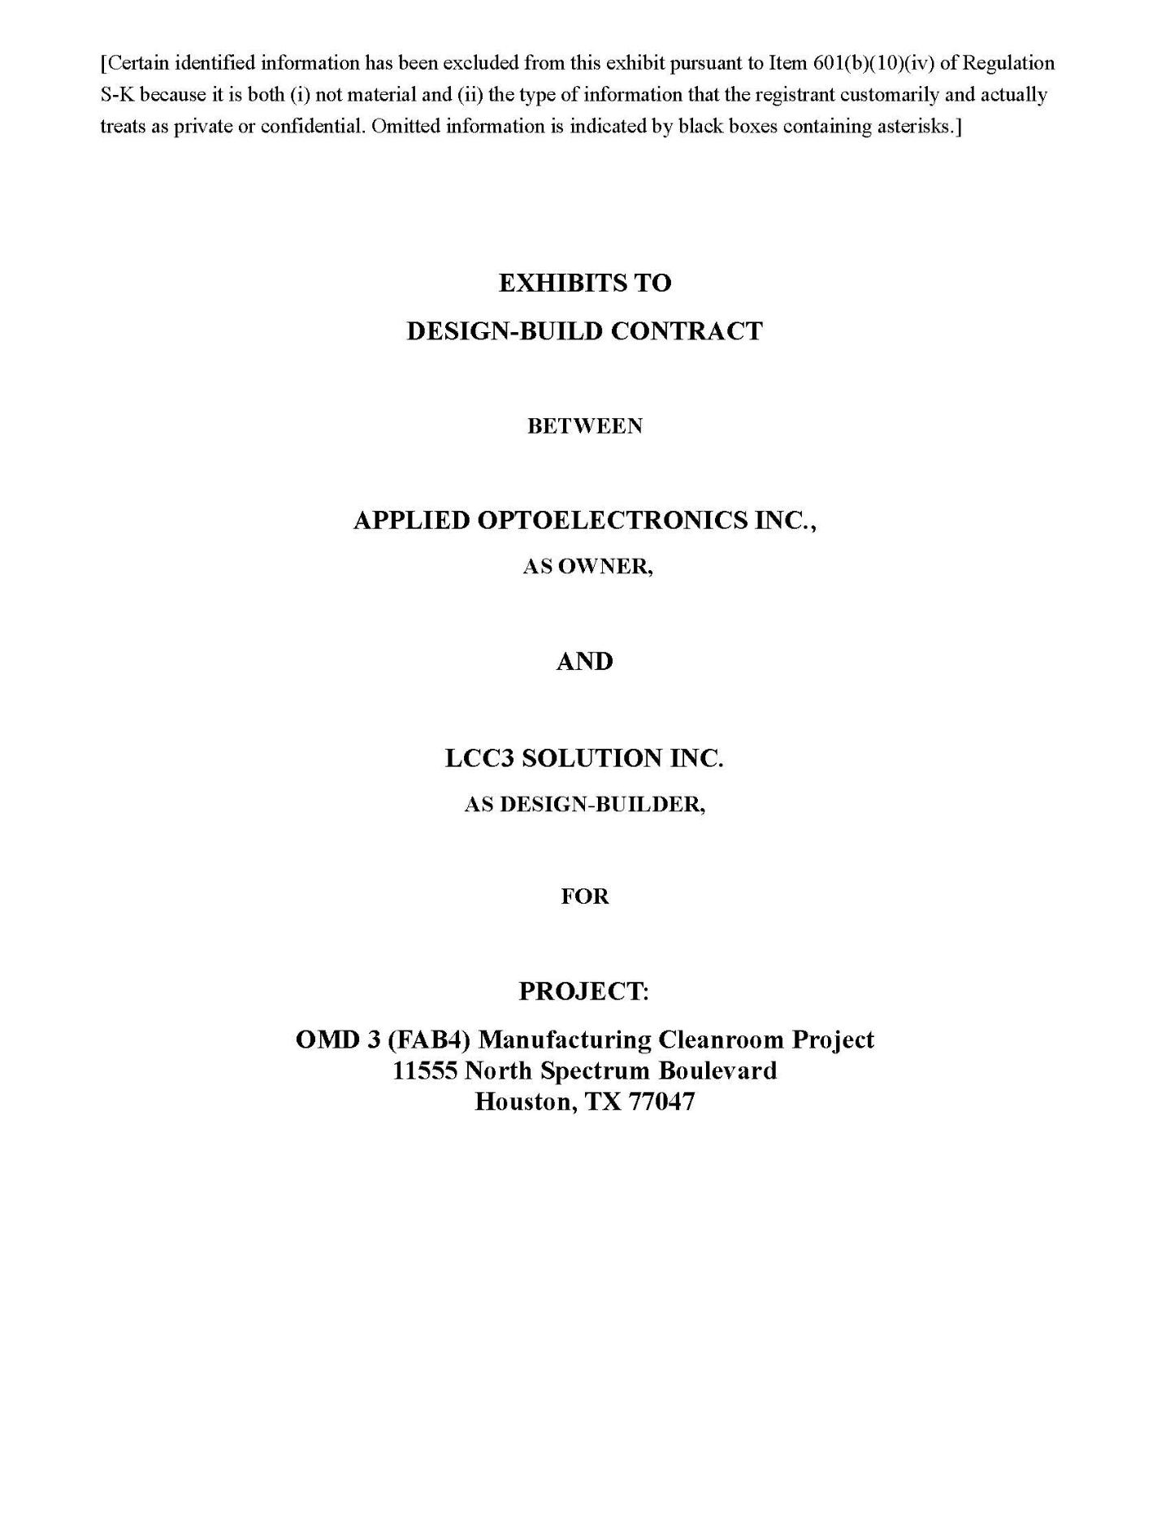

1

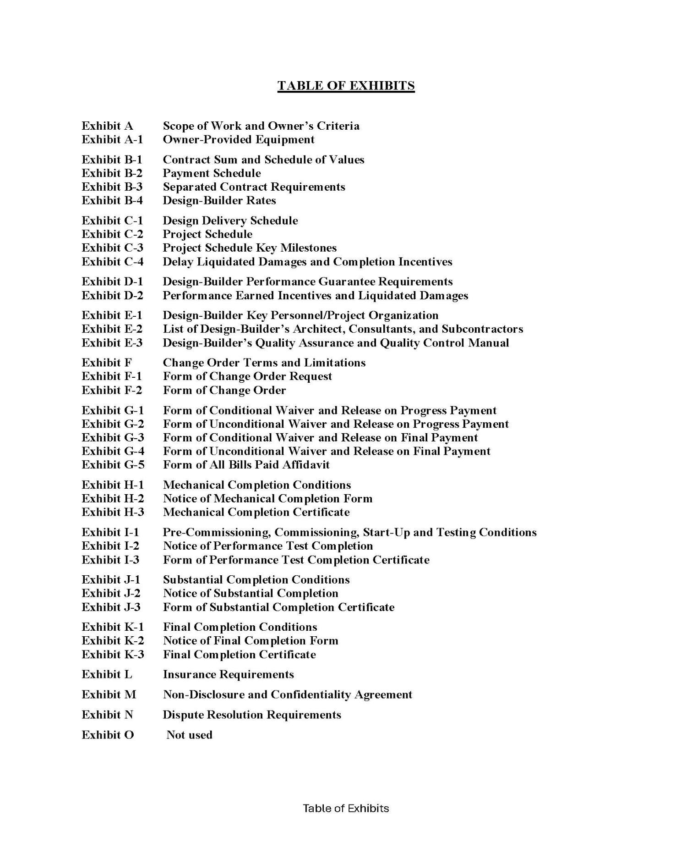

2

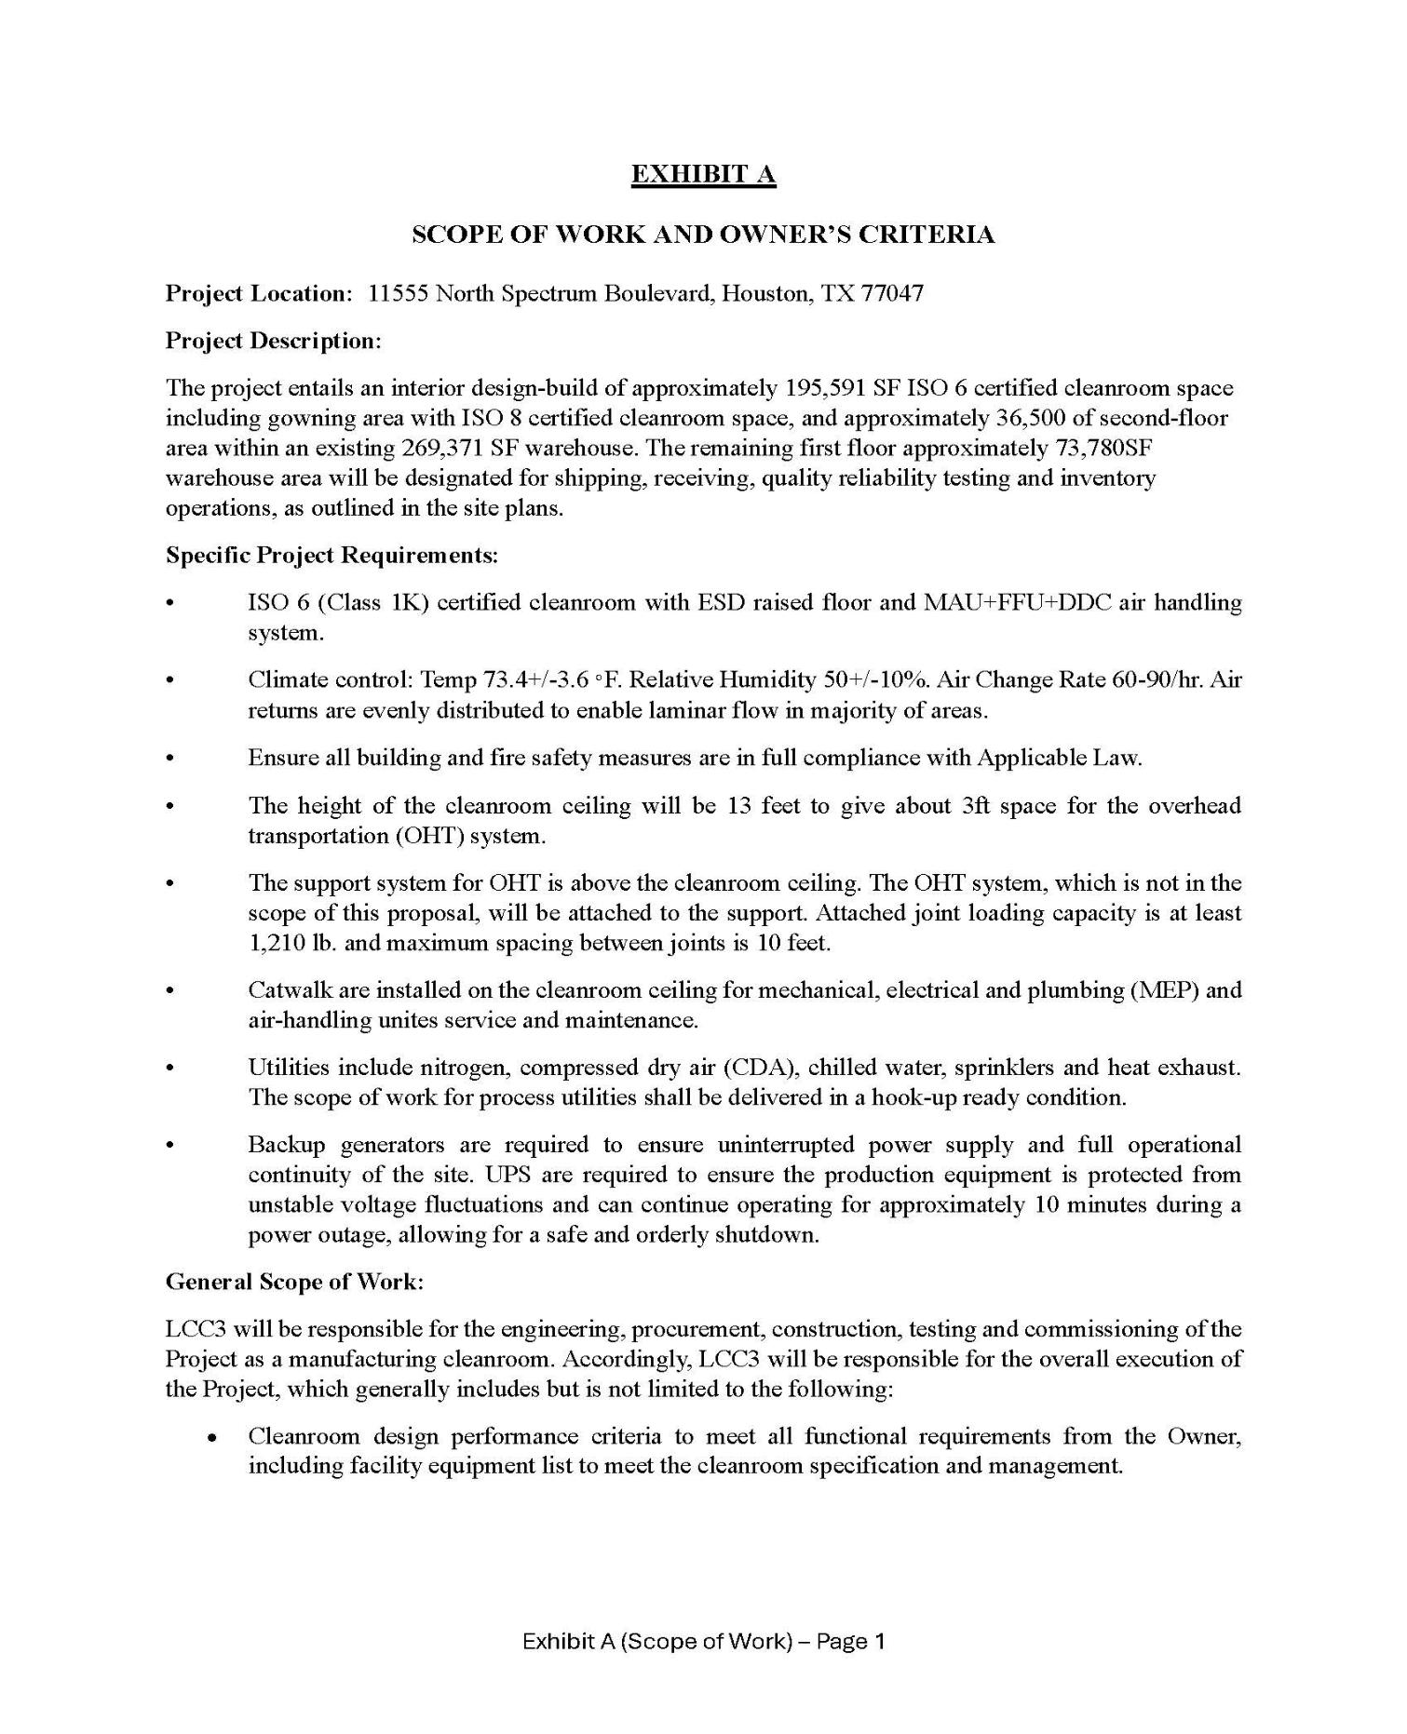

3

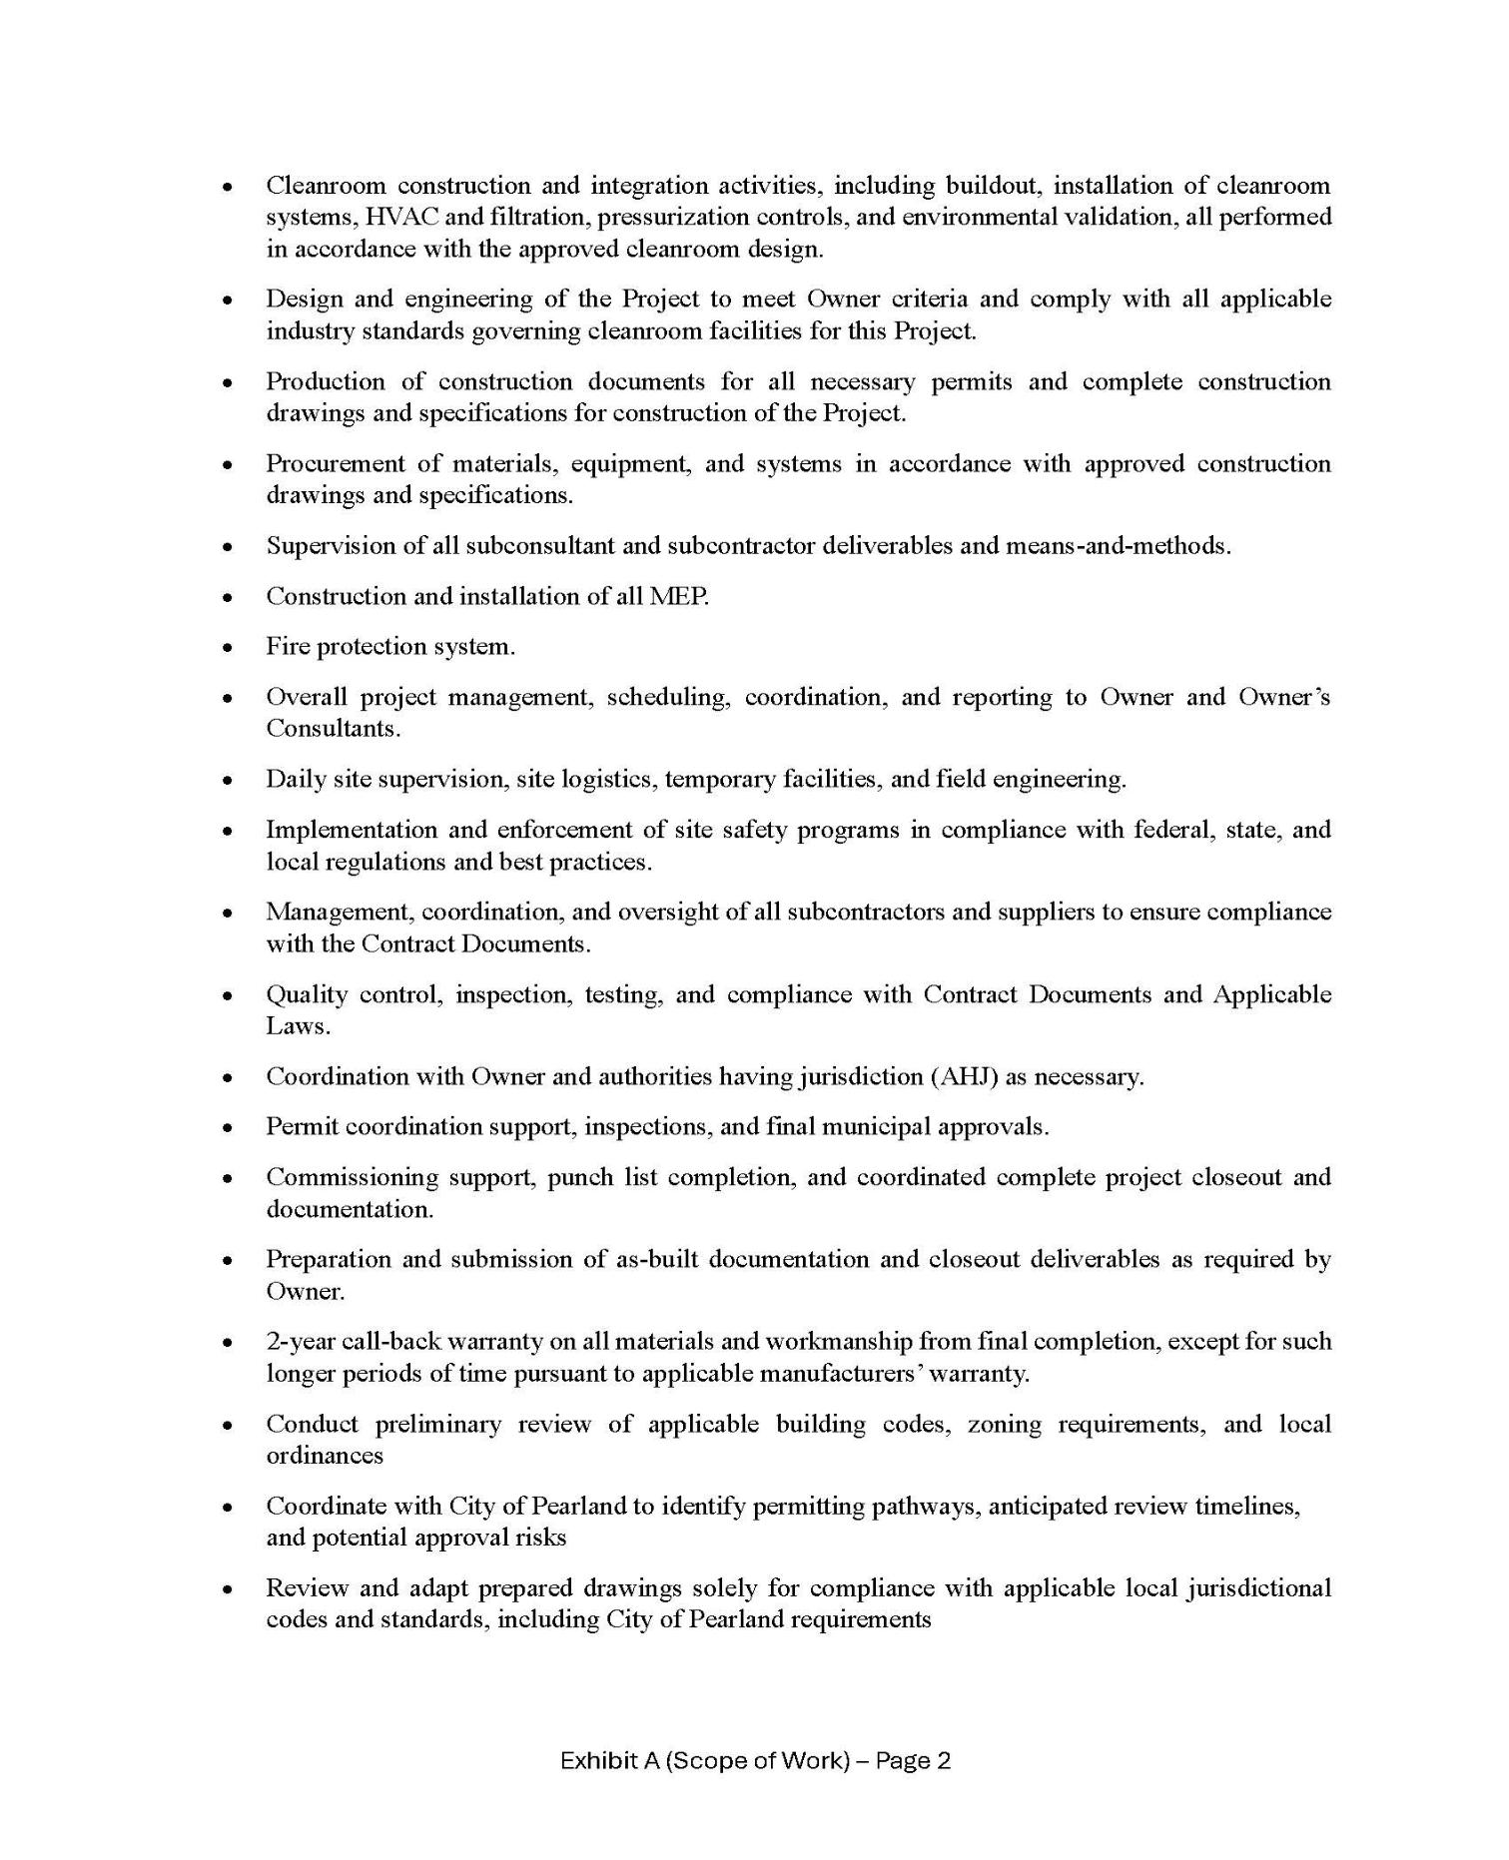

4

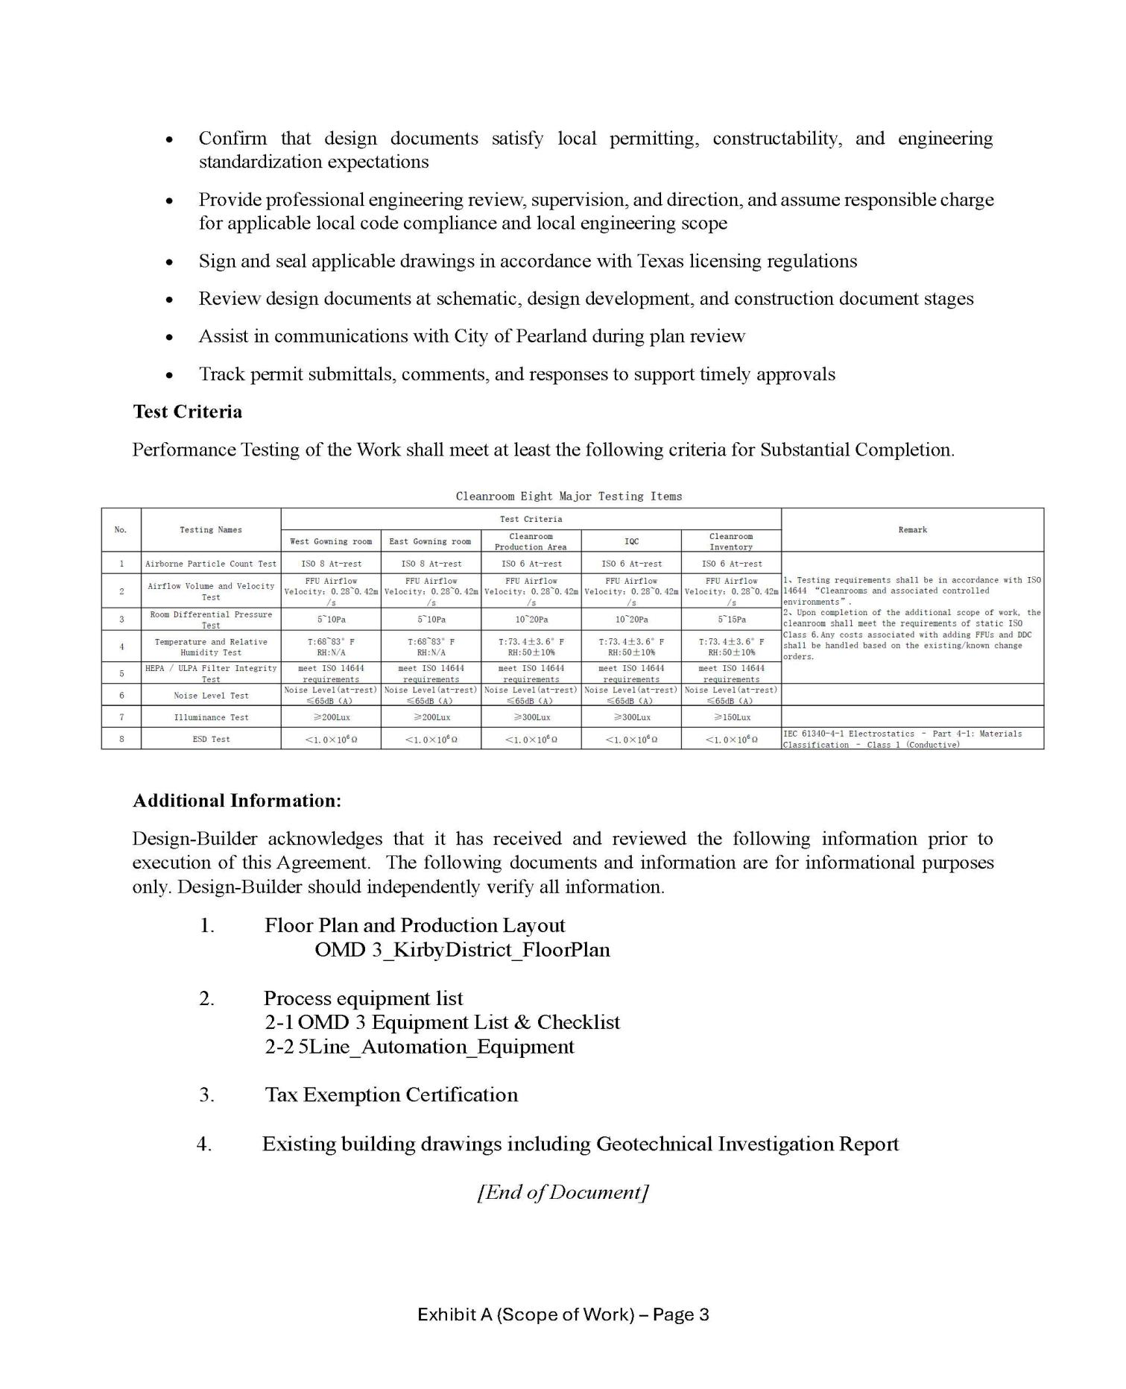

5

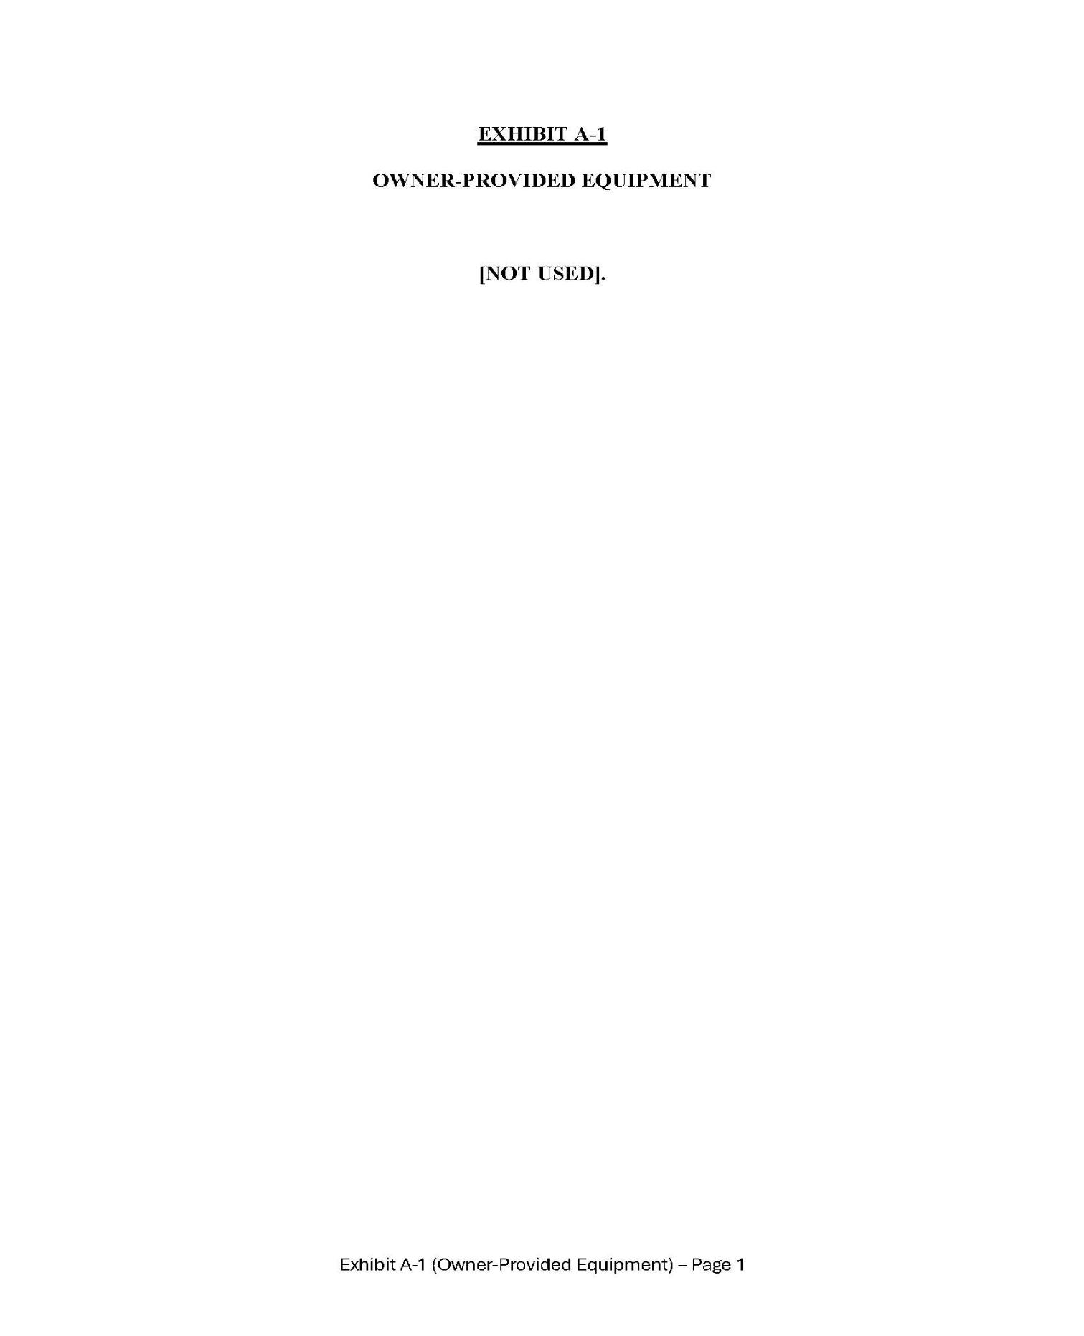

6

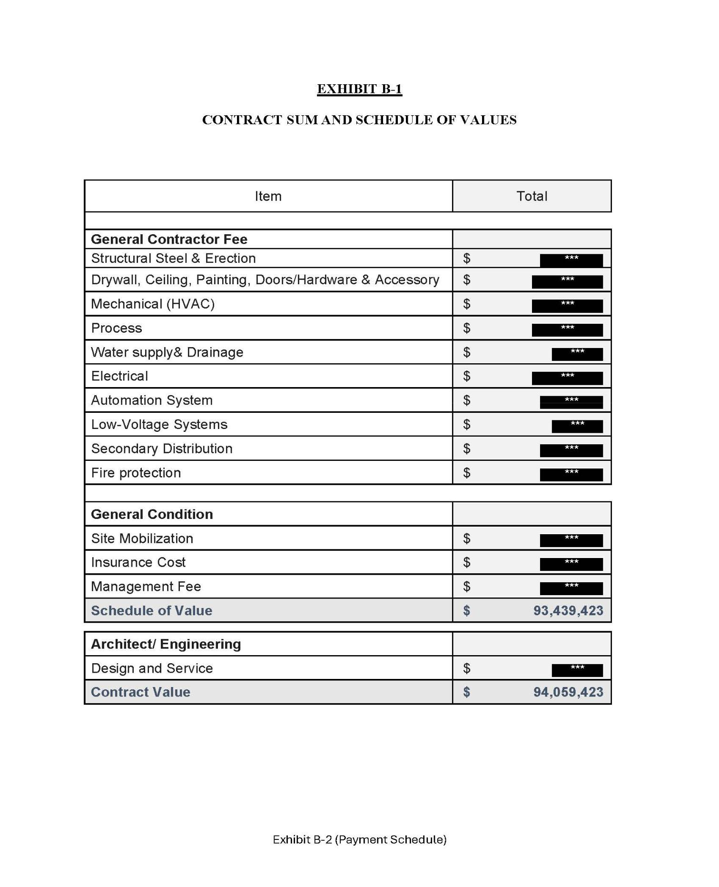

7

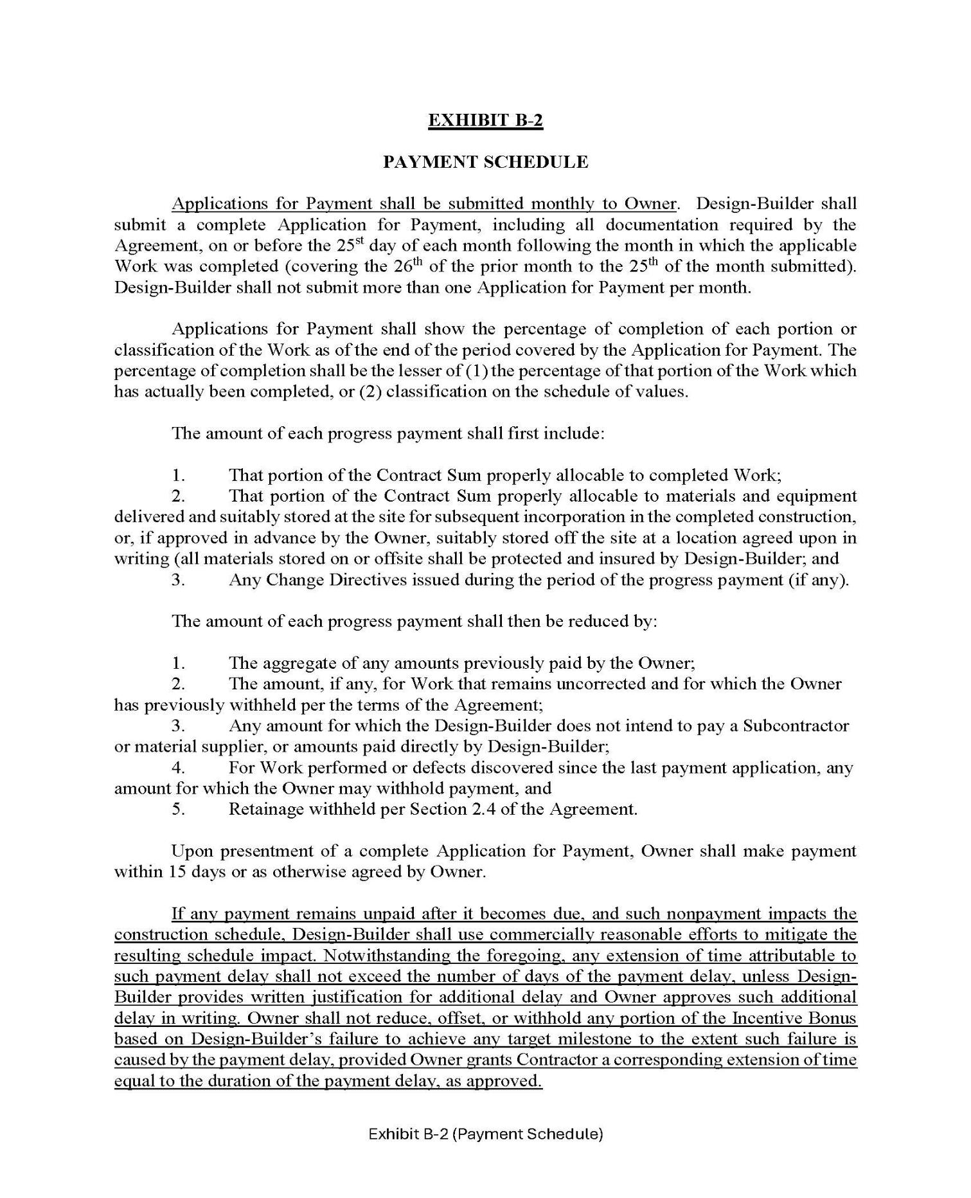

8

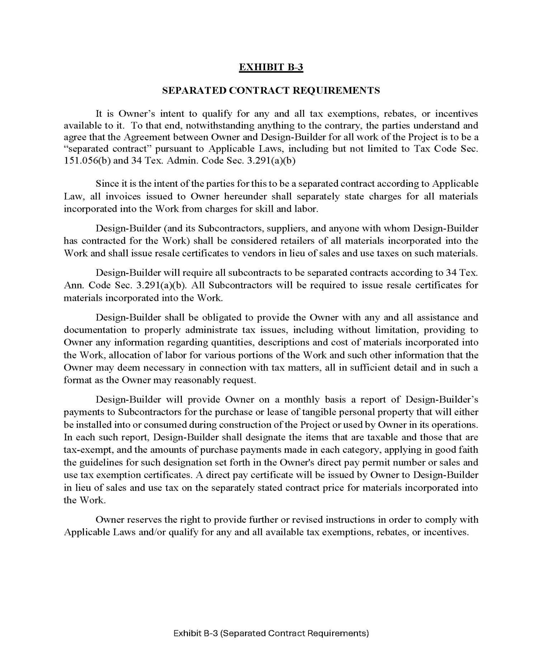

9

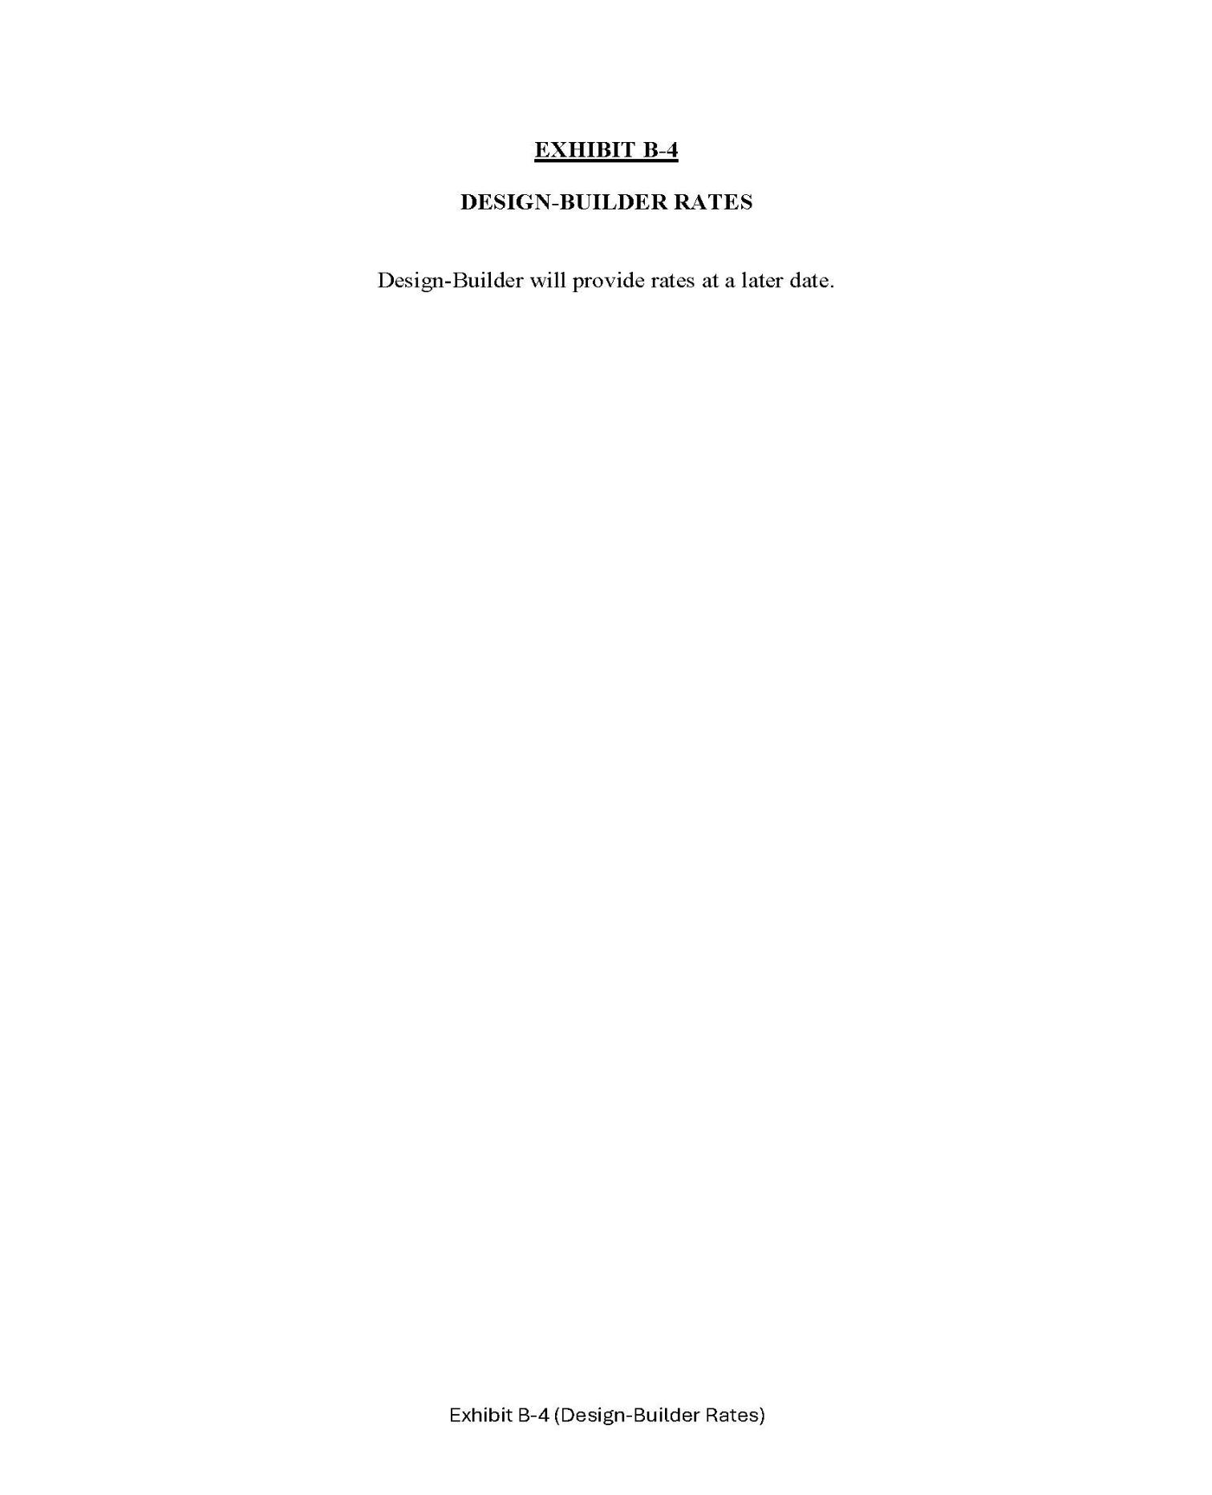

10

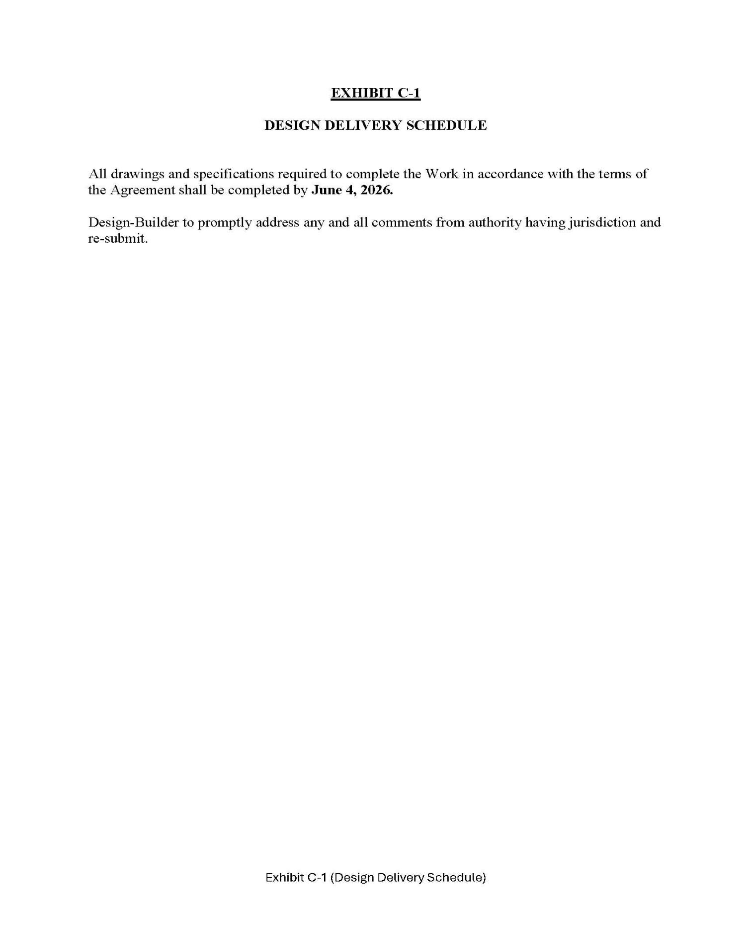

11

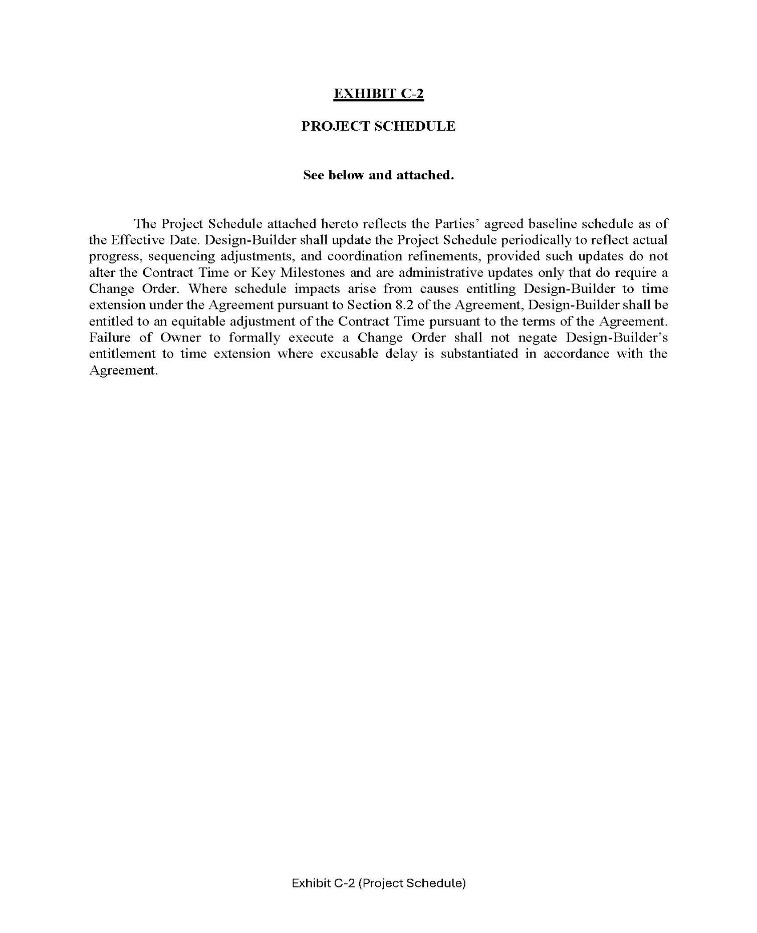

12

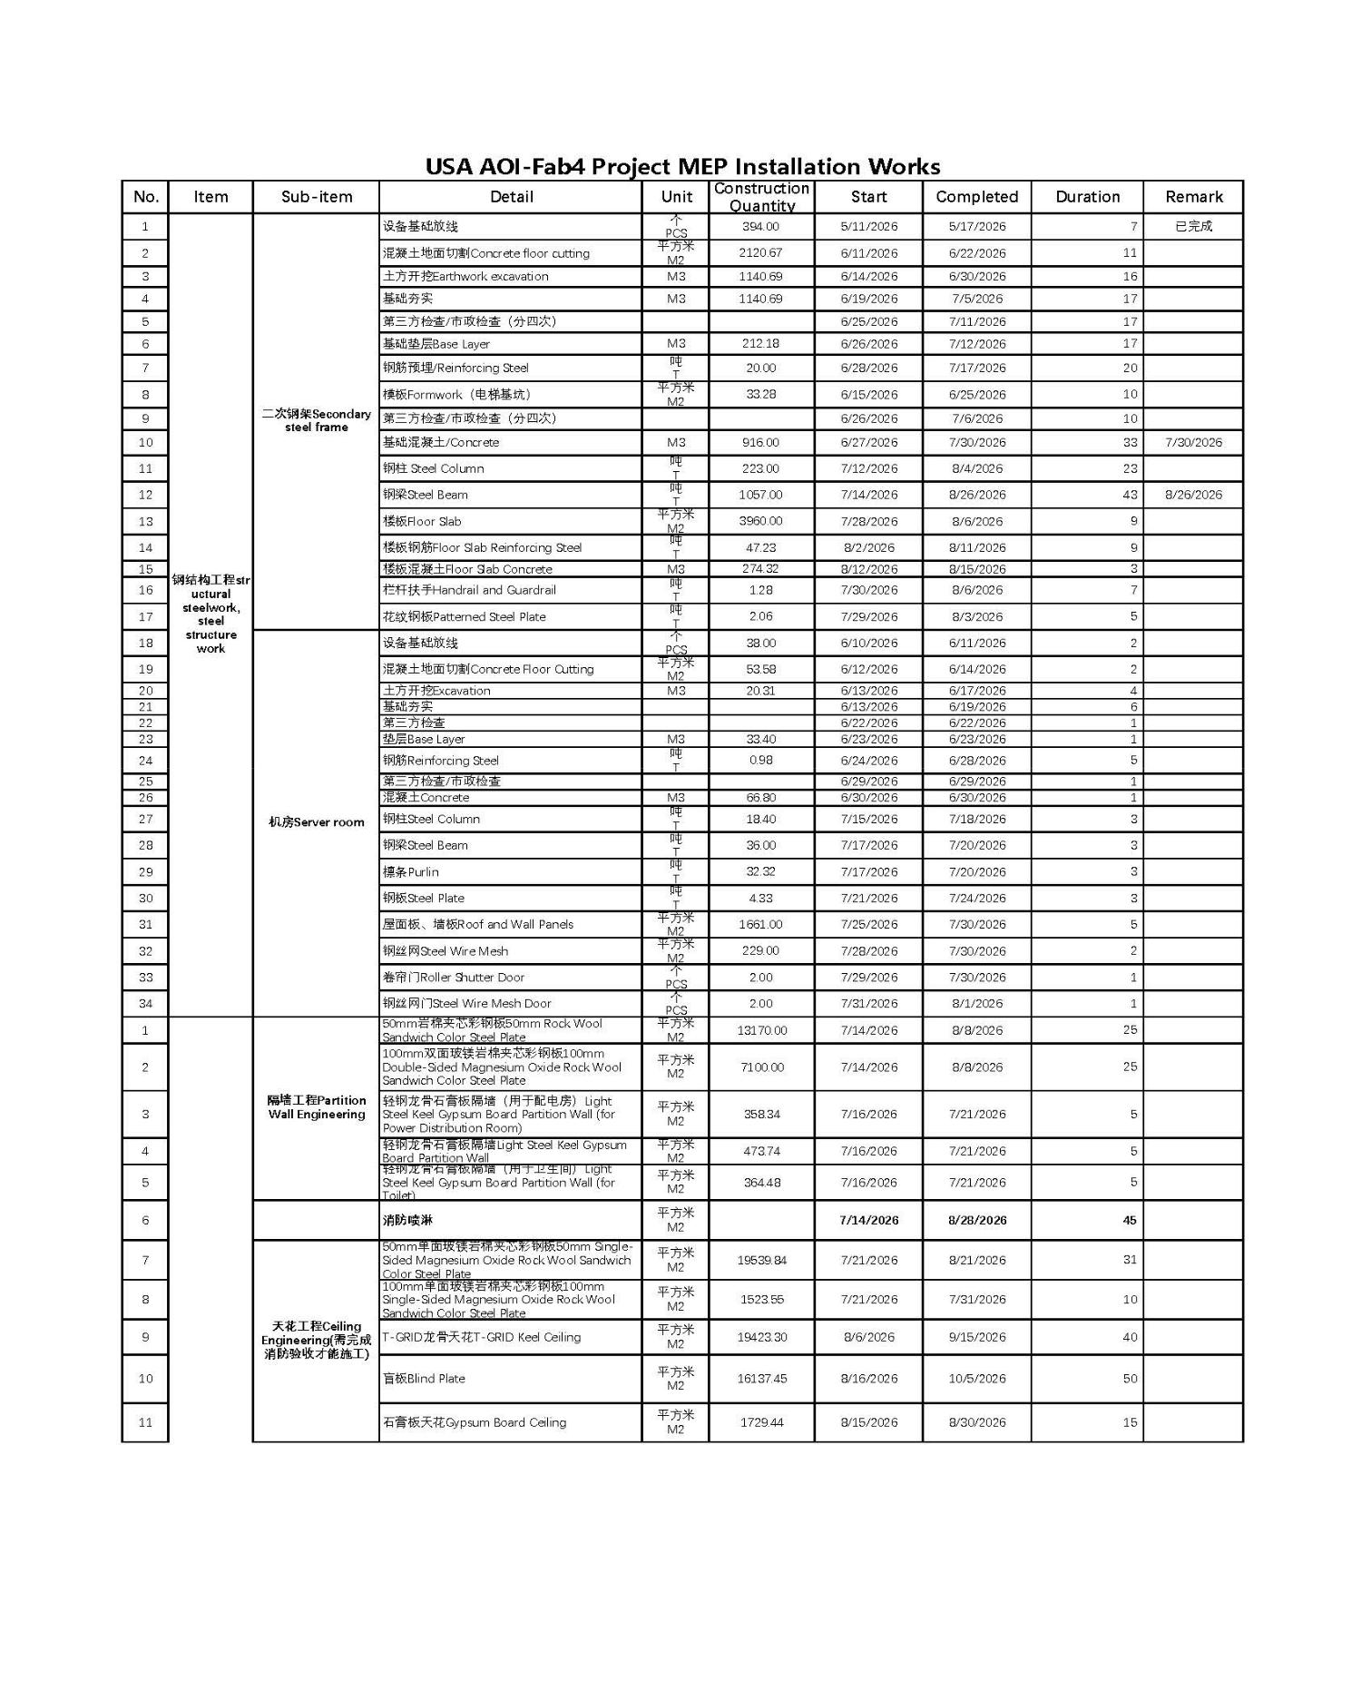

13

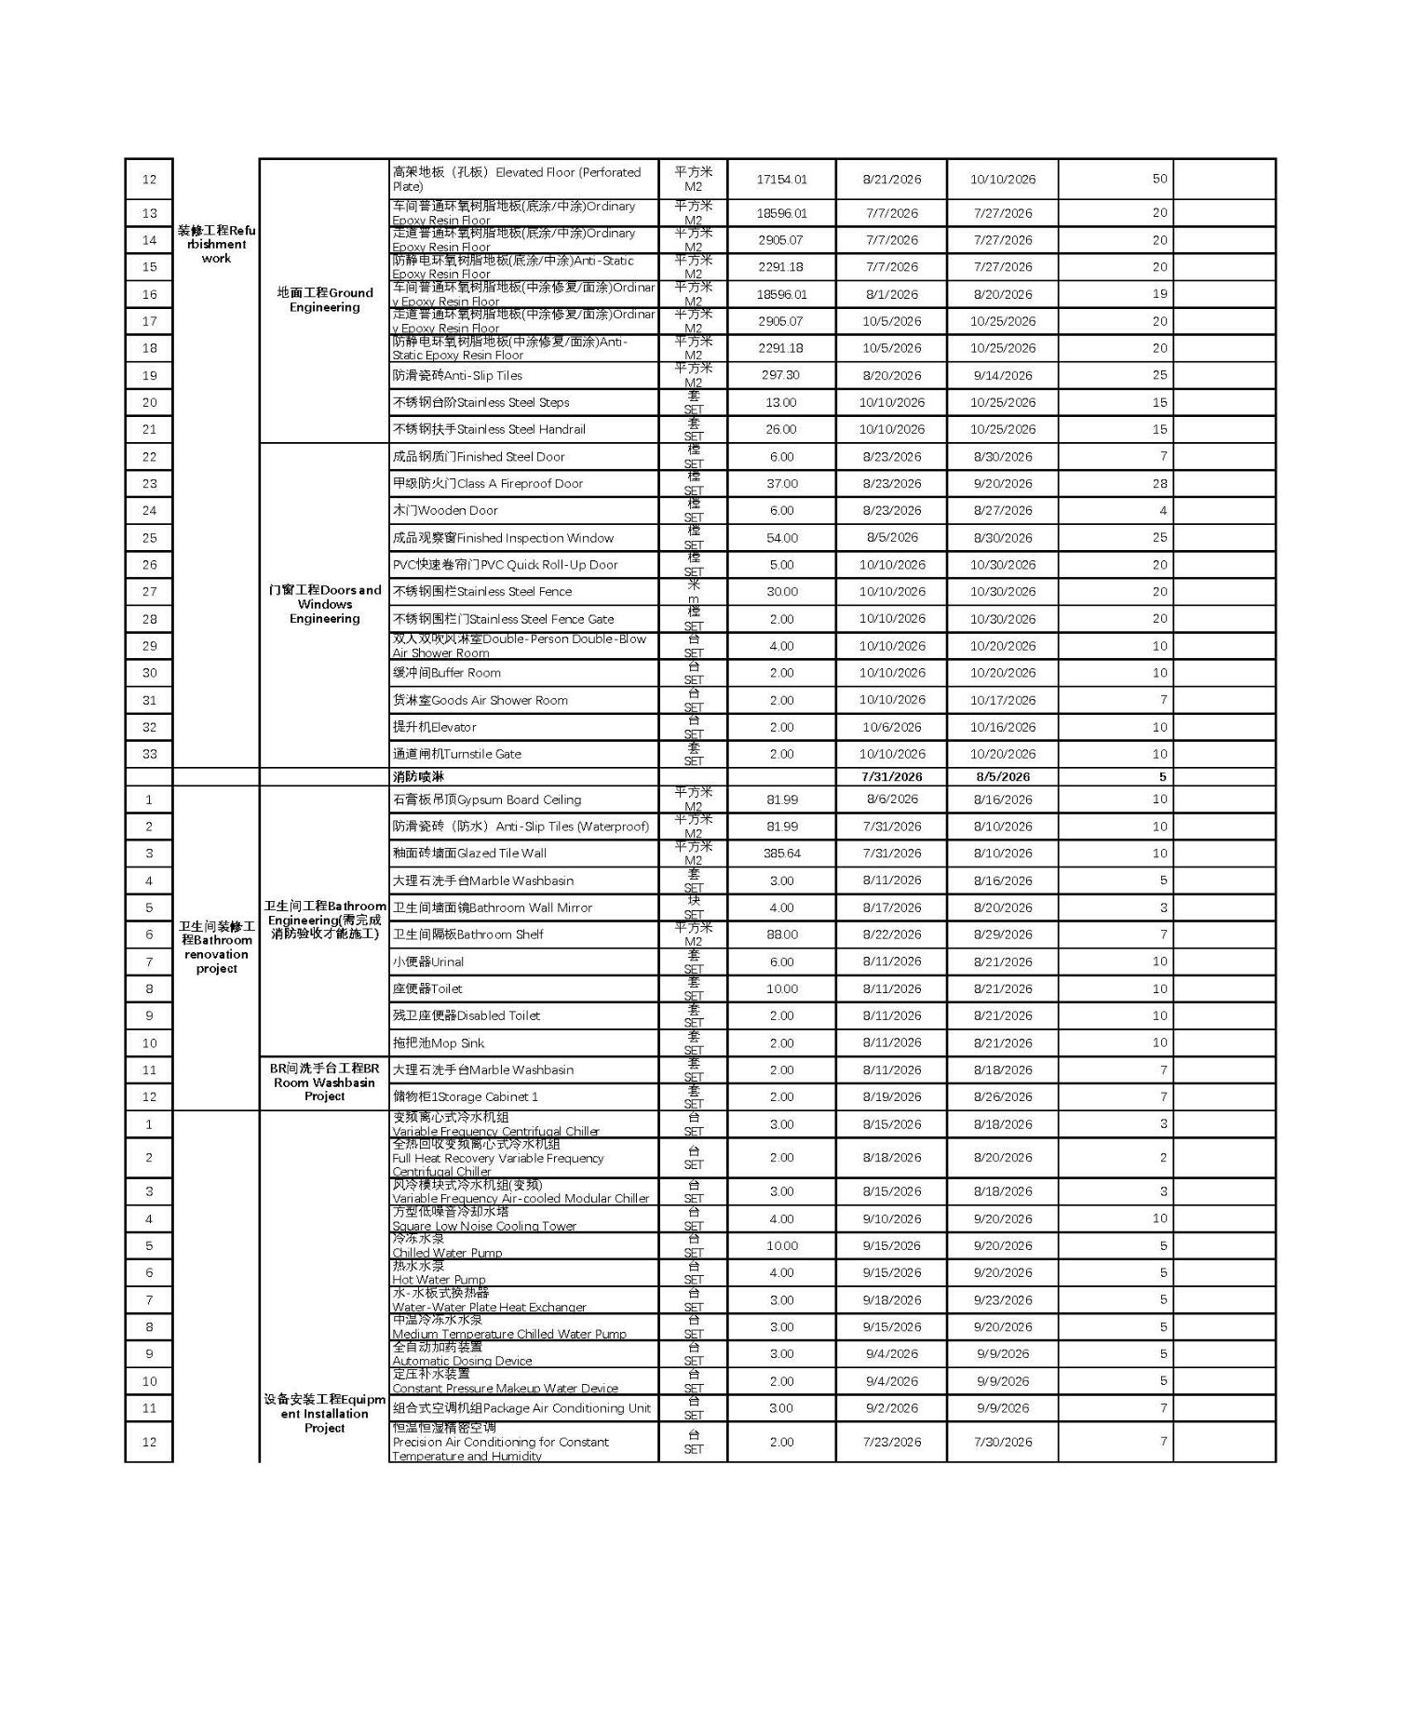

14

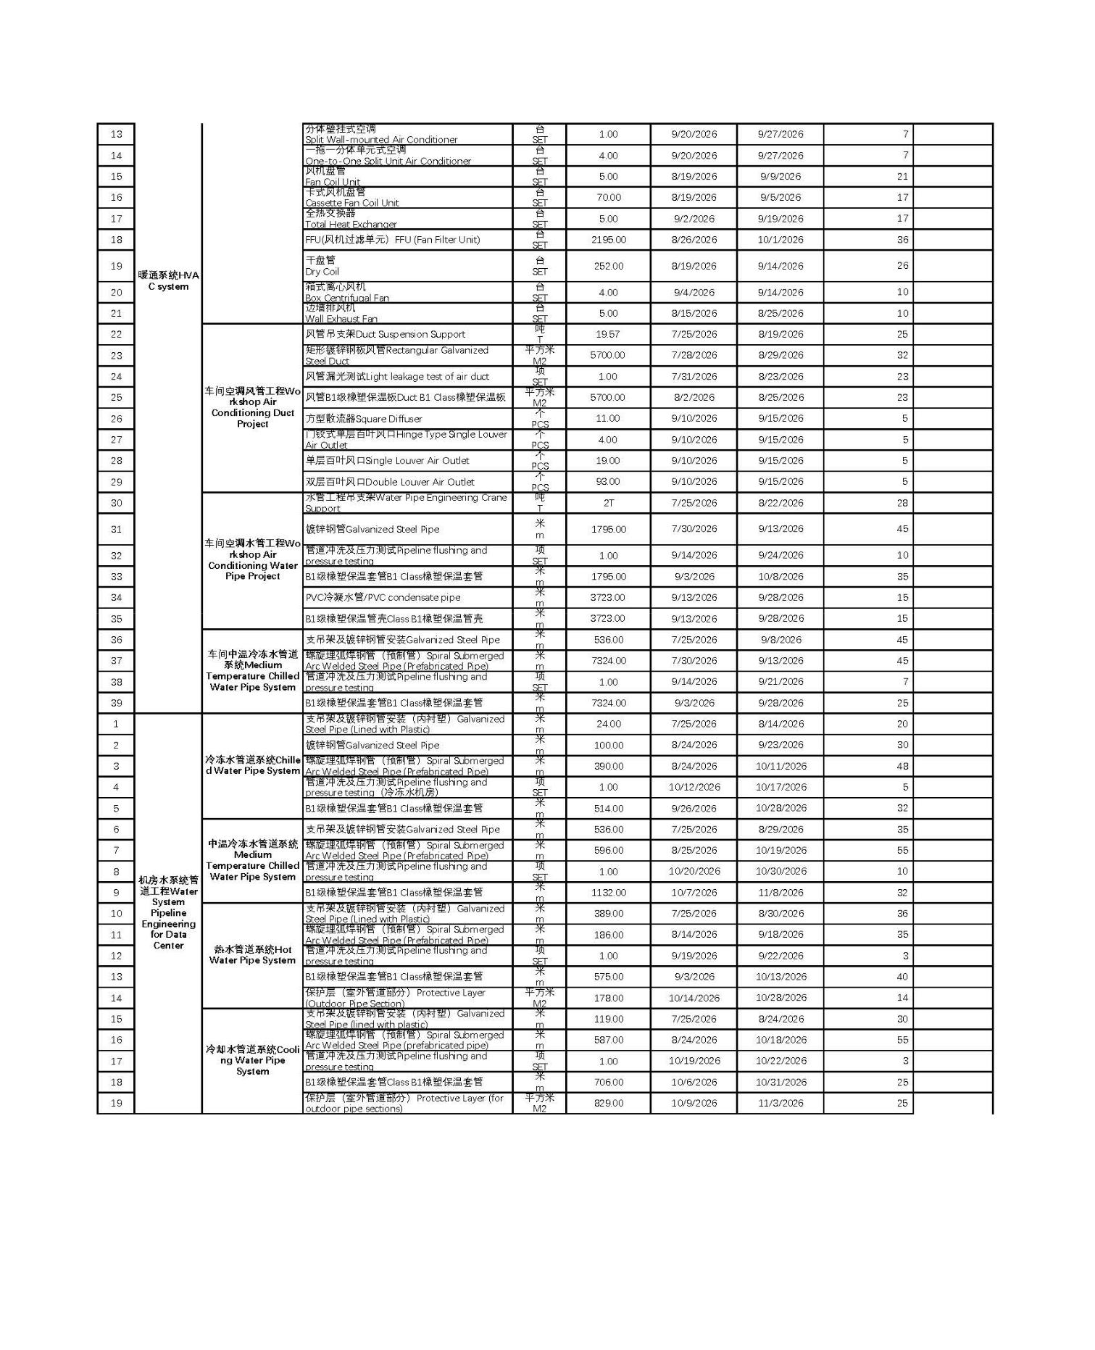

15

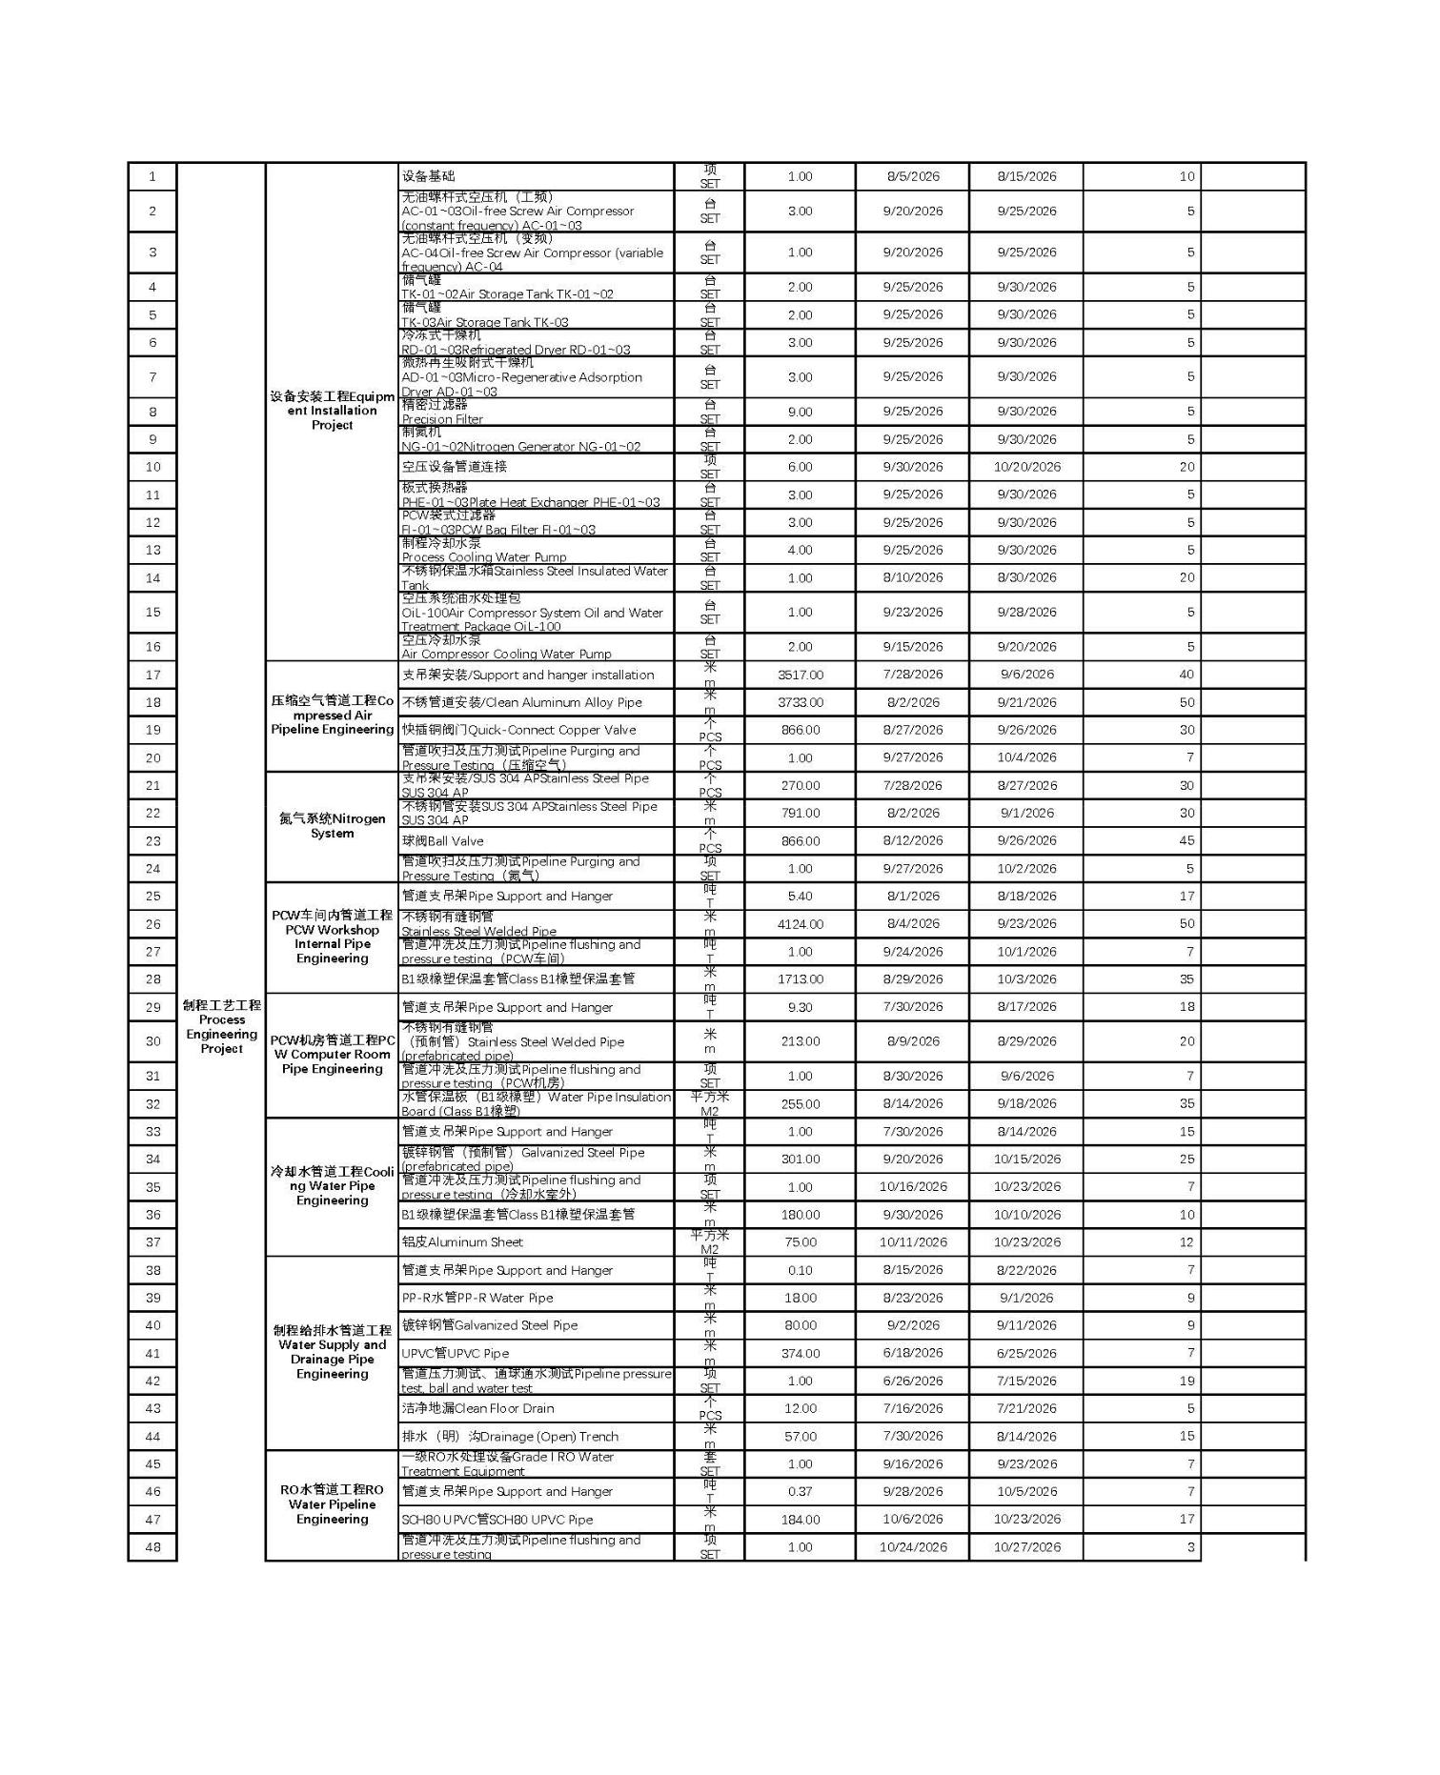

16

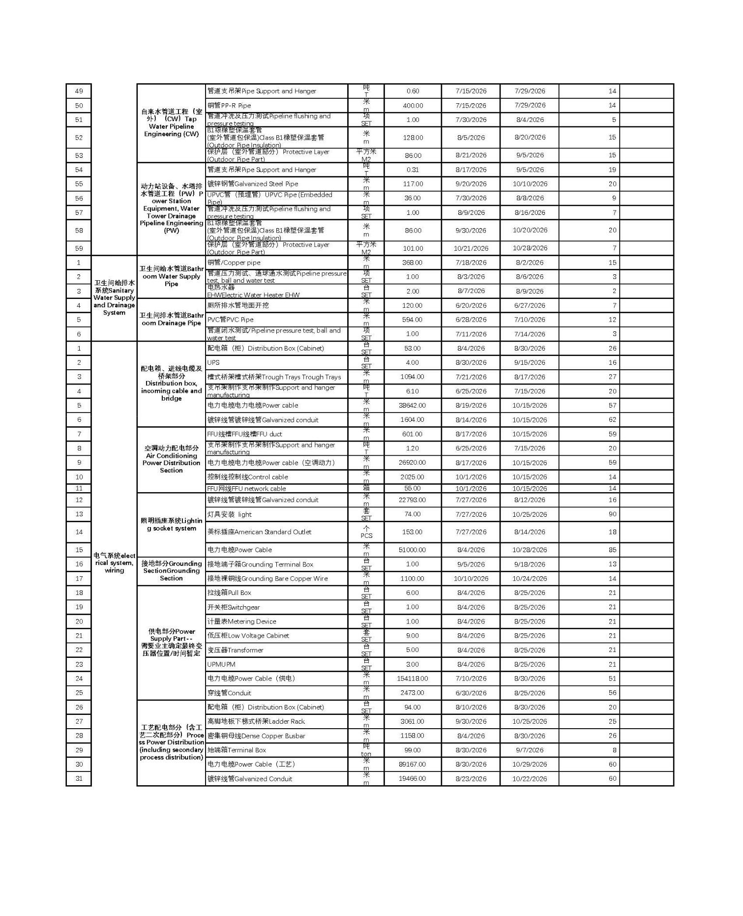

17

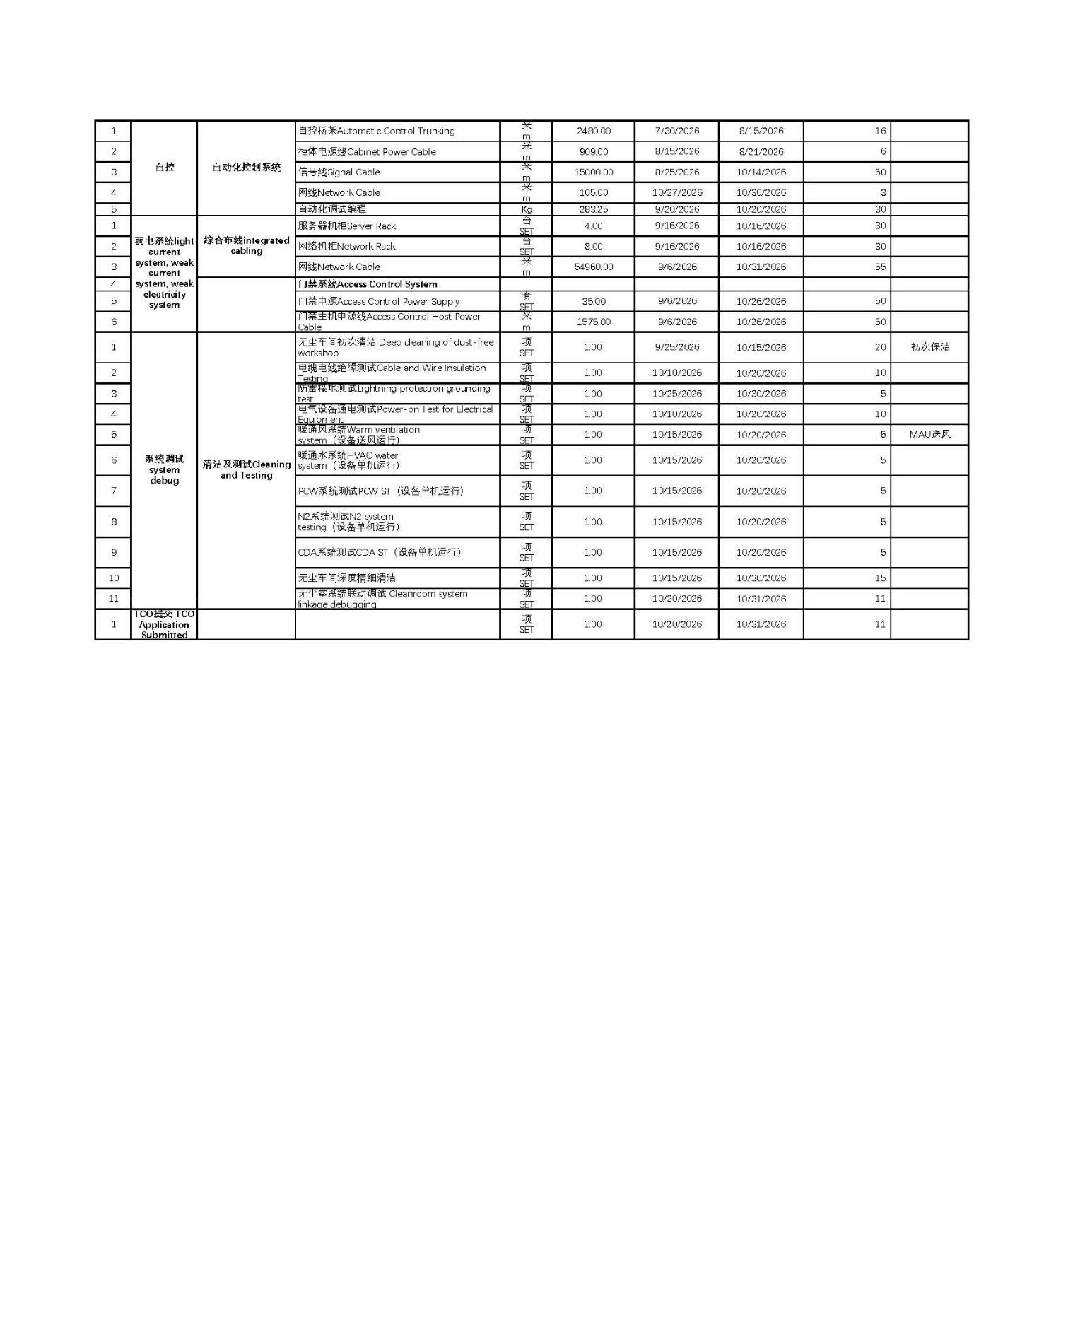

18

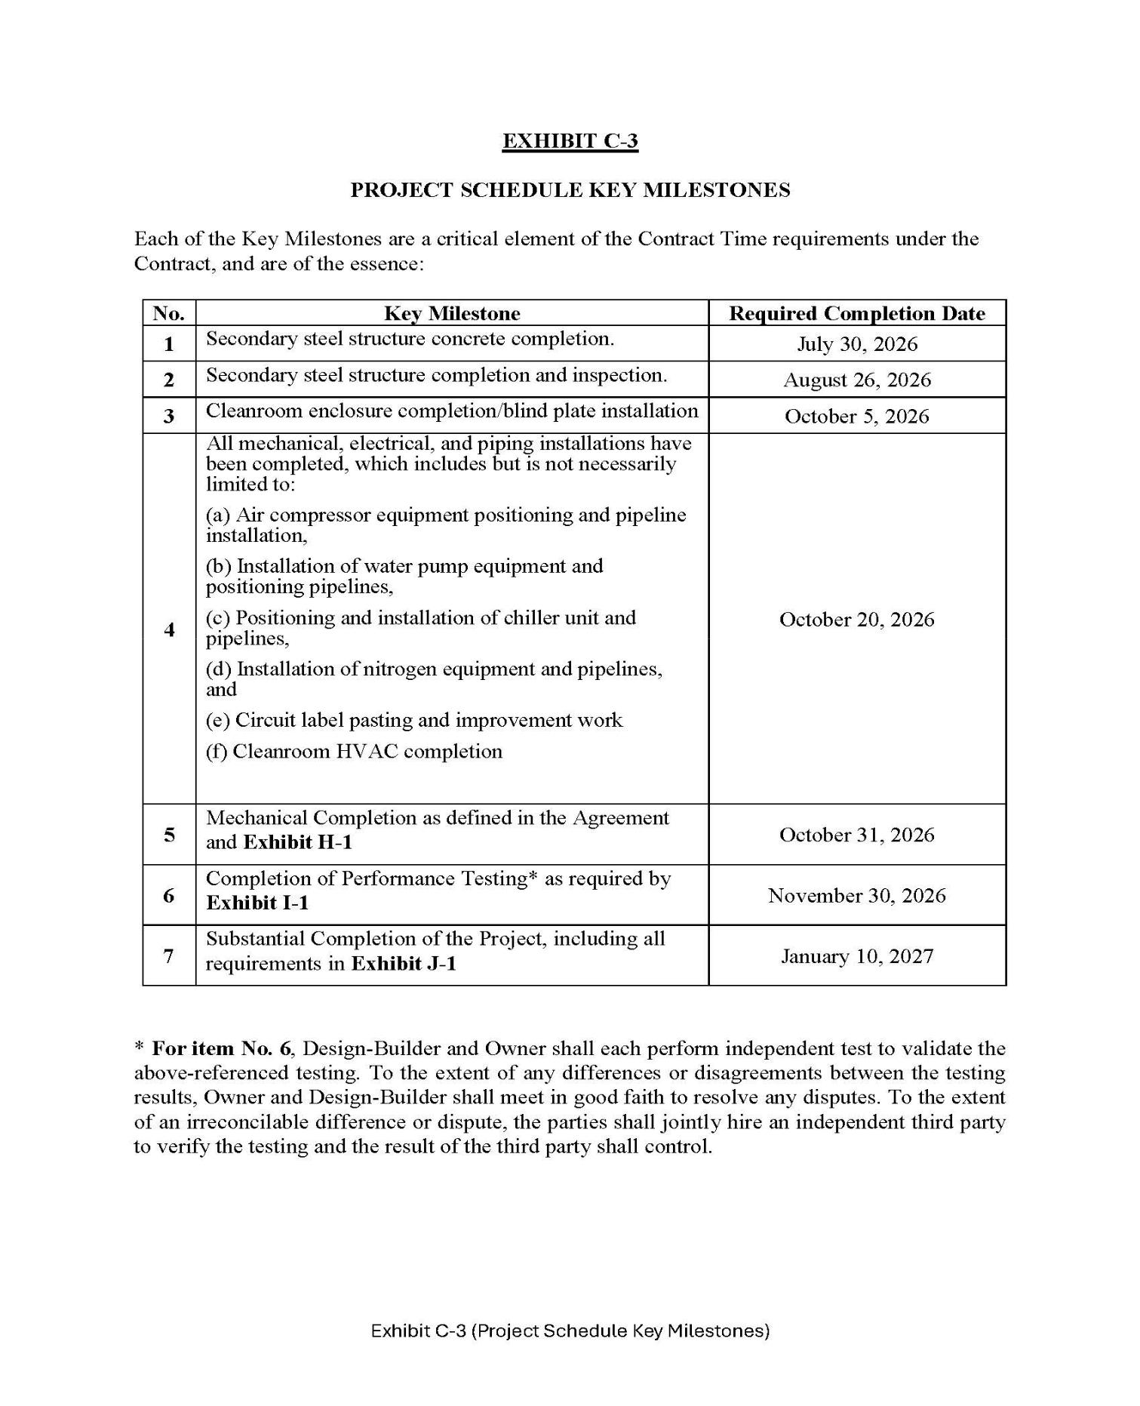

19

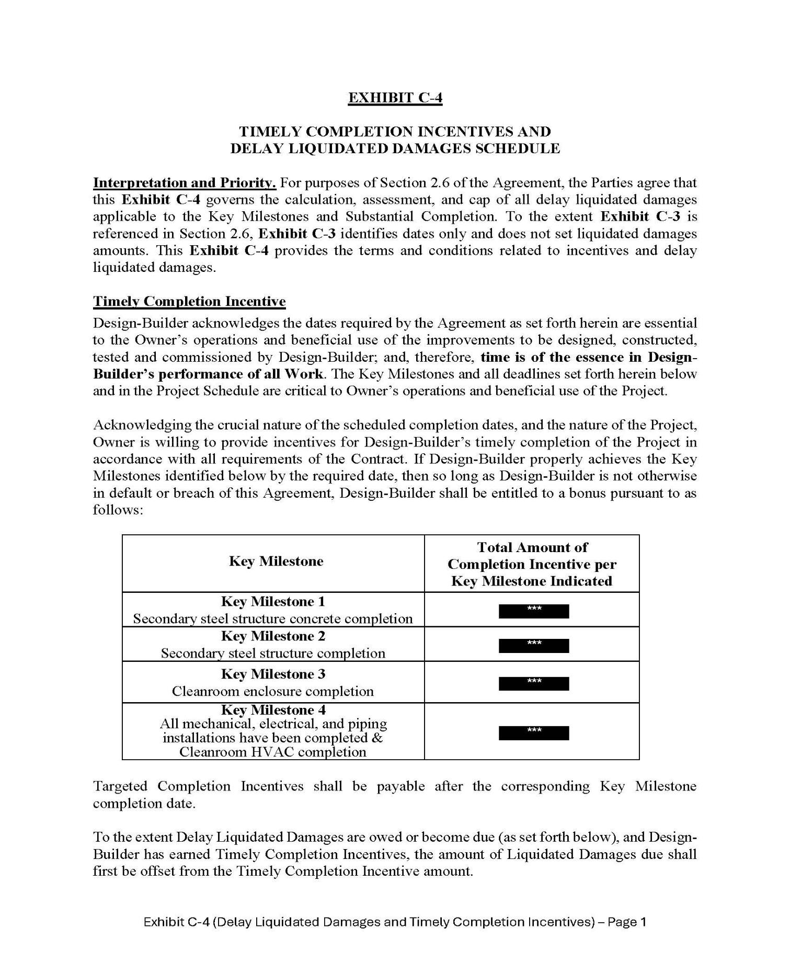

20

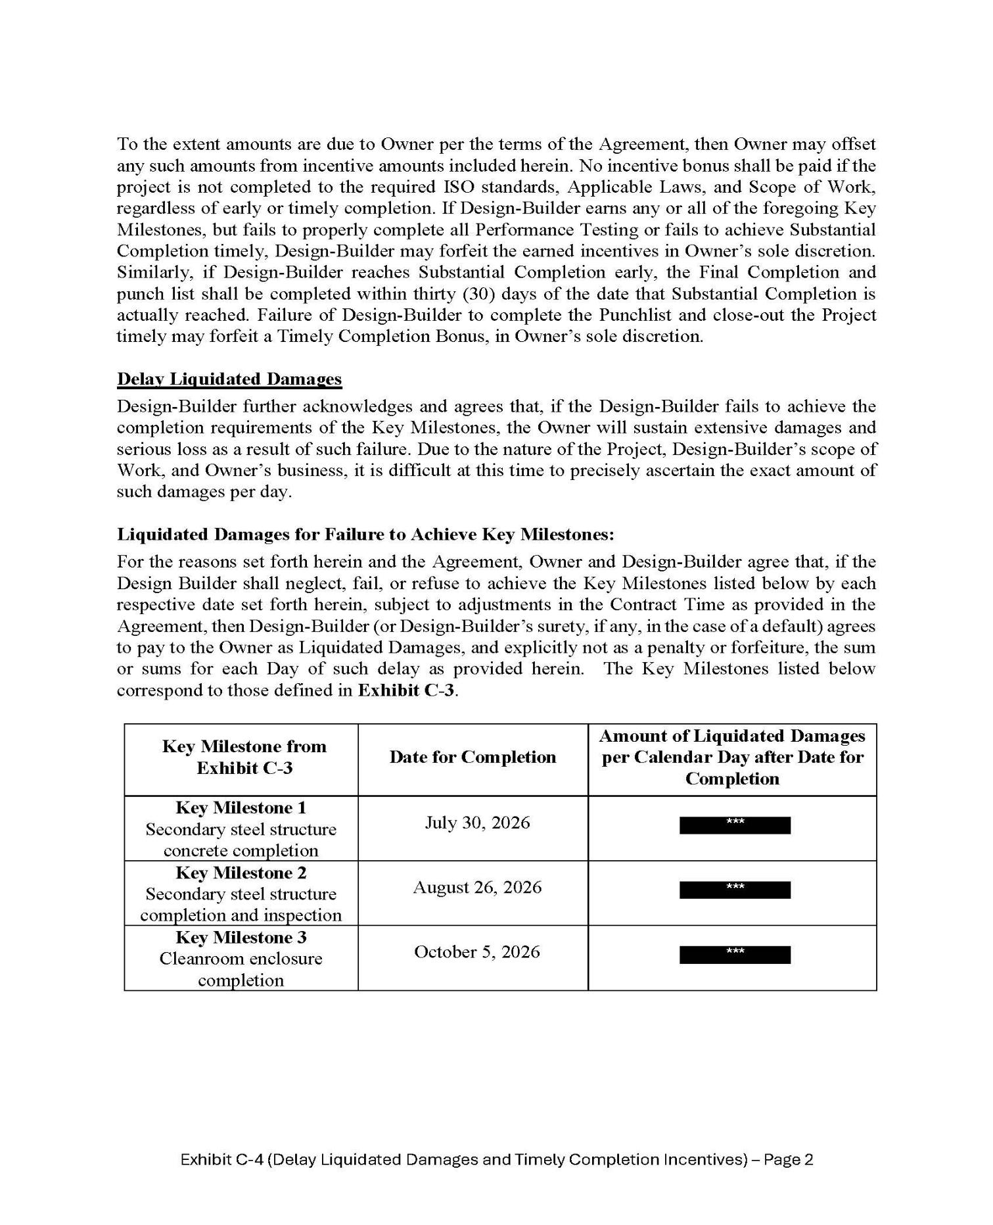

21

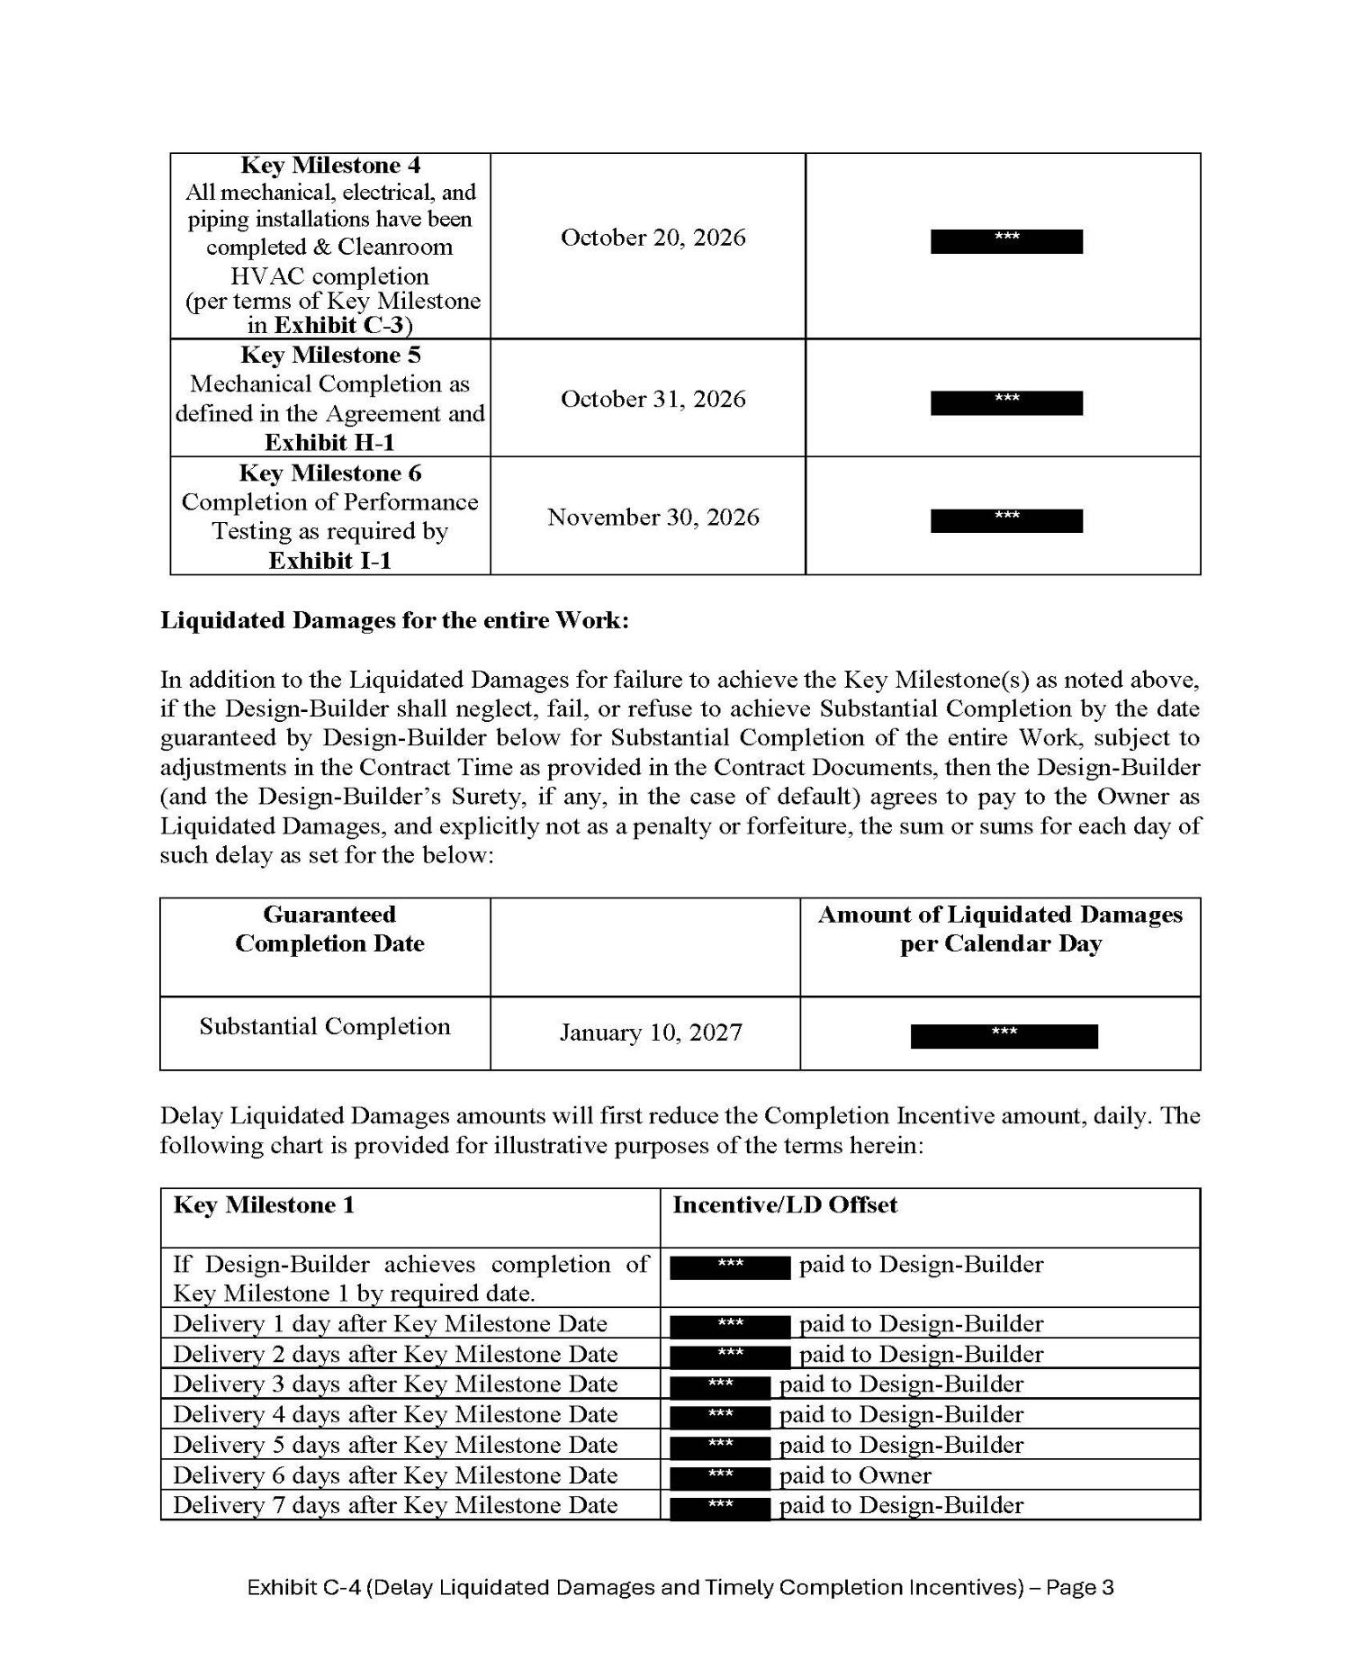

22

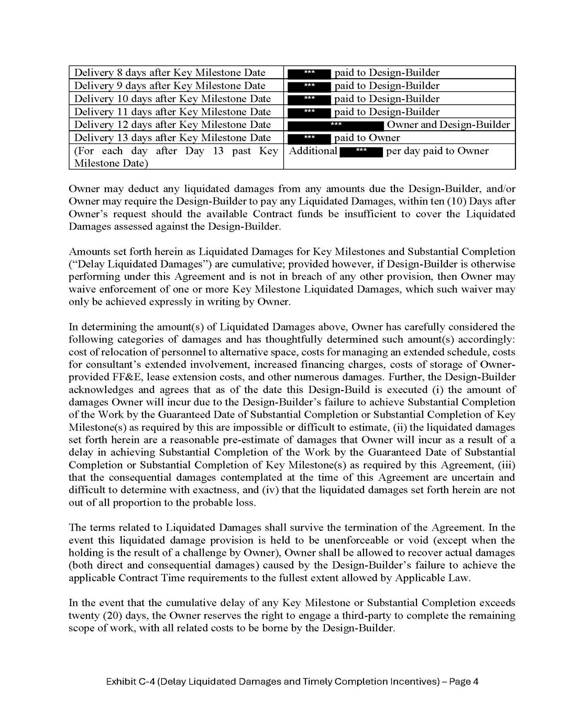

23

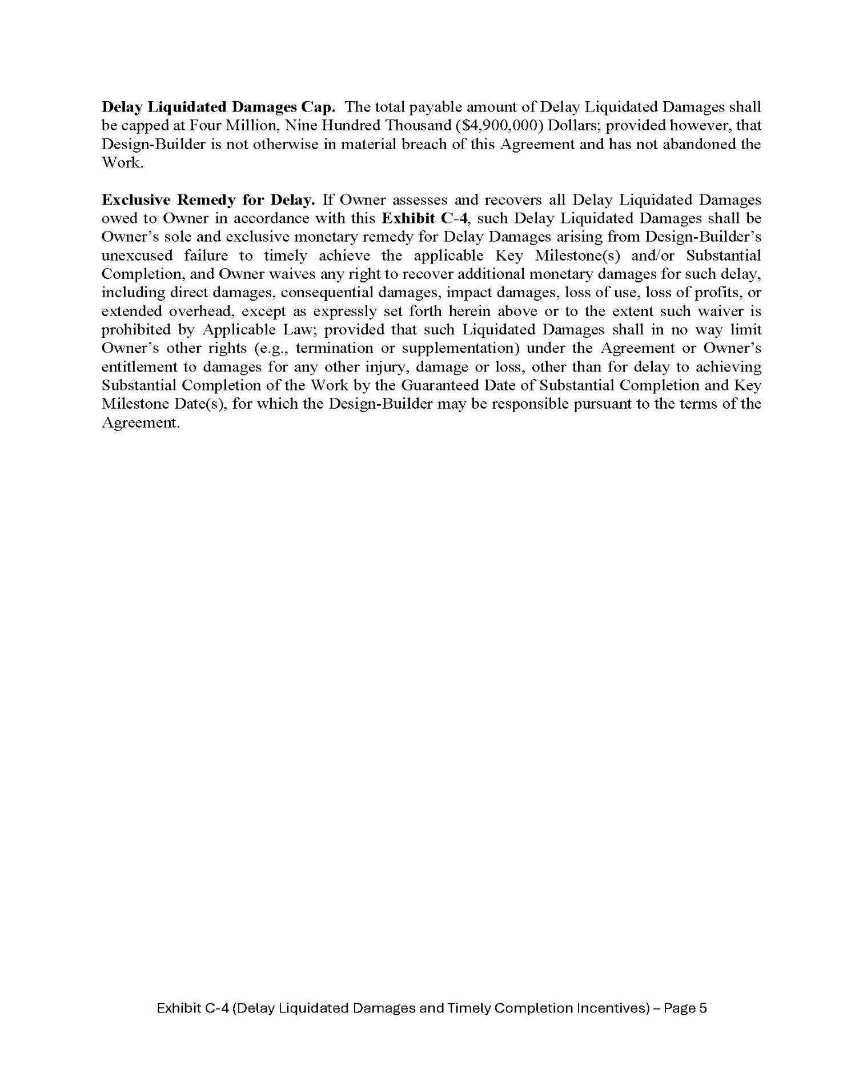

24

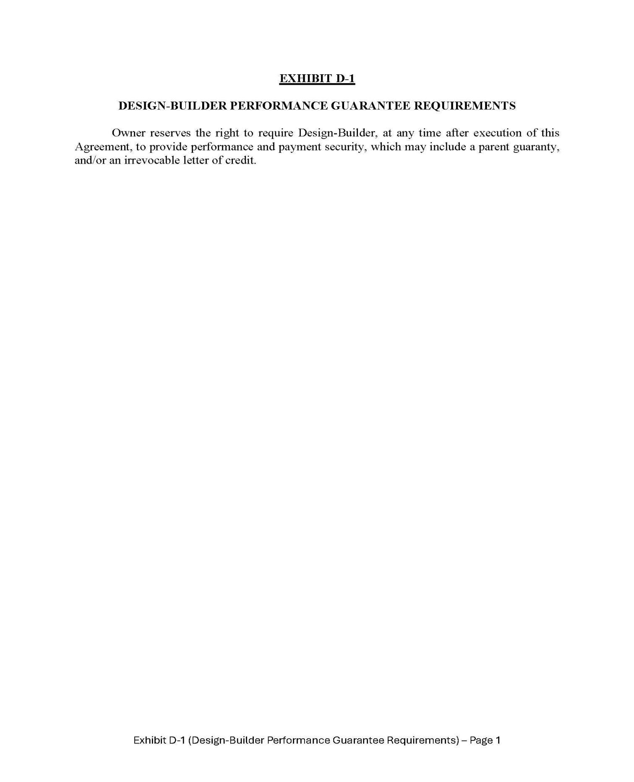

25

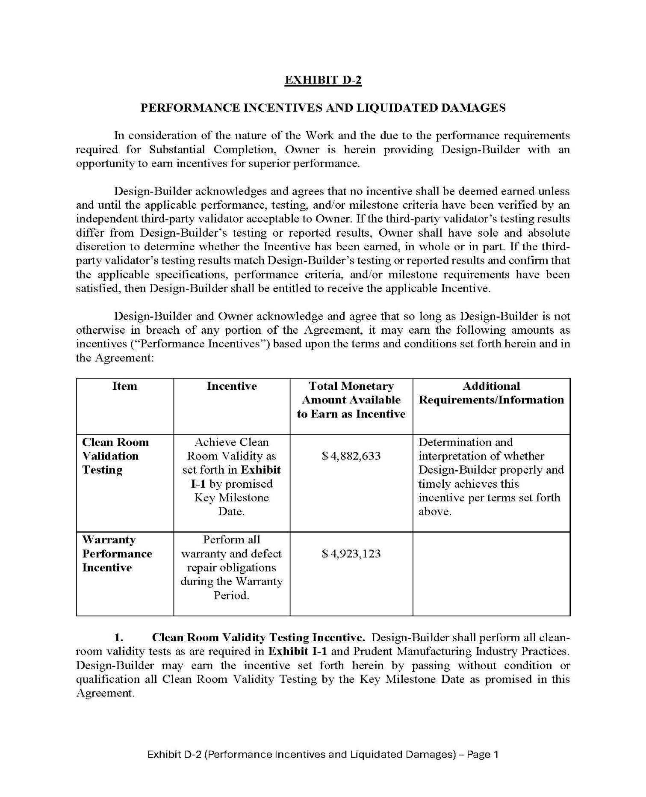

26

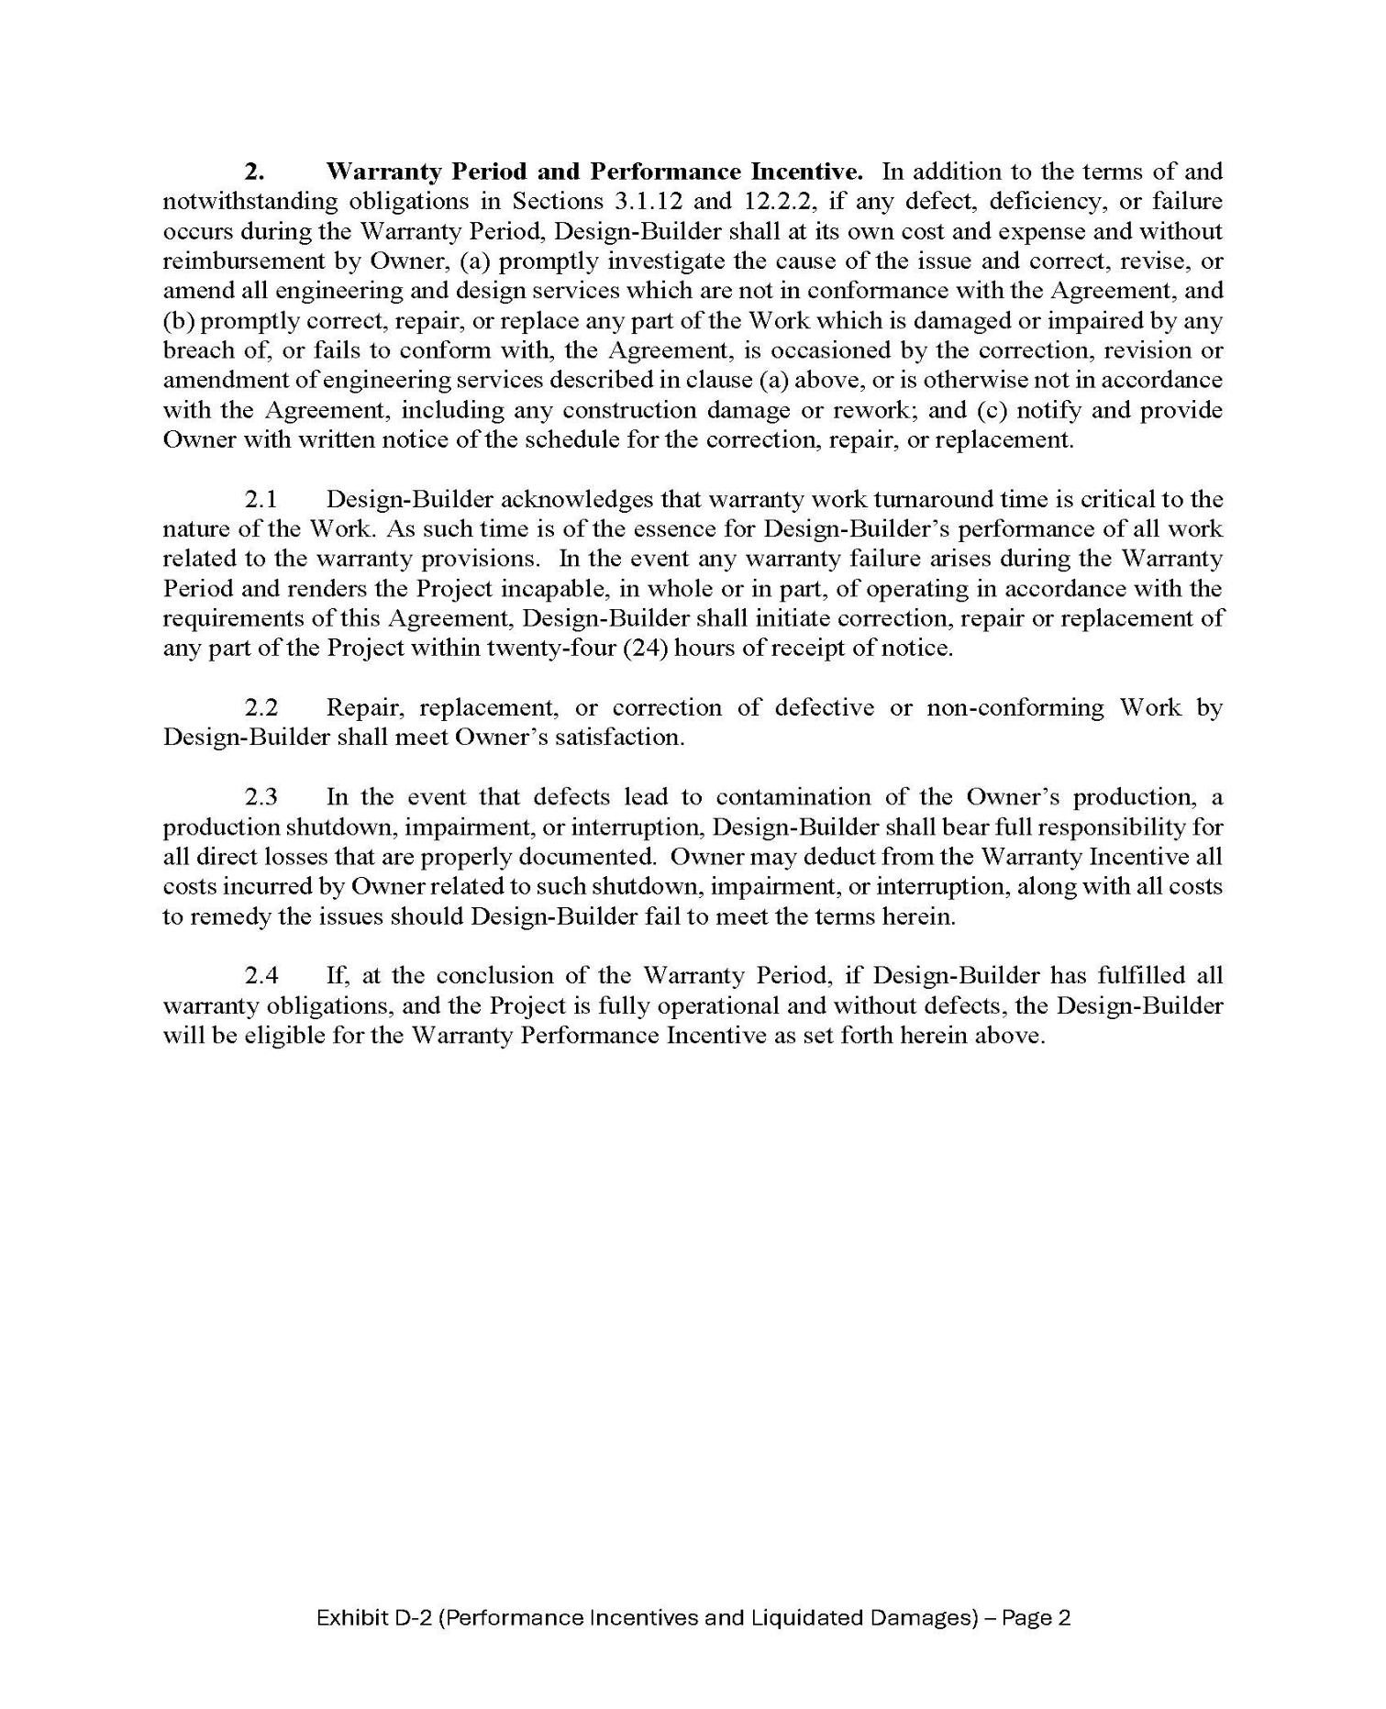

27

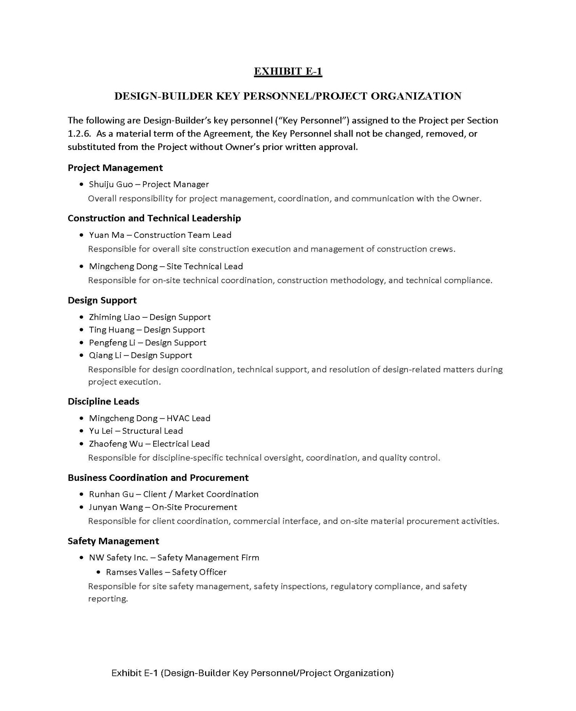

28

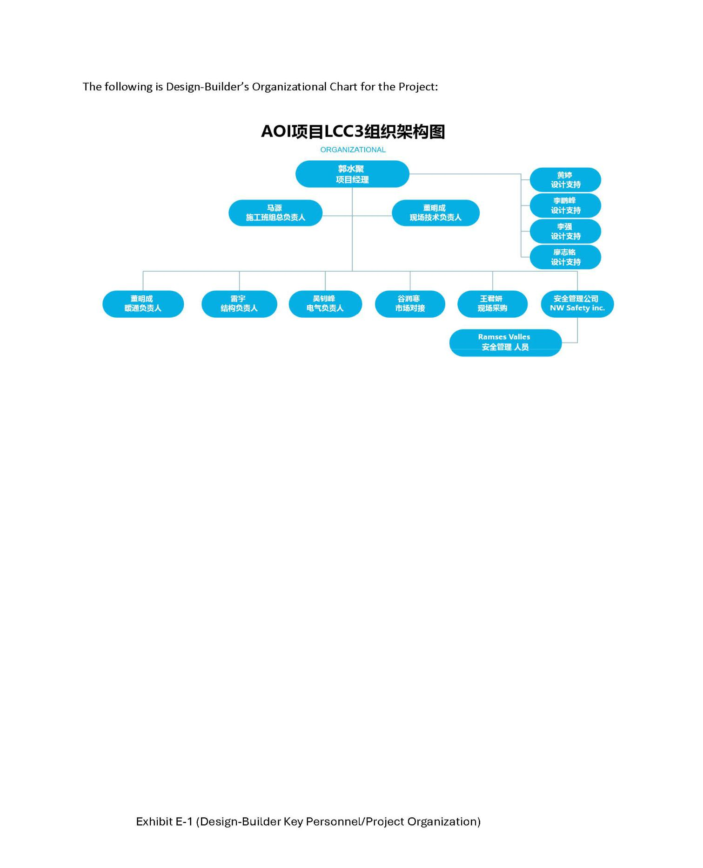

29

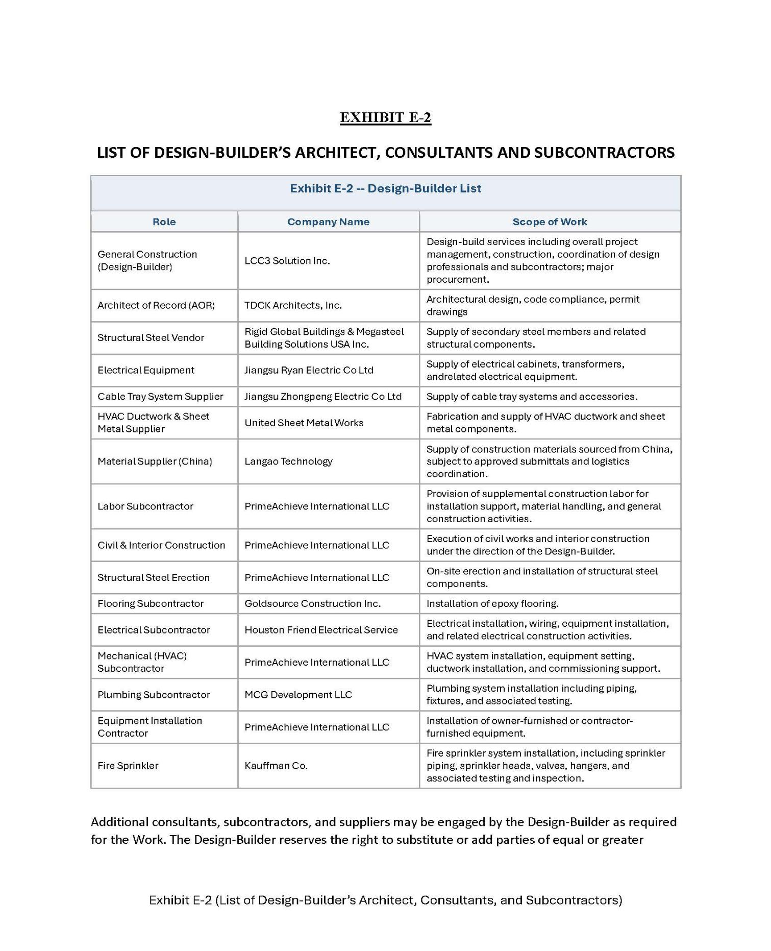

30

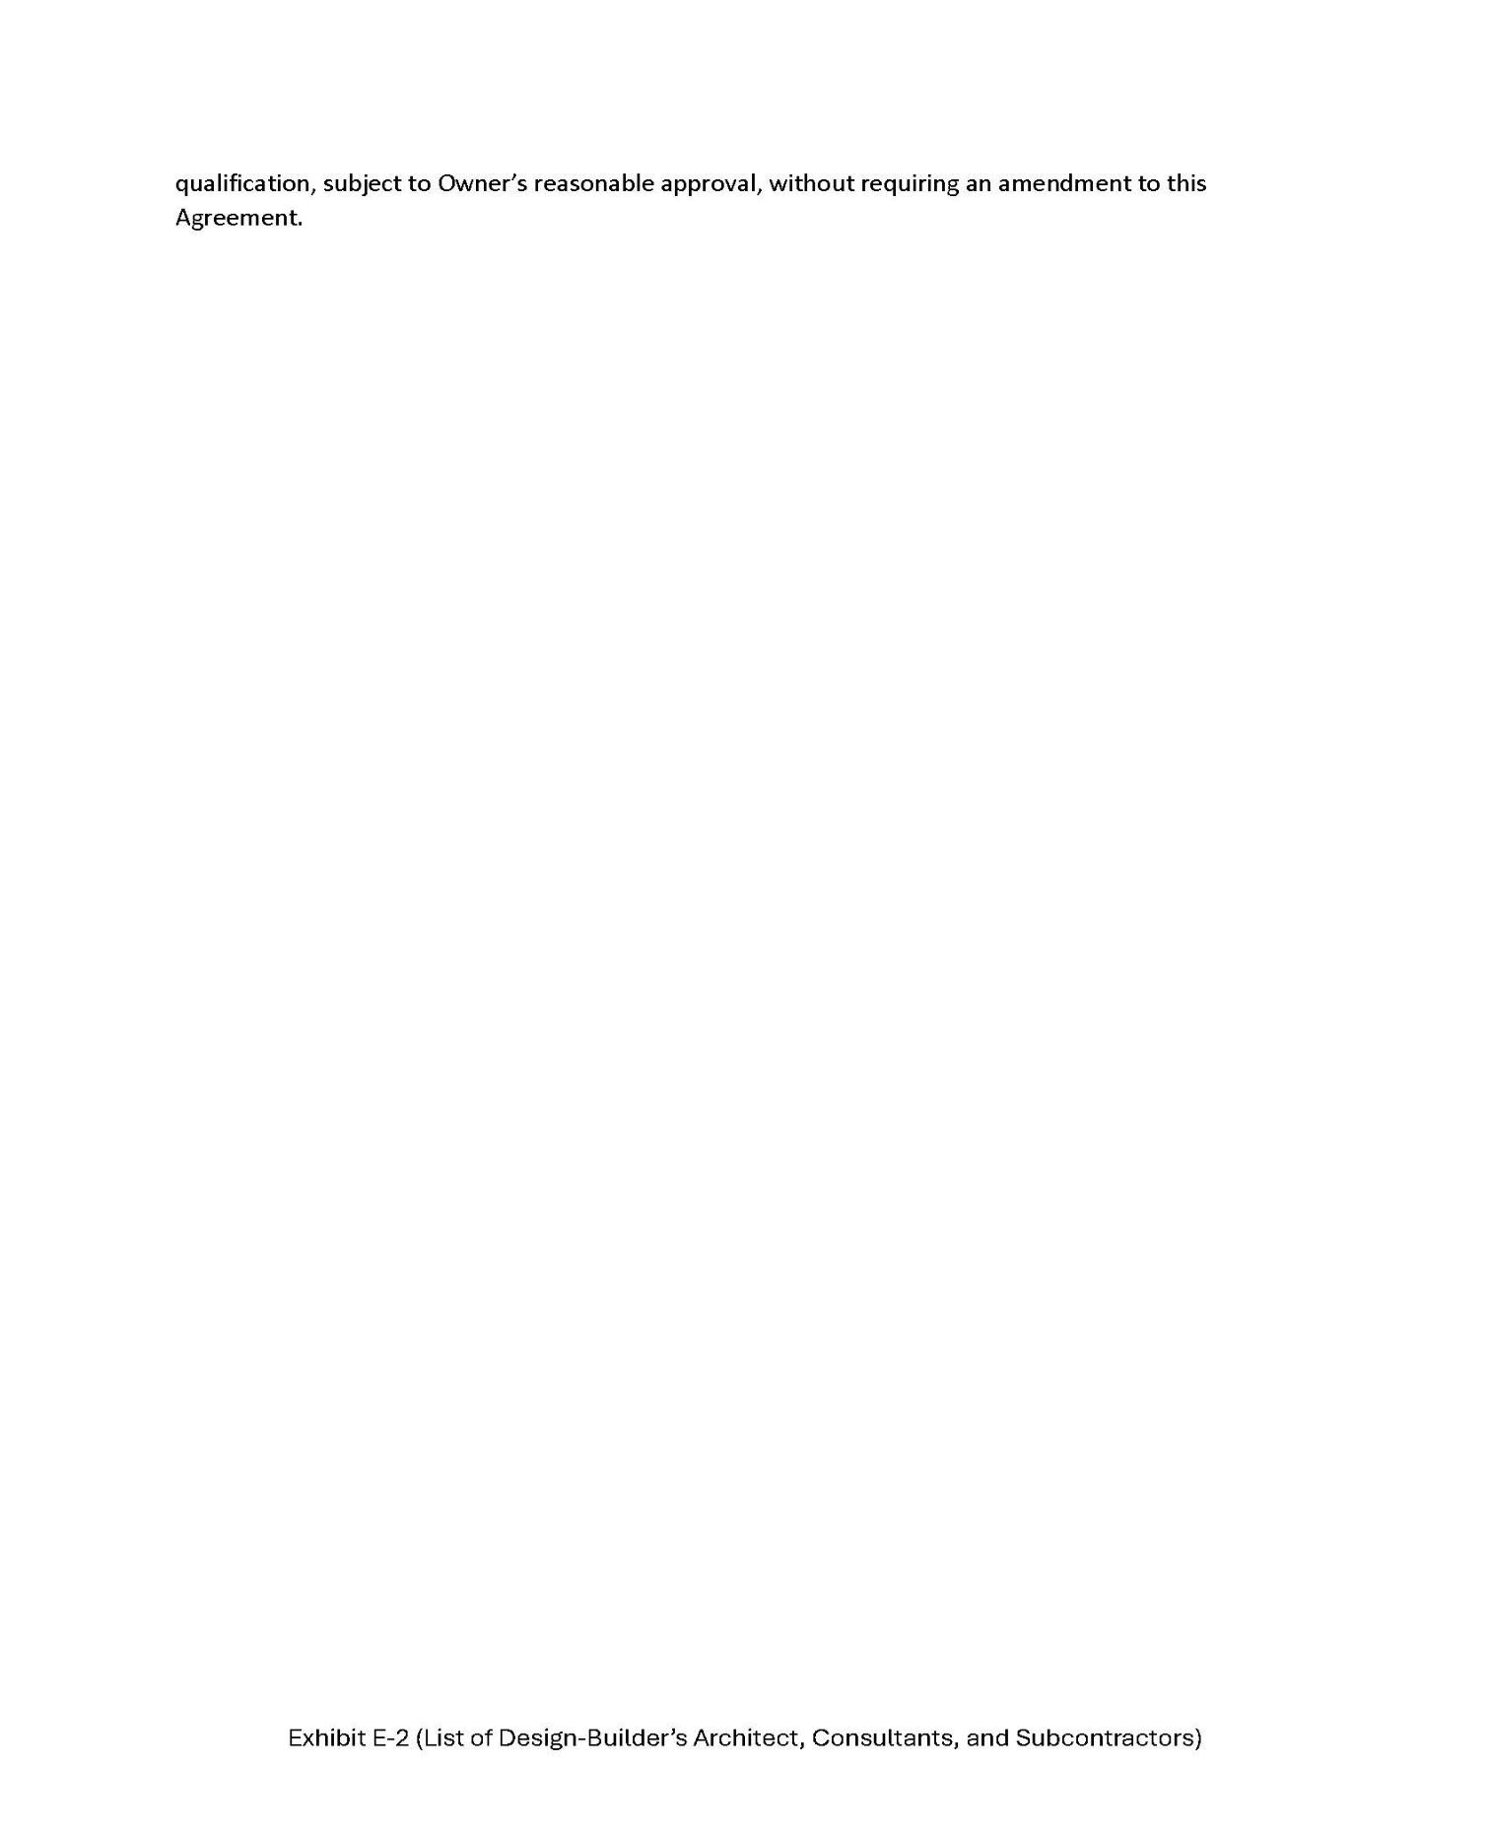

31

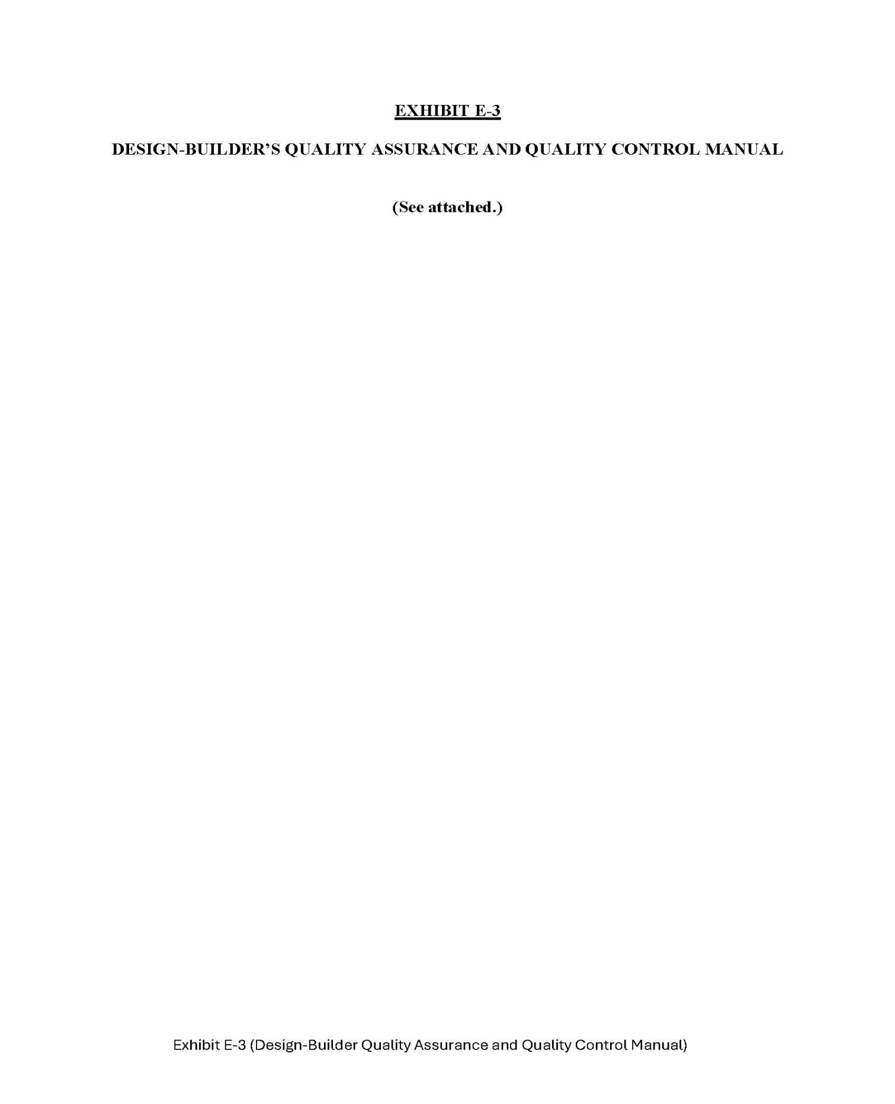

32

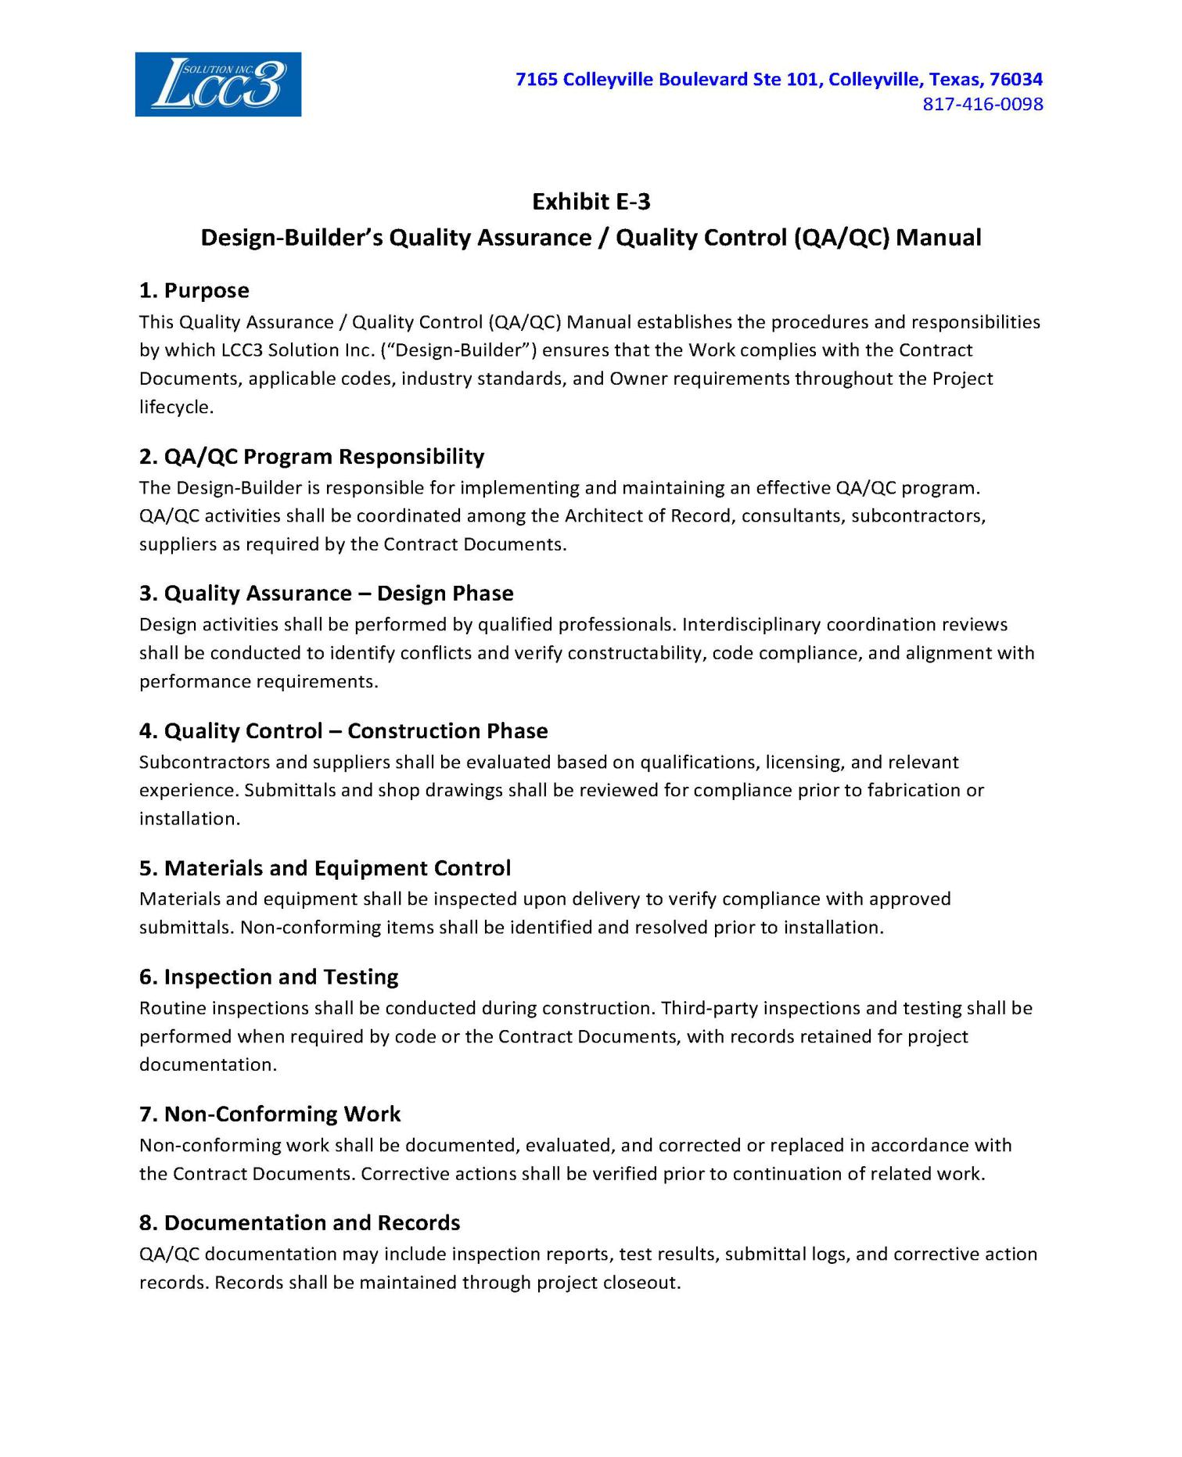

33

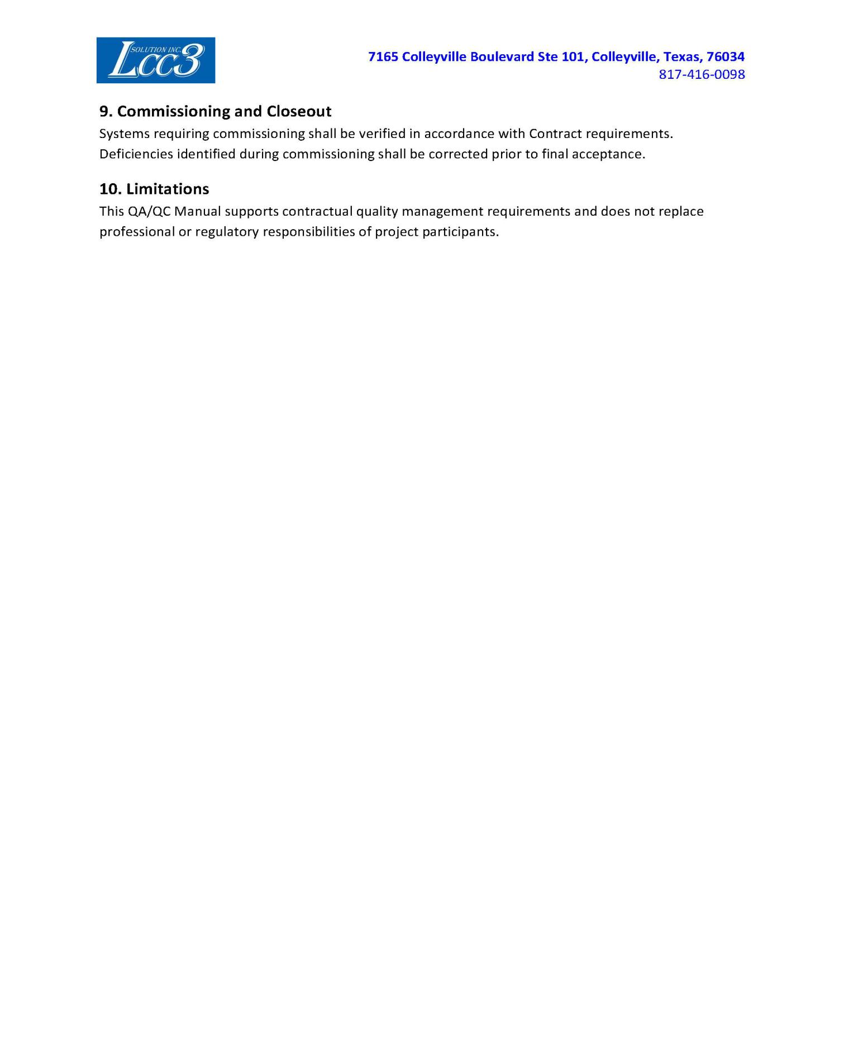

34

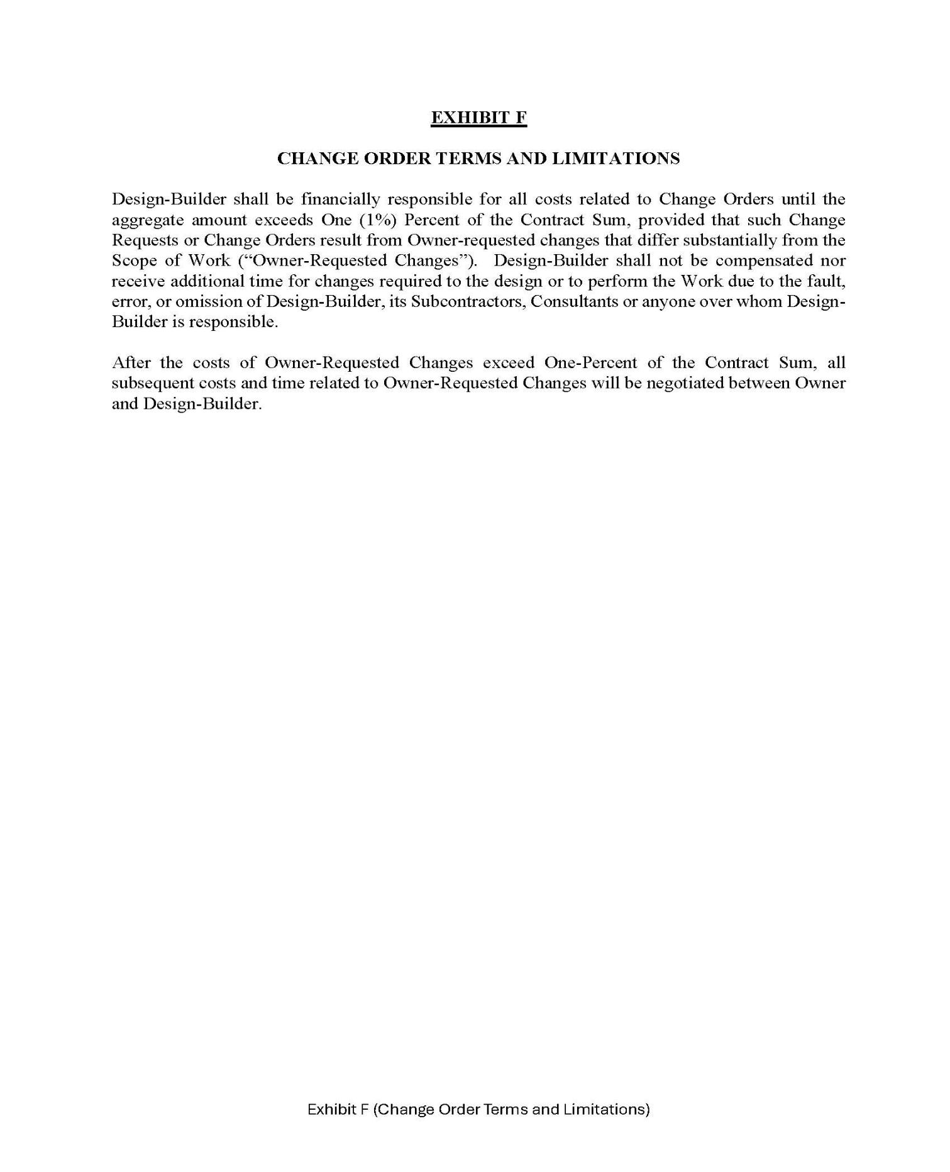

35

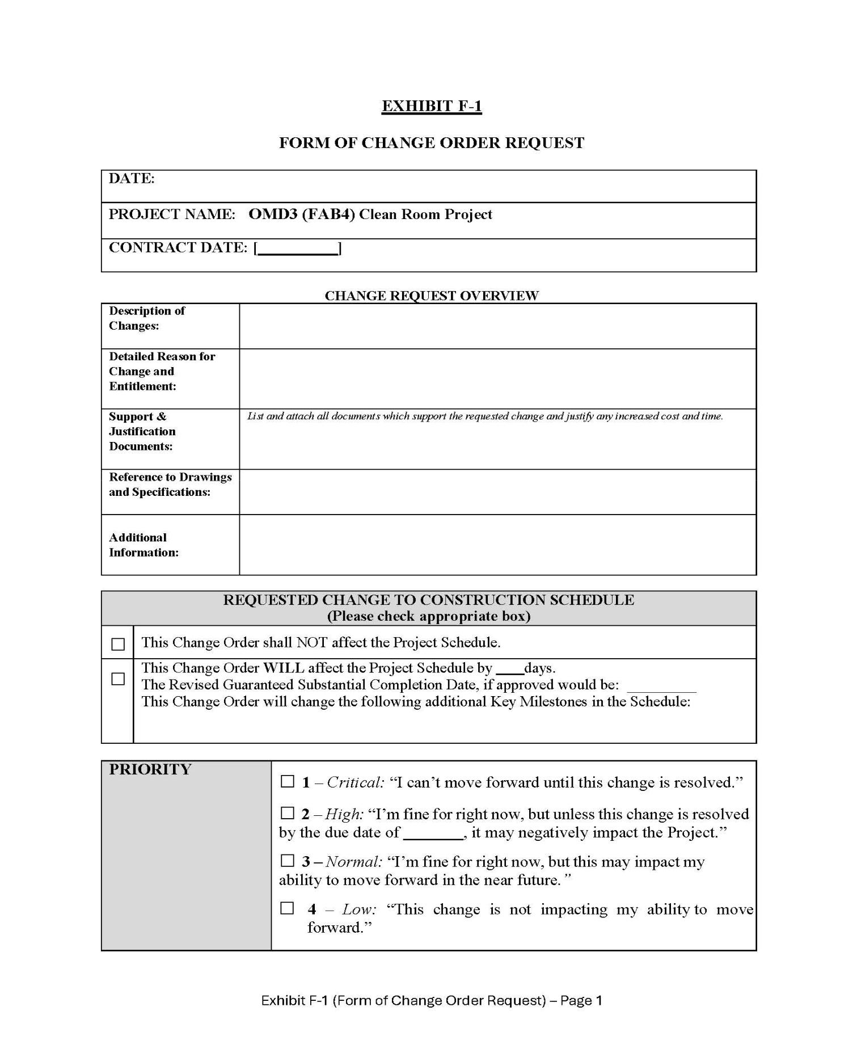

36

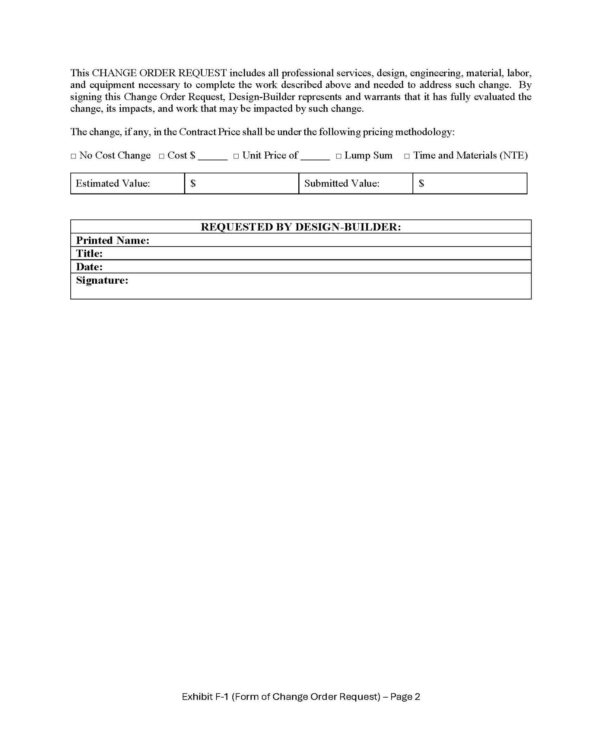

37

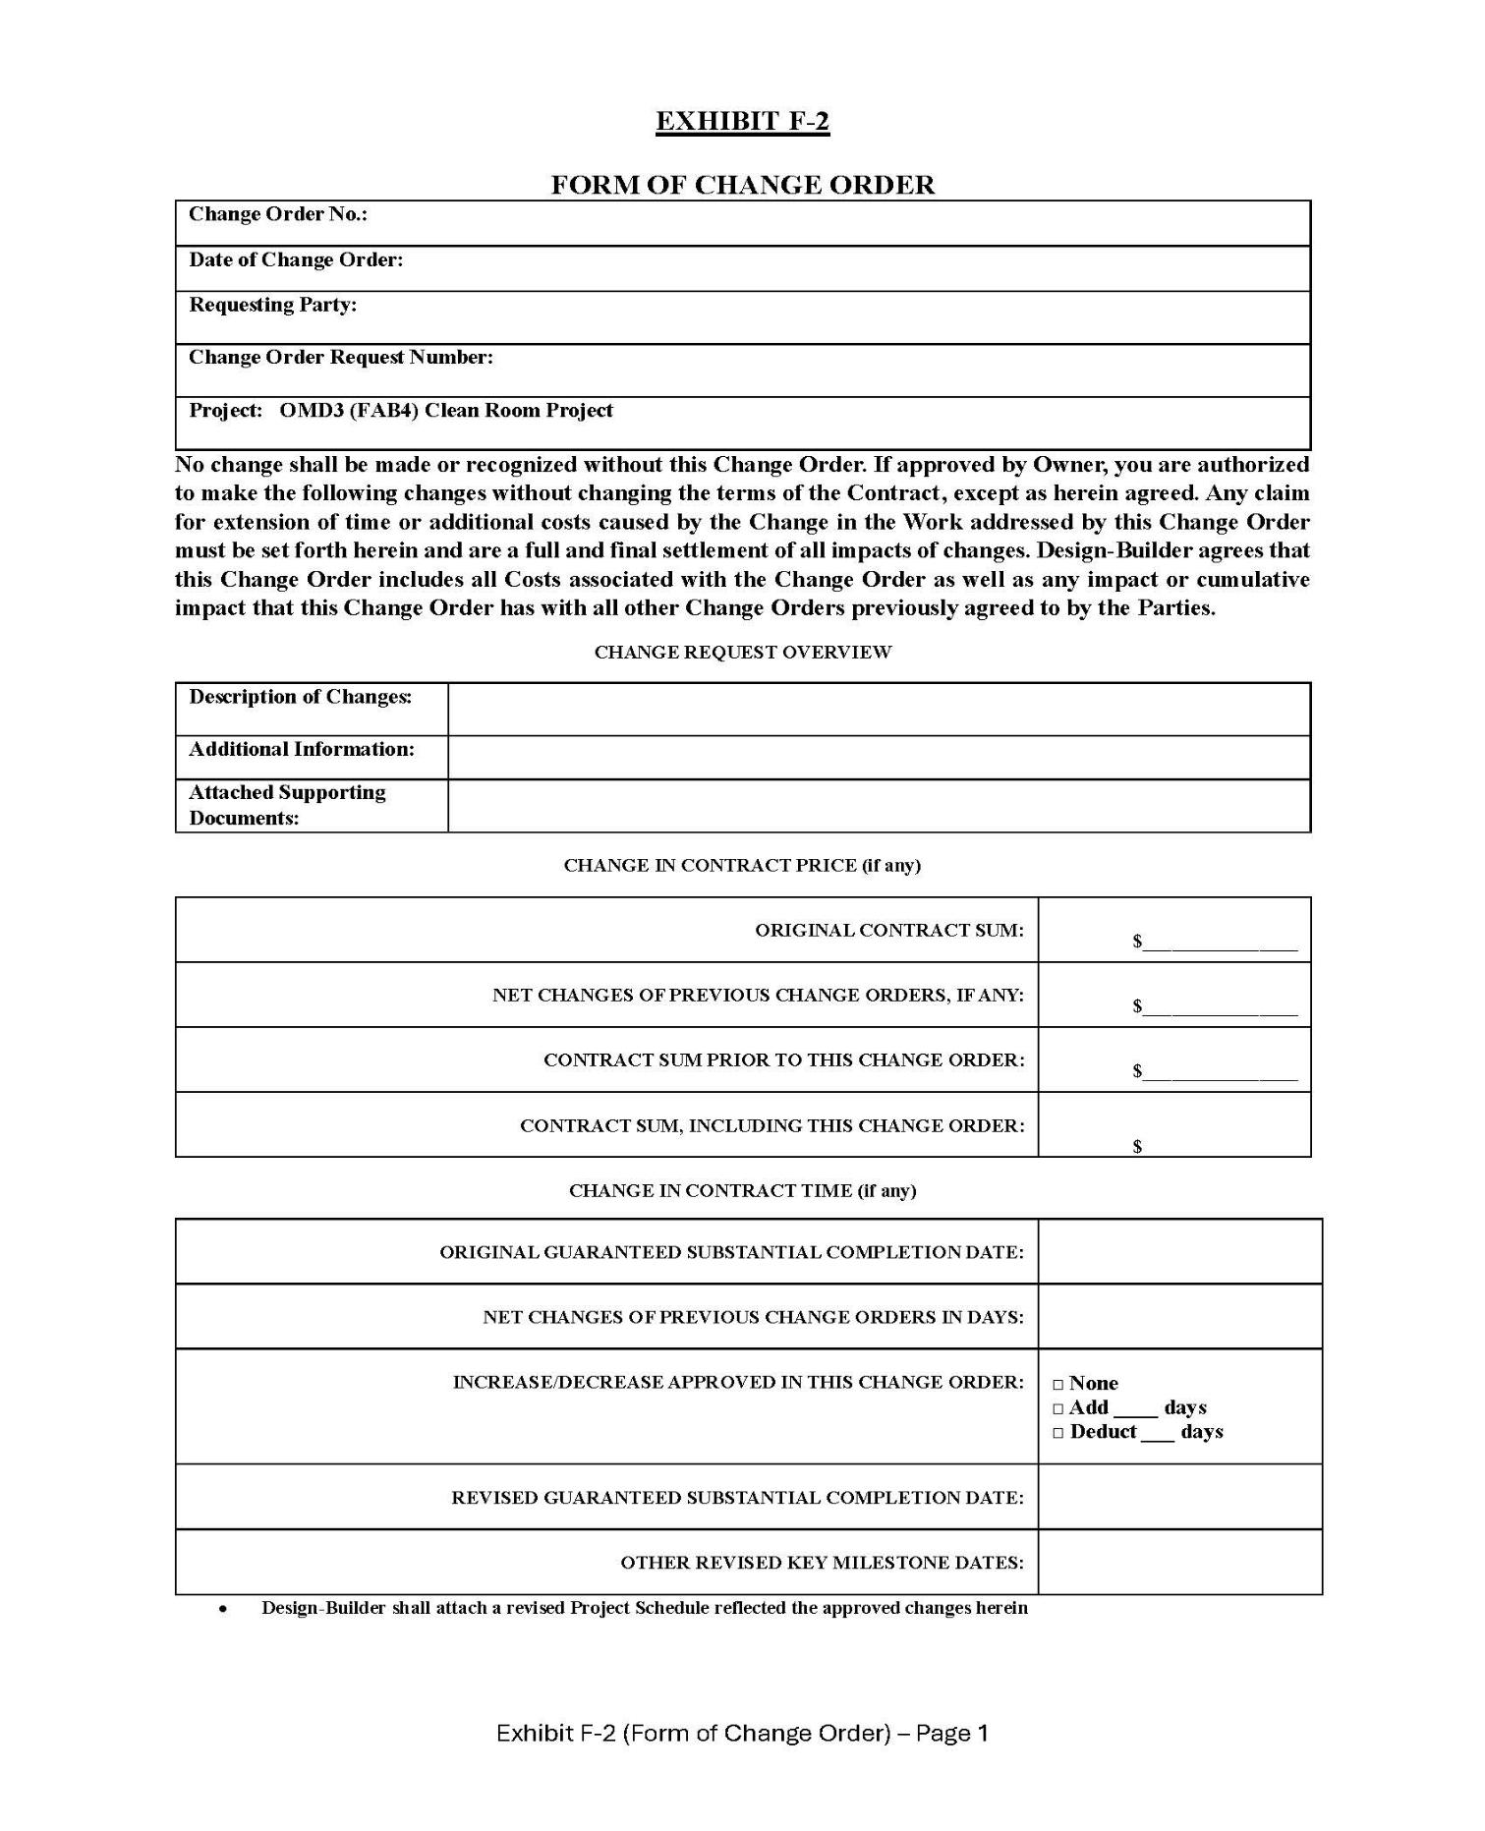

38

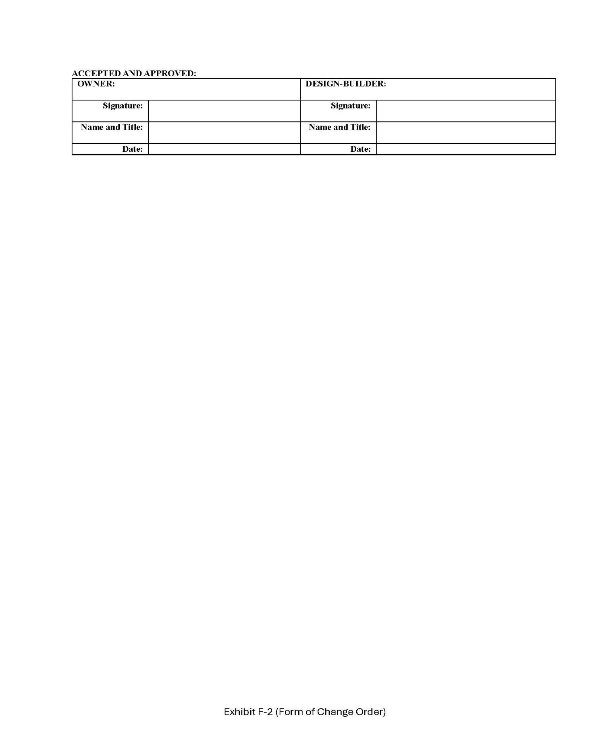

39

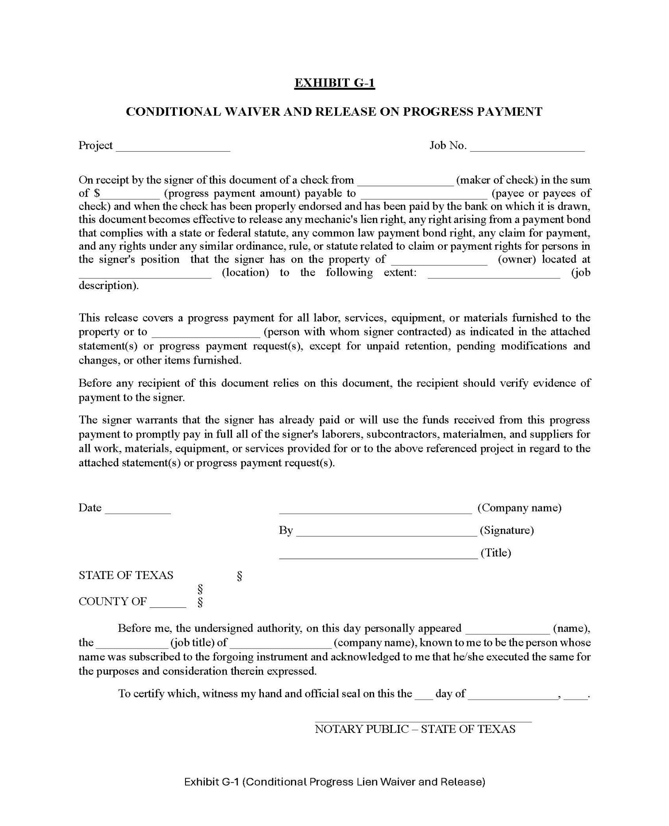

40

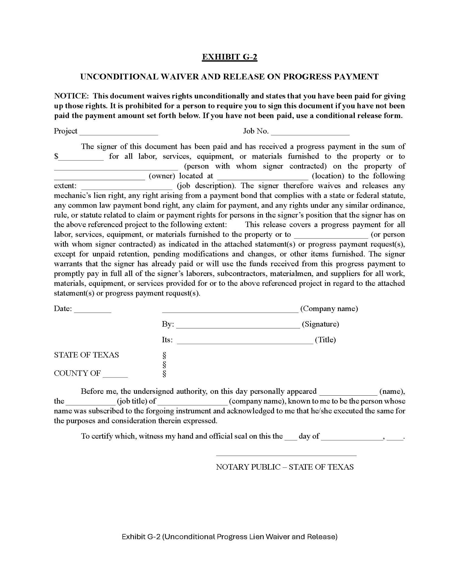

41

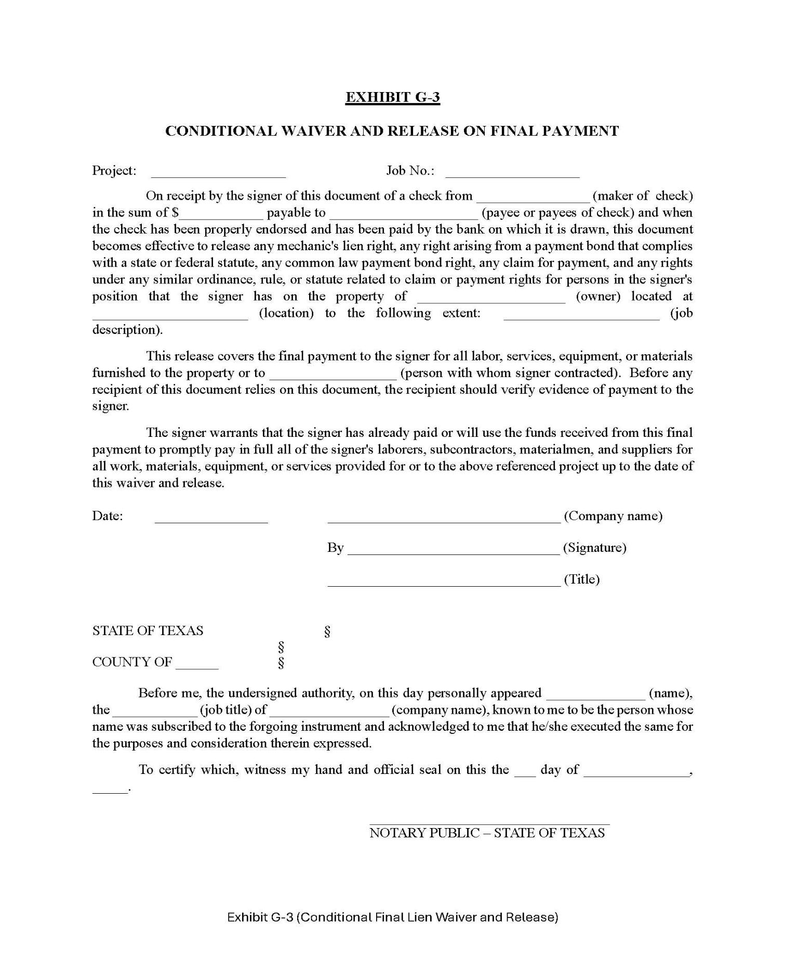

42

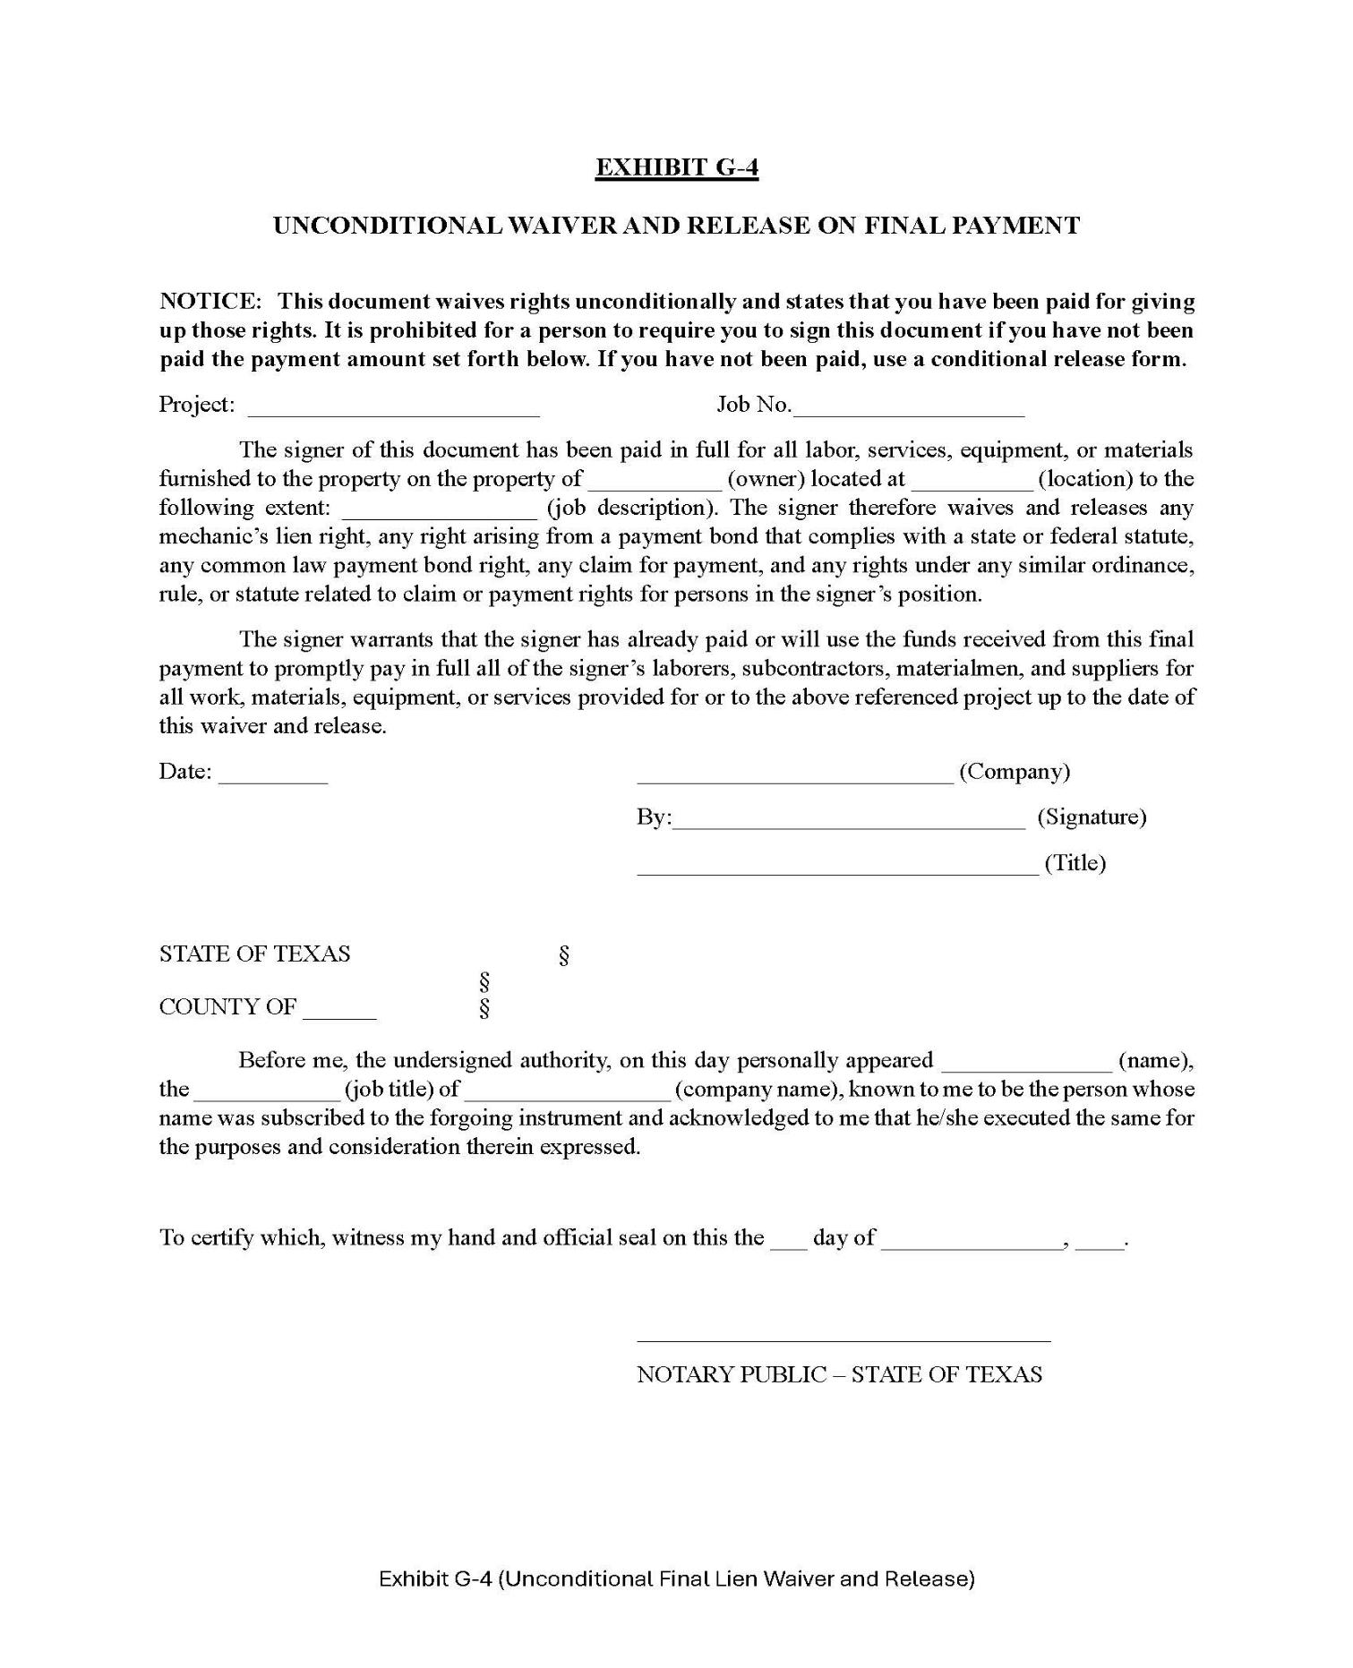

43

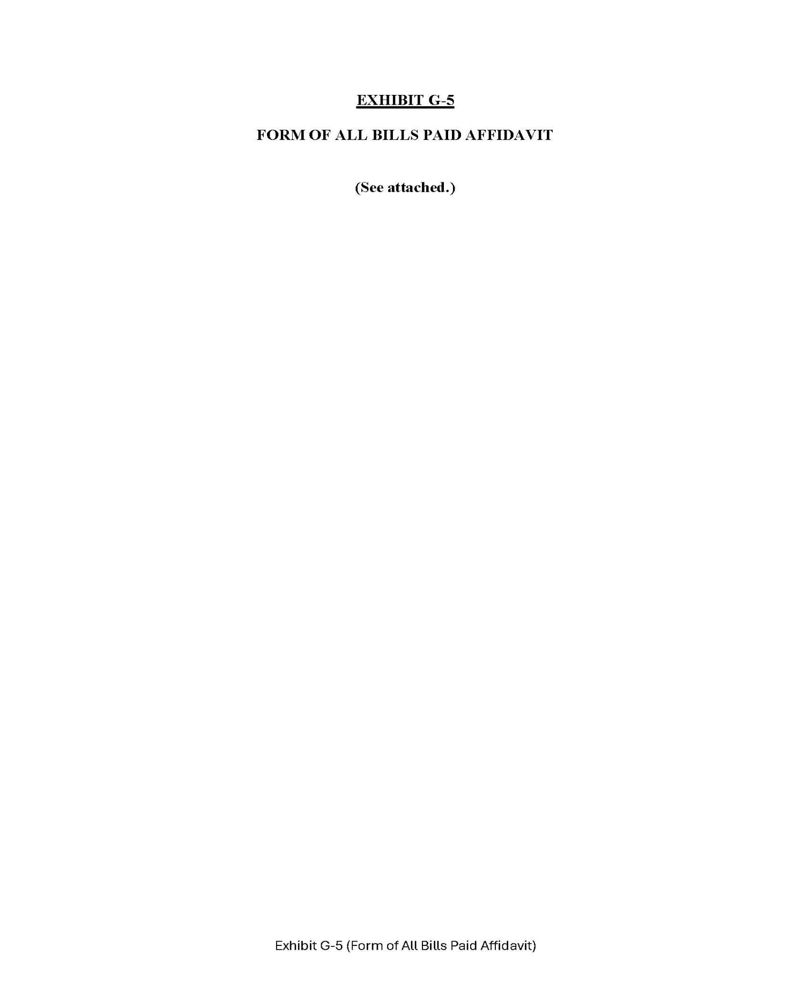

44

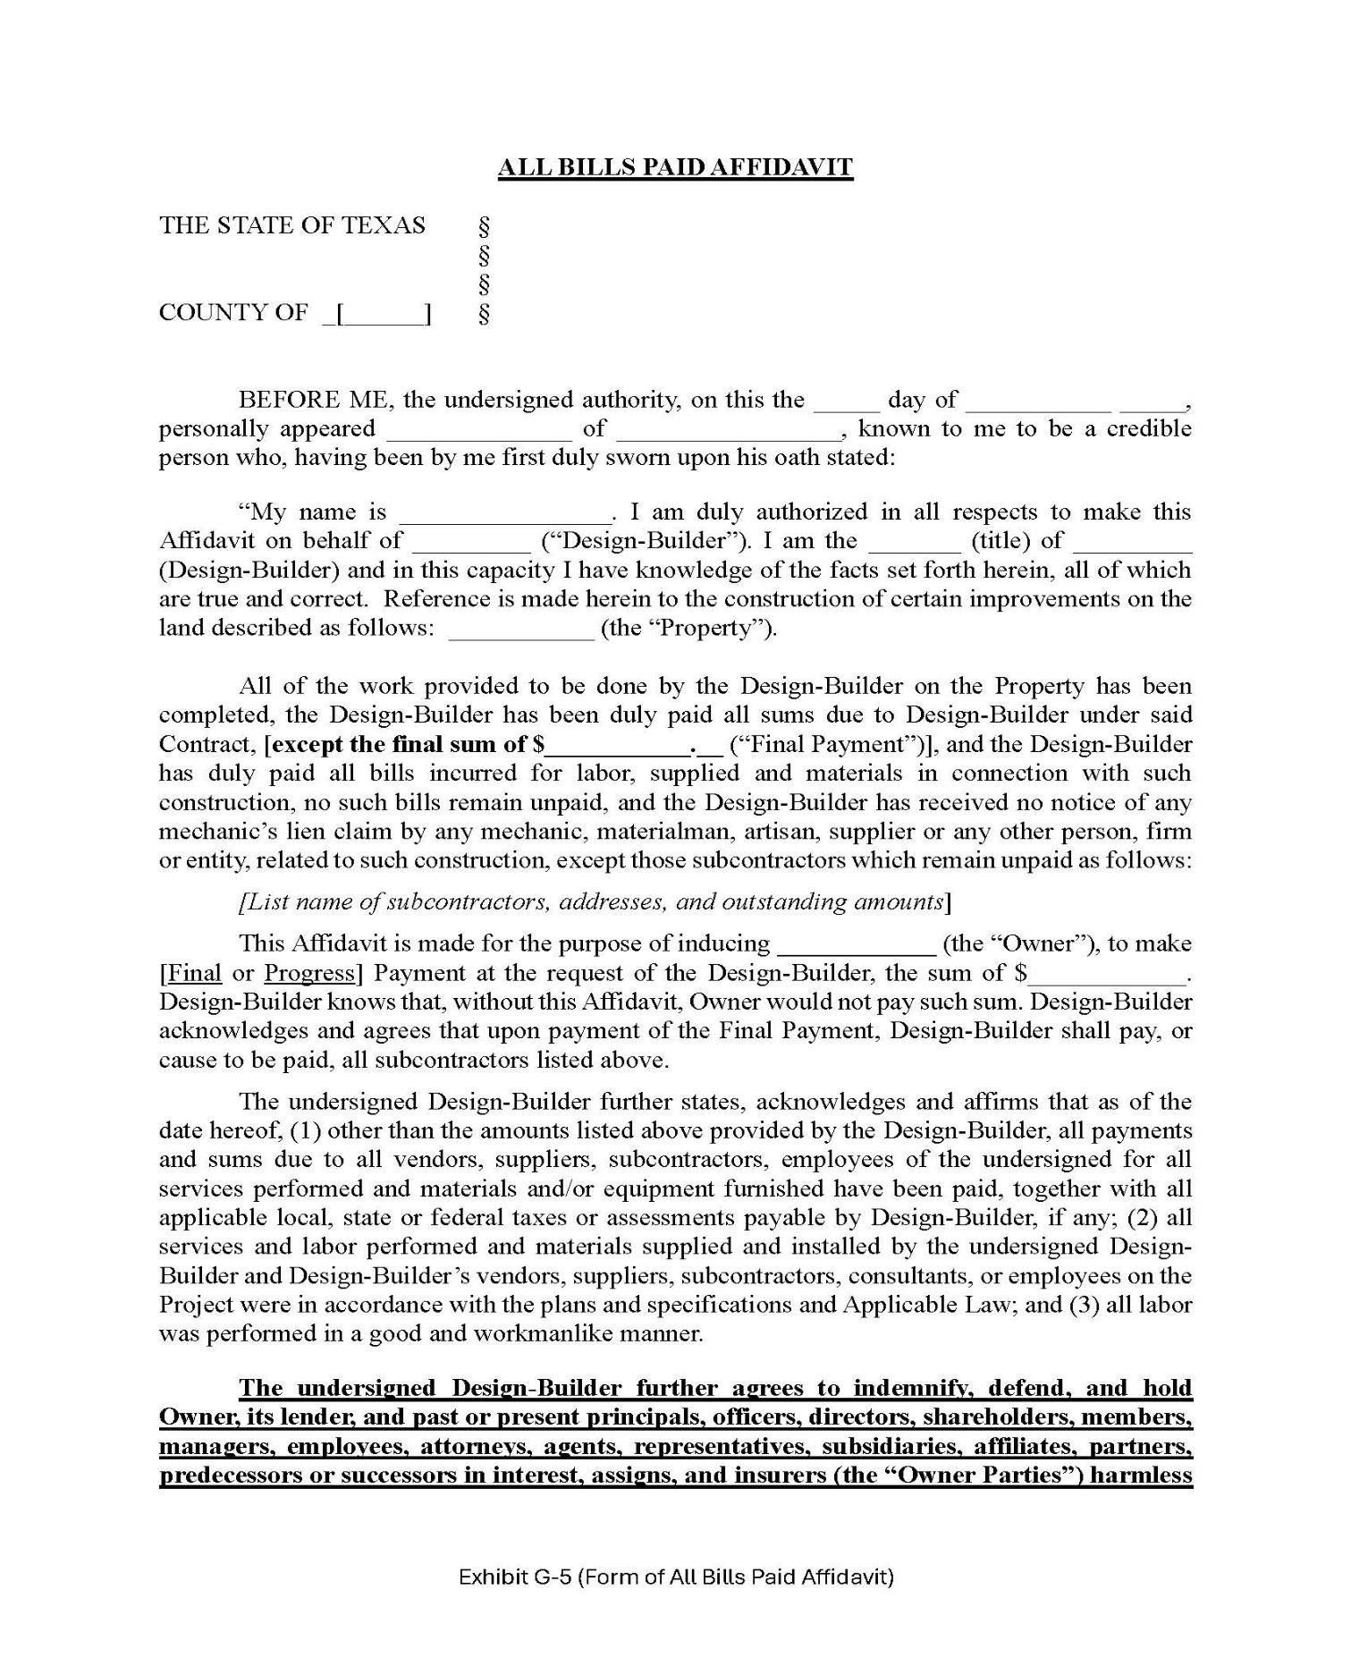

45

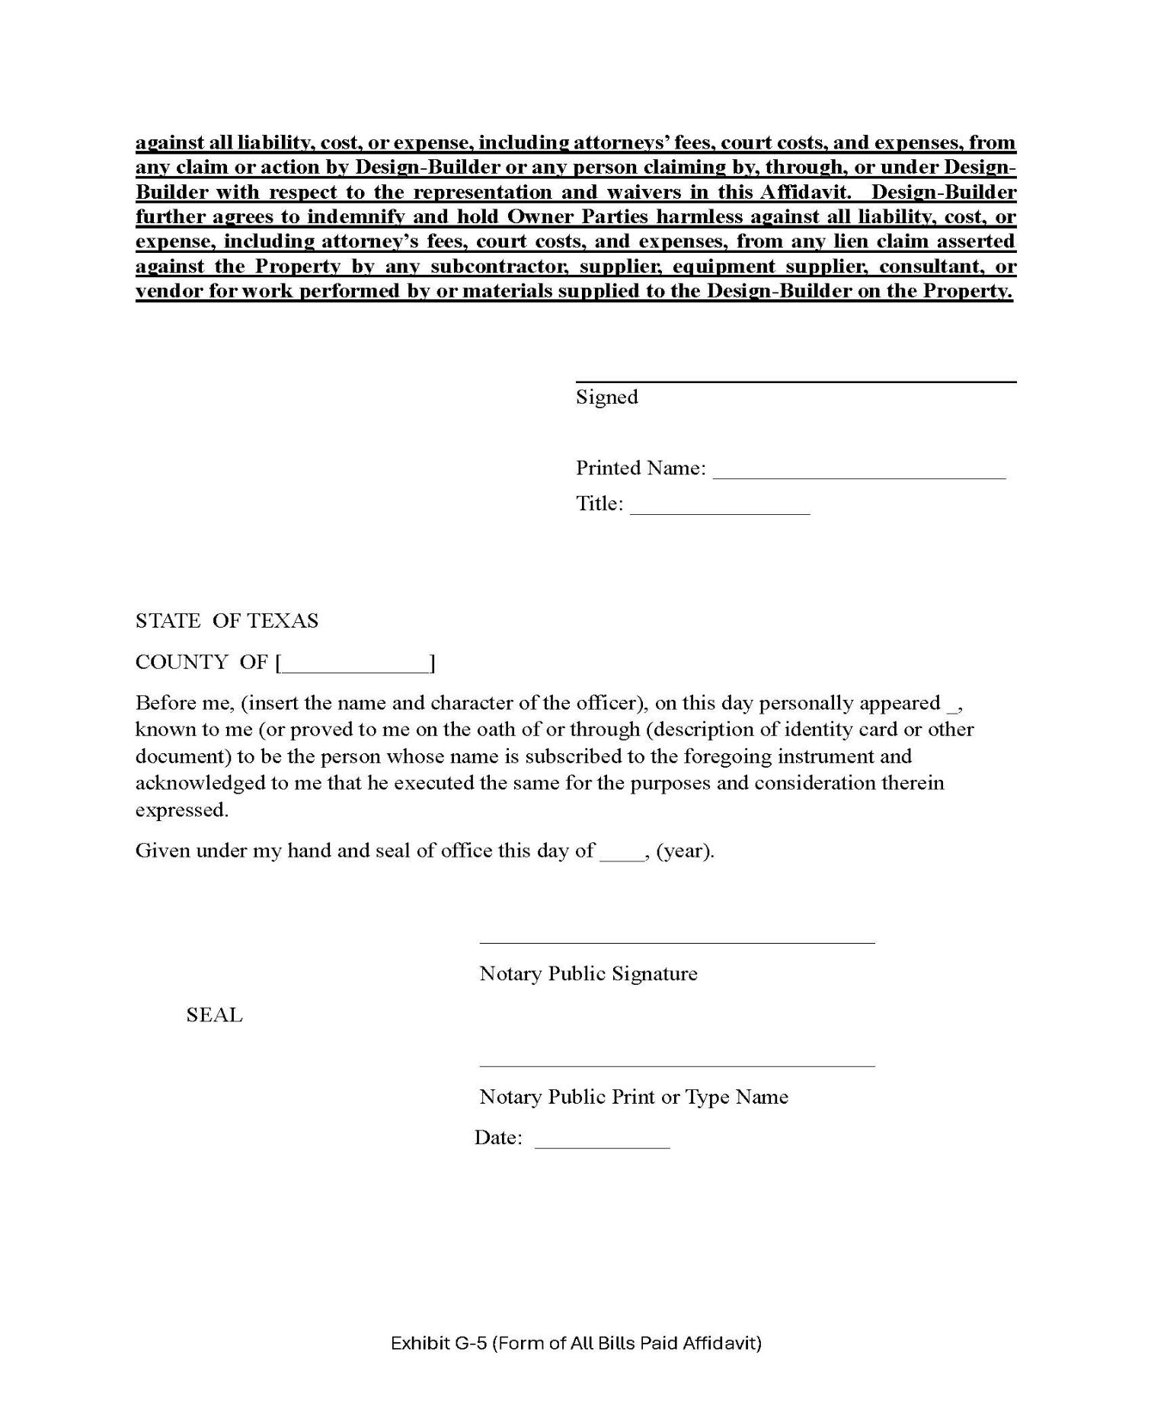

46

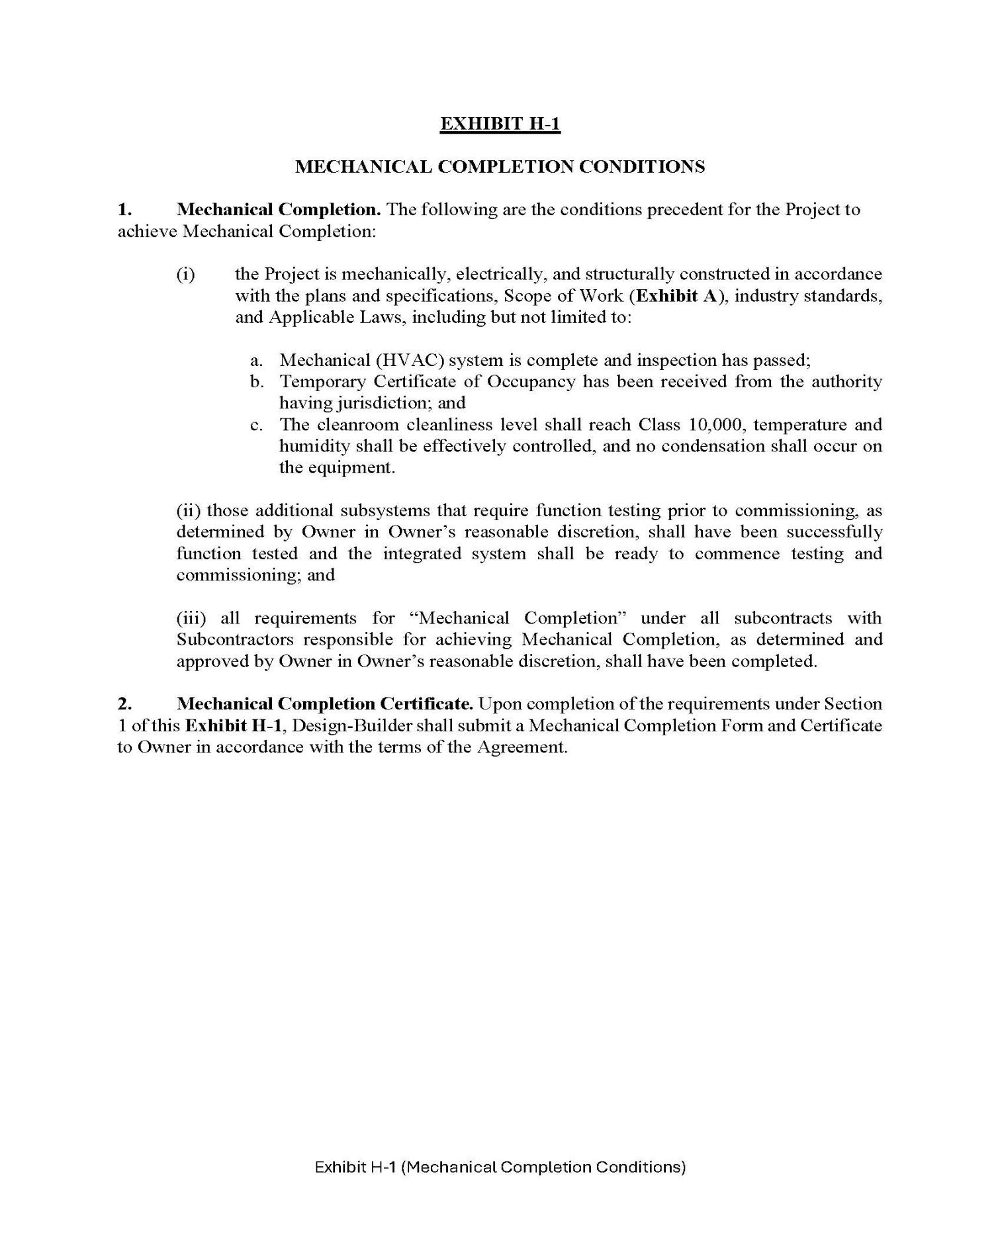

47

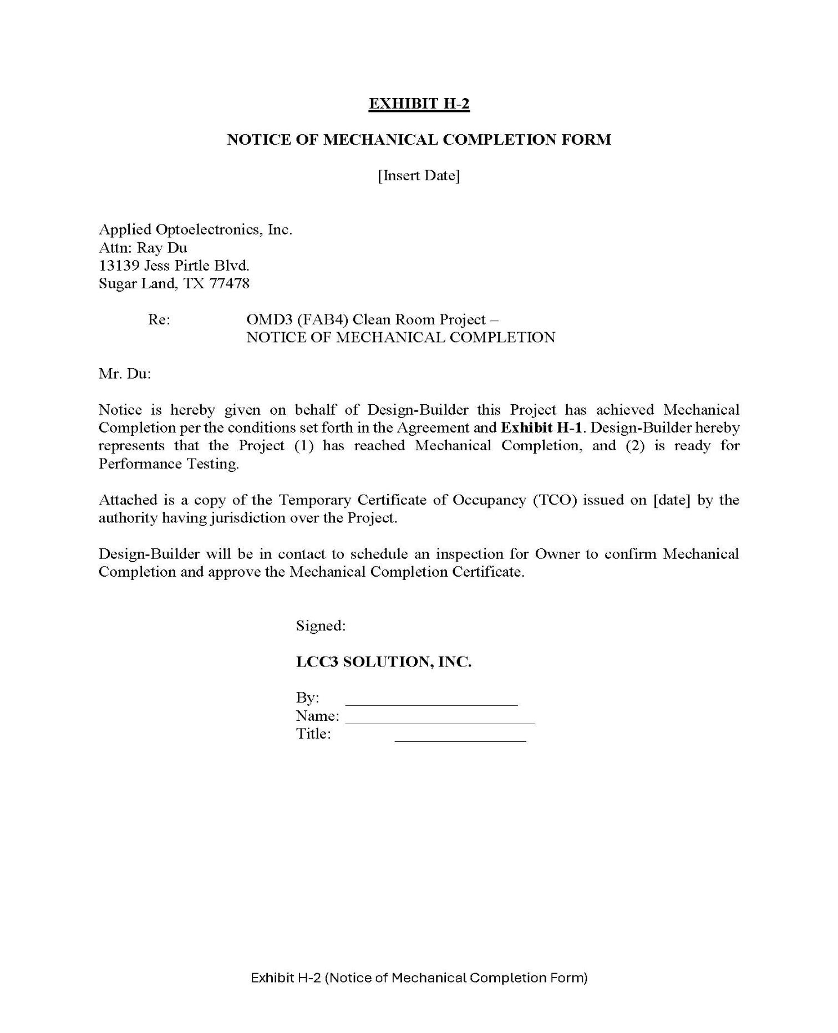

48

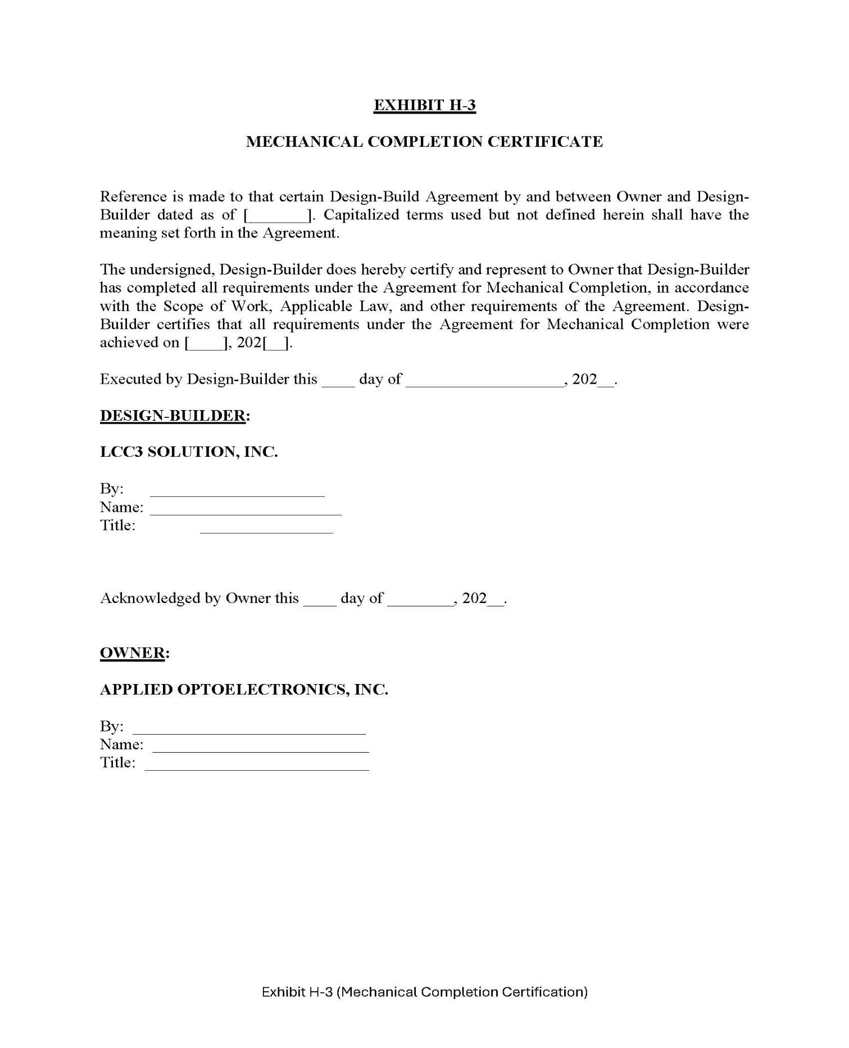

49

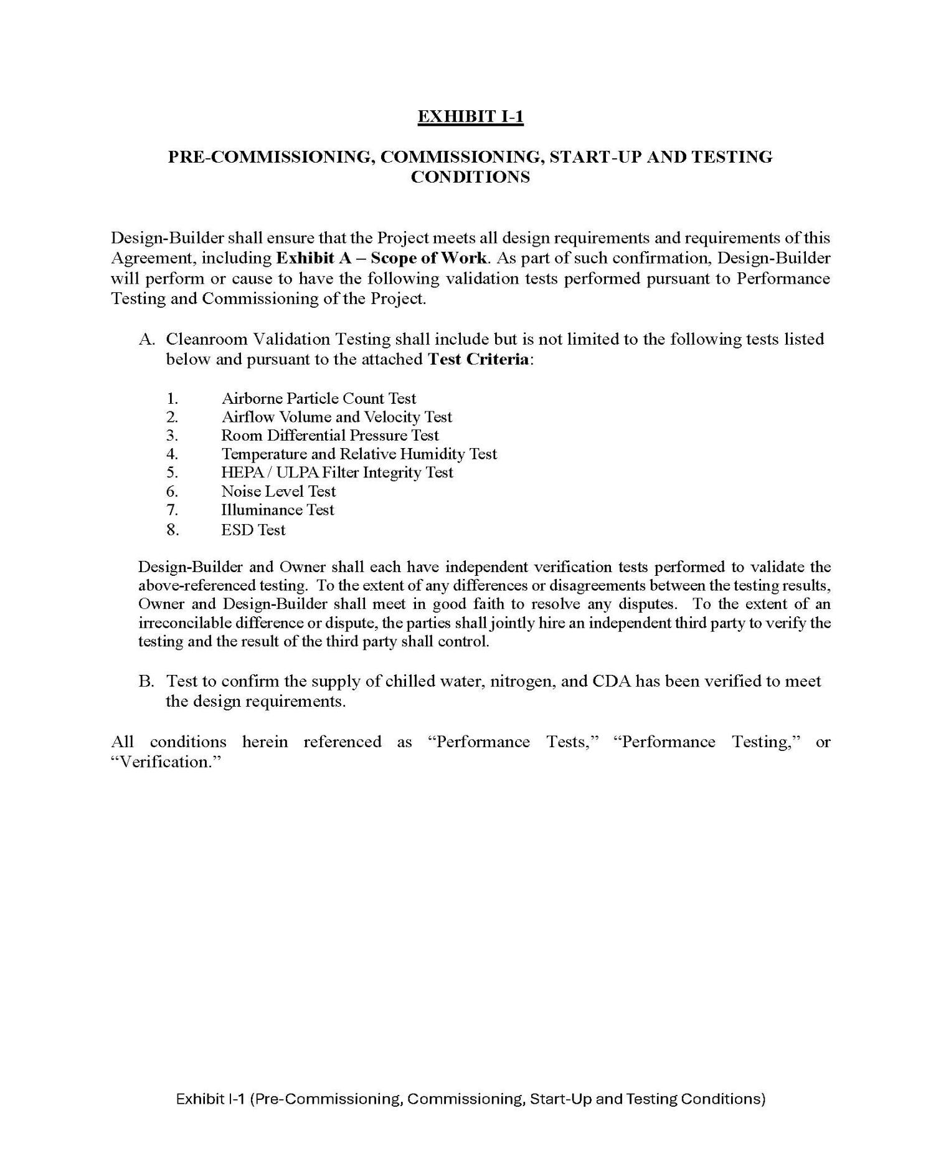

50

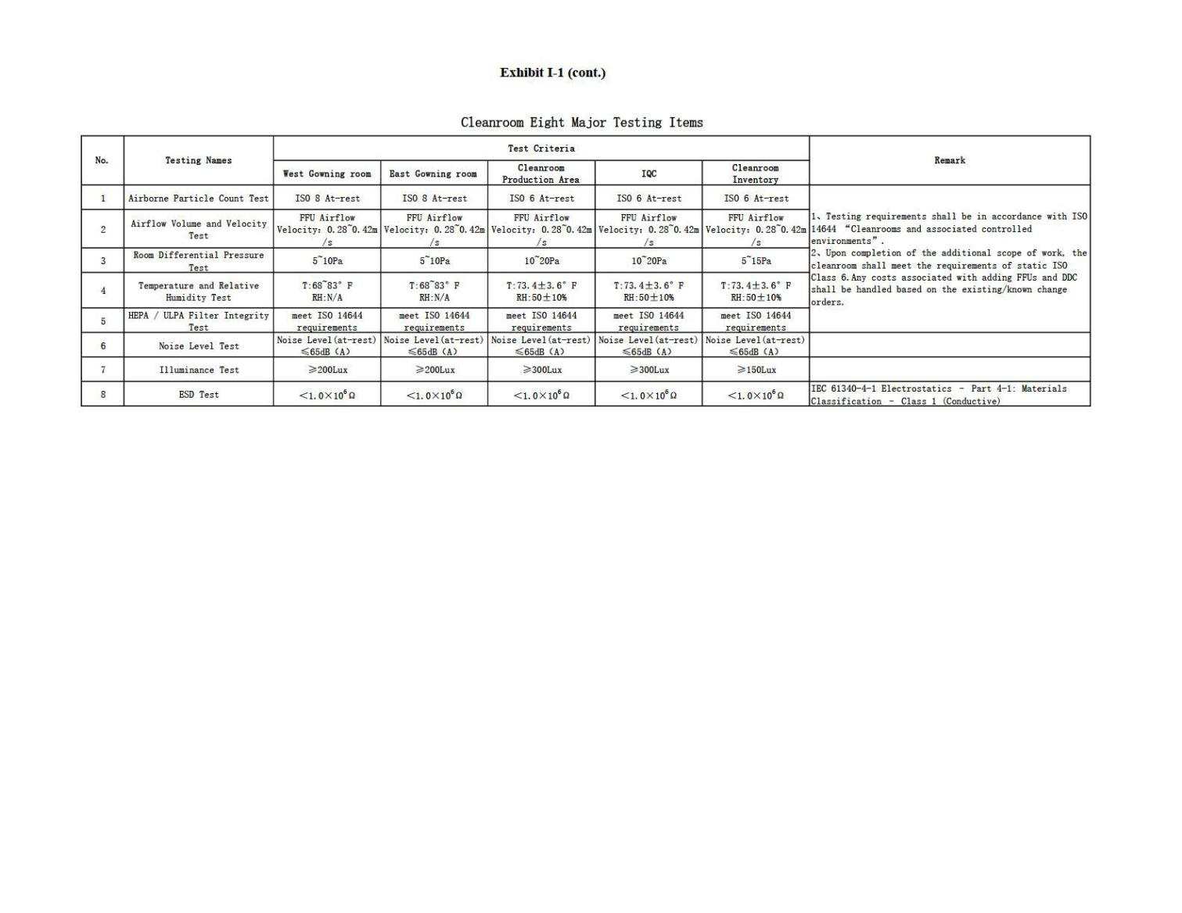

51

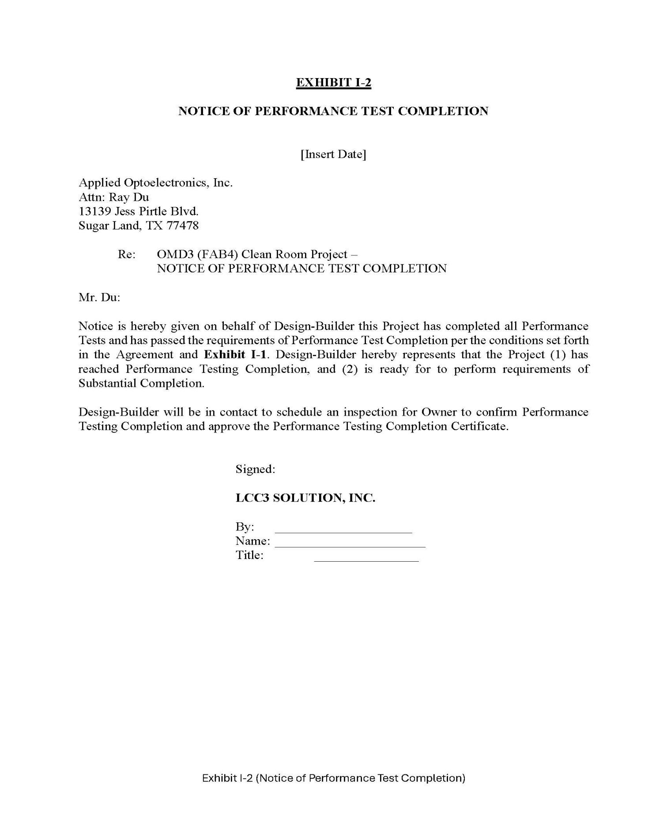

52

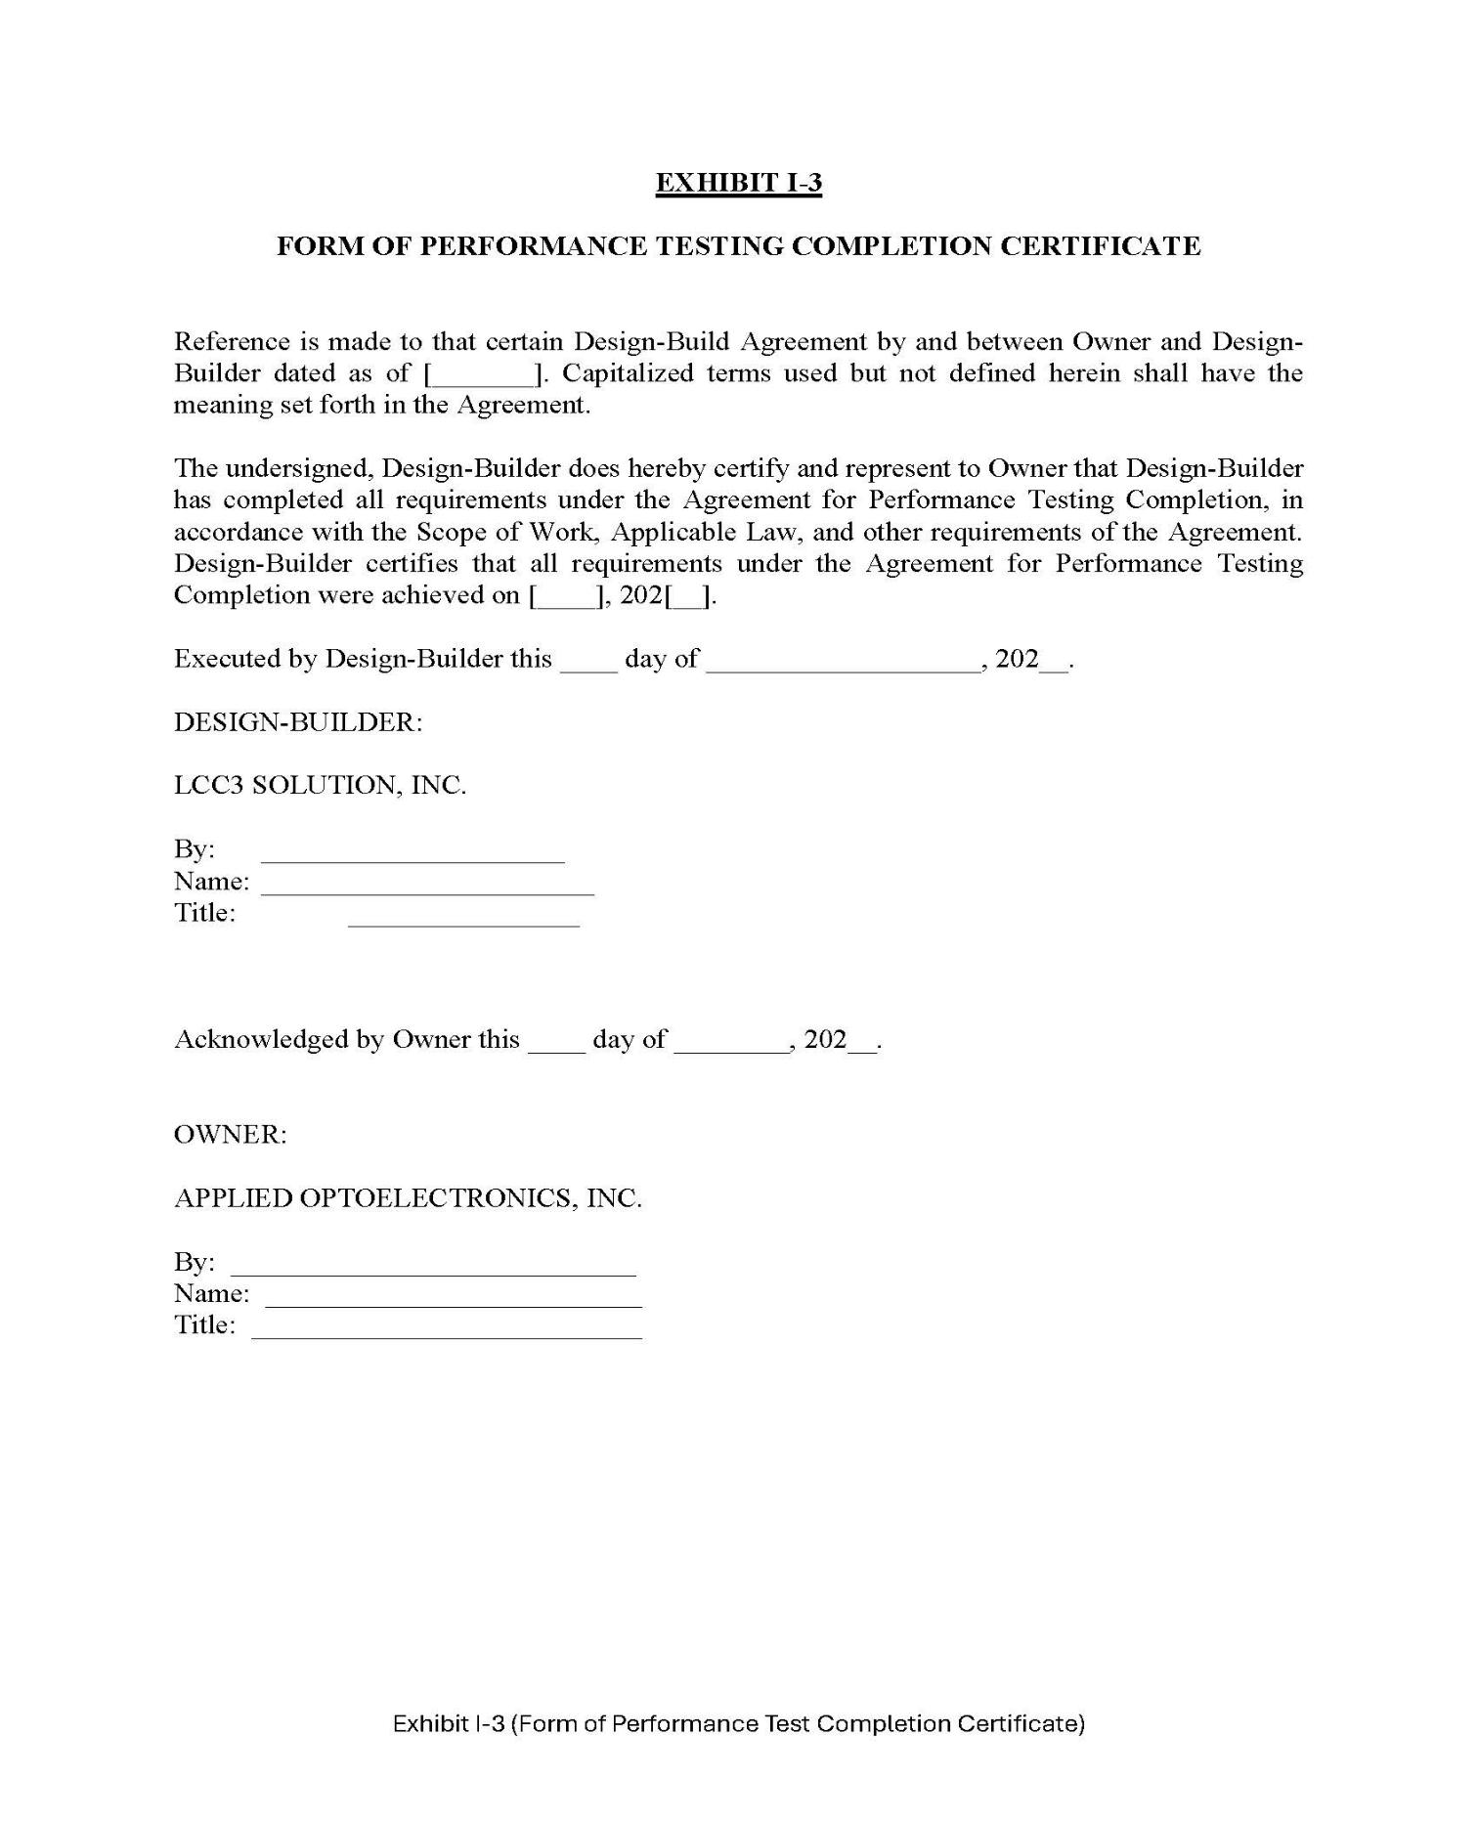

53

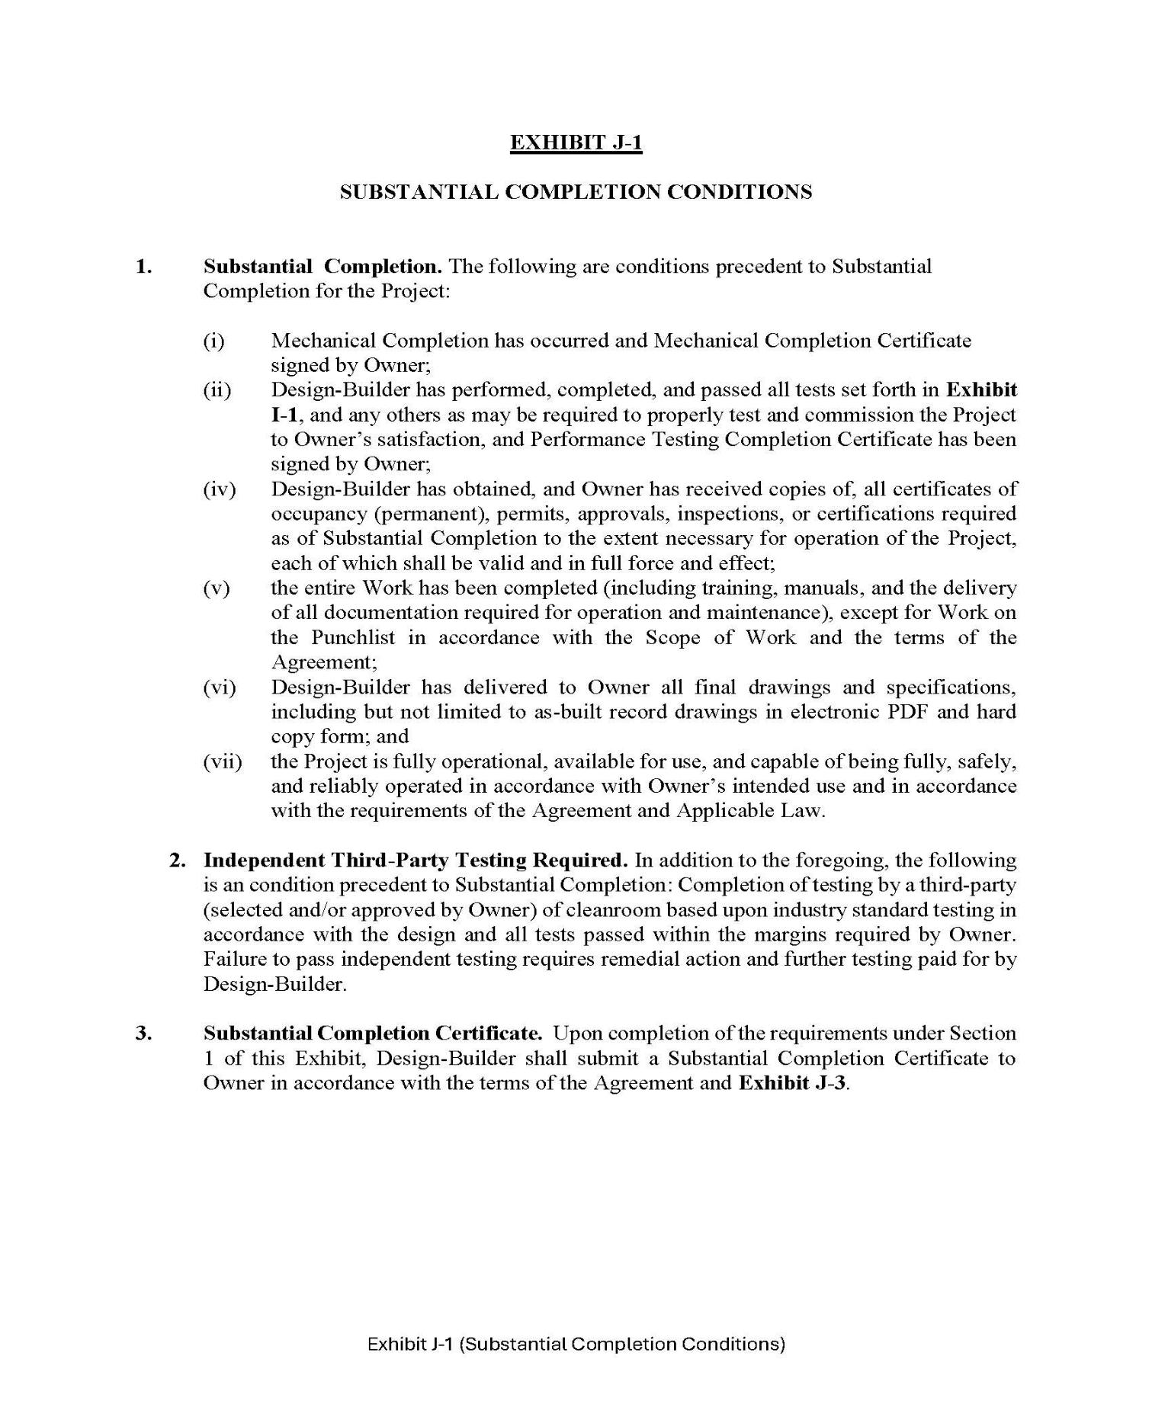

54

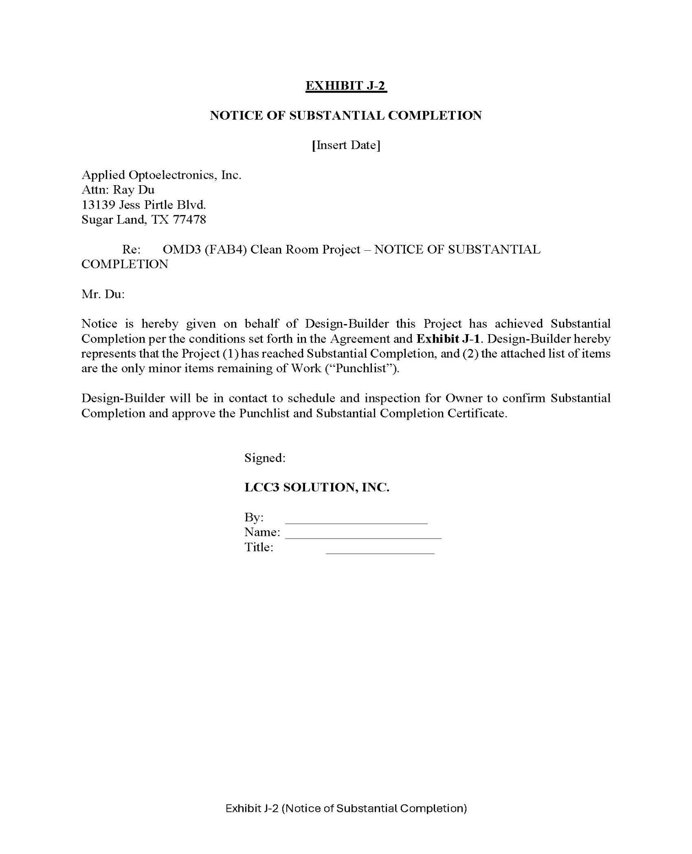

55

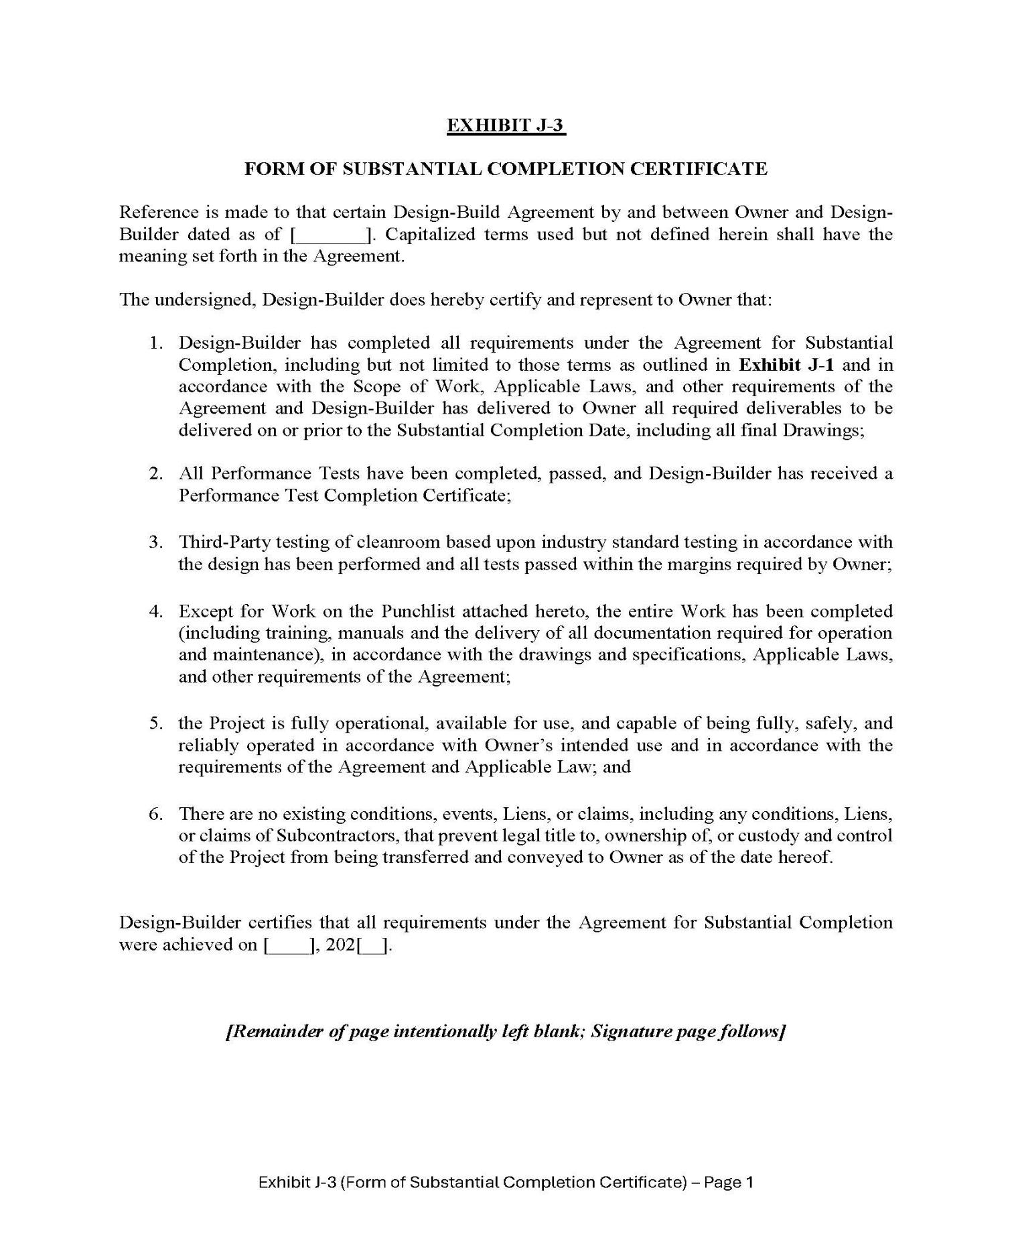

56

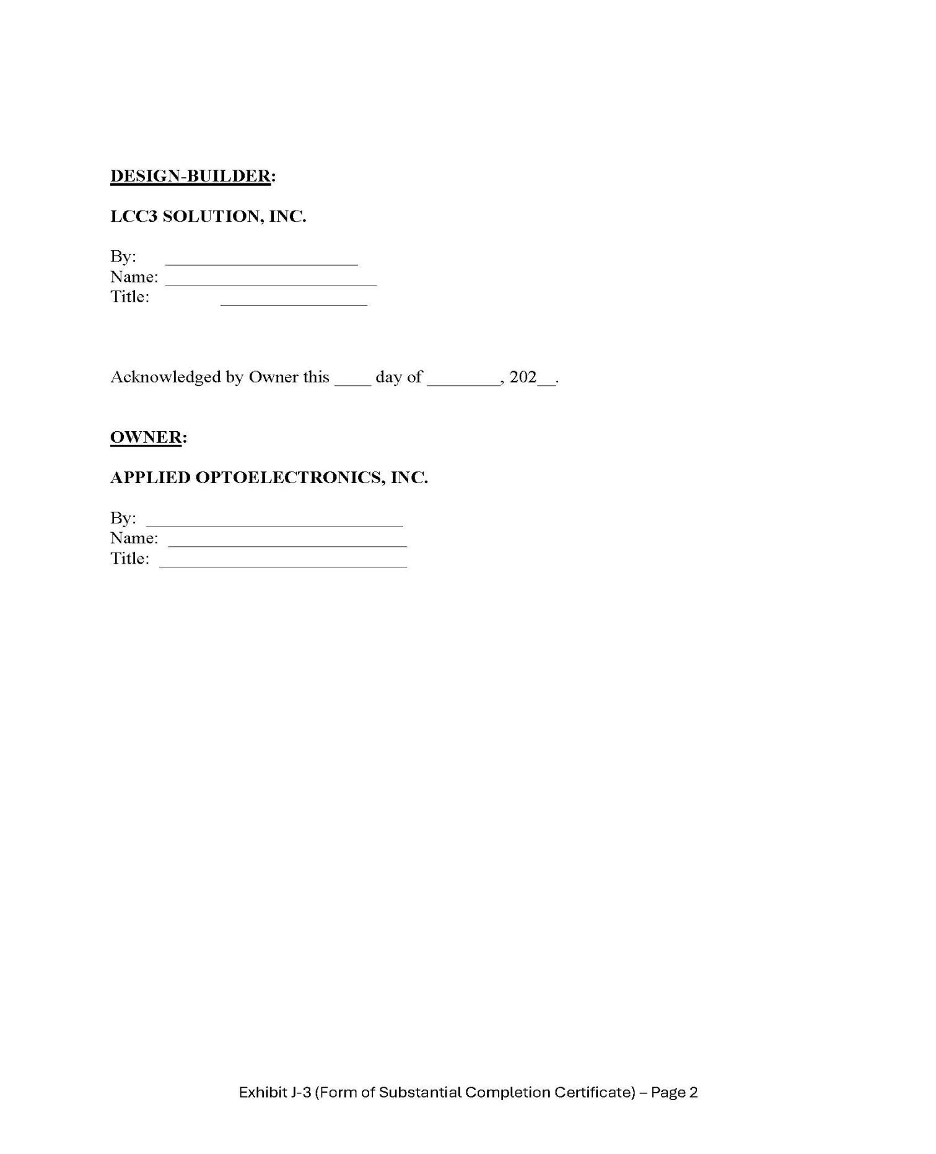

57

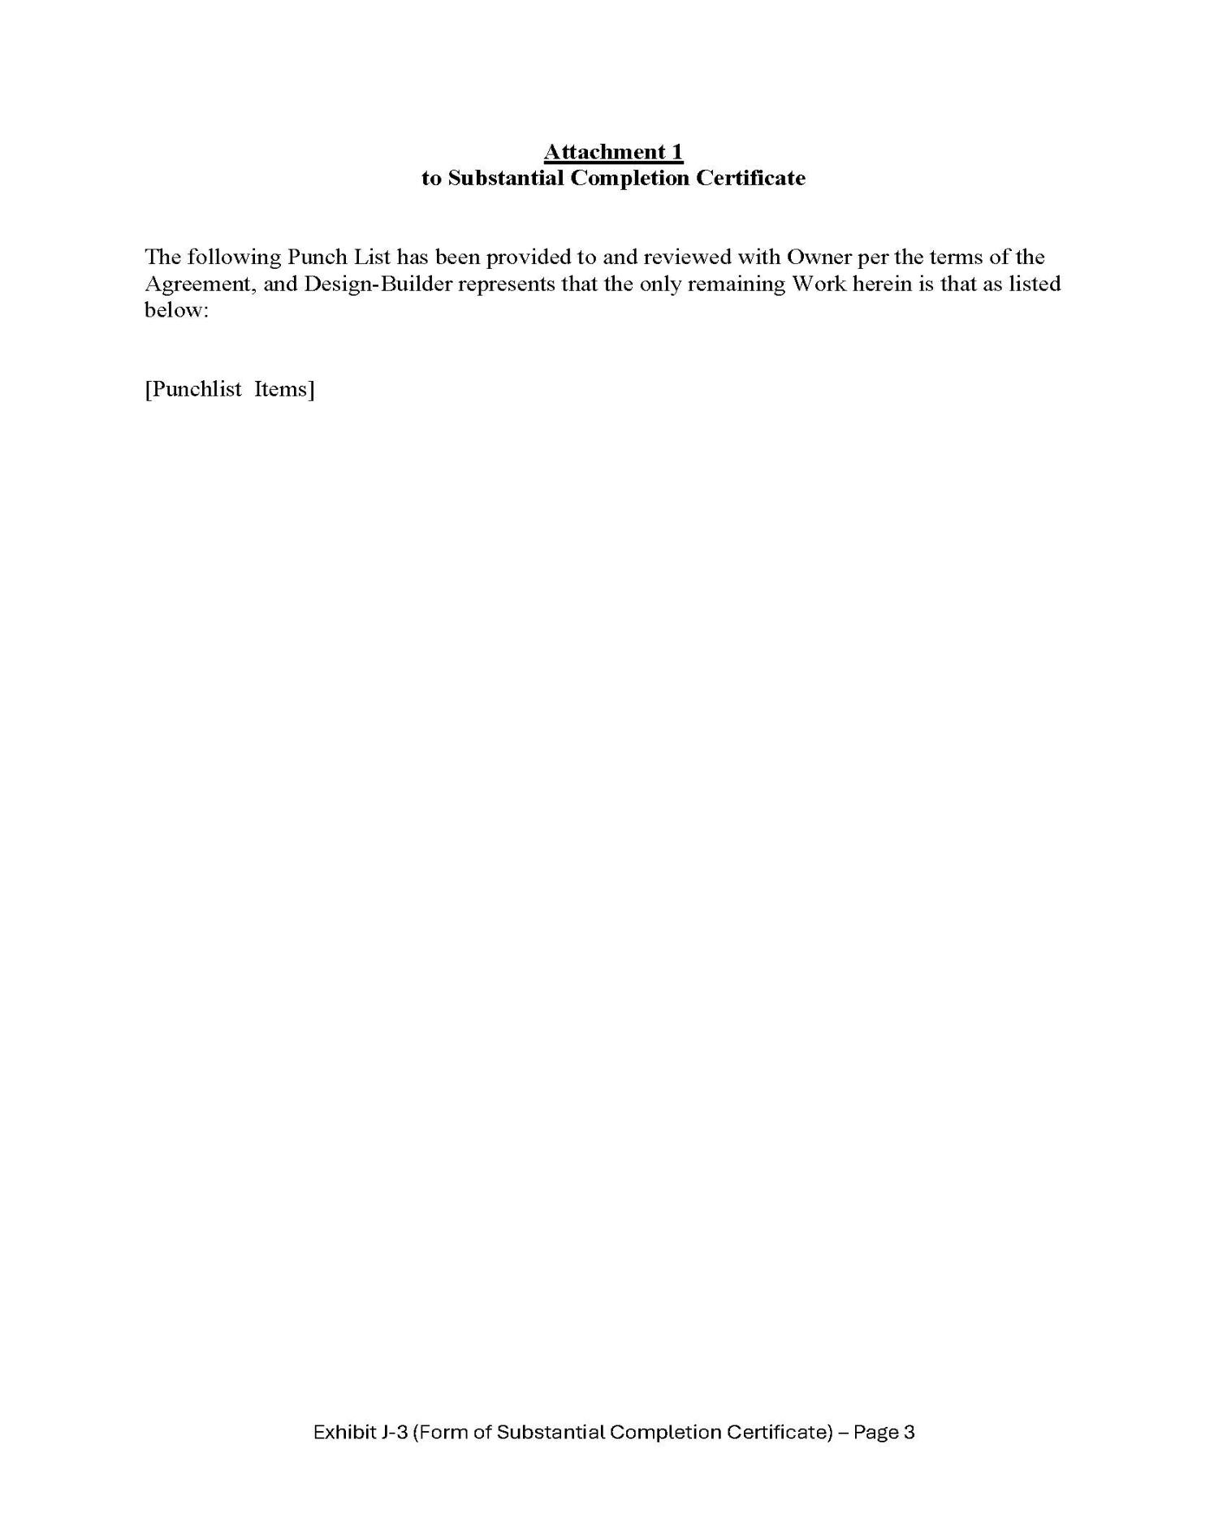

58

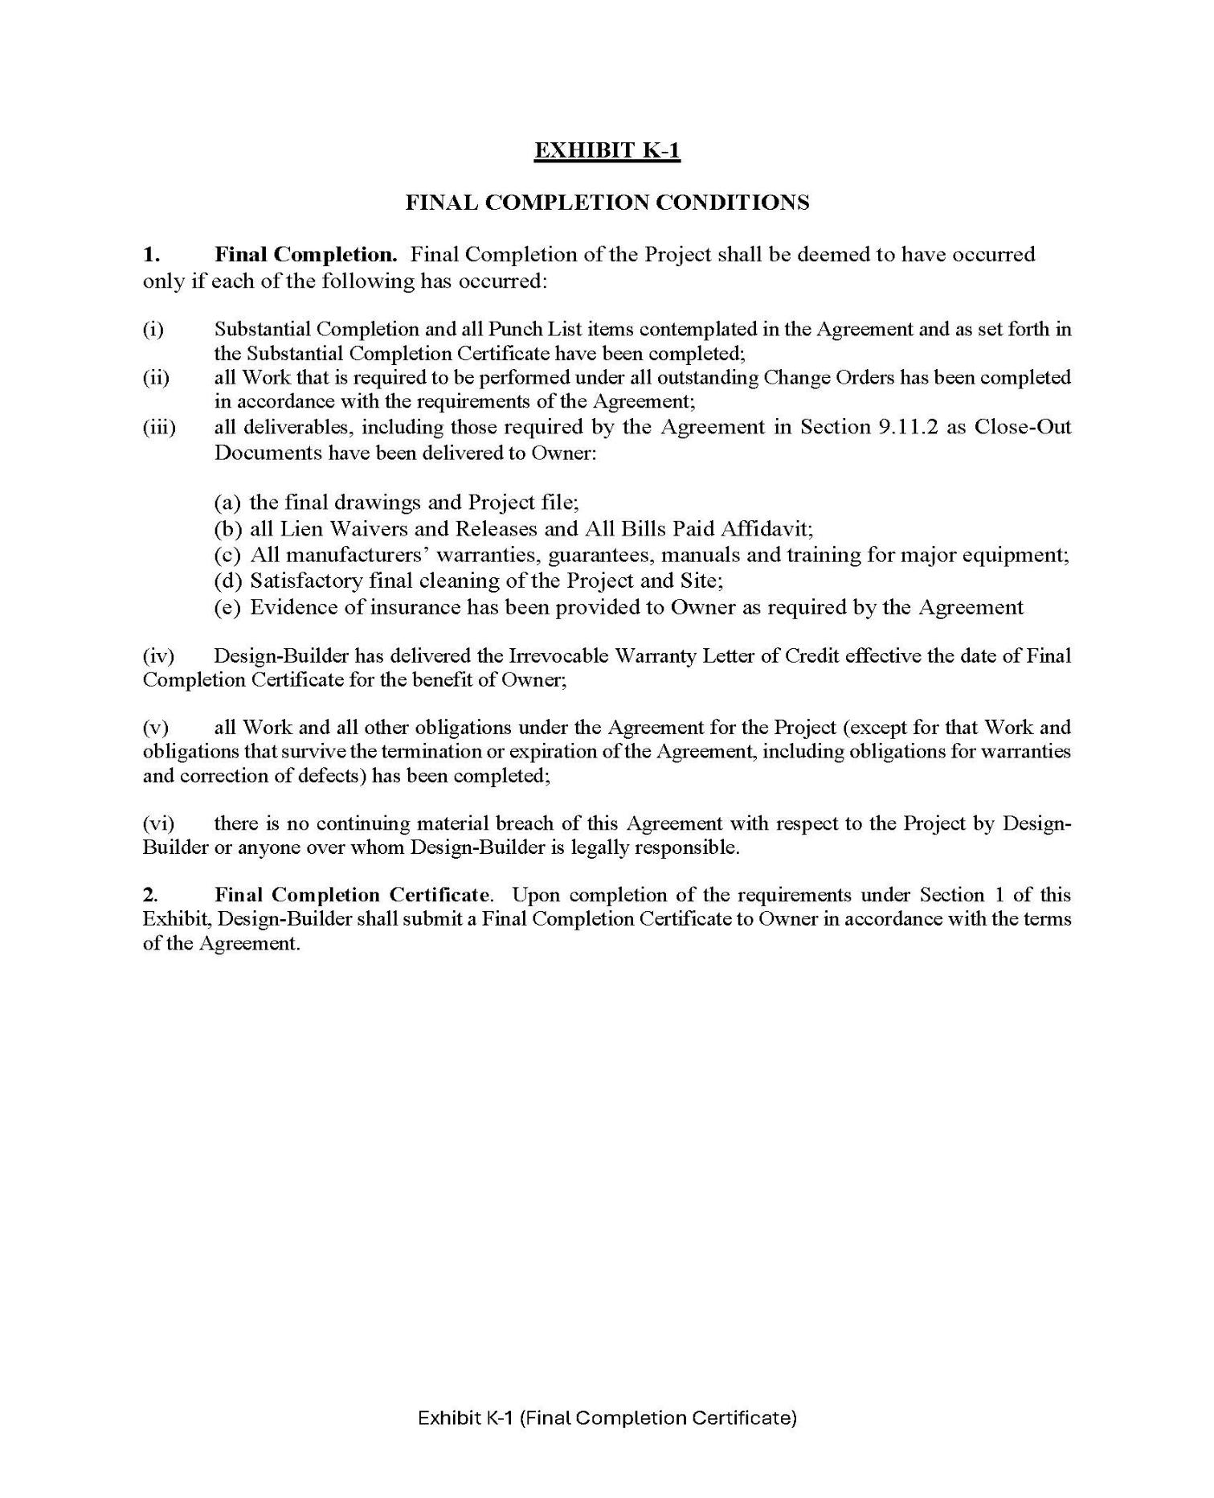

59

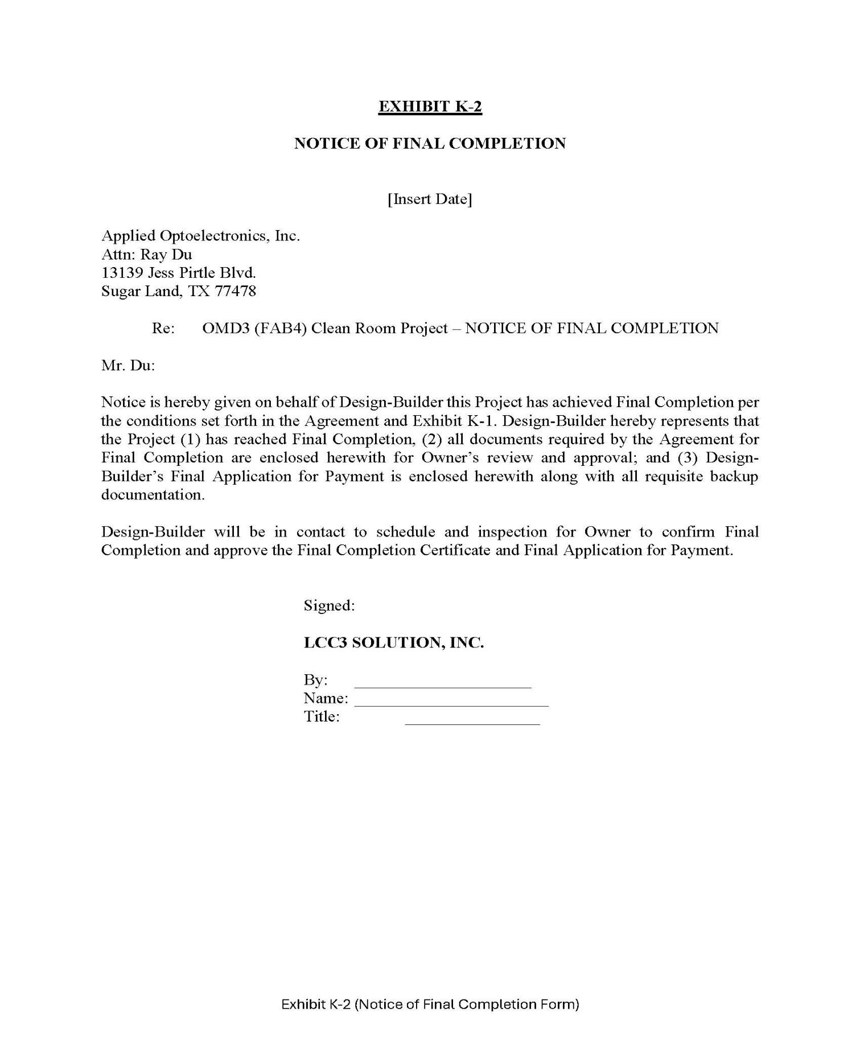

60

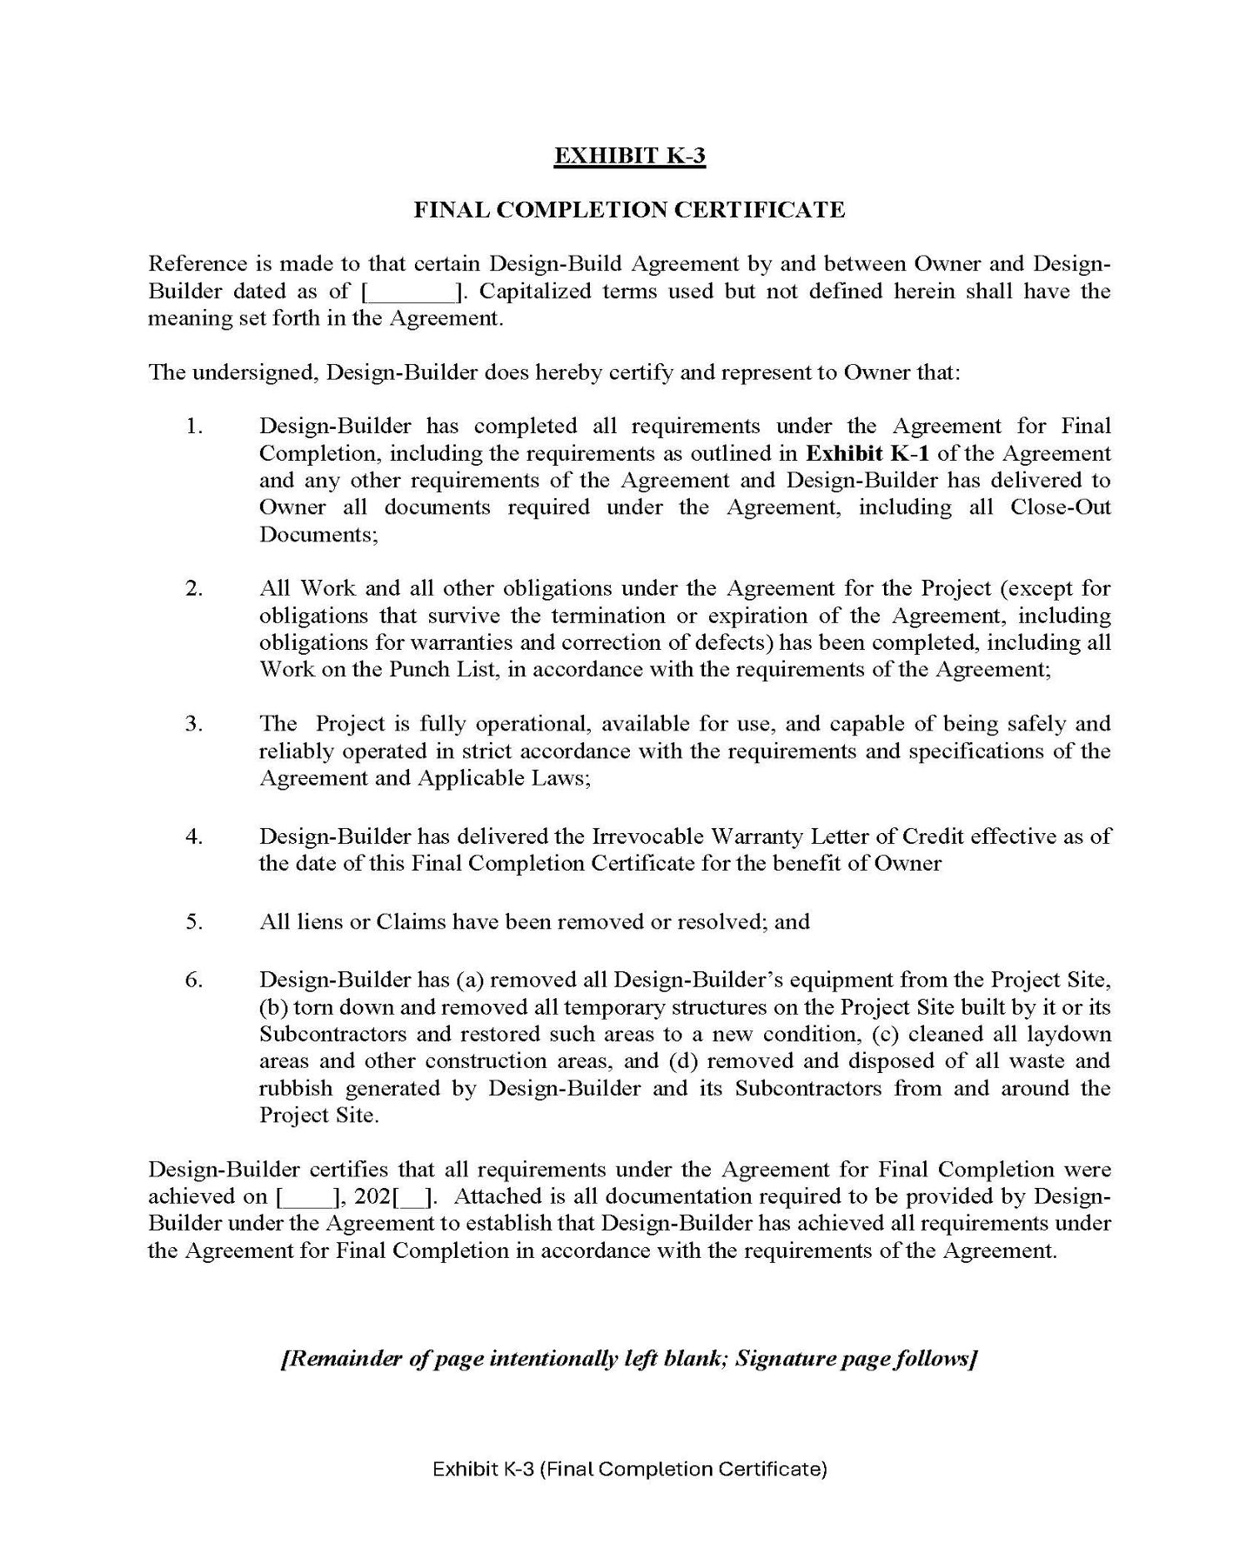

61

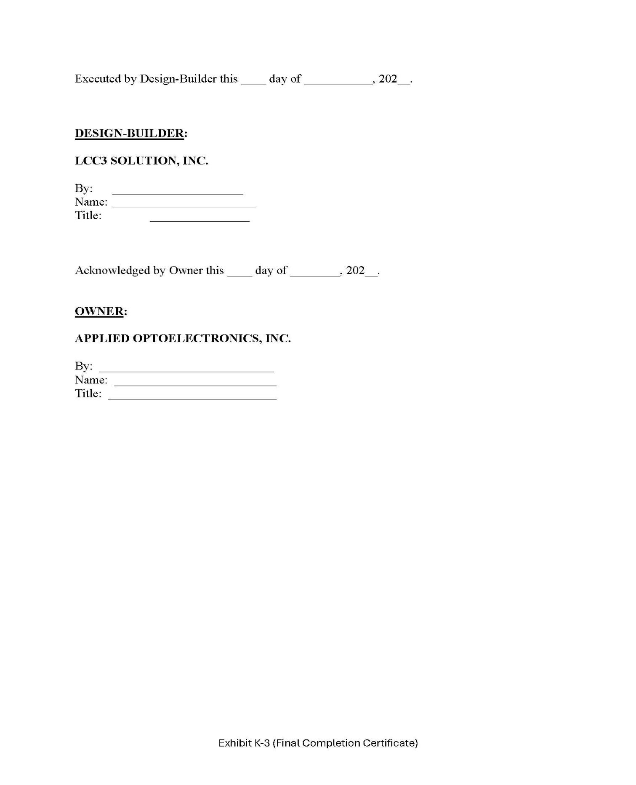

62

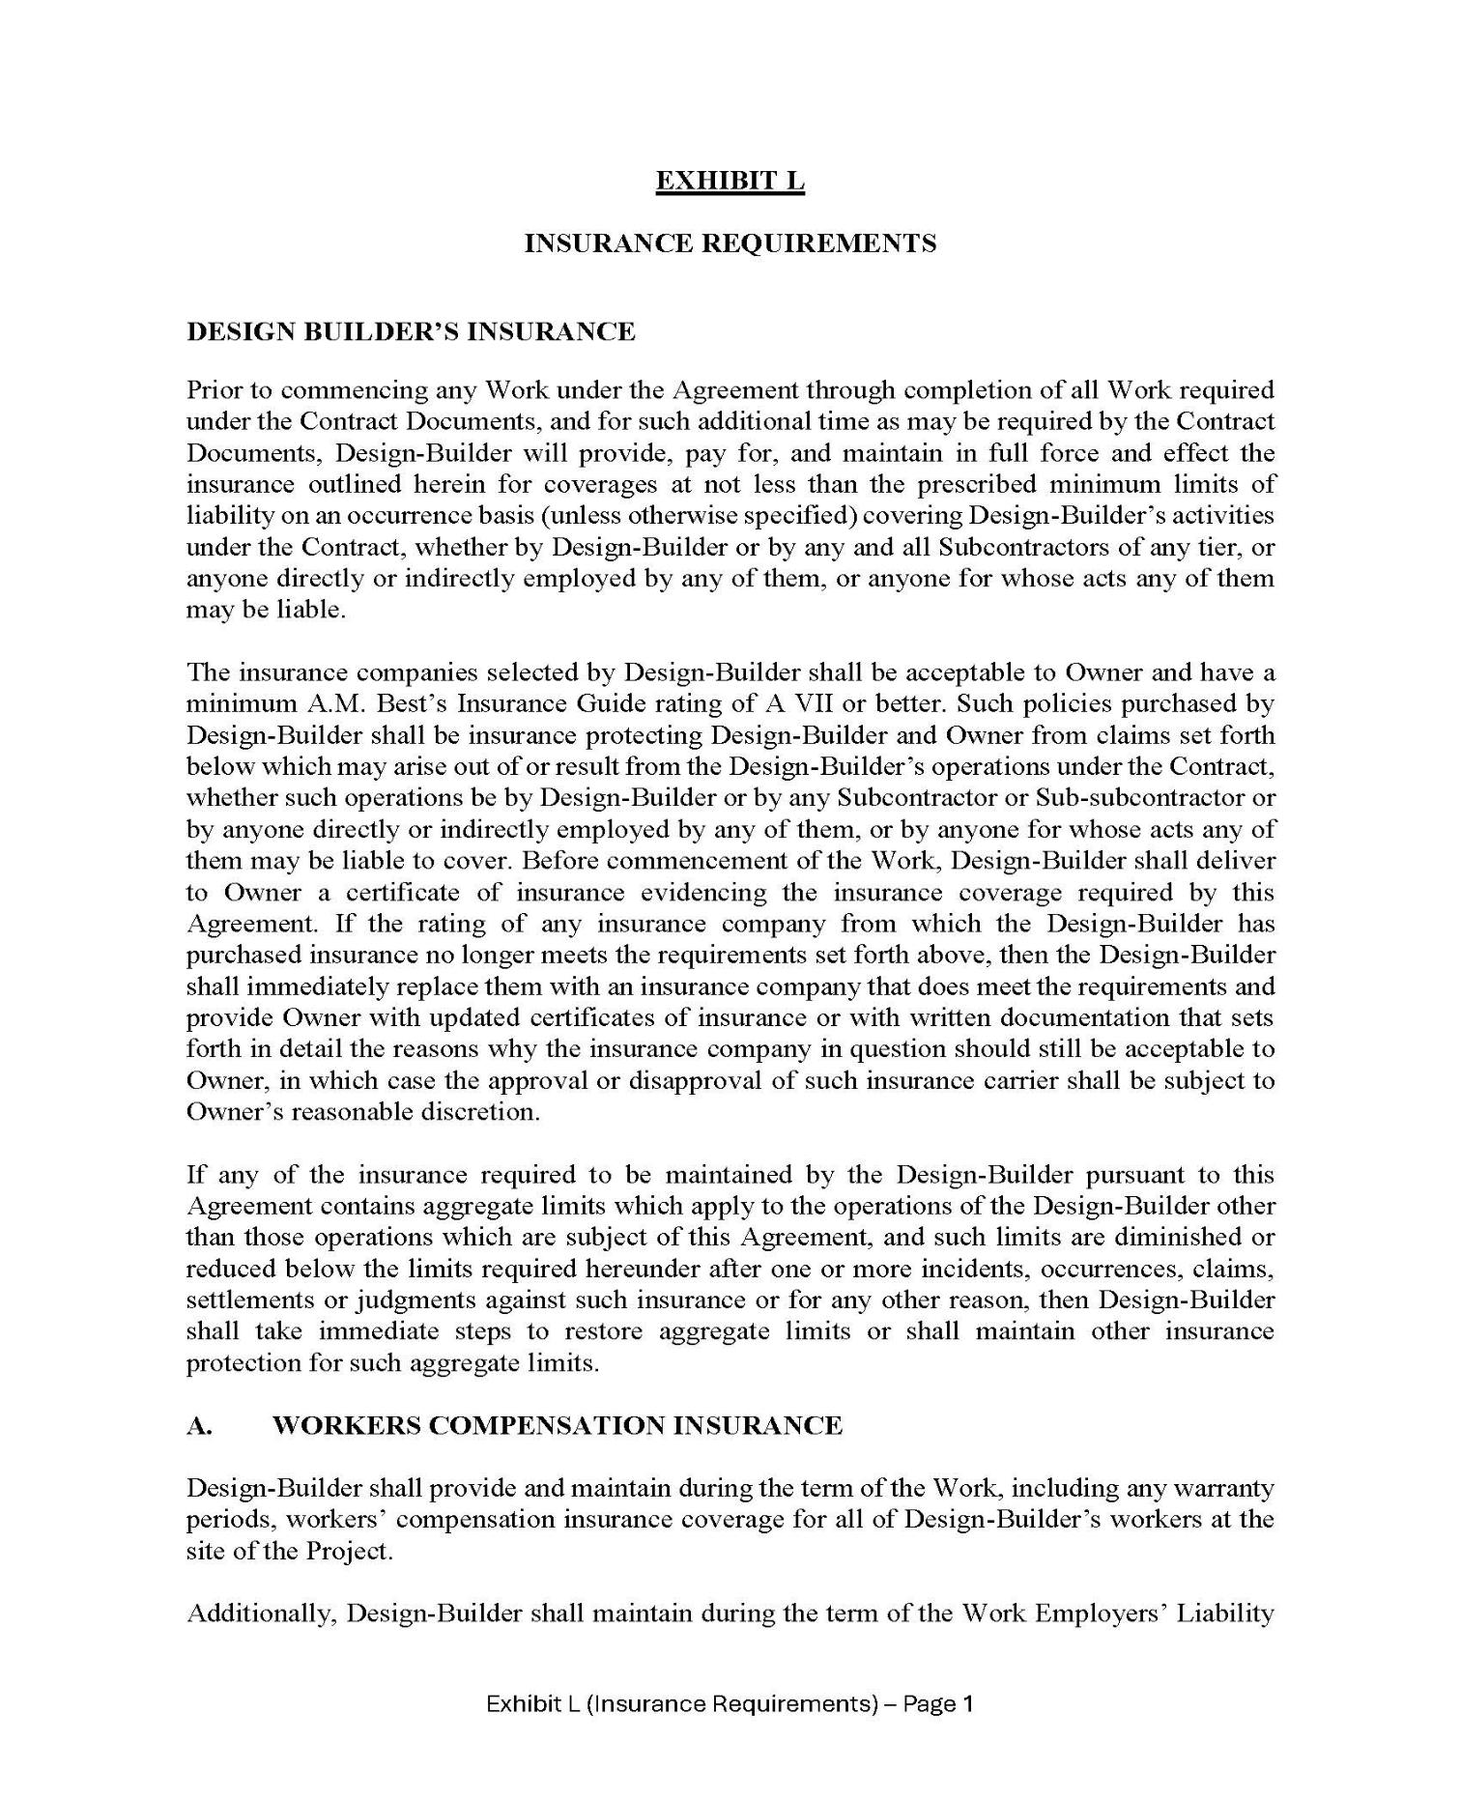

63

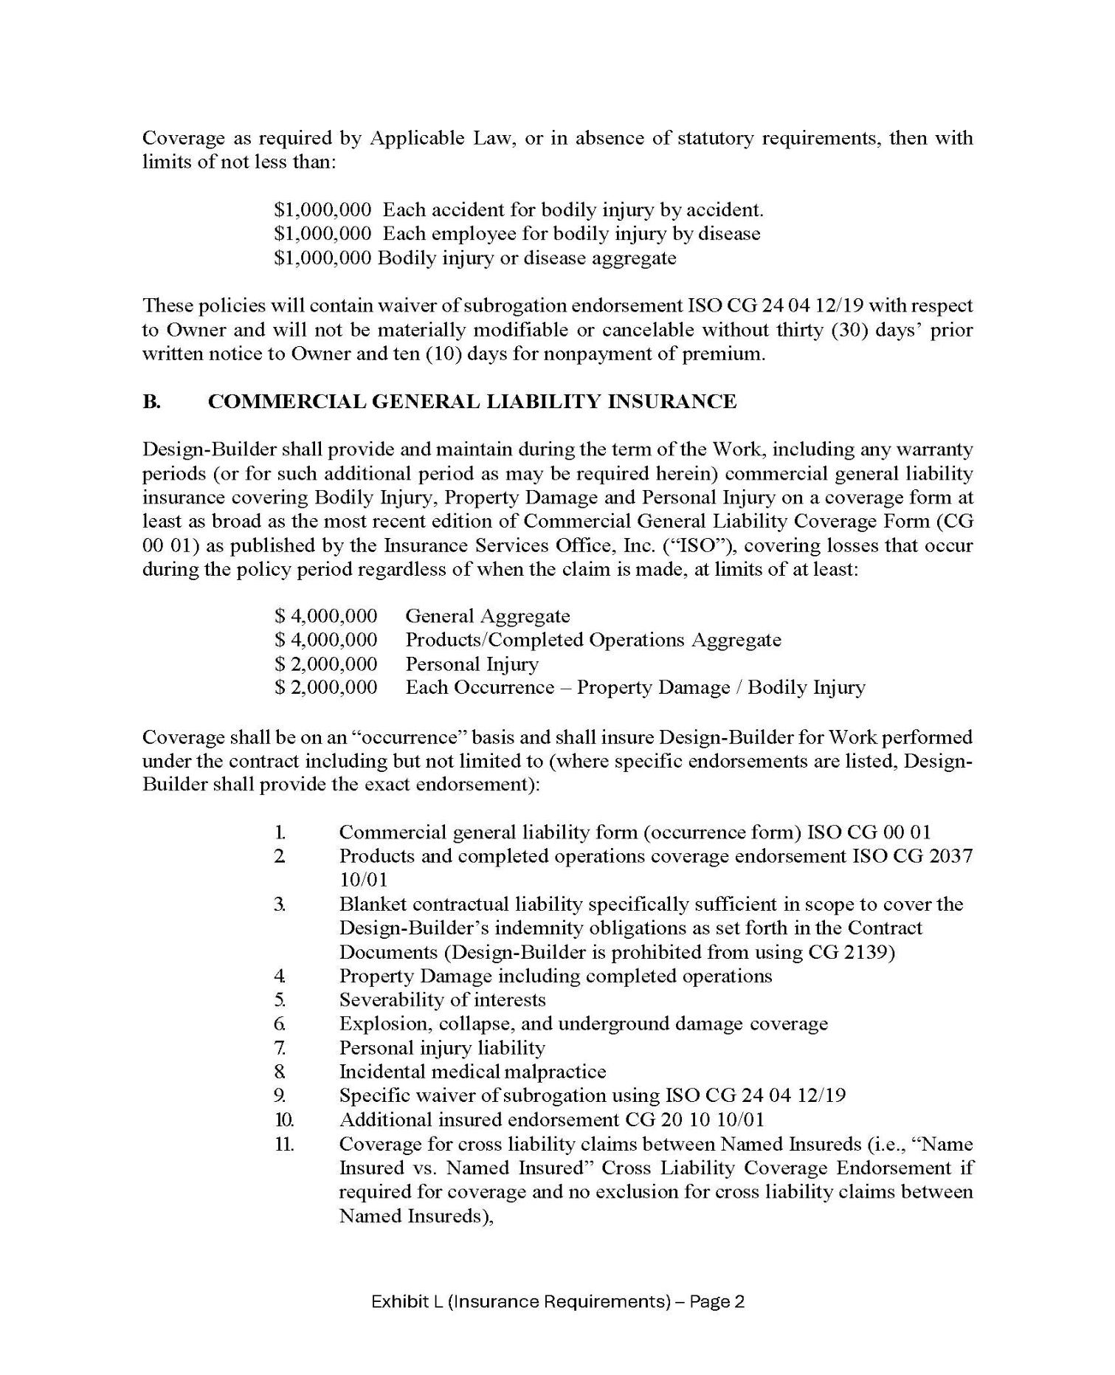

64

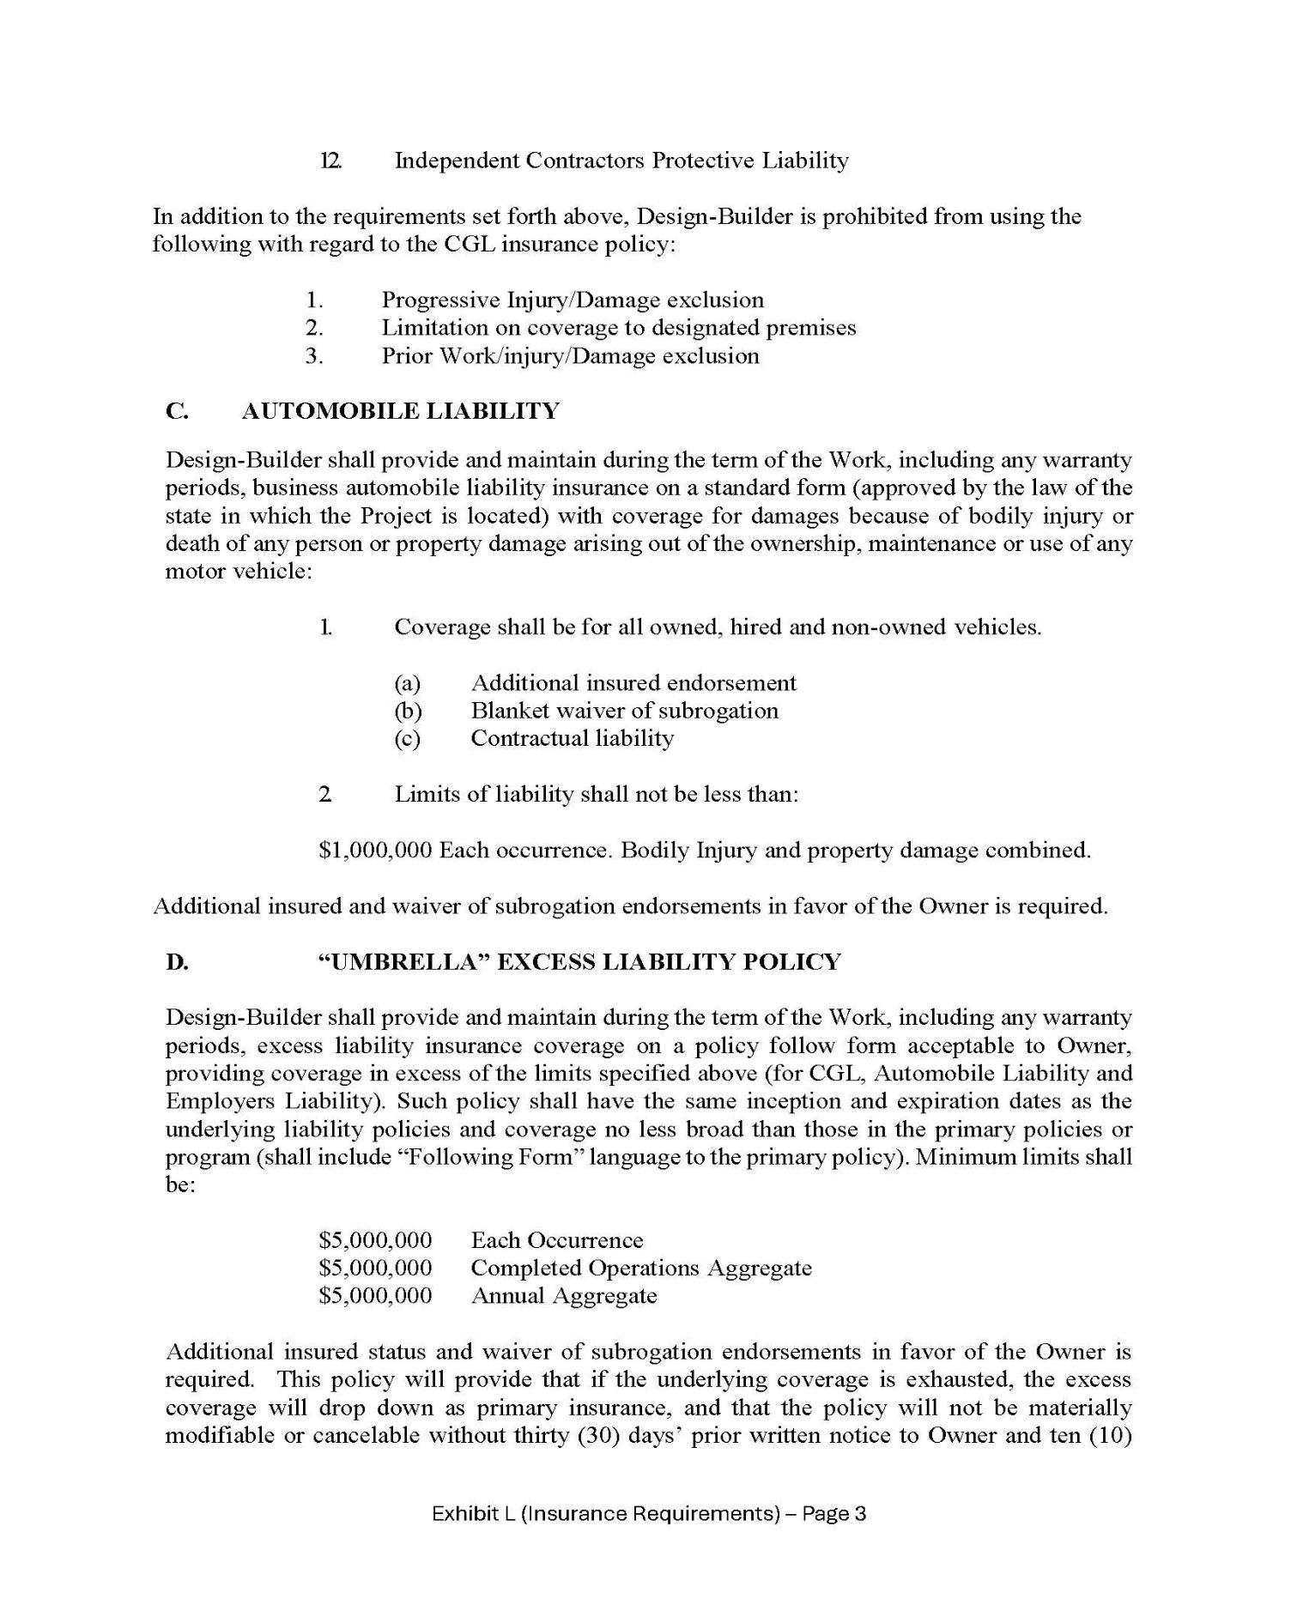

65

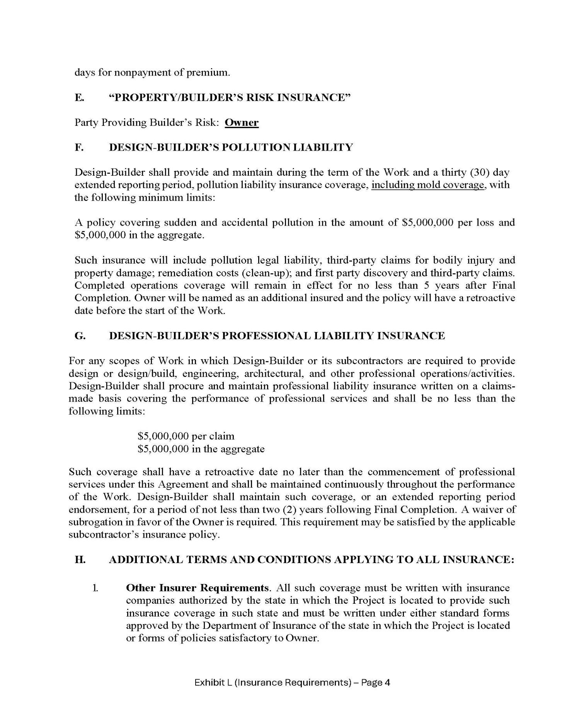

66

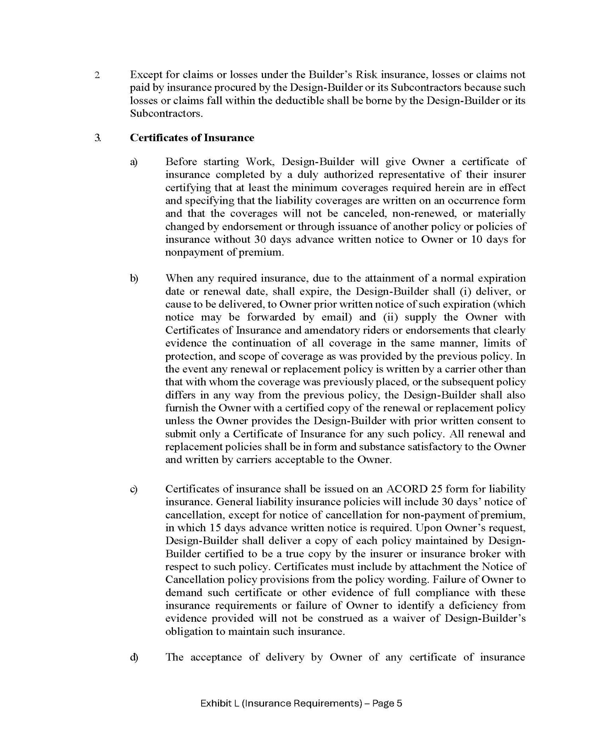

67

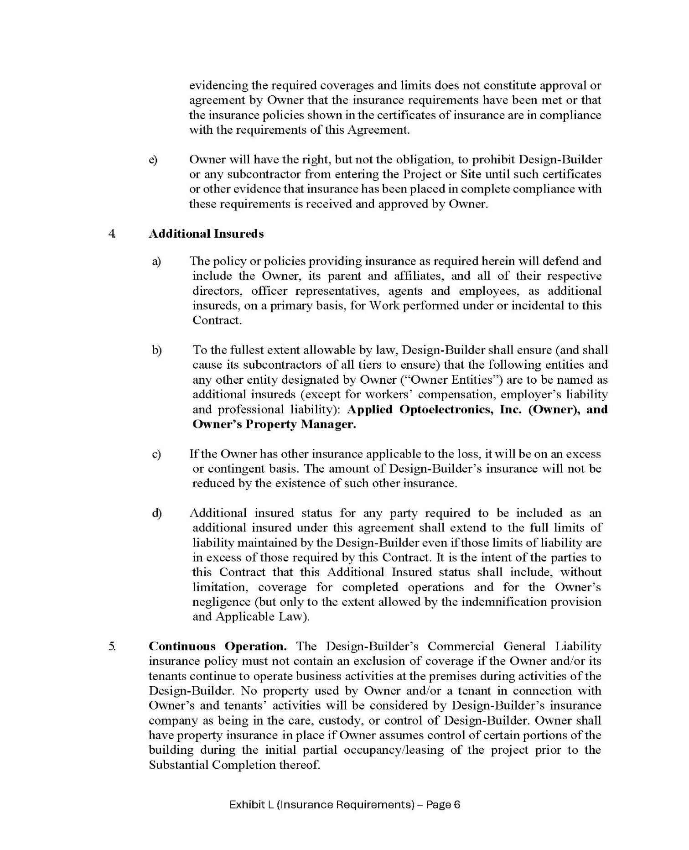

68

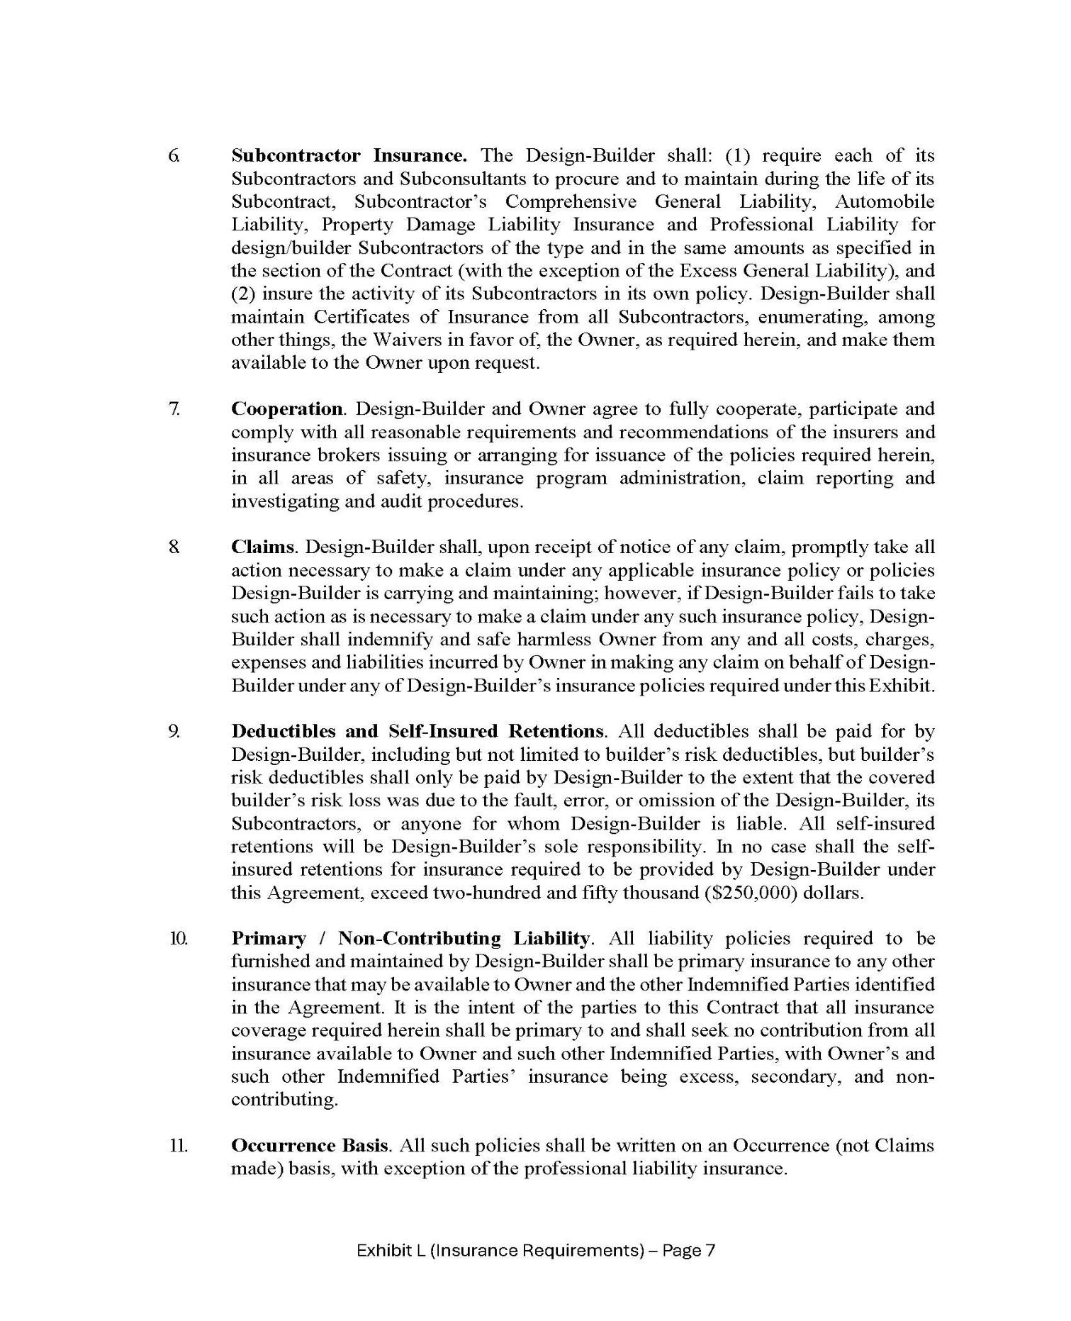

69

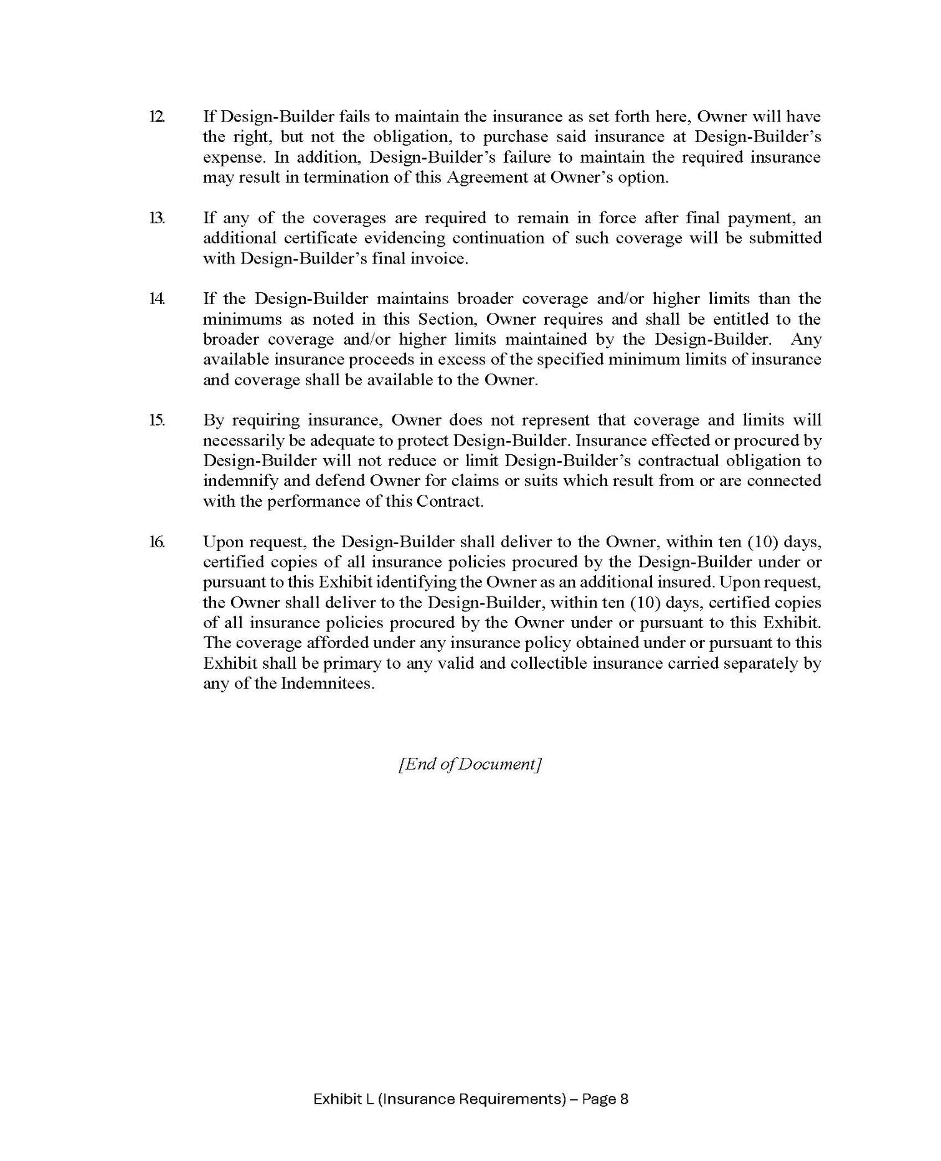

70

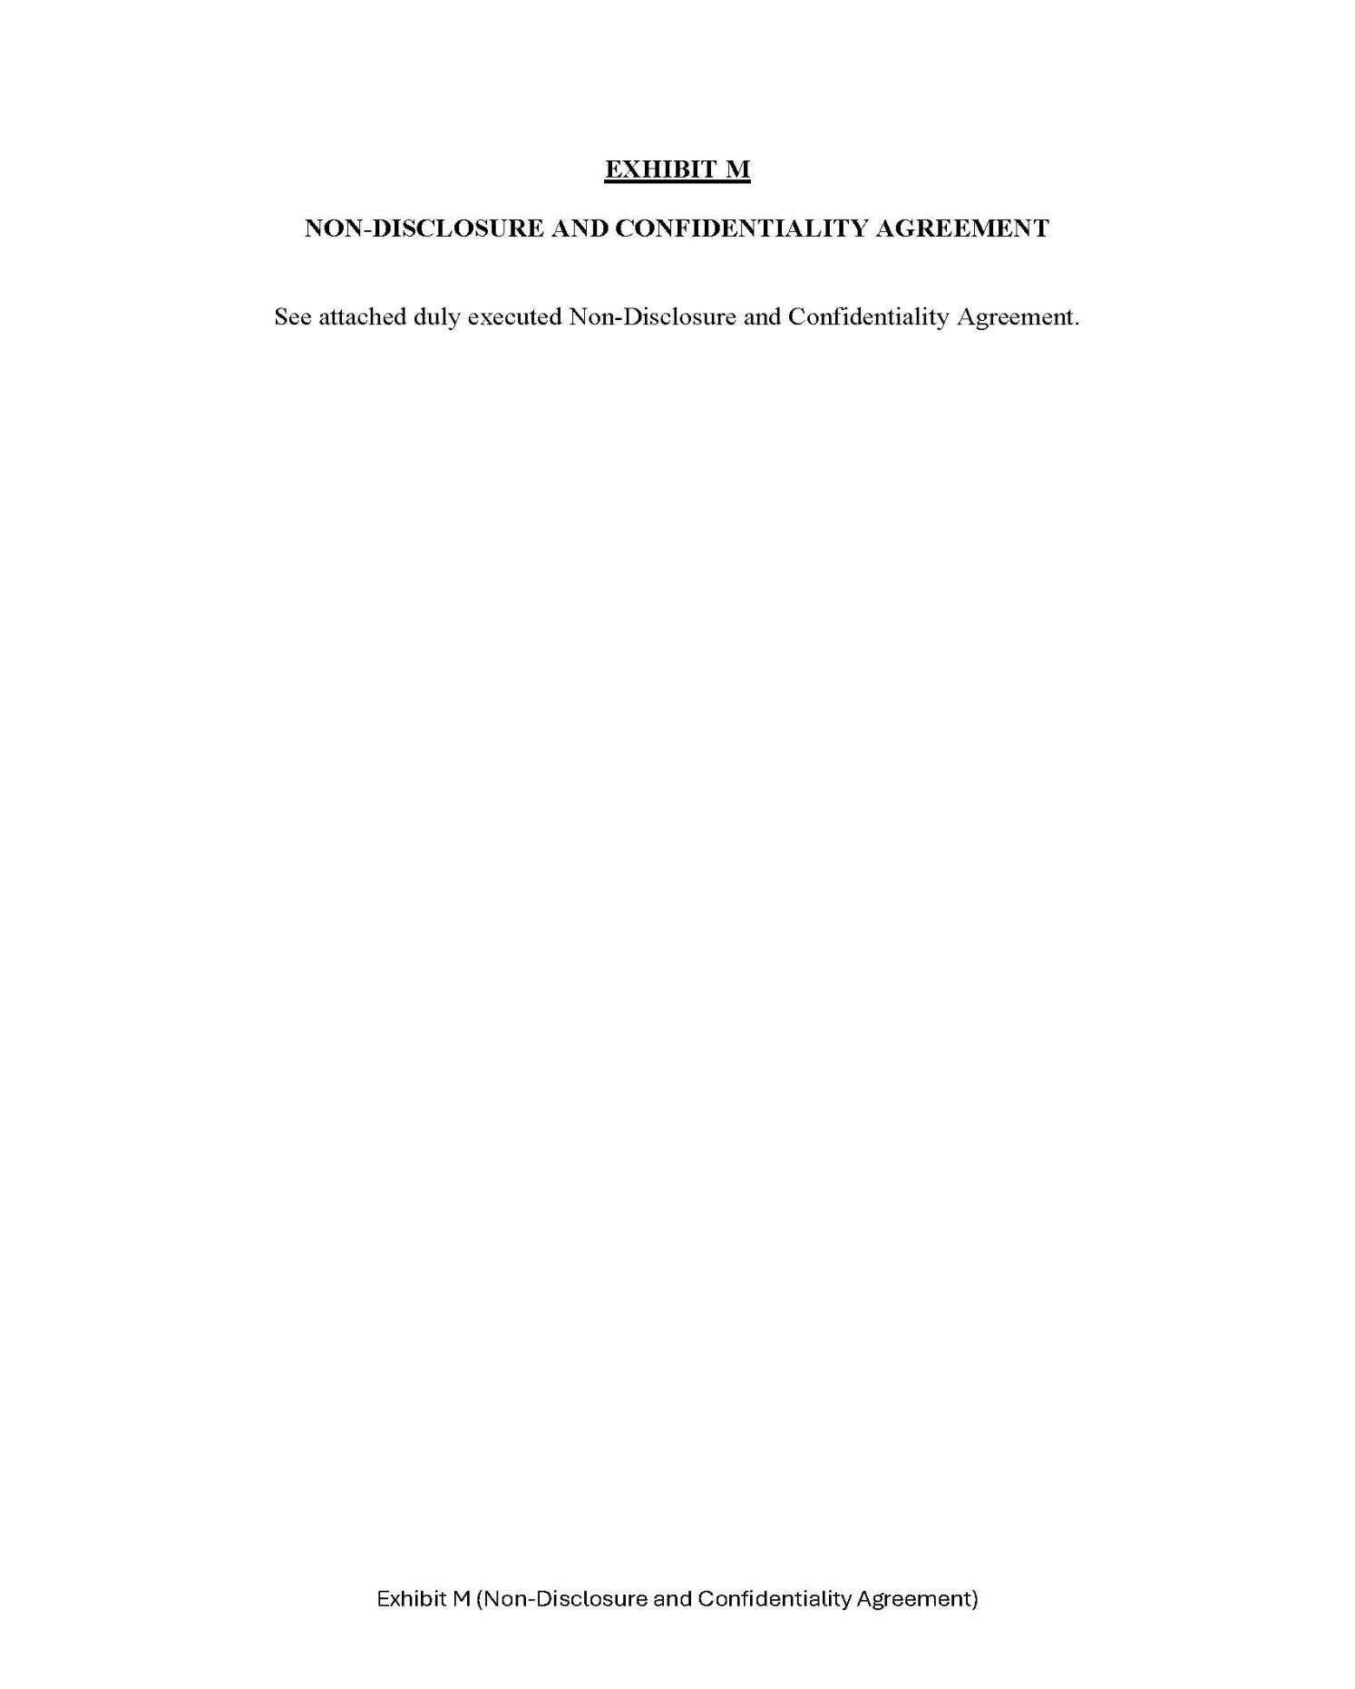

71

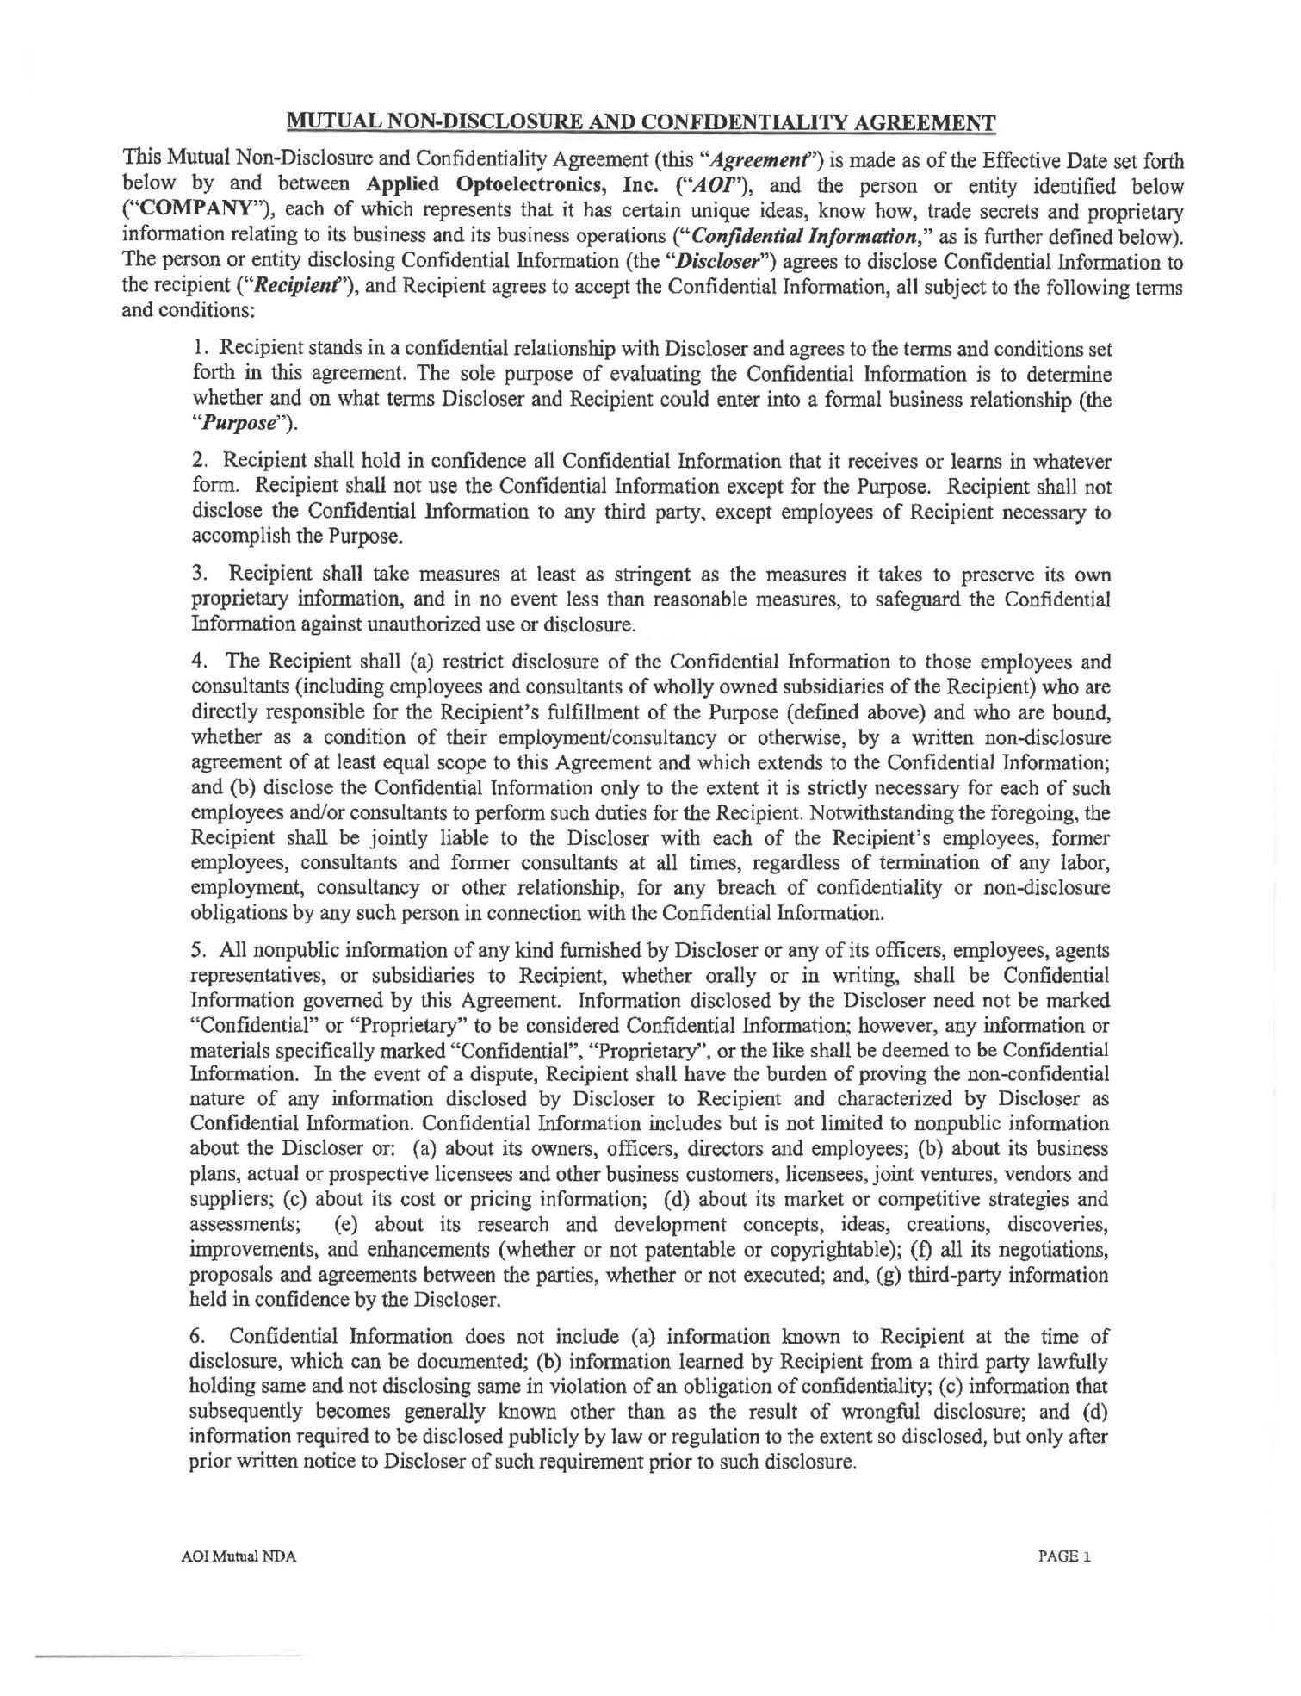

72

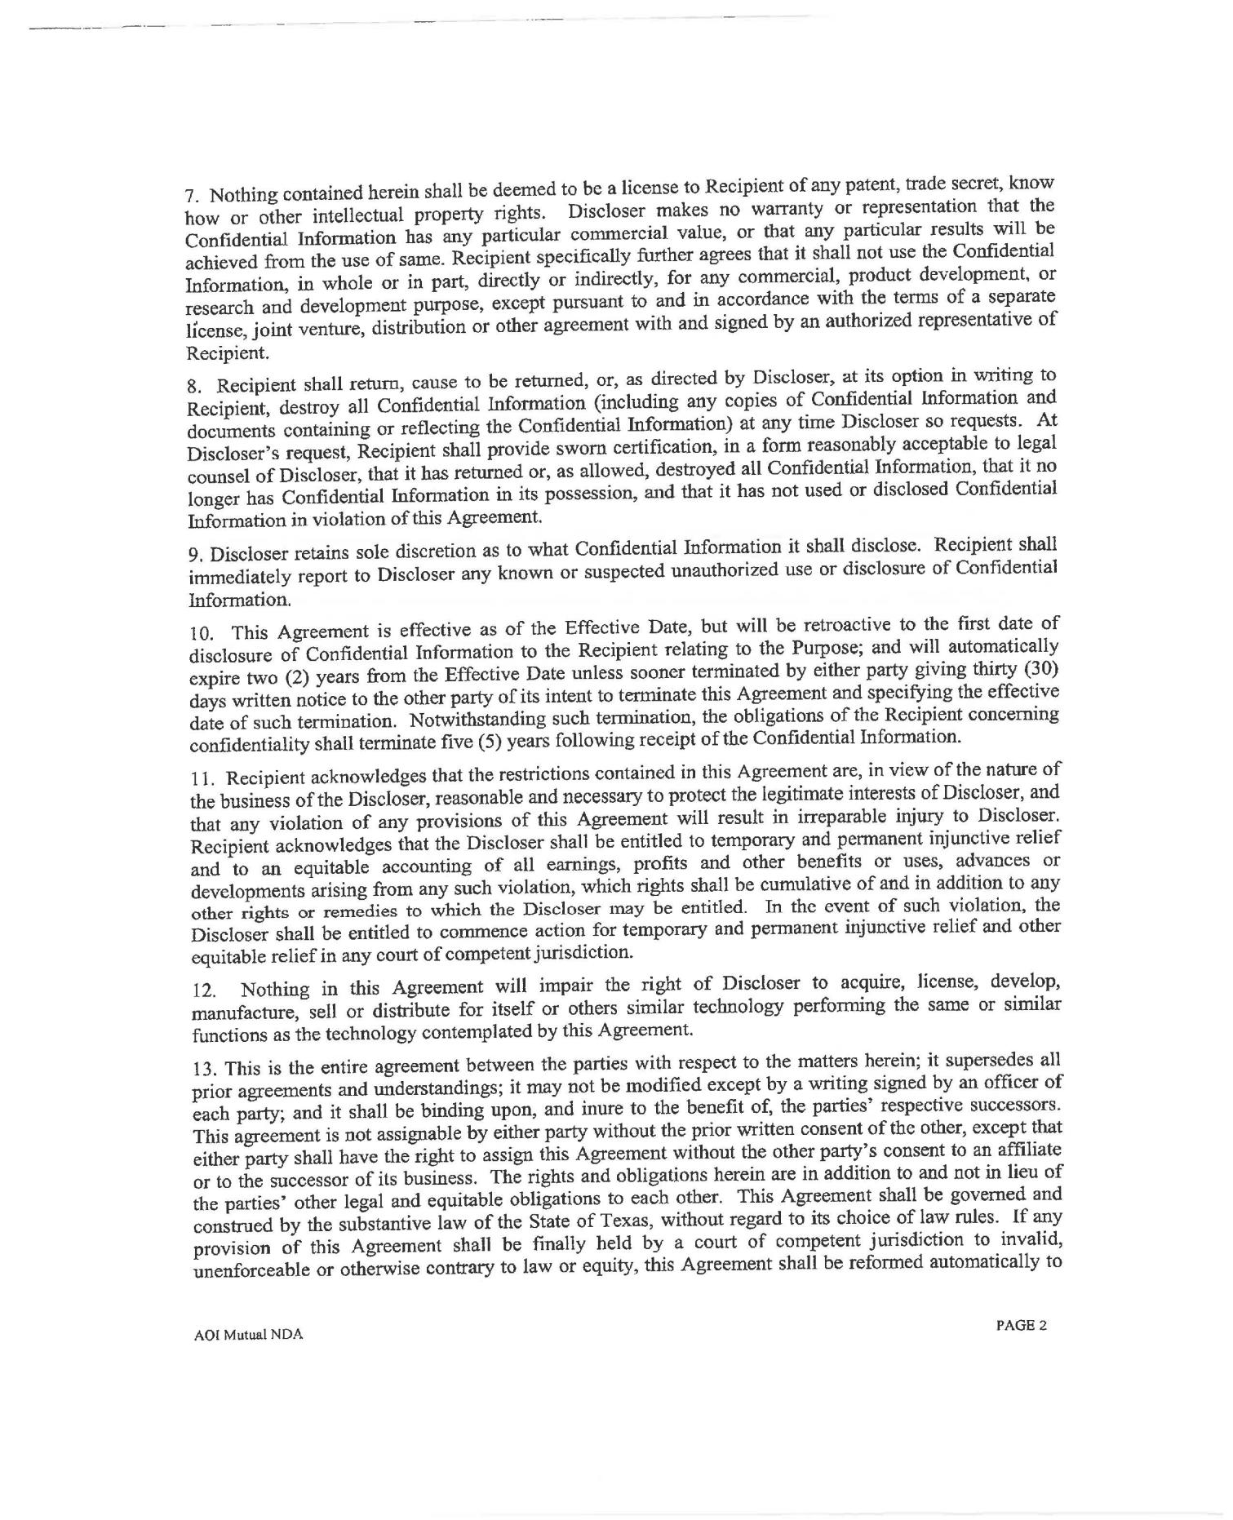

73

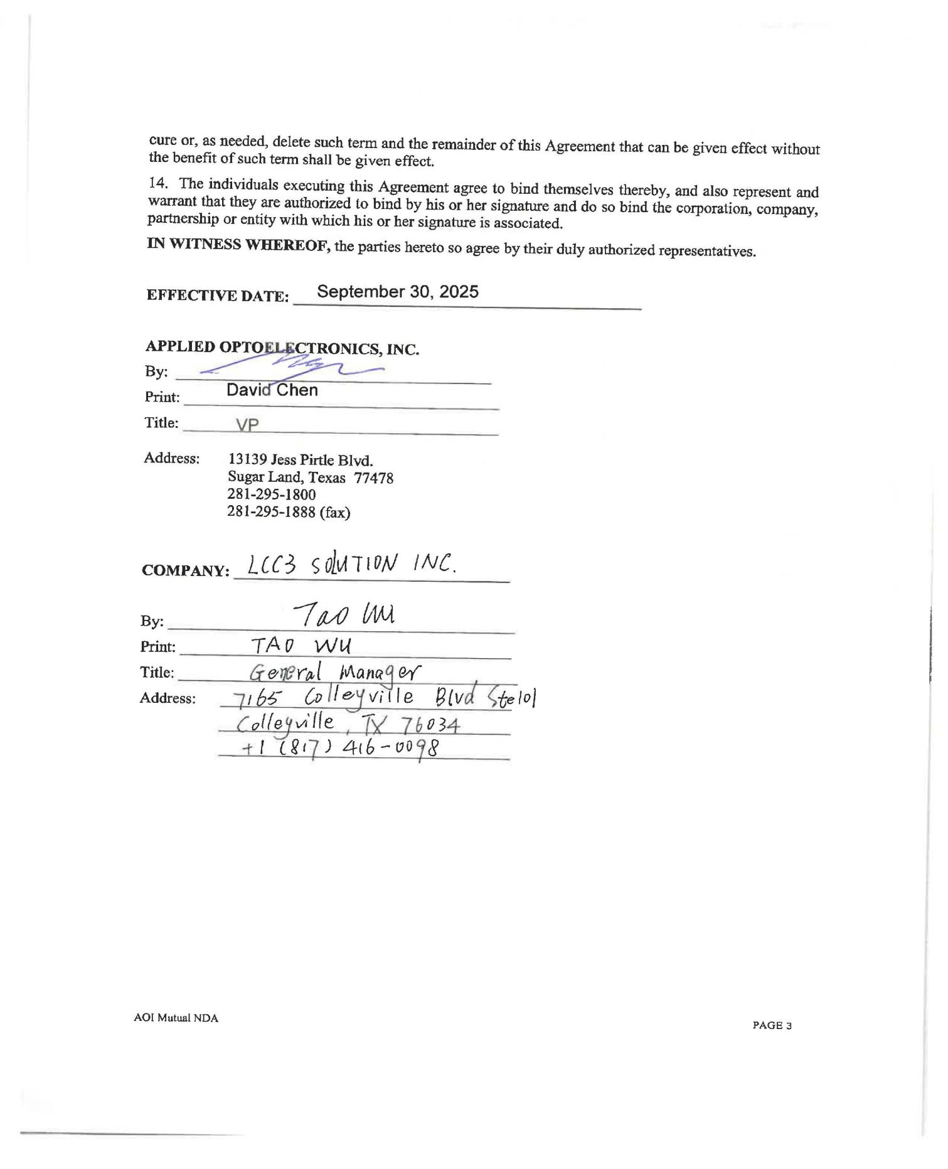

74

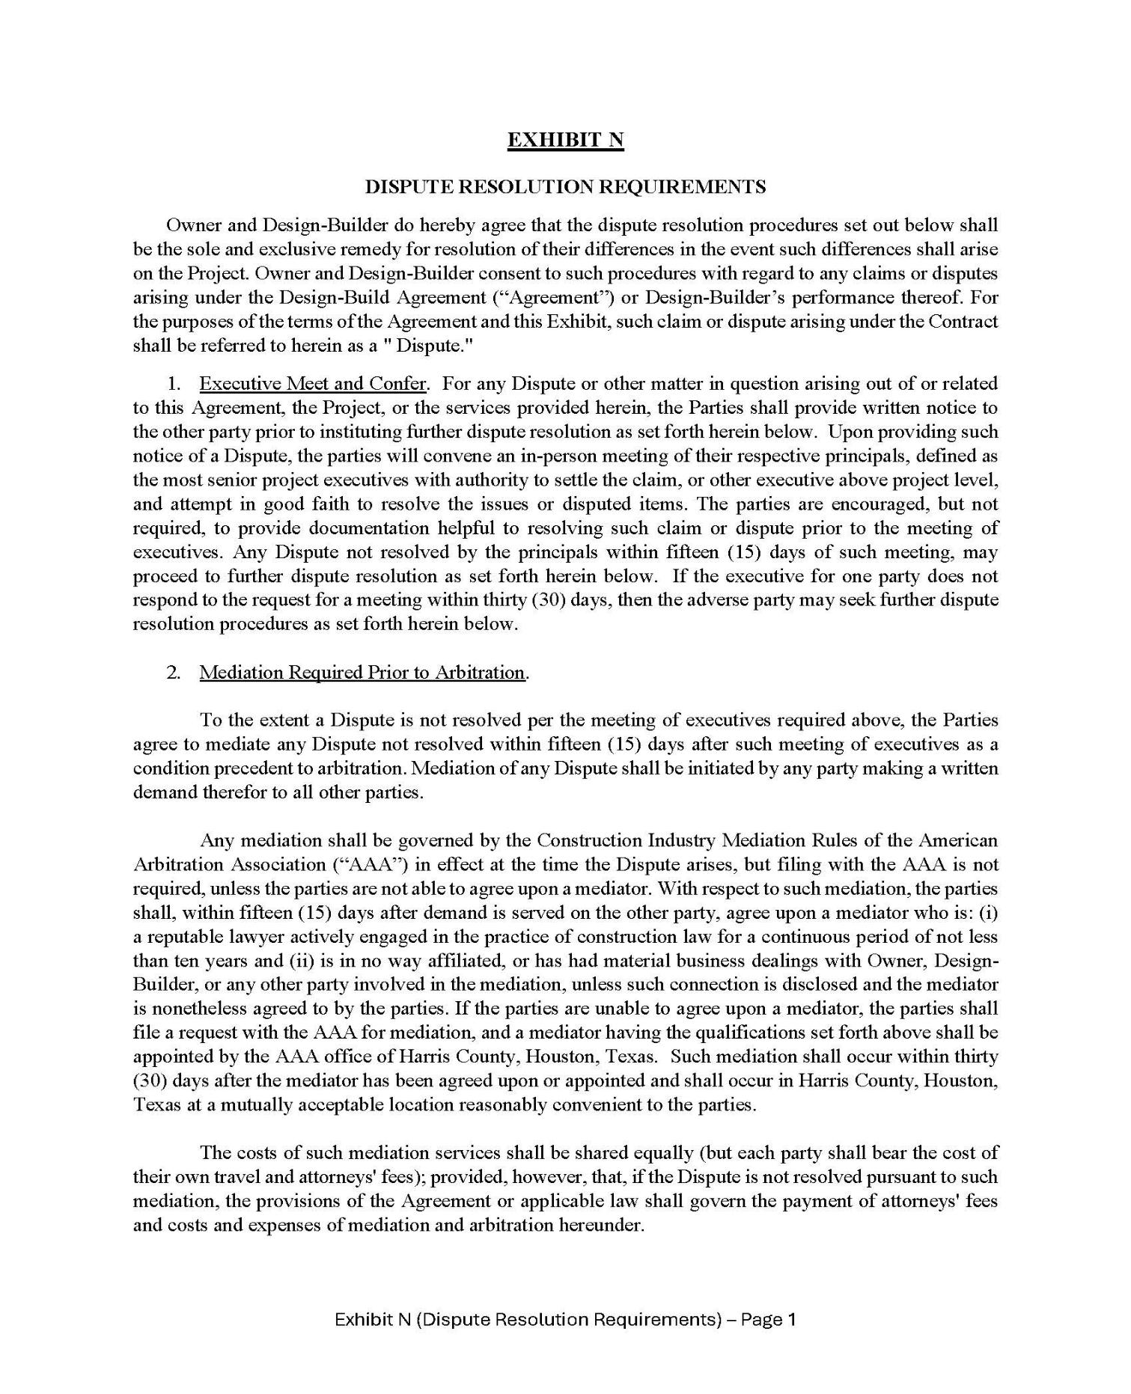

75

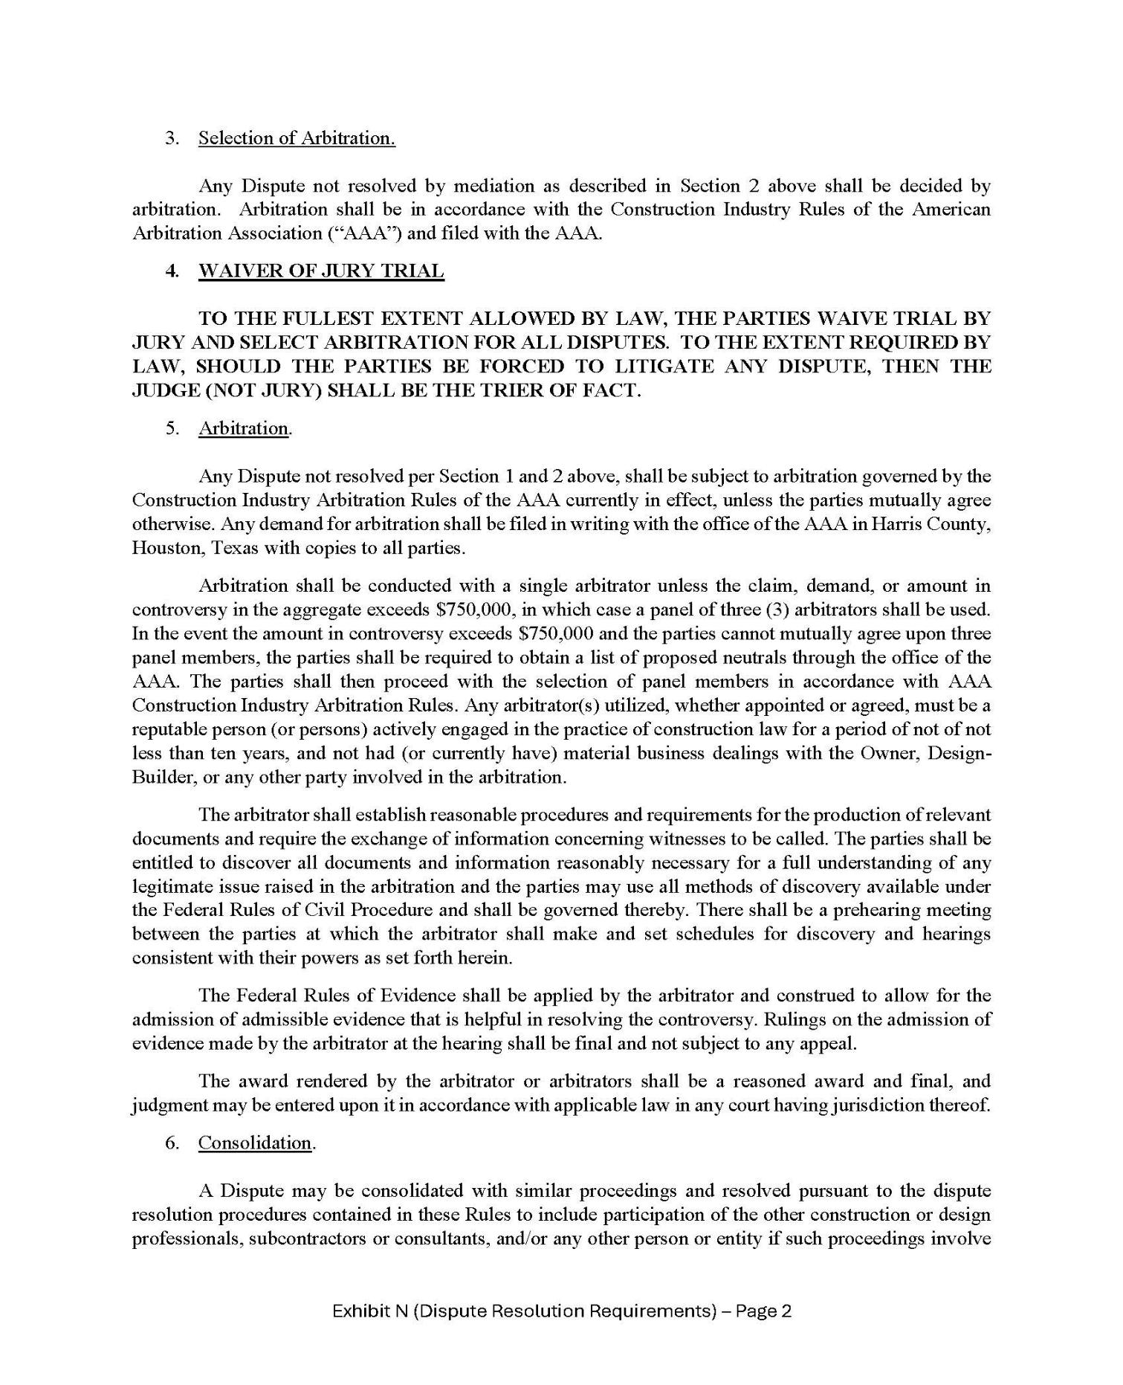

76

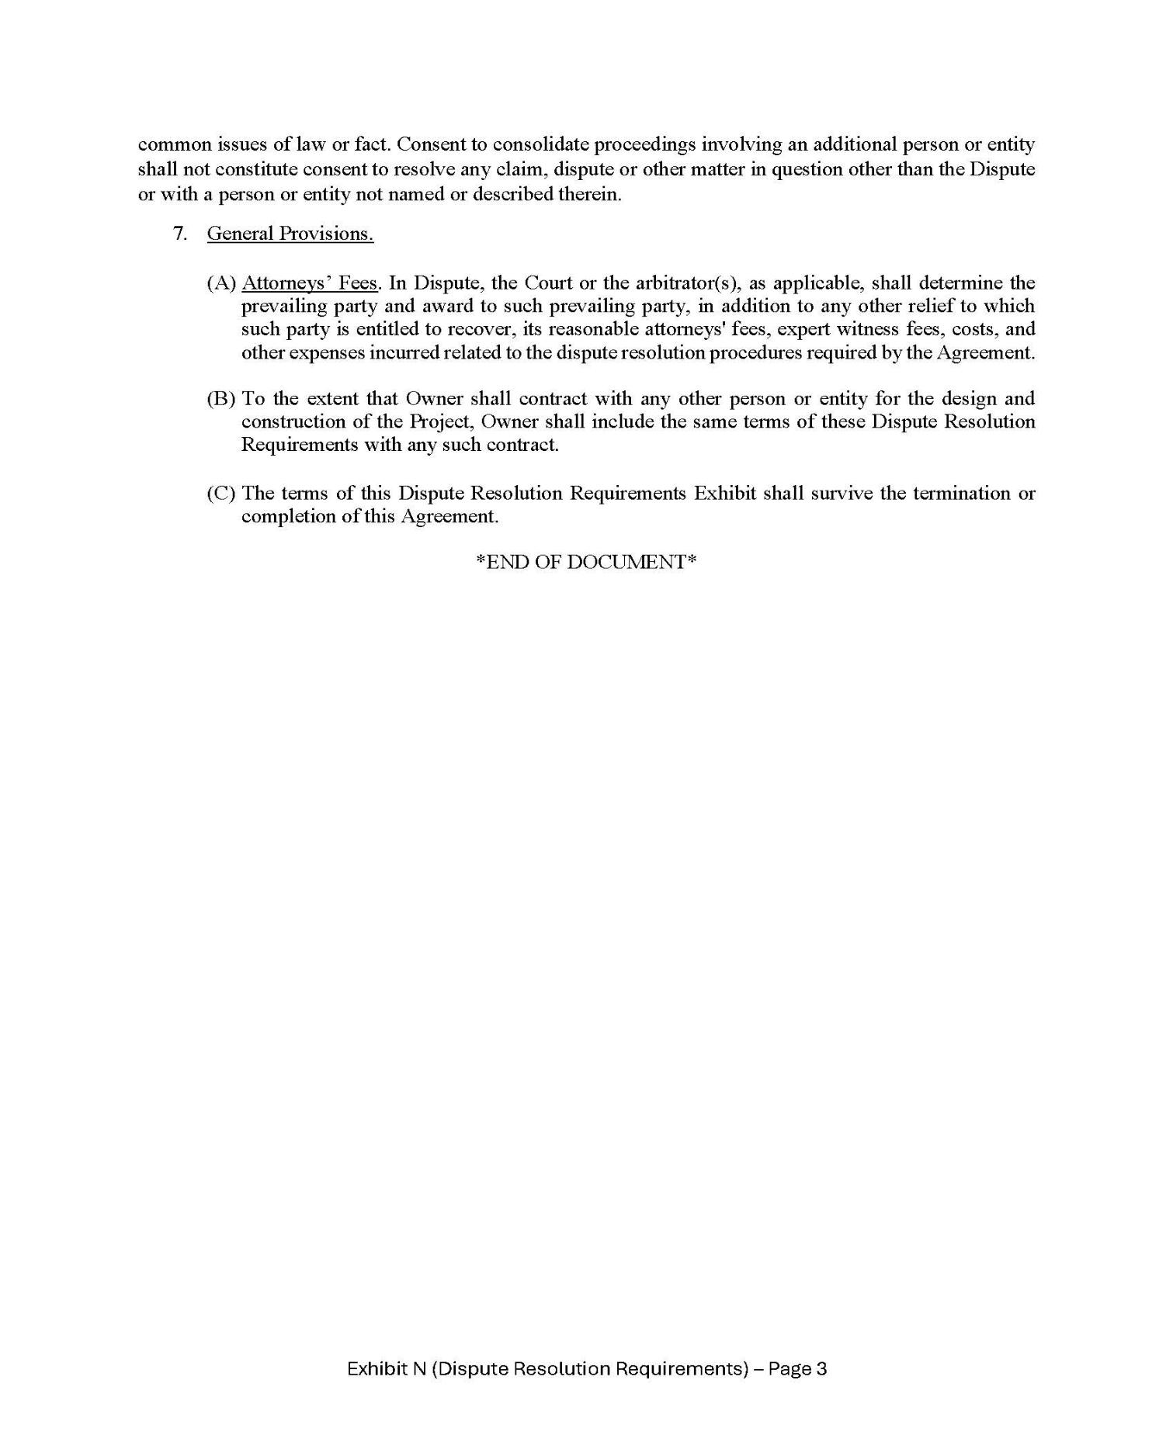

77

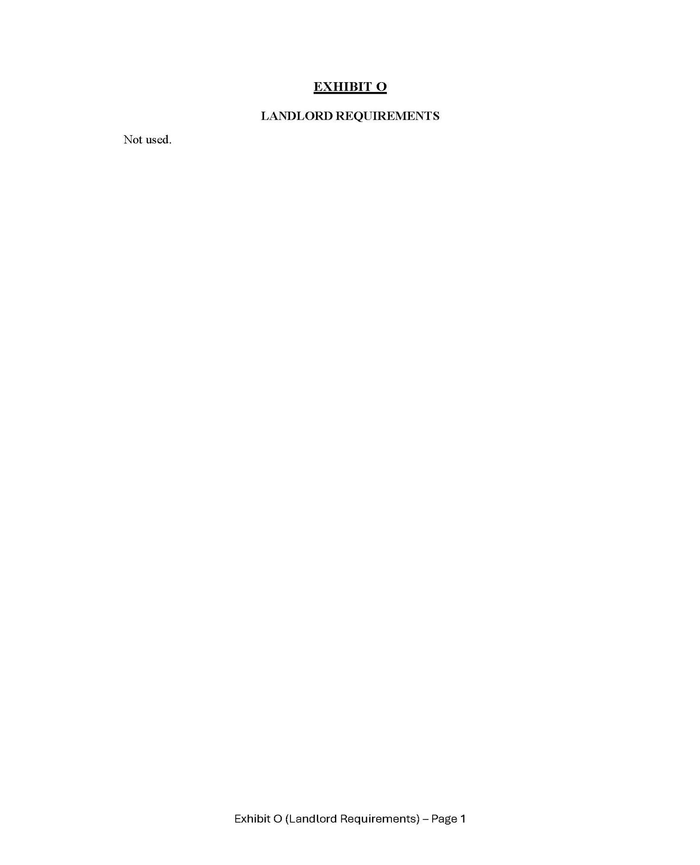

78

